Day to Day Operations- Procedure for maintaining and servicing Namlog vehicles .

    - Determine from the on set what are the vehicles service intervals- these are captured on LMS when the vehicle is purchased.(refer to NAM-SOP001-WS)
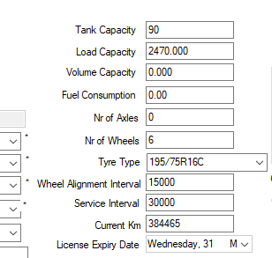

    - Bookings for services are made – the service report generated on LMS is used to determine which vehicle has reached its mileage for servicing.

    - An estimate/quotation is sent by the service agent/dealer , this estimate is than forwarded to the relevant departments manager to be loaded on fraxion.
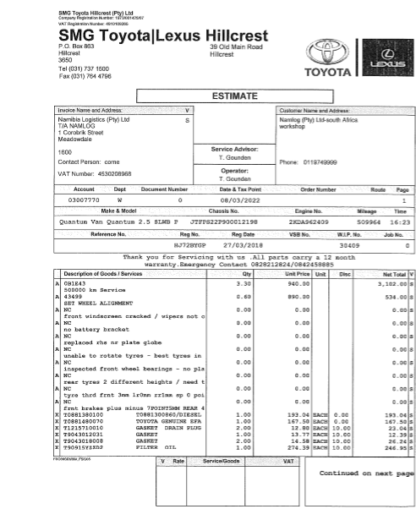

    - When the estimate is loaded on fraxion all relevant managers and directors approve the POR(Purchase Order Request).
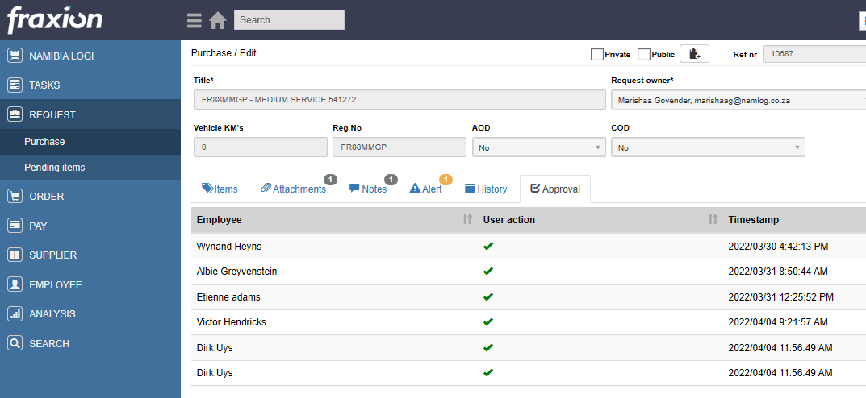

    - A Namlog order number is received and the order number is sent to the supplier .
    - The vehicle is than brought into the internal workshop for a preinspection before sending it to the supplier for a service.
    - In the instance where additional work is required to be done , the supplier informs the technical manager or foreman at Namlog , either of them will than go to the supplier to examine the additional work that needs to be done before approval and go ahead of the additional work.
    - The vehicle is returned after repairs and service, the workshop foreman or technical manager perform a post inspection of the vehicle and it is returned to the relevant contract manager .
    - The invoice is forwarded from supplier to finance department for payment processing.

