Swaziland: Clearing via Oshoek/Ngwenya Border Post to and from Swaziland

PURPOSE
The purpose of the Swaziland Clearing via Oshoek/Ngwenya Border Post to and from Swaziland Standard Operating Procedure (SOP) is to align all operational and clearing teams on expectations pertaining to the clearing process of this border. Also, to ensure all operational queries are directed to the correct individual. The SOP must be utilised as a guideline for all Namlog staff. This is to ensure delays are mitigated as far possible and limit any risk of financial loss to the company.
SCOPE
The SOP is applicable to operational and clearing teams directly and indirectly involved with the dealing in either cargo, documentation for clearing or any query directed in relation through this border. Clearly defining the process and expectation in which the process flow and dealings must be conducted. The SOP details to the clearing team in specific, operational staff verifying the documents, also capturing the information thereof, of the standard to follow.
Process
Identified times: 14h00 – 20h00
Border posts: Oshoek (Slabbert Clearing Agents at Oshoek / Slabbert Clearing Agents at Ngwenya)
3rd Party Transporter: Eliang Couriers
Daily operation will be scheduled as stipulated:
- From 14h00, all overflow cargo from the previous day should be framed and cleared.
- All Specials and dedicated loads arranged prior to 14h00, must be sent to the clearing supervisors and department head.
- All Specials and dedicated loads allocated through these borders from 14h00 must be cleared by Swaziland Framing Clerk between the shift of 14h00 to 20h00.
- JHB Hub dispatching locally collected over border cargo to this specified border post cut off time for submitting border documents to Framing Clerk by 19h00 daily.
- JHB Hub dispatching locally collected over border cargo to this specified border post being sent with 3rd party, cut off time for submitting border documents to Framing Clerk by 19h00 daily.
- Linehaul Operations must inform the Framing Clerk of vehicle and driver details by 17h00 daily.
- All Swaziland cargo routed to Swaziland via the specified border posts must be cleared by 20h00.
- Swaziland Linehaul Operational team in Johannesburg loading Swaziland Linehaul must submit LMS manifest to Lesotho Framing Clerk by 19h15 daily.
- All load documentation including LMS manifest, and EDI manifest must be sent to Slabbert Clearing Agents by 20h00 daily.
- Communication and cash up thereof must be posted on the Slabbert Clearance WhatsApp group by 20h00 daily with the format displayed in figure 1.
- All cargo being moved with 3rd party transporter Eliang, clearing should also be posted on the Slabbert Clearance WhatsApp group by 20h00, refer to figure 2.
- From 20h00 until 24h00, the Framing agent will continue with framing entries for SLI/Gentex Linehaul clearing or as directed by the Clearing Supervisor.

Figure 1

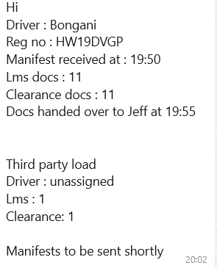

This SOP is implemented to ensure maximum efficiency and ensuring dedication to cut off times as stipulated in Linehaul Operations.

Operational and Clearing Contacts:
- Clearing and Forwarding Manager: 066 286 9987
- General Manager JHB Branch Operations: 066 197 7570
- LH Operation Manager: 082 959 1344
- LH Operation Manager: 072 746 0199
- Customs Controller: 060 961 9038

