Purpose:
The purpose of this document is to ensure the correct process is followed when drivers deviate from their panned route or when the drivers stop for no reason.

• Once you’ve logged into Mix, ensure you open streams
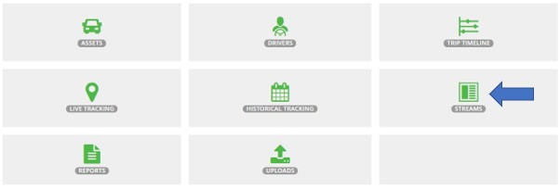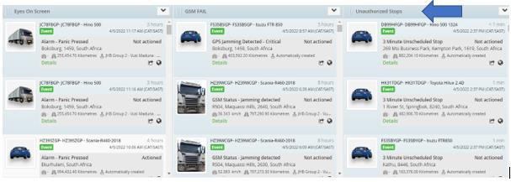(Notifications).

• An unauthorized stop will occur when a driver stops for a
period longer than 3min. A sound notification will be generated at the same time.
• Monitor vehicle on the map and ensure that the vehicle is on the correct route.

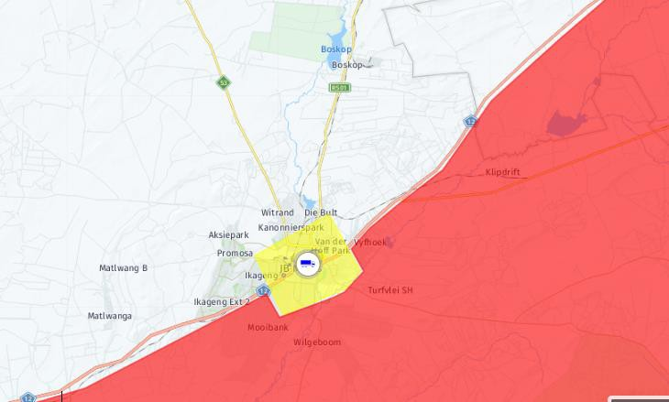
• Phone driver to confirm situation.
• - Voicemail. Escalate Immediately to his Manager.
• - Accident. (Notify Business unit manager/your direct manager). Follow escalation list. Ensure that Etienne Adams is notified.
• - Hijacking. Follow SOP below

• On Mix tracking, lock on asset to get constant location updates.

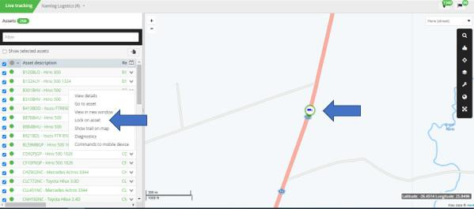

• Phone Mix and report the panic activation/incident. “Deploy recovery team”.

• Activate Beame device.

• Refer to the “SAPS contact details” under the shared control room folder and request assistance from the nearest police station.

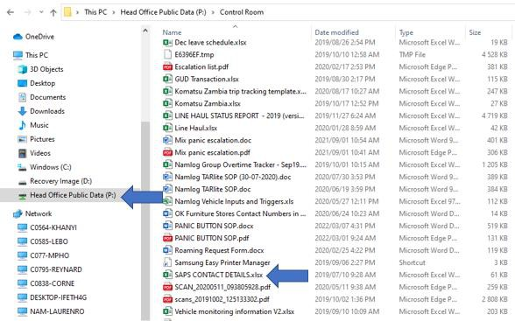

• Provide the officers with the necessary information to dispatch their team.

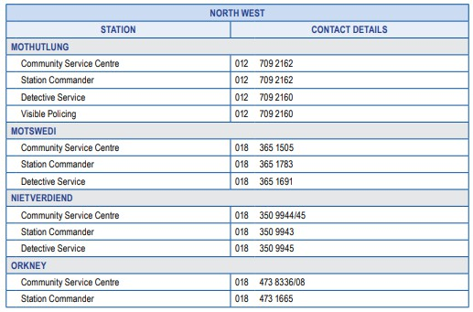

• Escalate matter to both your manager/Business unit manager.

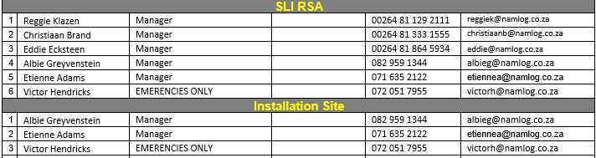

• Ensure constant communication between control and driver.

