Day to Day Operations- Procedure for Licensing Namlog vehicles .

    - Determine which vehicles are due for license disc renewals by drawing a monthly statement (R114 Statement) from the local traffic/licensing department.
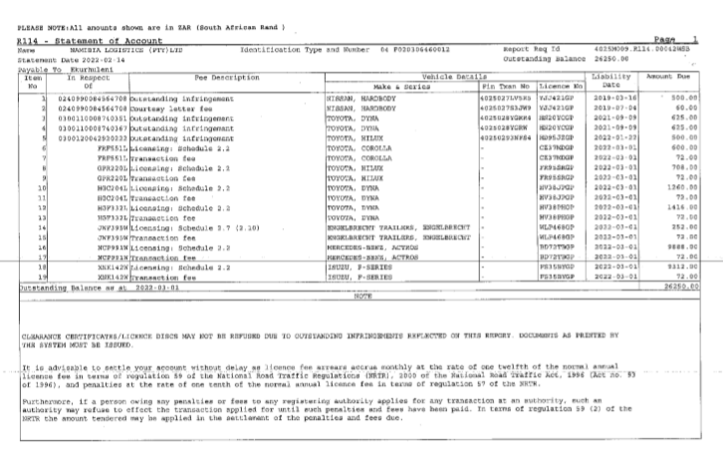

    - A license POR (Purchase Order Request) is loaded on Fraxion and is approved by all relevant management.
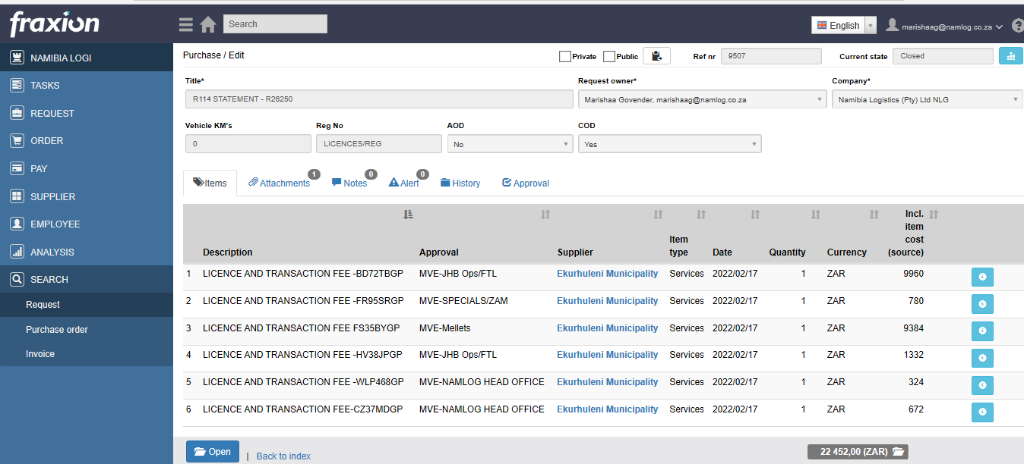

    - During this process , COF(roadworthy tests) are loaded for these vehicles on Fraxion for all vehicles and COF’s are booked accordingly with the supplier.

    - In the interim while testing is ongoing payment is made to traffic department in respect of the R114 statement to ensure funds are made available for the issuance of license discs timeously.

    - Upon passing the COF test, license forms are completed and submitted for all relevant vehicles to the traffic department.

    - Approximately three days after the submission, license discs are collected. Copies are made of the original license discs and kept in the vehicles file, whilst the originals are cut out and sent to the relevant contract manager.
