Day to Day Operations- Procedure for purchasing a new vehicle .

    - An instruction is sent via Email by directors to the technical fleet manager with details and specifications of a new vehicle that needs to be purchased, included in this Email will also be the cost center to which this vehicle will belong.
    - The technical manager designs the truck together with the supplier according to the specification the directors have set out. Once the design is completed an Offer To Purchase is raised.
    - The administrative workshop team open a file for a new vehicle; the Offer To Purchase and Authorization Letter is filed in it.
    - The Offer To Purchase is signed of by the directors and returned to the supplier to initiate the buying process.
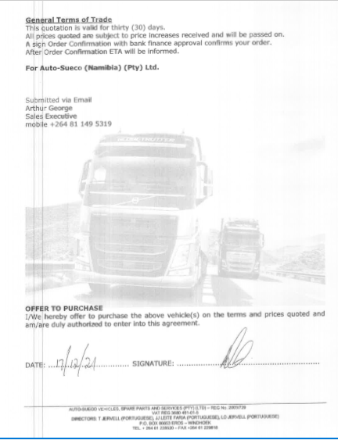
    - Whilst the vehicle is being arranged for delivery :
The following is arranged for the vehicle:
- MIX TELEMATICS-Tracking Unit and Drive Cam-Tracking Department
- License Registration for vehicle( Licence Discs)- Workshop
- Number Plates -Workshop
- E-tags and Fuel cards -Workshop
    - Once the vehicle is received all the details of the vehicle is loaded onto all the relevant systems used at Namlog.
Such As ;
- LMS
- FRAXION
- VEHICLE LIST – created by finance
- AVIS FUEL MANAGEMENT SYSTEM
- MIX TELEMATICS TRACKING SYSTEM

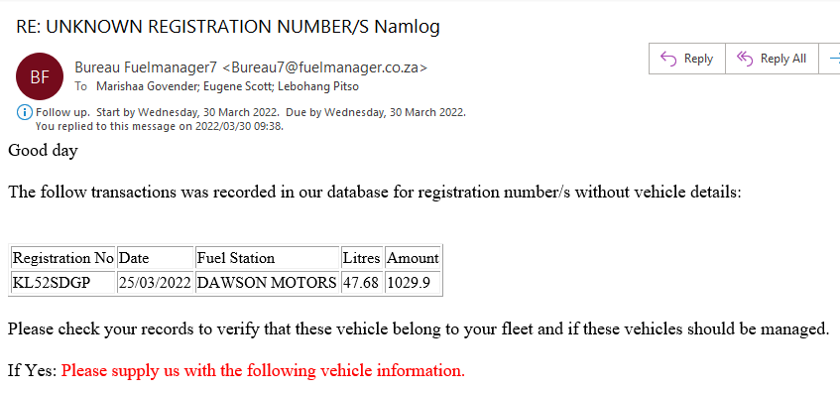

LMS

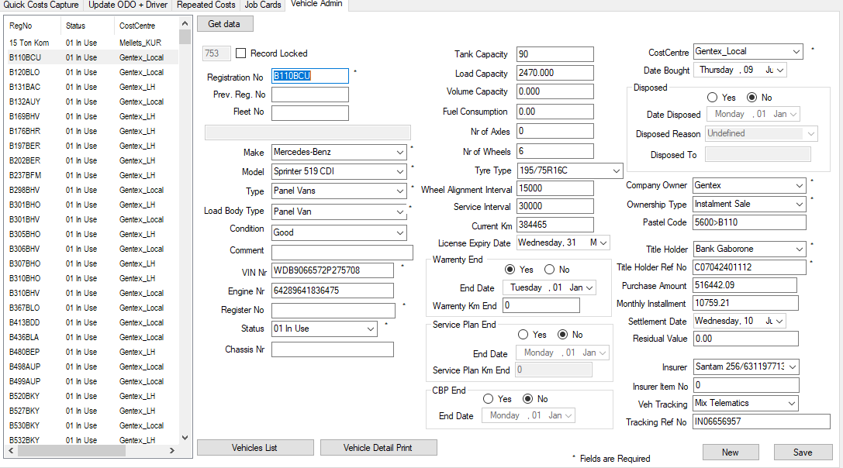

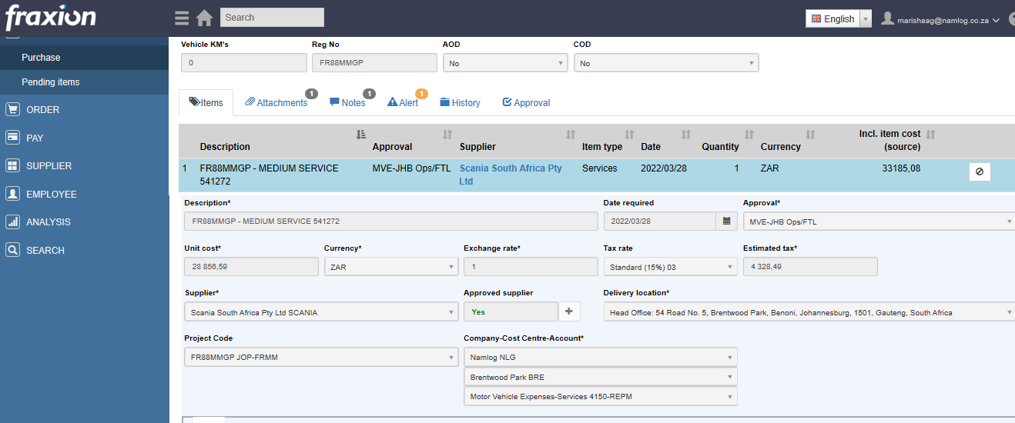
FRAXION

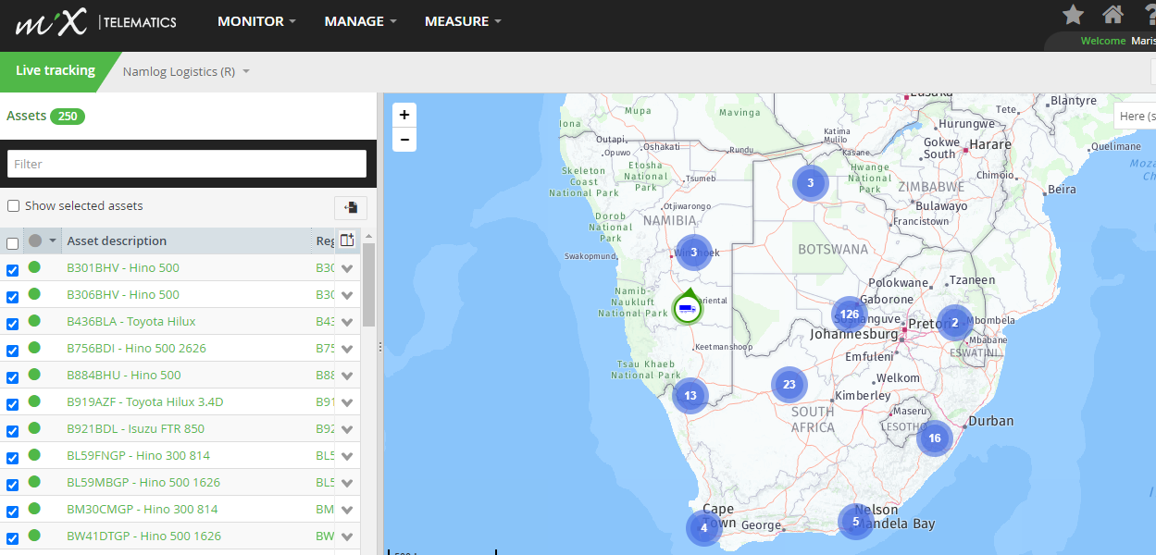
MIX TELEMATIC

VEHICLE LIST

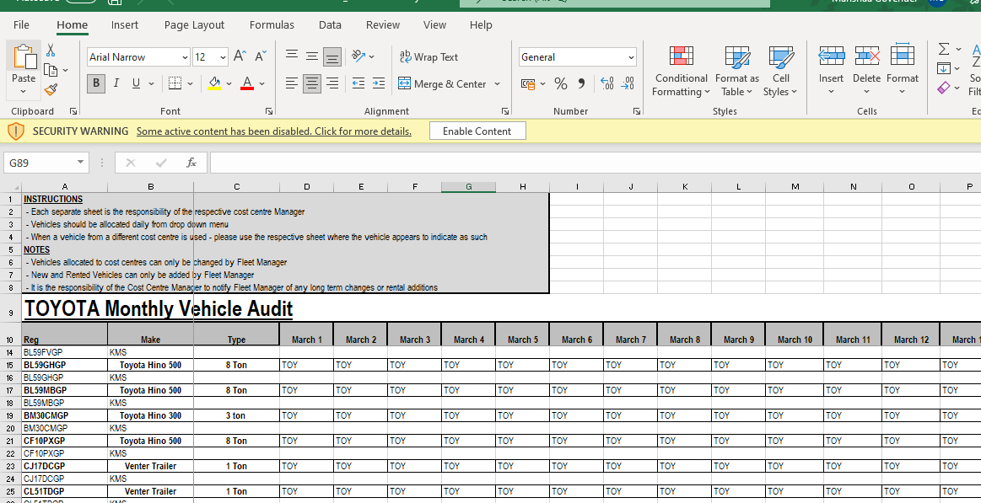

    - The vehicle is than issued to the contract manager.

