    - Workshop staff’s clock in times are sent every week. The clock in time sheet is sorted and the correct clock in times are captured onto the overtime master sheet(Overtime runs from the 16th of the current to the 16th of the following month)
Overtime master sheet
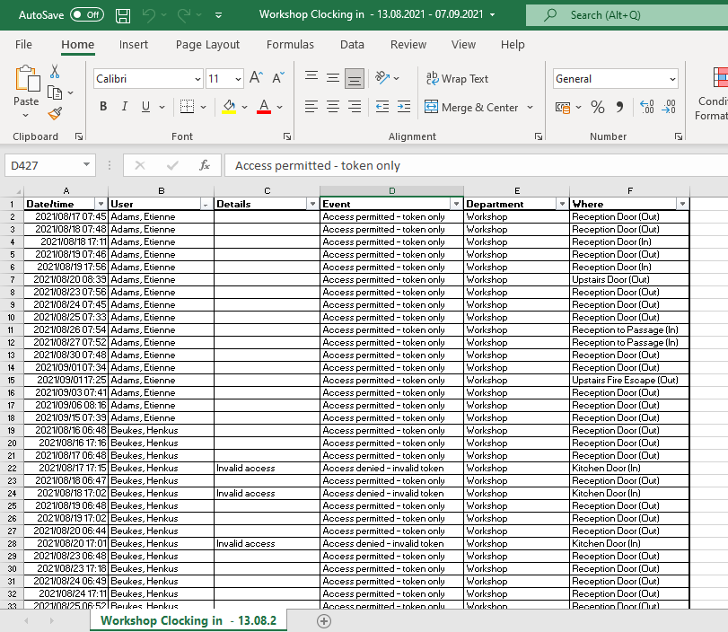
Clock in times received from HR department.

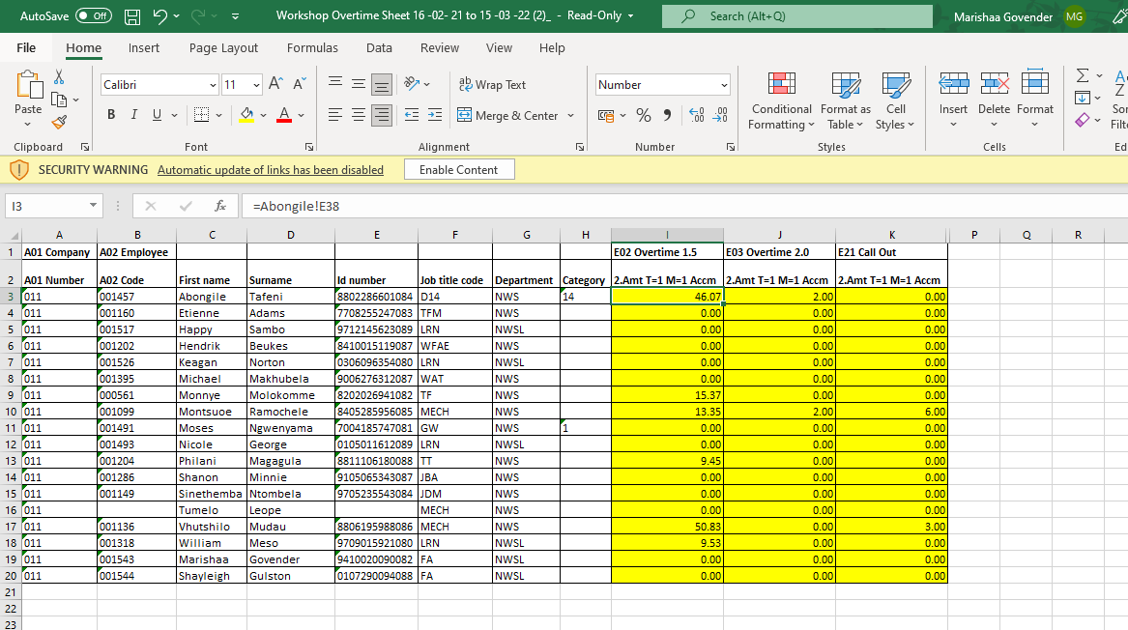

    - On the 16th all staff hand in their hours worked on an overtime sheet, this is manually completed. The clock in times is checked against the manually recording sheets. These sheets are also used to determine call outs or breakdown assistance that is out of the usual working hours.

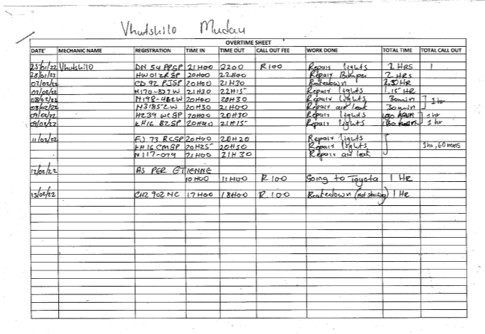

    - Once the overtime master is completed and finalised, it is sent to the technical manager for reviewing.
    - If necessary, changes are made as per the technical managers’ discretion.
    - The technical manager than forwards it onto the HR team.

