Front
1
1
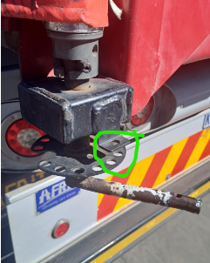

Driver:__________________________

Signature:_______________________

Truck reg:_______________________
Trailer 1 reg:_____________________
Trailer 2 reg:_____________________
BACK
Trailer 2
Trailer 1
1
2
3
4
5
6
7
8
9

1
2
3
4
5
6
7
8
9

1
1
1
2
3
4
5
6
7
8
9
10
11
12
13
14
15
16
17
18
19
1
2
3
4
5
6
7
8
9
10
11
12
13
14
15
16
17
18
19

Truck Tractor
Receiving Manager
Name:________________________

Signed:_______________________
Dispatching Manager
Name:________________________

Signed:_______________________

