IBU DIRECT SERVE

SMSA has created this document as a guidance to help a new country setup (SMSA Direct Serve) all the departments’ requirements and needs are listed in order that a smooth and seamless process for the start up is achieved in the quickest possible time. The department heads are responsible for the country startup.
This is a confidential document and must not be printed and shared with anyone other than the employees involved in the designated business unit. The SMSA confidentiality policy will apply. If you breach the policy then criminal, legal and disciplinary action can be taken by SMSA.
The EIGHT milestones involved in opening a Direct Serve country are as follows:
1 | Study | Sales & Marketing
2 | Country Specific strategy approved | IBU Director
3 | Country Specific feasibility study, plan along with approved budget. | IBU Director
4 | Operating Strategy | Committee
5 | Company Registration | Finance
6 | Mobilization  (Manpower, Vehicles, Infrastructure, Operations setup, Systems, budget) | All
7 | Go Live | All
8 | Continual Improvement | Country

The committee members for the operating strategy are as follows:
Finance Director, Operations Director, QRM Director, Managing Director.
The budget will be finalized once the operating strategy has been identified to the respective departments.

Finance

S. No. | Actions | Requirements | Remarks | Links
1 | Identification of legal partner | Using the corporate lawyers negotiate terms and conditions and deliverables and sign an agreement. | This action will occur after Sales & Marketing has identified which country we are entering.
2 | Brand Resolution | Approvals required from KSA owners.
3 | Article of Association | Attested by the Ministry Of Commerce, Ministry Of Foreign Affairs and countries embassy. | Arabic & English where applicable - each country will vary.
4 | Company Registration | The new company must be registered in the country. | Arabic & English where applicable - each country will vary.
5 | Power of Authority | Identify the personnel
6 | Finalize the new company | Name , capital , authorized personnel
7 | Set up Bank Account | Deposit capital and obtain certificate.
8 | Obtain licenses | - Postal License  - Transportation license  - Freight license  - Customs / Clearance license  - Municipality license  - Brand registration | - Commercial Registration,  - Labor registration,  - Immigration Registration  The above are obtain by HR. | HR
9 | Appointment of External auditors | In some countries this may be required.
10 | Appoint tax consultant | In some courtiers this may be required.
11 | Tax Registration | -VAT  -TAN | will vary from country to country
S. No. | Actions | Requirements | Remarks | Links
12 | 3rd party accounting company | consider | will vary from country to country
13 | Authority matrix | finalize based on the country |  | Sales & Marketing
14 | Services offered & services features | The actual services that will be offered will be decided by Sales. |  | Sales & Marketing
15 | Pricing & Discount | what rates / discount will apply will be decided by sales |  | Sales & Marketing
16 | Budget | Budget finalized prior to mobilization | Finance will sit with the country manager /sales to finalize the requirements based on needs of each department. | Sales & Marketing
17 | Stationary | order the required stationary for the country to operate | A set required will be given based on A , B , C category operating facility | Purchasing
18 | Cashiers office & Safe | A separate cashiers office required ensuring all safes are bolted to the floor & covered by CCTV

Information’s Technology (IT)
Category (A )

S. No. | Action | Requirements | Remarks | Links
1 | Infrastructure | Country HQ will be connected to SMSA HQ via leased line or dedicated Site-to-Site IP VPN. Connectivity within country local partners to extend network to other locations within the country, type of connectivity varies depend on cost of connectivity available. |  | Finance
2 | IP Telephony & Contact Center | Setting up Cisco IP Telephony at Country HQ will be connected to SMSA HQ. Extend to Countries other branches if it remains cost effective. Contact Center can be independent Contact Center or to be connected to HQ Contact Center if local law and business allows. |  | Finance
3 | Back Office ERP | Rolling out Oracle Fusion with all key modules , billing process will be performed by local country team with support of SMSA HQ |  | Finance
4 | Customer Automation Tools | - SECOM  - SAM Heavy  - SAM Light
5 | Operation System | - CORE  - POS System |  | Finance
6 | Value Added Services | - MRM  - SDC  - Logistics  - Fulfillment & Cold Chain Solution

Information’s Technology (IT)
Category (B)

S. No. | Action | Requirements | Remarks | Links
1 | Infrastructure | Country HQ which will be connected to SMSA HQ via dedicated Site-to-Site IP VPN. Connectivity within country, local infrastructure to extend our network to other locations within the country. The type of connectivity varies depend upon cost of connectivity available. | LAN / VAN, Internet Fiber,  Telecommunication | Finance
2 | IP Telephony & Contact Center | Setting Up Cisco IP Telephony at Country HQ which will be connected to SMSA HQ upon special approval. Extended to Countries other branches if it remains cost effective. Limited Contact Center may be implemented if local law doesn’t allow extending Contact Center to Saudi Arabia |  | Finance
3 | Back Office ERP | Rolling out Oracle Fusion with all key modules , billing process will be performed by local country team with support of SMSA HQ |  | Finance
4 | Customer Automation Tools | - SECOM  - SAM Heavy  - SAM Light | SAM Heavy will only be provided on exception basis
5 | Operation System | - CORE  - POS System |  | Finance
6 | Value Added Services | - MRM  - SDC  - Logistics  - Fulfillment & Cold Chain Solution | will only be provided upon MD Exceptional Approval.

Solution Matrix
IT Services |  |  | Direct Served Category A | Direct Served Category B | Direct Served Category C |  | Franchises
Direct Connectivity to SMSA Saudi Head Office |  |  | ✓ | ✓ | × |  | ×
Inter-Country Connectivity to Offices |  |  | ✓ | Limited | × |  | ×
Cisco IP Telephony Solution |  |  | ✓ | Limited | × |  | ×
Contact Center Solution |  |  | ✓ | × | × |  | ×
Oracle Fusion System |  |  | ✓ | ✓ | Limited |  | ×
Billing System |  |  | ✓ | ✓ | Limited |  | Integration
Customer Automation - SAM Heavy |  |  | ✓ | ✓ | × |  | ×
Customer Automation - SAM Online |  |  | ✓ | ✓ | ✓ |  | ✓
Customer Automation - SECOM |  |  | ✓ | ✓ | ✓ |  | ✓
CORE Operation System |  |  | ✓ | ✓ | ✓ |  | Limited
CORE POS System |  |  | ✓ | ✓ | Limited |  | Integration
Value Added – SDC Solution |  |  | ✓ | On-Request | × |  | ×
Value Added – MRM Solution |  |  | ✓ | On-Request | × |  | ×
Value Added – Logistics |  |  | ✓ | On-Request | × |  | ×
Value Added – Fulfillment |  |  | ✓ | On-Request | × |  | ×
Value Added – Cold Chain |  |  | ✓ | On-Request | × |  | ×
Quality & Risk Management
S. No. | Action | Requirements |  |  |  | Remarks |  | Links
1 | Security Office | This is required in hub / stations at the entrance of the facility |  |  |  | Depends on the size of the operations. The office will require  1x Computer  1x Desk  1x Counter  2x Chairs  1x Cabinet |  | Finance  Facility
2 | Alarm system & Panic Alarm | This will be reviewed in hub / stations/ regional offices based on the following - is it a 24/7 operations.  - Criminal activity in the area  - Does the area have shared security or a night watchman.  - Magnetic doors linked to alarm system. |  |  |  | Will also be required in the 'X' Ray areas based on civil aviation requirements. |  | Finance  Facility
3 | Lighting | Ensure that loading unloading areas have adequate lighting including perimeters, each door has own lighting. |  |  |  | Use LED lights in the facility. |  | Facility
4 | Access control | An access control system to be installed in Regional office, Cashier office, Server rooms, Sensitive and restricted areas. |  |  |  |  |  | Facility
5 | Visitors Badges | Visitors badges must be available in HUB/Station and regional offices. |  |  |  | Badges available from HRD, quantity based on the size of the facility. |  | HR
6 | Visitors log | to register all visitors to regional offices, HUB / Station & SMSA Service Center (SSC). |  |  |  | Log sheets available on GUIDE. Doc 324 and in place at all locations.
7 | CCTV System | CCTV is required in Regional office, HUB/ Station & SMSA Service Center (SSC). SMSA has a set standard of CCTV equipment |  |  |  | The number of cameras and the size of DVR will depend on the size of location, vulnerable areas should be covered . |  | Finance
S. No. | Action | Requirements |  |  |  | Remarks |  | Links
8 | Parking Area | Designated parking area to be marked. No parking 25 meters from loading bay. Customer's parking to be considered. |  |  |  | The points to be considered during the initial rental /purchase /lease of the facility. |  | Facility
9 | Emergency EXITS/ Signage's. | All facilities should have emergency exits and signage's clearly displayed. |  |  |  | This should be considered in the initial set up of the facility and is H&S requirement. |  | Finance  Facility
10 | Fire Fighting Equipments | - Fire Hose .  - Fire Alarm.  - Smoke detectors.  - Water Sprinklers.  - Water Pumps.  - Fire Extinguishers .  - Maintenance Contracts.  - (Consider Fire Doors ) |  |  |  | Each facility should meet the country's H&S requirements & certifications.  Maintenance Contract to be signed for the equipments. |  | Finance  Facility
11 | Fire Awareness. | Notice Board available for the staff clearly displaying evacuation plan & Floor Plan of the emergency evacuation. Fire Assembly Area/Point to be clearly marked . |  |  |  | This is required in HUB-STN and Regional Offices |  | Country Manager
12 | Posters | The facility should have all the posters available . |  |  |  | The following posters are required :  Vision &  Mission  Quality Policy.  EHS Policy.  Core Values.  ISO Certificates. ( List )  Fire Assembly Point Request to be made through ERP) |  | Purchasing
13 | Emergency Lights | All locations should have emergency lights. |  |  |  | This is a H & S Requirement. |  | Finance  Facility
S. No. | Action | Requirements |  |  |  | Remarks |  | Links
14 | First Aid Kits | All locations should have a basic First Aid Kits. |  |  |  | In certain countries the minimum First Aid kit requirements are set by local authorities /Laws .(This need to be considered during the purchase ) |  | Country Manager
15 | Smoking Areas | SMSA is a "No Smoking " environment .Smoking area outside needs to be marked and poster displayed. |  |  |  |  |  | Facility
16 | Forklift/Charging station | Forklift charging station should be clearly marked and bollards available. |  |  |  | This is a H & S Requirement. |  | Facility
17 | Corner Mirrors | To be installed in Inbound and Outbound areas to avoid accidents. |  |  |  |  |  | Finance  Facility
18 | Security Seals | Security Seals used to seal vehicles and high-value shipments if location is TAPA certified then an ISO standard seal is required. |  |  |  | Ensure sufficient quantity of seals available. |  | Operations
19 | Vehicle Security | All vehicles should have a clasp so that the security seals can be put on for line-haul vehicles. |  |  |  |  |  | Fleet
20 | Storage areas for oil/diesel | If the facility is going to have an area for storage of oil/diesel then a separate area away from main building needs to be erected. |  |  |  | This is a H & S Requirement. |  | Facility
21 | Key Box/Key Controls | All keys should be marked and written on a key register Doc # 319 on GUIDE, highlighting who has what keys. |  |  |  | The key-Box should contain spare key.
22 | Security officers and Security uniform. | Consider Outsource security or In-house security depending in the country we operate. |  |  |  | If In-house security then security uniforms need to be ordered through ERP.
23 | X-Ray Machine | Depending on the country we may need to purchase a X-Ray Machine if SMSA has to do In-house Security X-Ray prior to shipments flying. |  |  |  | This needs to be considered during the initial set-up and a separate area will be required. |  | Finance  Facility

SMSA Service Center (SSC)
S. No. | Action | Requirements | Remarks | Links
1 | Choosing a new SMSA Service Center (SSC). | Check the population statistics in the area. | Consider the following :  - Price meets budget, Size meets short, medium and long term based on strategy, Access to location, Parking, Disability access., Surrounding building, Crime, Competition., Footfall, Public transport for employees, Congestion.  Flexibility of Landlord, No sharing electricity meter. | Finance  Facility
2 | Contract. | Review finalize deed and sign the rental contract ,and payment of rent. | - Obtain space drawing if possible. | Finance  Facility
3 | Licenses. | Obtain the necessary license(s ) to operate the SMSA Service Center (SSC) .  All licenses displayed as per standard. | - Civil Defense.  - Municipality.  - Trade.  - Transportation etc.. | Finance  IT
4 | New Design . | Admin will do the new design based on the requirement . | Consider SMSA Service Center (SSC) classification A,B,C .Mega & flagship SSC. | Facility
5 | Signage Design . | Request made to marketing for signage design and then order based on the requirement provided necessary made and once received to be installed. | - 3D Signage's at the back of counter will also need to be ordered. | Finance  Marketing
6 | Renovation. | Obtain 3 X quotations and select contractor for the renovation.  Payment made and work commenced. |  | Finance  Facility
7 | CCTV | Work with QRM to identify 3 X vendors with drawing plan where CCTV will be installed, and where DVR will be housed. | - CCTV Cameras .  - DVR .  - DVR Cabinets. | QRM  Finance
8 | Display. | All display of wall graphics ,stands etc will be as per SMSA Service Center (SSC) standard. | - Refer marketing manual for SMSA Service Center (SSC) standards,

9 |  | LAN/VAN Connectivity |  |  |  | Cross ref. with IT regarding connectivity |  |  |  |  |  |  |  | Finance  IT
 | S. No. | Action |  |  | Requirements |  |  |  |  |  | Remarks |  |  | Links
 | 10 | Supplies. |  | All SMSA Service Center (SSC) will need to order the following.  A-4 Paper, SMSA Airway bills, Plain 10 KG Box, Plain 25 KG Box, SMSA 10 KG Box, SMSA 25 KG Box, SMSA 05 KG Box, Domestic PAK - Large, Domestic PAK -Extra Large, High Value Bag -HV-1, High Value Bag -HV-2, High Value Bag -HV-3, Plastic SMSA Pouch Adhesive, SMSA Envelope, Domestic MPS sticker/label, Master MPS Sticker/label, SMSA Mother Bag white/Punched, SMSA Baby Bags, Security Seals blue color, OVG Sticker/Label, SPO Sticker/Label, SFO Sticker/Label, Fragile Sticker/Label, New RRT Sticker/Label, SMSA POD /Delivery Records, SMSA COD/POD Delivery Records, Insurance Books, Indemnity Books, New RTS Sticker/Label, Thermal Label (Zebra ) 4X 6 ", HOLD -HAL Sticker /Label, Stretch Film Clear and Plain, Pens, Markers, Brown Tape, Clear Plastic Bags for trash bins. |  |  |  |  |  | - Initial Supplies minimum quantity one box each to be ordered. |  |  | Inventory
 | 11 | SMSA Service Center (SSC) Equipments. |  | The Following equipments will need to be  ordered for SMSA Service Center (SSC) through ERP with item codes.  Printer -Copier - 3000112, Honey Well Scanner -3000054, POS Machine (IT) -3001094, Telephone Sets -3000404, Water Dispenser-3000631, LCD-TV 42" 3000557, DVD Player -3000552, Storage Set (ARCOMA ) -3000952, Squeezer Set -5000038, Three (3) seater visitor chair -3000449, Trolley - 3000617,O/B Wooden Box -3000772, Box Files ( Blue ) -5000265, Calculator - 5000214, Cutter Knife -5000296, Scissors -5000099, Paper Punching Machine -5000201, Stapler-NOVA -5000145, Thrash Bins -3001053, Staff Notice Board-5000272, Wall Graphics -4000059, First Aid Box -3000632, Weighing Scale 150 KG -3000570, Weighing Scale 600 KG -3000594, Computer -3000897, Visitor Table -300468, Happy -Not Happy Machine -No Code, SPAN Machine - No Code, SMSA Logo 3-D - No Code, Measuring Tape -No Code. |  |  |  |  |  |  |  |  | Finance  Purchasing
SMSA SERVICE CENTER (SSC) PLAN TYPE (A)

INTERIOR PERSPECTIVE TYPE (A)

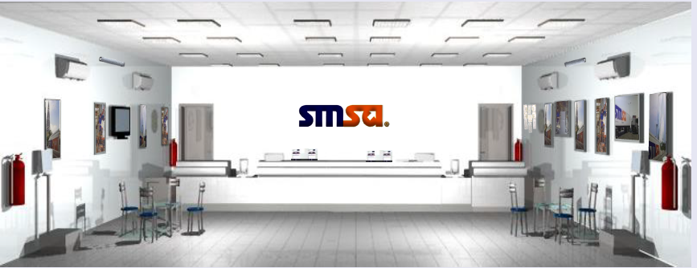
Outdoor Perspective TYPE (A)

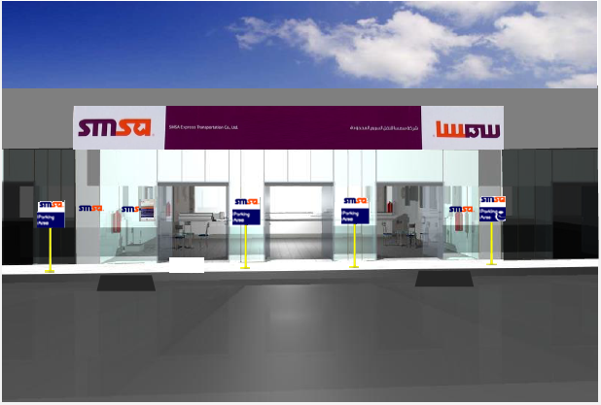

Perspective TYPE (A)

STORE VIEW TYPE (A)

SMSA SERVICE CENTER (SSC) PLAN TYPE (B)

INTERIOR PERSPECTIVE TYPE (B)
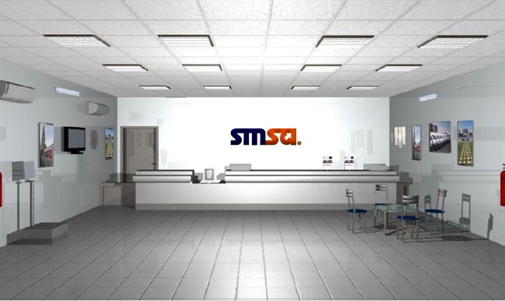

Outdoor Perspective TYPE (B)
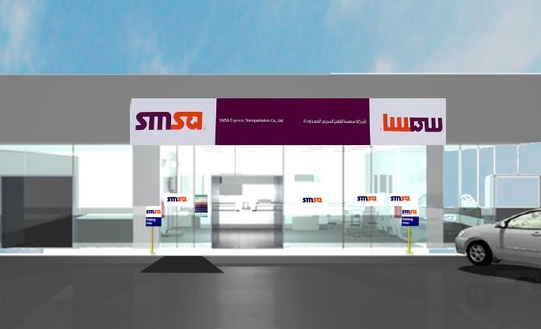

SMSA SERVICE CENTER (SSC) PLAN TYPE (C)

INTERIOR PERSPECTIVE TYPE (C)
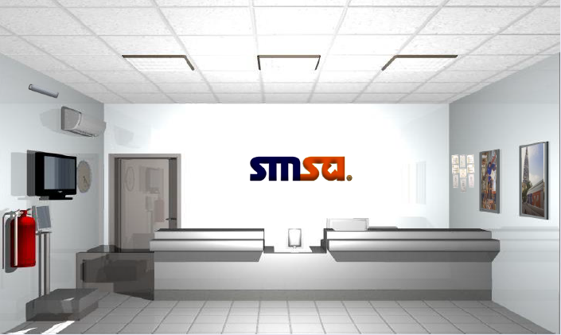
Outdoor Perspective TYPE (C)
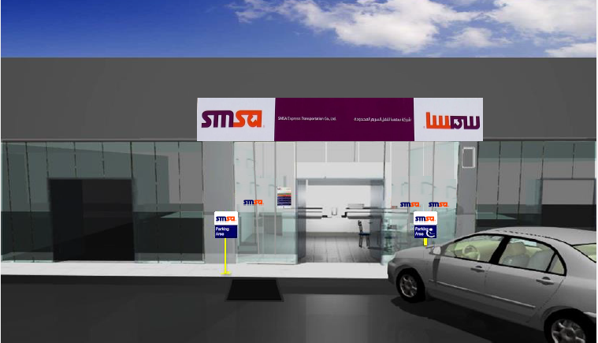
Perspective TYPE (C)
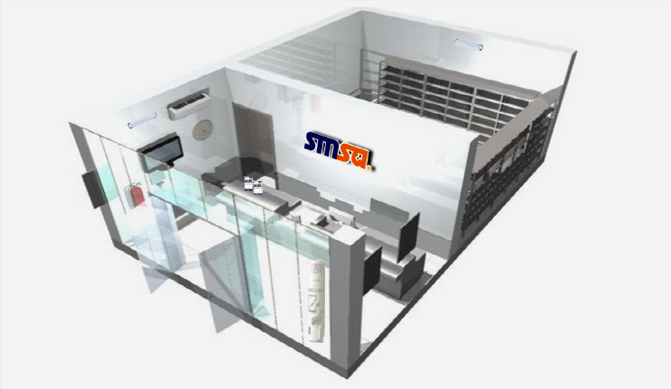

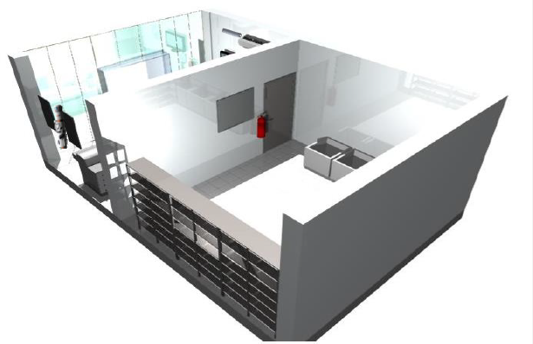STORE VIEW TYPE (C)

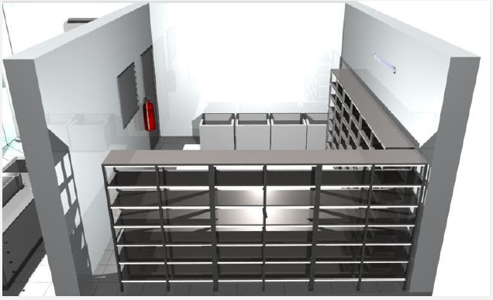

Specifications of SMSA Service Center (SSC)
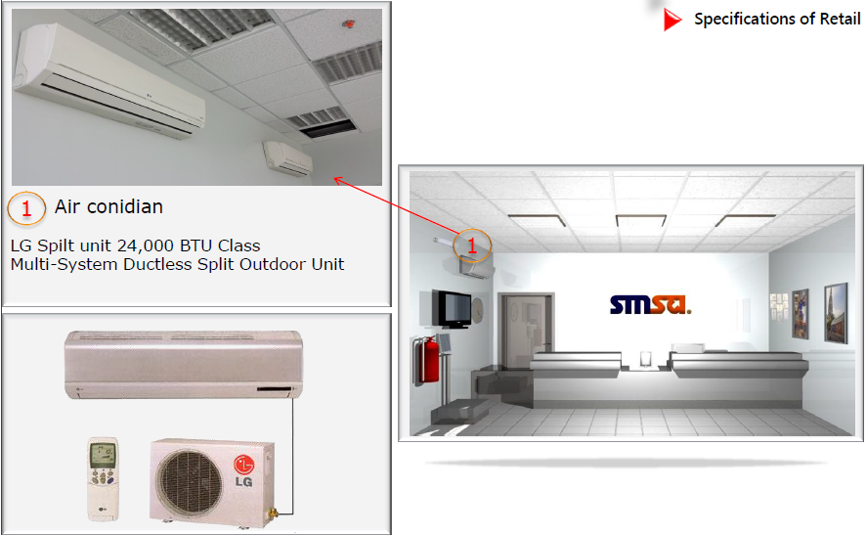

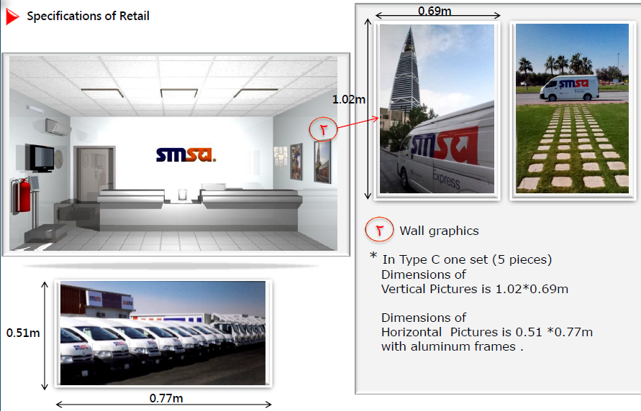

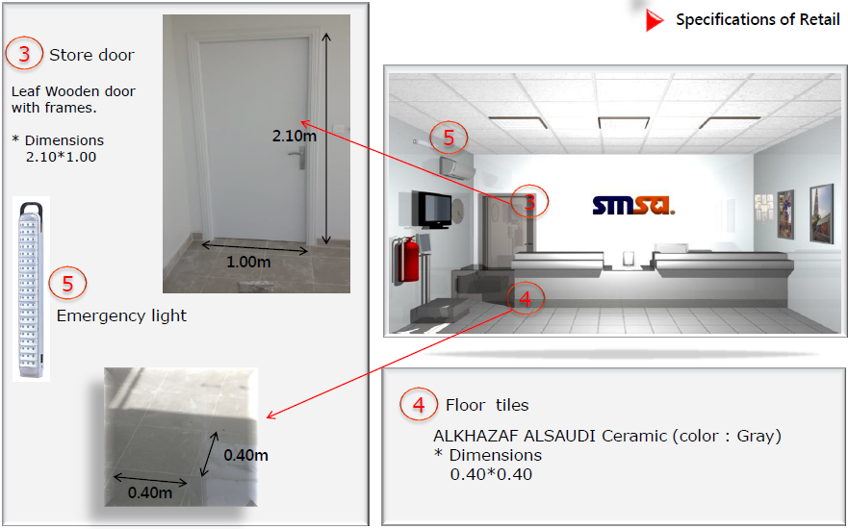

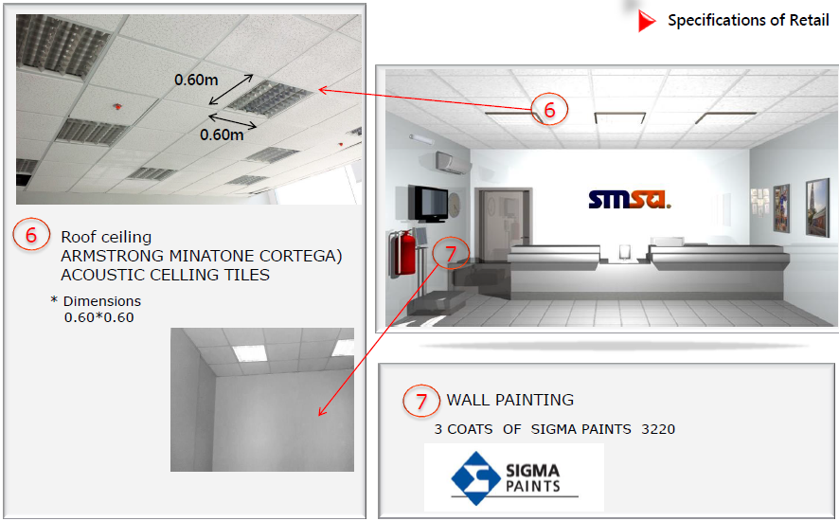

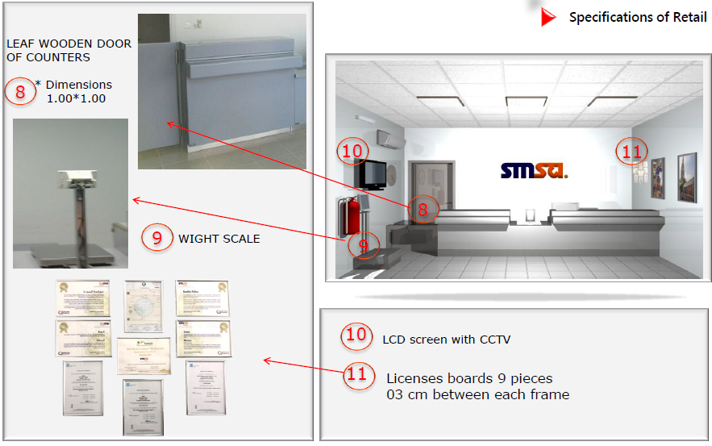

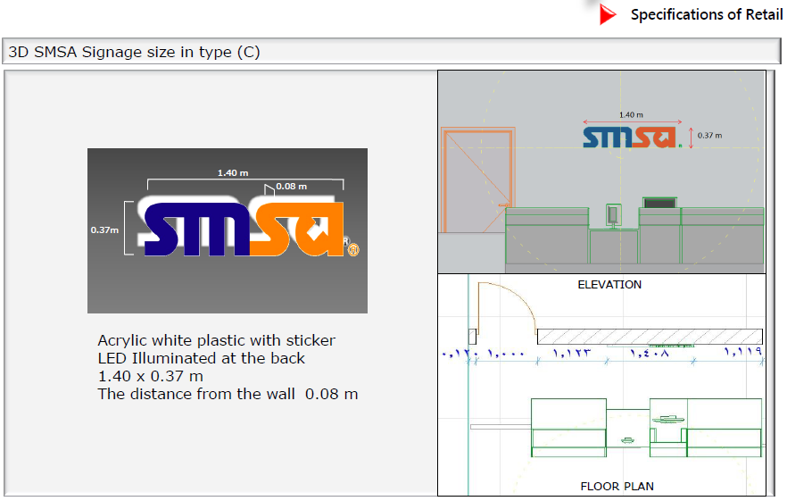

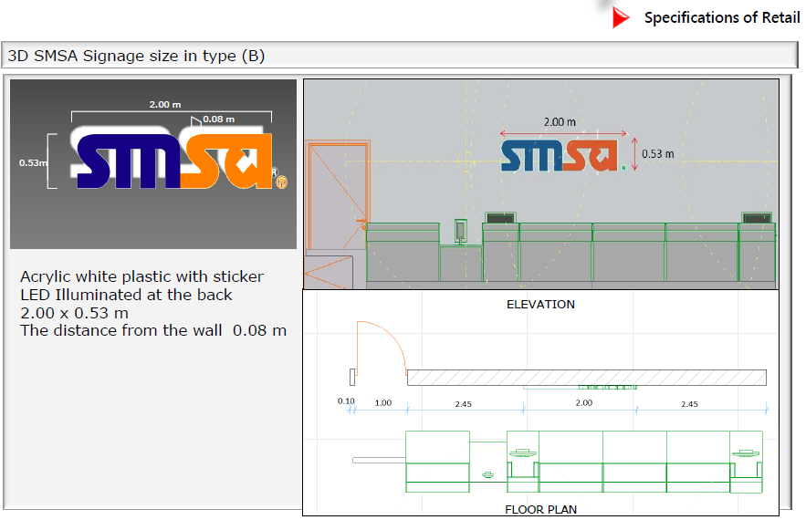

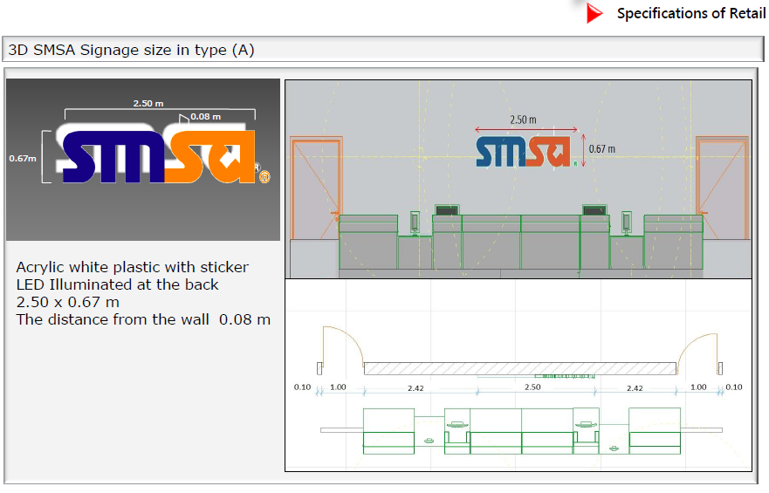

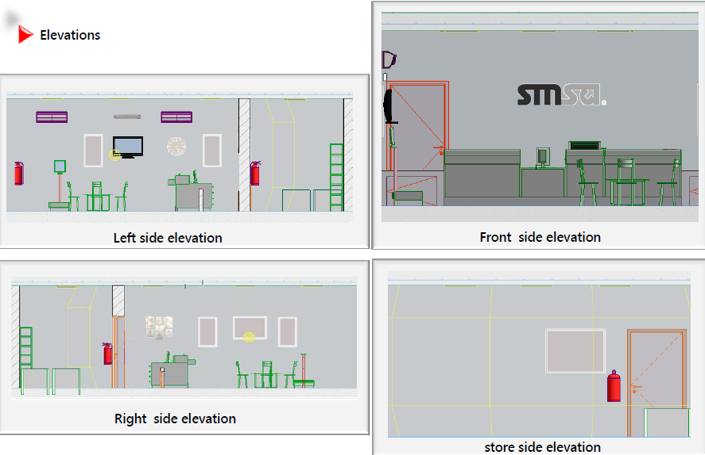

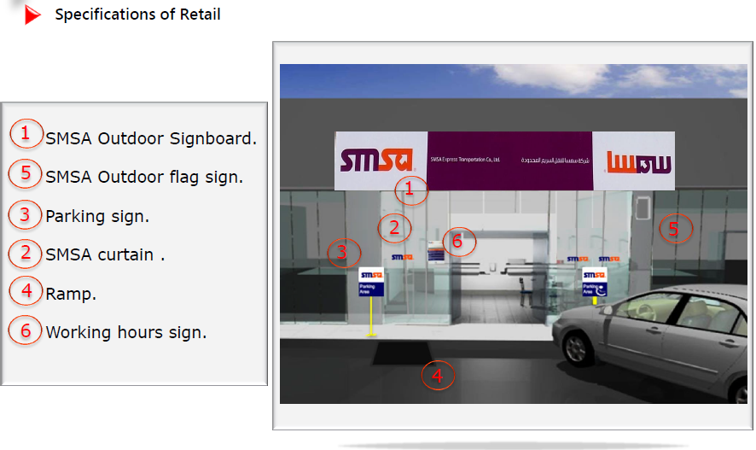

Operations
 | HUB Requirements
 | S. No. | Action |  | Requirements |  |  | Remarks |  |  |  |  |  |  | Links
 | 1 | Infrastructure |  | Below steps to be followed-  Acquiring a Warehouse space and facility, Warehouse Designing, HUB Spoke Plan, Dock Area, Floor Markings, Emergency Doors, Emergency Stairs and walk ways, Designated room for Manager, Common Room for Supervisors, HUB agents, coordinators, DEOs. Toilets, Kitchen/Tea Room, Heavy Vehicle parking area, Area for High Value items (caged), Forklift parking, Area for storing jack lifters, supplies, forklift spares (tyres, batteries/Diesel), RTS Area, Closed area X-ray Machine and Scanning, Pallets storage area. |  |  | The size of the facility will depend on operating strategy that has been identified. |  |  |  |  |  |  | Finance  Facility
 | 2 | Office Furniture |  | Office Tables, chairs, work stations, cabinets, Shelves, Office cup board, Drawers are required for performing basic work, Sorting Bins, Sorting Baskets, Vertical Office Filing 4 Drawer Cabinet, Multi Bay Racking System, High Value Steel Cage, Top and side open Cages |  |  | CAPEX request to be submitted and request should be done by ERP. |  |  |  |  |  | Finance Purchasing
 | 3 | Security Personnel & Office |  | Depends on the size of the operations. The office will require  1x Computer, 1x Desk, 1x Counter, 2x Chairs, 1x Cabinet, CCTV Cameras, Hand Held Metal Detectors, Walk Through Metal Detector. |  |  | This is required in hub / stations at the entrance of the facility. This will again depend on the operating strategy, size of operations and time of operations. |  |  |  |  | Finance  Facility
 | 4 | X-ray machine |  | X-ray Machines (Only for areas where Local Civil Aviation authorizes courier companies for security check) |  |  | For scanning the shipments for any objectionable material, X-ray machine is needed to scan the International shipments prior to sendoff through gateway. |  |  |  |  | QRM  Purchasing
 | S. No. | Action |  | Requirements |  |  | Remarks |  |  |  |  |  | Links
 | 5 | Electrical Equipments |  | Electrical equipments required for the daily use:  Air Conditioners (For both Heating & Cooling).Moderate Air Temperature = 30 ºC , Fans, Electrical connection ports and extension, Water Dispenser, Turntable Wrapping Machine, High Bay LED Lighting, Electrical connection ports and extension, Vending Machine, Emergency Lights |  |  | Some items will require a CAPEX request. |  |  |  |  |  | Finance  Purchasing  Facility
 | 6 | Hardware tools |  | Systems required for Operational daily use.  Honeywell CT50s, Sim Cards for Honeywell CT50s & chargers, |  |  | To be used for all types of scanning purposes. For live updating af all the scans on CORE and to facilitate courier to communicate with the staff. SIM cards should be compatible with the trackers. |  |  |  |  |  | Finance  Purchasing  IT
 | 7 | Software Apps |  | CORE Access, ERP Access, SAM Access |  |  | To monitor the flow and track the movement of shipments, applying scans, resolve tickets, assign Pickups, generate reports and to prepare CONS manifest.  For staff to access their ERP portal.  For preparing Electronic AWB. |  |  |  |  |  | IT
 | 8 | Systems |  | Systems required for daily use  Computer Systems, Fingerprint access control system, CISCO Telephones and Cords, Printers, Zebra Printer, Scanners, Photocopier machines |  |  | For operational daily usage  Request to be made through ERP. |  |  |  |  |  | Finance  Purchasing
 | 9 | Supplies |  | General office items, including A4 sheets, Tonners, Printer Cartridge, Tapes, sticky notes, Diaries, staplers and pins, pens. |  |  | For operational usage  Request to be made through ERP. |  |  |  |  |  | Inventory  Finance
 | S. No. | Action |  | Requirements |  |  | Remarks |  |  |  |  |  | Links
 | 10 | Man power |  | Hire essential manpower only |  |  | Manpower to be hired by HRD recruitment |  |  |  |  |  | HR  Finance
 | 11 | Uniforms & ID |  | SMSA Uniforms, Staff ID Cards |  |  | Male & Female uniforms |  |  |  |  |  | HR  Finance
 | 12 | Trainings |  | CORE System Training, Environment, Health & Safety Awareness, SMSA Ground Operations & Services Training, ISO awareness, CAPA users, GUIDE awareness, Forklift Safety & Operations Training |  |  |  |  |  |  |  |  | Training & Support dept.
 | 13 | Transportation |  | Staff Vehicles, High Roof Hi Ace Vans, Vehicles (4 Tonner, 8 Tonner, 20 Tonner) |  |  | Based on operations strategy |  |  |  |  |  | Finance
 | 14 | Signage's & Posters |  | The following posters are required :  Vision & Mission, Quality Policy, EHS Policy, Core Values, ISO Certificates. ( List ), Sign boards needed for No smoking, Assembly points, Fire Extinguishers, No entry, Restricted area, Smoking Area, No Parking, Staff Parking, HUB Manager Office, HUB Operations Office, HUB names. Request to be made through ERP) |  |  | The facility should have all the signage's & posters available . |  |  |  |  |  | Purchasing
 | S. No. | Action |  | Requirements |  |  | Remarks |  |  |  |  |  | Links
 | 15 | Health & Safety items |  | Safety Shoes, Cotton Gloves, First Aid Box, Helmets. |  |  | As per EHS |  |  |  |  | Finance  Purchasing
 | 16 | Fire equipments |  | Fire Extinguishers, Fire Alarms, Smoke Detectors, Emergency Fire fighting System, including Fire Hoses, PUMPs and fittings, Water Sprinklers |  |  | As per Country regulatory requirements. |  |  |  |  | Finance  Facility  Purchasing
 | 17 | Alarm system & Panic Alarm |  | This will be reviewed in hub / stations based on the following- - is it a 24/7 operations.  - Criminal activity in the area  - Does the area have shared security or a night watchman.  - Magnetic doors linked to alarm system. |  |  | Will also be required in the 'X' Ray areas based on civil aviation requirements & country regulatory requirements. |  |  |  |  | Finance  Facility

Operations
Station Requirements
S. No. | Action | Requirements | Remarks | Links
1 | Infrastructure | Below steps to be followed-  Acquiring a Warehouse space and facility, Warehouse Designing, Floor Markings, Emergency Doors, Emergency Stairs and walk ways, Designated room for Manager, Common Room for Supervisors, HUB agents, coordinators, DEOs. Toilets, Kitchen/Tea Room, Heavy Vehicle parking area, Area for High Value items (caged), Forklift parking, Area for storing jack lifters, supplies, forklift spares (tires, batteries/Diesel), RTS Area, Closed area X-ray Machine and Scanning, Pallets storage area. | The size of the facility will depend on operation strategy that has been identified. | Finance  Facility
2 | Planning | Priority Route Planning  Commitment Planning | Once planned this needs to be communicated.
3 | Office Furniture | Office Tables, chairs, work stations, cabinets, Shelves, Office cup board, Drawers are required for performing basic work, Sorting Bins, Sorting Baskets, Sorting Tables, Vertical Office Filing 4 Drawer Cabinet, Multi Bay Racking System, UTL Steel Cage, Wall mounted shelves. | CAPEX request to be submitted and request should be done by ERP. | Finance  Purchasing
S. No. | Action | Requirements | Remarks | Links
4 | Security Personnel & Office | Depends on the size of the operations. The office will require  1x Computer, 1x Desk, 1x Counter, 2x Chairs, 1x Cabinet, CCTV Cameras, Hand Held Metal Detectors, Walk Through Metal Detector. | This is required in hub / stations at the entrance of the facility. This will again depend on the operating strategy, size of operations and time of operations. | Finance  Facility
5 | Electrical Equipments | Electrical equipments required for the daily use:  Air Conditioners (For both Heating & Cooling).Moderate Air Temperature = 30 ºC , Fans, Electrical connection ports and extension, Water Dispenser, Turntable Wrapping Machine, High Bay LED Lighting, Electrical connection ports and extension, Vending Machine, Emergency Lights | Some items will require a CAPEX request. | Finance  Purchasing  Facility
6 | Hardware tools | Systems required for Operational daily use.  Honeywell CT50s, Sim Cards for Honeywell CT50s & chargers, | To be used for all types of scanning purposes. For live updating af all the scans on CORE and to facilitate courier to communicate with the staff. SIM cards should be compatible with the trackers. | Finance  Purchasing  IT
7 | Software Apps | CORE Access, ERP Access, SAM Access, SAM LITE, SPANEL Access, SIEBEL, SMSA SDM | To monitor the flow and track the movement of shipments, applying scans, resolve tickets, assign Pickups, generate reports and to prepare CONS manifest.  For staff to access their ERP portal.  For preparing Electronic AWB.  For resolving customer complaints, tracking UTL shipments, tracking courier activity | IT
S. No. | Action | Requirements | Remarks | Links
8 | Systems | Systems required for daily use  Computer Systems, Fingerprint access control system, CISCO Telephones and Cords, Printers, Zebra Printer, Scanners, Photocopier machines | For operational daily usage.  Request to be made through ERP. | Finance  Purchasing
9 | Supplies | General office items, including A4 sheets, Tonners, Printer Cartridge, Tapes, sticky notes, Diaries, staplers and pins, pens. | For operational usage  Request to be made through ERP. | Inventory
10 | Man power | Hire essential Manpower only | Manpower to be hired by HRD recruitment | HR  Finance
11 | Uniforms & ID | SMSA Uniforms, Staff ID Cards | Male & Female uniforms. | HR  Finance
12 | Trainings | CORE System Training, Environment, Health & Safety Awareness, SMSA Ground Operations & Services Training,  ISO awareness, CAPA users, Guide awareness. |  | Training &  Support dept.
13 | Transportation | Staff Vehicles, Hi Ace Vans, Vehicles (4 Tonner, 8 Tonner) | Based on operations strategy | Finance  Fleet
S. No. | Action | Requirements | Remarks | Links
14 | Signage's & Posters | The following posters are required :  Vision & Mission, Quality Policy, EHS Policy, Core Values, ISO Certificates. ( List ), Sign boards needed for No smoking, Assembly points, Fire Extinguishers, No entry, Restricted area, Smoking Area, No Parking, Staff Parking, STN Manager Office, STN names. Request to be made through ERP) | The facility should have all the signage's & posters available . | Purchasing
15 | Health & Safety items | Safety Shoes, Cotton Gloves, First Aid Box, Helmets | As per EHS | Finance  Purchasing
16 | Fire equipments | Fire Extinguishers, Fire Alarms, Smoke Detectors, Emergency Fire fighting System, including Fire Hoses, PUMPs and fittings, Water Sprinklers | As per Country regulatory requirements | Finance  Facility  Purchasing
17 | Alarm system & Panic Alarm | This will be reviewed in hub / stations based on the following- - is it a 24/7 operations.  - Criminal activity in the area  - Does the area have shared security or a night watchman.  - Magnetic doors linked to alarm system. | Will also be required in the 'X' Ray areas based on civil aviation requirements & Country regulatory requirements. | Finance  Facility

Human Resources
S. No. | Action | Requirements | Remarks | Links
1 | Hiring Country Manager | Consider prior to appoint GM, appoint a Man power recruitment agency for recruiting GM. |  | Finance
2 | HR office | Design as per Admin. As per budget. | Depends on size. Furniture is required Desk chairs, Cabinets, Computers etc. | Admin  Finance
3 | Designed Structure | Create salary scale for the country based on BSI (Salary Index) | Based on budget & country salary scales. | Finance
4 | HR personnel | Hire HR representative, HR admin staff | Based on budget & requirements | Finance
5 | System | ERP | As per IT infrastructure requirements | IT
6 | Obtain Licenses | Comm. Registration, Labor Registration, Immigration Registration, |  | Finance  Legal

Training
Pre-requisite Module
Courses | Operations |  |  | SMSA Service Center (SSC) |  |  | CSD | Supervisors & Middle Managers |  | General Staff
NHO (New Hire Orientation) | ✓ |  |  | ✓ |  |  | ✓ | ✓ |  | ✓
Basic Modules
Courses |  | Operations | SMSA Service Center (SSC) |  |  |  | CSD | Supervisors & Middle Managers |  | General Staff
SMSA Ground Operations and Services |  | ✓ | ✓ |  |  |  | ✓ | × |  | ×
Customer Service Excellence |  | ✓ | ✓ |  |  |  | ✓ | × |  | ×
SMSA Process Training |  | ✓ | ✓ |  |  |  | ✓ | × |  | ×
POS (Point-of-Sale) System Training |  | × | ✓ |  |  |  | × | × |  | ×
CORE System Training |  | × | ✓ |  |  |  | ✓ | × |  | ×
Defensive Driving Training |  | ✓ | × |  |  |  | × | × |  | ×
PAS (Performance Appraisal System) Training |  | × | × |  |  |  | × | ✓ |  | ×
Excerpts of ISO 9001:2015 Workshop |  | × | × |  |  |  | × | ✓ |  | ×
Sapphire training |  | × | × |  |  |  | × | × |  | ×
Middle Management Courses: E-learning (non-classroom) |  | × | × |  |  |  | × | ✓ |  | ×
Any of the Basic Modules that is relevant to their roles or the equivalent E-learning modules |  | × | × |  |  |  | × | × |  | ✓
Advanced Modules
Courses |  | Operations | SMSA Service Center (SSC) |  |  |  | CSD | Supervisors & Middle Managers |  | General Staff
Suspicious Package Awareness |  | ✓ | ✓ |  |  |  | ✓ | × |  | ×
Dangerous Goods Awareness |  | ✓ | ✓ |  |  |  | ✓ | × |  | ×
CORE System Training (for certain individuals) |  | ✓ | × |  |  |  | × | × |  | ×
EHS (Environment, Health, Safety & Security) Awareness |  | ✓ | ✓ |  |  |  | ✓ | × |  | ×
FCPA (Foreign Corrupt Practices Act) Training |  | ✓ | ✓ |  |  |  | ✓ | × |  | ×
Forklift Safety & Operations Training (for certain individuals) |  | ✓ | ✓ |  |  |  | × | × |  | ×
Forklift Annual Refresher (for certain individuals) |  | ✓ | ✓ |  |  |  | × | × |  | ×
SMSA Service Center (SSC) Selling Skills |  | × | ✓ |  |  |  | × | × |  | ×
PAS (Performance Appraisal System) Refresher |  | × | × |  |  |  | × | ✓ |  | ×
*** Advanced Modules relevant to their roles, and as per need/request for external trainings (E.G. DGR Certification, Supply Chain Management, Specific Management Trainings, etc.) |  | × | × |  |  |  | × | ✓ |  | ×
*** Required completion of E-learning modules, any Advanced Modules relevant to their roles, and as per need/request for external trainings |  | × | × |  |  |  | × | × |  | ✓
QRM Courses

Courses | Operations |  |  |  | SMSA Service Center (SSC) | CSD |  | Supervisors & Middle Managers | General Staff
Fire safety awareness | × |  |  |  | × | × |  | ✓ | ×
ISO awareness - 9001 | × |  |  |  | × | × |  | ✓ | ×
GUIDE users | × |  |  |  | × | × |  | ✓ | ×
CAPA users | × |  |  |  | × | × |  | ✓ | ×
Security training | × |  |  |  | × | × |  | ✓ | ×
X-Ray training | × |  |  |  | × | × |  | ✓ | ×
EHS Management Safety awareness | × |  |  |  | × | × |  | ✓ | ×

Target participants
S. No. | Training Modules | Mandatory | Optional
1 | New Hire Orientation (Welcome to SMSA) | Minimum 80% of all New Joiners | NIL
2 | SMSA Ground Operations and Services | SMSA Service Center (SSC) Executive, SMSA Service Center (SSC) Floater, Courier, Clerk, UTL - Agent, Contact Center Agent, Call Back Agent, Agent on Floor, Customer Care Agent, Clearance Coordinator | Employees of - Core Business & other Departments as requested by Dept Mgr.
3 | Customer Service Excellence | SMSA Service Center (SSC) Executive, Floater, Courier, Clerk, UTL - Agent, Validation Agent - SDC, Contact Center Agent, Call Back Agent, Agent on Floor, Customer Care Agent, Clearance Coordinator and Employees dealing with direct customers. | Employees of - Core Business & other Departments as requested by Dept Mgr.
4 | CORE System Training | SMSA Service Center (SSC) Executive, SMSA Service Center (SSC) Floater, Courier, UTL - Agent, Contact Center Agent, Call Back Agent, Agent on Floor, Customer Care Agent | Employees of - Core Business Departments as requested by direct Mgr.
5 | Dangerous Goods Awareness | SMSA Service Center (SSC) Executive, SMSA Service Center (SSC) Floater, Courier, Clerk, UTL - Agent, Validation Agent - SDC, Clearance Coordinator, Contact Center Agent, Call Back Agent, Agent on Floor, Customer Care Agent | Employees of - Core Business Departments
6 | Suspicious Packages Awareness | SMSA Service Center (SSC) Executive, Floater, Courier, Clerk, UTL - Agent, Contact Center Agent, Call Back Agent, Agent on Floor, Customer Care Agent, Clearance Coordinator | Employees of - Core Business Departments
7 | SMSA Processes Training | SMSA Service Center (SSC) Executive, SMSA Service Center (SSC) Floater, Courier, Clerk, UTL - Agent, Validation Agent - SDC, Contact Center Agent, Call Back Agent, Agent on Floor, Customer Care Agent | Employees of - Core Business Departments as requested by direct Mgr.
S. No. | Training Modules | Mandatory | Optional
8 | Environment, Health & Safety Awareness | SMSA Service Center (SSC) Executive, Floater, Courier, Clerk, UTL - Agent, Contact Center Agent, Call Back Agent, Agent on Floor, Customer Care Agent, Clearance Coordinator | Employees of - Core Business Departments as requested by direct Mgr.
9 | Foreign Corrupt Practices Act Training | SMSA Service Center (SSC) Executive, Floater, Courier, Clerk, UTL - Agent, Contact Center Agent, Call Back Agent, Agent on Floor, Customer Care Agent, Clearance Coordinator & Employees deals with Govt. Depts. | Employees of - All Departments
10 | Defensive Driving Training | Courier, UTL - Agent & Heavy Duty Drivers | Employees Driving Company Vehicles
11 | Point of Sale Training | SMSA Service Center (SSC) Executive, SMSA Service Center (SSC) Floater | Employees of - SMSA Service Center (SSC)
12 | SMSA Service Center (SSC) Selling Skills | SMSA Service Center (SSC) Executive, SMSA Service Center (SSC) Floater | Employees of - SMSA Service Center (SSC)
13 | Forklift Safety & Operations Training | Forklift Operator, Handler, Senior Handler | Hub employees recommended by HUB Manager
14 | PAS (Performance Appraisal System) Training & PAS Refresher Training | Supervisors & Middle Managers | NIL

Customer Service

S. No. | Action | Requirements | Remarks | Links
1 | Business strategy | Centralized call center from KSA / Independent call center |  | Committee
2 | Hire staff | CSD agents to be hired. | As per business requirements. | HR
3 | Furniture | Office furniture like Office Tables, Chairs High back, Visitor chair, small table, Sofa set. | As per the location | Finance  Purchasing
4 | SLA / KPI to be set | Department & Individual KPI to be set up as per the scope of the work.
5 | Hardware equipment | Computers, Laptops, Printers, LCD TV, Cisco telephones, Head phones.
6 | Connectivity | Network connectivity, data cables, Extension wires, CISCO Telephones |  | Facility
5 | Software applications | CORE, SDM, Seibel, Spanel, ERP, Social media, Ticketing system. |  | IT
7 | CISCO license |  |  | IT
8 | Toll free number | To set a toll free number if setting up an independent call center. |  | IT

SMSA Freight department
S. No. | Action |  | Requirements |  | Remarks |  | Links
1 | Business strategy |  | Business plan has to set, and country Manager has to be recruited. |  |  |  | Committee
2 | Office location |  | Arrange lease contract with renter and obtain require license to open up the new office. |  |  |  | Finance
3 | Appoint consultant Co. |  | Business consultant company will help to study the market, license requirement and other legal aspects to operate business in the new country. |  |  |  | Facility
4 | Hire staff |  | Based on business plan, Manpower to be hired. |  |  |  | Finance  HR
5 | Licenses |  | Trade licenses, Obtain licenses to operate freight business as per country requirements& other licenses. |  |  |  | Finance
6 | Sign up with global / Overseas partners to handle freight business globally |  | Look for a Global partner to cater service to/from new country. Also can incorporate with existing global & local partners.  Sign up with local agents to provide local service like customs clearance, Sea/ Air export, Land trucking etc.
5 | Furniture |  | Office furniture like Office Tables, Chairs High back, Visitor chair, small table, Sofa set. |  | As per the location |  | Finance  Purchasing
7 | Hardware equipment |  | Computers, Laptops, Printers, Cisco telephones, Photocopier machines.
8 | Software applications |  | Implement software - Logistaas |  |  |  | Finance  IT
9 | Membership |  | Enroll in WCA, Enroll in TT club insurance, IATA/FIATA Membership |  |  |  | Finance
10 | Policy & Procedures mapping on GUIDE |  | Operational procedure to be set before start the business in the country along with all required forms to be set for Sales & Operations. Also the process mapping required for the country. |  |  |  | QRM
Admin
Admin towards SMSA Service Center (SSC) setup
S. No. | Action | Requirements |  | Remarks |  | Links
1 | New Design | Admin will do the new design based on the requirement . |  | Consider SMSA Service Center (SSC) classification A,B,C. Mega & flagship SSC.
2 | Identify SMSA Service Center (SSC) facility | In consultation with management, a SMSA Service Center (SSC) is identified. |  | Same as SMSA Service Center (SSC) |  | SSC
3 | Contract | Review finalize deed and sign the rental contract ,and payment of rent. |  | Obtain space drawing if possible.
4 | Licenses | Municipality, Civil defense, & Other license (If required) |  |  |  | SSC
Admin towards Operation setup
S. No. | Action | Requirements |  | Remarks |  | Links
1 | Infrastructure | Below steps to be followed-  Acquiring a Warehouse space and facility, Warehouse Designing, HUB Spoke Plan, Dock Area, Floor Markings, Emergency Doors, Emergency Stairs and walk ways, Designated room for Manager, Common Room for Supervisors, HUB agents, coordinators, DEOs. Toilets, Kitchen/Tea Room, Heavy Vehicle parking area, Area for High Value items (caged), Forklift parking, Area for storing jack lifters, supplies, forklift spares (tires, batteries/Diesel), RTS Area, Closed area X-ray Machine and Scanning, Pallets storage area. |  | To start any operation, a facility or space is needed to perform all necessary functions.

 | Specifications |  |  | Operation | SMSA Service Center (SSC) |  |  | CSD | Finance |  |  | HR |  | Remarks
 | Air conditioner  (LG Spilt unit 24,000 BTU Class  Multi-System Ductless Split Outdoor Unit) |  |  | ✓ | ✓ |  |  | ✓ | ✓ |  |  | ✓
 | Firefighting system & design  (N/A for all SMSA Service Center (SSC). It is only require as per the country law). |  |  | ✓ | ✓ |  |  | ✓ | ✓ |  |  | ✓
 | Fire Alarm & design  (N/A for all SMSA Service Center (SSC). It is only require as per the country law). |  |  | ✓ | ✓ |  |  | ✓ | ✓ |  |  | ✓
 | Smoke detector  (N/A for all SMSA Service Center (SSC). It is only require as per the country law). |  |  | ✓ | ✓ |  |  | ✓ | ✓ |  |  | ✓
 | Signage's |  |  | ✓ | ✓ |  |  | ✓ | ✓ |  |  | ✓
 | Store door  (Leaf Wooden door  with frames)-Dimensions  2.10*1.00 |  |  | × | ✓ |  |  | × | × |  |  | ×
 | Floor tiles  ALKHAZAF ALSAUDI Ceramic (color : Gray)  * Dimensions  0.40*0.40 |  |  | × | ✓ |  |  | × | × |  |  | ×
 | Counters  Fiber glass - 4 Types  A- 122/96 B- 61/94 E- 71/76 F- 90/90 (cm) |  |  | × | ✓ |  |  | × | × |  |  | ×
 | Wall graphics  - Dimensions of  Vertical Pictures is 1.02*0.69m  - Dimensions of  Horizontal Pictures is 0.51 *0.77m  with aluminum frames . |  |  | ✓ | ✓ |  |  | ✓ | ✓ |  |  | ✓
 | Furniture |  |  | ✓ | ✓ |  |  | ✓ | ✓ |  |  | ✓
 | Facilities renovation |  |  | × | ✓ |  |  | × | × |  |  | ×
 | Emergency light |  |  | ✓ | ✓ |  |  | ✓ | ✓ |  |  | ✓
 | LED light |  |  | ✓ | ✓ |  |  | ✓ | ✓ |  |  | ✓ |  | Ops also require High bay LED lights
 | Specifications |  |  | Operation | SMSA Service Center (SSC) |  |  | CSD | Finance |  |  | HR |  | Remarks
 | Roof ceiling  (ARMSTRONG MINATONE CORTEGA)  ACOUSTIC CELLING TILES  * Dimensions  0.60*0.60 |  |  | ✓ | ✓ |  |  | ✓ | ✓ |  |  | ✓
 | Wall Painting  3 COATS OF SIGMA PAINTS 3220 |  |  | ✓ | ✓ |  |  | ✓ | ✓ |  |  | ✓
 | Counter doors  Leaf Wooden - * Dimensions  1.00*1.00 |  |  | × | ✓ |  |  | × | × |  |  | ×
 | Weight Scale |  |  | ✓ | ✓ |  |  | × | × |  |  | ×
 | LCD screen with CCTV |  |  | × | ✓ |  |  | × | × |  |  | ×
 | Licenses boards  (9 pieces  03 cm between each frame) |  |  | × | ✓ |  |  | × | × |  |  | ×
 | 3D SMSA Signage size in type A  Acrylic white plastic with sticker  LED Illuminated at the back  2.50 x 0.67 m |  |  | × | ✓ |  |  | × | × |  |  | ×
 | 3D SMSA Signage size in type B  Acrylic white plastic with sticker  LED Illuminated at the back  2.00 x 0.53 m |  |  | × | ✓ |  |  | × | × |  |  | ×
 | 3D SMSA Signage size in type C  Acrylic white plastic with sticker  LED Illuminated at the back  1.40 x 0.37 m |  |  | × | ✓ |  |  | × | × |  |  | ×
 | SMSA Outdoor Signboard. |  |  | ✓ | ✓ |  |  | × | × |  |  | ×
 | SMSA Outdoor flag sign. |  |  | × | ✓ |  |  | × | × |  |  | ×
 | Parking sign. |  |  | ✓ | ✓ |  |  | × | × |  |  | ×
 | SMSA curtain  (Fabricated in front wall elevation) |  |  | × | ✓ |  |  | × | × |  |  | ×
 | Ramp  (Aluminum - 90/120 cm and also depends on location) |  |  | × | ✓ |  |  | × | × |  |  | ×
 | Specifications |  |  | Operation | SMSA Service Center (SSC) |  |  | CSD | Finance |  |  | HR |  | Remarks
 | Working hours sign. |  |  | ✓ | ✓ |  |  | x | x |  |  | x
 | Data cables  (CAT6 A/ or any alternative as per country) |  |  | ✓ | ✓ |  |  | ✓ | ✓ |  |  | ✓
 | Electrical wirings / Extension  (As per requirement & to follow international market) |  |  | ✓ | ✓ |  |  | ✓ | ✓ |  |  | ✓
 | Switches  (As per requirement & to follow international market) |  |  | ✓ | ✓ |  |  | ✓ | ✓ |  |  | ✓
 | First Aid |  |  | ✓ | ✓ |  |  | ✓ | ✓ |  |  | ✓
 | Emergency Contact numbers |  |  | ✓ | ✓ |  |  | ✓ | ✓ |  |  | ✓
 | Water Dispenser |  |  | ✓ | ✓ |  |  | ✓ | ✓ |  |  | ✓
 | Turntable Wrapping Machine |  |  | ✓ | ✓ |  |  | ✓ | ✓ |  |  | ✓
 | Work stations |  |  | ✓ | ✓ |  |  | ✓ | ✓ |  |  | ✓
 | Cabinets, Shelves |  |  | ✓ | ✓ |  |  | ✓ | ✓ |  |  | ✓
 | Office cup board |  |  | ✓ | ✓ |  |  | ✓ | ✓ |  |  | ✓
 | Drawers |  |  | ✓ | ✓ |  |  | ✓ | ✓ |  |  | ✓
 | Sorting Bins |  |  | ✓ | ✓ |  |  | x | x |  |  | x
 | Sorting Baskets |  |  | ✓ | ✓ |  |  | x | x |  |  | x
 | Vertical Office Filing 4 Drawer Cabinet |  |  | ✓ | ✓ |  |  | ✓ | ✓ |  |  | ✓
 | Multi Bay Racking System |  |  | ✓ | ✓ |  |  | x | x |  |  | x
 | High Value Steel Cage |  |  | ✓ | x |  |  | x | x |  |  | x
 | Top and side open Cages |  |  | ✓ | x |  |  | x | x |  |  | x
 | Moderate Air Temperature = 30 ºC |  |  | ✓ | x |  |  | x | x |  |  | x
 | Fans |  |  | ✓ | x |  |  | x | x |  |  | x
 | Vending Machine |  |  | ✓ | x |  |  | x | x |  |  | x
 | Alarm system & Panic Alarm |  |  | ✓ |  | x | x |  |  |  | x |  | x
Marketing department
S. No. |  | Action | Requirements |  |  |  |  |  |  | Remarks |  |  |  |  | Links
1 |  | Market Research | Research plan has to be set such as, competitive analysis, Target Market Analysis, Market demand Analysis, and SWOT Analysis. |  |  |  |  |  |  |  |  |  |  |  | Country Manager  Marketing
2 |  | Office location | Arrange lease contract with renter and obtain require license to open up the new office. |  |  |  |  |  |  |  |  |  |  |  | Finance
3 |  | Legal permission | Intellectual property and ADS regulations permissions to be obtained. |  |  |  |  |  |  |  |  |  |  |  | External legal
4 |  | Penetration marketing  plan | Including Smart Objective, Target market profile, Positioning, Marketing Mix Strageties, Calendar |  |  |  |  |  |  |  |  |  |  |  | Marketing
5 |  | Budget | Marekting budget has to be set and released as per the new market requirement |  |  |  |  |  |  |  |  |  |  |  | Finance
6 |  | Brand Image | Guidelines, Premises branding, Fleet branding, Photoshooting. |  |  |  |  |  |  |  |  |  |  |  | Country Manager  Marketing  Finance
5 |  | Furniture | Office furniture like Office Tables, Chairs High back, Visitor chair, small table, Sofa set. |  |  |  |  |  |  | As per the location |  |  |  |  | Finance  Purchasing
7 |  | Hardware equipment | Computers, Laptops, Printers, Cisco telephones, Photocopier machines.
8 |  | Marketing KIT | Operational Materials, Marketing Collaterals, Stationary, Camera. |  |  |  |  |  |  |  |  |  |  |  | Finance  Purchasing
Sales department
S. No. |  | Action | Requirements |  |  |  |  |  |  | Remarks |  |  |  |  | Links
1 |  | Market Research | Research plan has to be set such as, Pricing, Market size, Market share, Products & services offered, Domestic coverage, increased promotion, marketing recommendations, SWOT Analysis |  |  |  |  |  |  |  |  |  |  |  | Country Manager  Sales  Finance
2 |  | Pricing | Review competition, Decide standard tariff, Decide discount policy, Authority matrix |  |  |  |  |  |  |  |  |  |  |  | Country Manager  Finance
3 |  | Penetration plan | Review research, Decide service planner, Decide cities / Territories planner, Decide marketing plan |  |  |  |  |  |  |  |  |  |  |  | Country Manager  Sales  Marketing
4 |  | Legal licenses | Review terms & conditions, Obtain T&C approval, Review of contracts & agreements, Authorizations. |  |  |  |  |  |  |  |  |  |  |  | External Legal
5 |  | Trainings | New Hire Orientation, SMSA Processes, SMSA Ground Operations & Services, Customer service excellence, Selling Skills 1, Joint Sales calls, ISO awareness. |  |  |  |  |  |  |  |  |  |  |  | Training & Support dept.
6 |  | System Applications | CRM, SSHR, ERP, CORE, Siebel, Guide Access, CAPA Ticketing system. |  |  |  |  |  |  |  |  |  |  |  | IT  QRM
5 |  | Furniture | Office furniture like Office Tables, Chairs High back, Visitor chair, small table, Sofa set, File cabinets, |  |  |  |  |  |  | As per the location |  |  |  |  | Purchasing Finance
7 |  | Hardware equipment | Computers, Laptops, Printers, Cisco telephones, Photocopier machines, Binding machines, Fax machines, Scanner, Document shredder machine. |  |  |  |  |  |  |  |  |  |  |  | Purchasing  Finance

SMSA Healthcare Setup

This document is to be used as a guidance to help setup (SMSA Healthcare Projects). These requirements and specifications are listed for smooth start up of SMSA Healthcare facilities in the quickest possible time.
The guidelines are listed as follows:
 | Guidelines
1 | Security Systems Requirements
2 | Environment Health and Safety Requirements
3 | Generator Requirements
4 | Temperature Monitoring System Requirements
5 | Facility Requirements
6 | Transport Vehicle Requirements
7 | Business Continuity and Disaster Recovery (BCDR)
8 | Standard Operating Procedures
9 | WHO-GDP requirements (within ISO 9001:2015 Framework)
10 | CAPEX
11 | Certifications timeline

I. Security Systems

Sl No |  | Action | Primary Requirements |  | Secondary Requirements
1 |  | Access Control System | + Fingerprint access control devices required (At all office and storage entry points)  + System to be controlled by one authorized admin  + Software integration function in the system is required for remote access  + System must be able to store event logs for 90 days and above.  + All authorized personnel to be registered on the system  + System should be able to print event logs |  | ++ Visitor policy to be implemented  ++ Updated access control list to be maintained  ++ Review period to be set for the above  ++ Maintenance schedule to be available (This can be in-house or externally sourced)  ++ Network connection to each terminal required  ++ Dedicated CPU or Laptop for system software access required.  ++ All security system power supply must be through one breaker (located in access controlled area)
2 |  | CCTV System | + Day/Night operational HD cameras required (Honeywell, HIKvision etc)  + Digital recordings must be in place. Must be connected to dedicated DVR's (Recommended Storage disk size 1 TB)  + System must be able to maintain digital recordings for 30 days and above.  + CCTV System must be connected to additional power supply (UPS) to stay operational in case of power failure.  + System must be able to operate and store data at 3fps per camera |  | ++ Monitors required and must be connected to the CCTV through the DVR's for monitoring by security.  ++ System to be operated and access controlled by authorized personnel  ++ Cameras must be mounted in a way that all operational and docking areas are covered and clearly visible and that there would be no obstructions in the camera angle view.  ++ DVR's to be stored in access controlled room/area  ++ Lighting in the areas must be bright (recommended LED) for clear view on the CCTV  ++ CCTV footage review policy to be implemented  ++ All security system power supply must be through one breaker (located in access controlled area)
3 |  | Intrusion Alarm System | + 24x 7 operational Alarm systems required with interactive touch panel.  + Software integration function in the system is required for remote access  + System must be able to store event logs for 60 days and above.  + System should be able to print alarm event logs  + All entry, exit, Server room, shutters and emergency doors to be connected to the alarm system.  + System motherboard(control board) size should be selected depending on the facility size and areas to be covered, - to have open slots (for alarm connection and transmission)  + System must have GSM functionality (for SMS)  +System must be connected to UPS  + System main board should have battery backup integration slot. (For system to forward SMS) in case of total power failure.  +Alarm Chime to be also available in the control room connected to the alarm system. |  | ++ SIM card required for the system to work on GSM  ++ System to be operated and access controlled by authorized personnel  ++ System can be connected to the entry exit areas (wirelessly as well) with signal repeater depending on the size of the warehouse  ++ Maintenance schedule to be available (This can be in-house or externally sourced)  ++ Network connection /cabling (In case done with wires) to each terminal and main touch point required  ++ Dedicated CPU or Laptop for system software access required.  ++ All zones connected to the alarm system must be clearly identified on the system for easy identification through the touch interactive panel.  ++ Alarm monitoring procedures, alarm response procedures along with alarm logs to be implemented.  ++ All security system power supply must be through one breaker (located in access controlled area)
4 |  | Panic Alarm | + System must have GSM functionality (for SMS)  +System must be connected to UPS  + System main board should have battery backup integration slot. (For system to forward SMS) in case of total power failure. |  | ++ Panic button to be connected to the main transmission console and button/switch should fixed to be hidden from plain sight but easy to access.  ++ Maintenance schedule to be available (This can be in-house or externally sourced)  ++ Network connection /cabling (In case done with wires) to each terminal and main touch point required  ++ Safety and security standard procedures and incident management procedures to be implemented.
II. Environment Health & Safety
5 | First Aid Kits |  |  | + Medium size First Aid kits required at the facility.  '+ First aid kits refill must be as per local regulatory authority requirements. |  | ++Regular Inventory for the kits refill must be maintained by authorized personnel.  ++ Staff must be trained on first aid course  ++ First aid policy to be implemented  ++ Technical staff health checks must be done on yearly basis.  ++Kits location must be specified on the facility emergency layout.
6 | Stretchers |  |  | +Mobile stretchers required at the facility (Qty required depends on the size of the facility and number of staff working at the location) |  | ++Regular checks for stretcher conditions to be done by appointed authorized staff.  '++ Staff must be trained on first aid course  '++Stretchers must be installed near the first aid kits.  '++Stretcher location must be clearly marked on the facility emergency layout.
7 | Breathing apparatus |  |  | +Breathing apparatus required at the facility to be used by fire marshals in case of fire.  +Apparatus must have (Oxygen cylinder connected to respirators, straps for easy mobility by the user) |  | ++Regular checks for cylinder conditions to be done by appointed authorized staff.  ++ Staff must be trained on use of the breathing apparatus  ++Storage area must be created in the facility to store the apparatus  ++Location to be clearly marked on the emergency layout plan.
8 | Scissor lift /scaffolding |  |  | +Scissor lift/scaffolding must be available at the facility.(To be used if working on heights) |  | ++ Safety harness must be used while working on heights  ++Staff must be trained on use of such elevation equipments.
9 | Personal protective equipment |  |  | +PPE must be available and in use at the facility. This includes (Gloves, face mask,3M masks, Eye glasses, ear plugs, ear muffs, safety shoes etc)  + PPE's must be used as required depending on the type of technical/maintenance/housekeeping work being carried out. |  | ++Regular Inventory for the PPE's must be maintained by authorized personnel.  ++ Contractor management procedure to be implemented.  ++Staff to be trained on Health and Safety requirements.  ++Job aid signage's must be installed at the facility in clearly visible areas.
10 | Waste Management |  |  | + Waste bins required at the facility as follows:  -Green for paper disposal  -Blue for plastic disposal  -Yellow for hazardous waste disposal  - Waste bins for general waste |  | ++Waste management policy must be implemented.  ++Staff to be trained on EHS module  ++ Large bins (for cardboard, paper and plastic collection in one area) required.
11 | Emergency exits |  |  | + Emergency exits must be created depending on the size and number of staff working at the facility. (If available adequacy of the doors must be checked to ensure quick and easy evacuation) |  | ++ Fire drill procedure must be implemented.  ++Fire marshals must be identified and trained  ++ All exit doors must have blinking/regular emergency lights fixed on top of the doors.  ++List of staff at location must be maintained.  ++ Location to be clearly marked on the emergency layout plan.  ++ All emergency exit doors must be alarmed.  ++All doors must be hinged from the inside to avoid tampering/ intrusion.
12 | Emergency lights |  |  | +Industrial grade emergency lights must be installed in areas (Covering working areas/storage areas and exit pathways)  +Adequacy to be checked depending on the size of the facility.  +Emergency lights must be connected to battery (Backup power supply) |  | ++ Regular checks must be done by appointed authorized staff to ensure lights function in case of emergencies.
13 | Spill kits |  |  | + Medium spill kits required at the facility.  +Spill kits to be used for (pharmaceutical spills, oil spills, diesel spills) |  | ++Hazardous bag (Yellow with markings) must be used to contain the cleaned spill.  ++Waste management procedure must be implemented.  ++Staff to be trained on Health and Safety requirements.  ++Job aid signage's must be installed at the facility in clearly visible areas.  ++Storage area must be created in the facility to store the kits in appropriate locations  ++Location to be clearly marked on the emergency layout plan.  ++ Eye washers and 3M mask must be placed next to the spill kits.
14 | Pest and rodent Control |  |  | + Insect killer must be installed in all working areas and cafeteria at the facility  + 2 sided Rat traps must be installed throughout the facility. |  | ++ Contract must be in place with pest/rodent control company.  '++Traps installed must be marked on the facility layout.  '++ Regular checks/housekeeping must be maintained.  ++Housekeeping policy must be implemented
15 | Forklift safety |  |  | + Use battery operated forklifts  +Regular maintenance/contract must be in place to ensure forklift safety.  +Forklift must be able to weigh the boxes/pallets stacked (This is to ensure allowable weight is stacked on the racks to avoid accidents/incidents. Weighing mechanism on forklift required) |  | ++Barrier to be available between staff and forklift  ++Forklift charging stations must be away from work areas  ++Speed limit must be defined/locked for forklift operating inside W/H  ++Pre-work checklist for forklift operations must be in place  ++Forklift operations training must be given to the staff.  ++ Only Licensed/certified staff must operate the forklifts.  '+ +Corner mirrors must be installed in the inbound and outbound area (To avoid forklift collision/accidents)  ++Waste management procedure must be referred to when disposing spare parts/lube oil.

III. Generators
16 | Generator requirement | + Diesel generators required at the facility. (Qty and size of the generator depends on the size of the facility and the optimum output required in KW)  +Generators must be set to work in case of power failure at the facility.  +Separate legal storage area must be defined for permanent storage of generators | ++ Separate storage area to be created for Lube oil barrels (Used and new)  ++ Circuit diagram for the facility must be in place.  ++Must be connected to alarm (To give out chime in case of technical emergencies)  ++ Storage area must be clearly identified with signage.  ++Generator area to be barricaded to avoid tampering  ++ Generator must cover all areas of the facility (W/H).  ++Lockout tag out procedure must be implemented.  ++Noise, emission from generator is to be measured. Figures must be documented. Appropriate action to be taken to reduce environmental impact if required.
17 | Diesel tank | +Diesel tank for diesel storage required at the facility (Size of the tank depends on the consumption amount and number of generators).  + Storage area must be defined for permanent storage of tank (Recommended close to the generators)  +Diesel tank storage must be in a reasonable open area for refill and cleaning of the tank  +Diesel storage level indicator on the diesel tank must be horizontal to ensure proper reading of the actual liters stored in the tank | ++ Retention wall around diesel storage required - short wall/barrier (As is a legal requirement to have retention wall to avoid /store spillage.  ++ Large Spill kits must be placed near the diesel tank along with hazardous waste bins.  ++Regular housekeeping to be maintained in the area  ++Tank area to be barricaded to avoid tampering
IV. Temperature monitoring system
18 | TMS for cold rooms and facility | + Temperature monitoring system required for Temp monitoring and humidity of the facility and the cold/freezer rooms.  + Software integration function in the system is required for remote access  + System must be able to store logs for 3 months and above.  + System should be able to print event logs  +Independent Monitoring Sensors required  ++ Vendor Calibration for overall monitoring system must be available  + System should have battery backup integration slot. (For system to forward SMS) in case of total power failure.  +Alarm Chime to be also available and connected to the system (System must give out alarm in case of temp variation) | ++ Standard sensors accuracy ± 0.5 °C for Temp monitoring must be maintained.  ++Sensors accuracy ± 5% RH for humidity monitoring must be maintained.  ++Alarms available must be (audible, Visual). Alarm must be connected to the security/control room as well.  ++Calibration contract must be in place for yearly calibration of the system. (Calibration certificate given by the contractor must be traceable to international standards)  ++Overall TMS preventive maintenance contract must be in place.  ++Contingency plan, procedure and incident management procedure must be implemented.  ++Monitoring reports must be maintained on daily basis  ++Dedicated PC, Data network connection , IP address for servers,SIM card for SMS and email set up for alarm by email is required.
V. Facility Requirements
19 | Infrastructure | +Requirements are as follows:  Floor Markings, Emergency Doors, Emergency Stairs and walk ways, Designated room for Manager/supervisor, Work stations for Supervisors, clerks etc. Toilets, Kitchen/Tea Room, Vehicle parking area, Area for Recall and expired items. Forklift parking, Area ,Pallets storage area, Docking areas, inbound and outbound staging area, cold/freezer room (In a defined area), mosque, Bay racks, office furniture (Chairs, table, cabinet etc), wrapping machine, weighing machine etc. | ++ The overall setup will depend on the size of the facility and operating strategy that has been identified.
20 | Cold/Freezer rooms | +Facility must have a dedicated area with access control for cold/freezer rooms.  '+ The overall size and setup of the cold/freezer room will depend on the scale of business and operating strategy that has been identified at the facility.  +Doors must have the same finish and thickness as that of the walls and ceiling, complete with stainless steel fittings and accessories including rubber gaskets, internal safety release handles and door heaters. | ++Shelving inside the rooms will depend on the operating strategy that has been identified at the facility.  ++ Thermal mapping study must be available.  ++Contract must be in place for preventive/regular maintenance and thermal mapping (When required)  ++TMS system (mentioned above) to be integrated here.  ++Chillers must be installed in a dedicated legal area  ++ MSD must be available  ++Noise emission from the chiller must be measured and documented.
21 | Storage racks | +High bay racking to be installed for storage at the facility.  +Following aspects must be considered:  Height of the bottom level and the top-level  Distance between the front and opposite pallets  Design of the run-outs at both ends of the aisle  Racks storage capacity  +MSD must be available | ++Certificate required for storage racks weight capacity. Storage rack needs be tested and periodic review and maintenance is required.  ++The overall size and setup of the high bay racks will depend on the scale of business and operating strategy that has been identified at the facility.
22 | Facility Security | + Facility must be 24x7 security monitored.  (Manpower arrangement depends on the size of the operations.)  +Dedicated security office with access control required. (Security room must be independent from the main office areas)  +Dedicated security patrol vehicle required with logo and flashing lights(lights to be fixed after permission from the local regulatory body) | ++The security office will require  Computer, Desk, Counter, Chairs, Cabinet, and Hand Held Detectors.  ++Security must go through and pass the SMSA security training module  ++ Security manual must be implemented  ++Security systems (CCTV, Intrusion system) must be maintained/controlled from the security room.  ++Staff uniform policy to be implemented.
23 | Lighting | +Ensure that loading unloading and operational areas have adequate lighting including docking area and external perimeter of the facility. | ++ Bright High Bay LED lights must be used  ++Lighting level must be measured and documented.
24 | Parking Area | +Designated parking area to be marked. No parking 25 meters from loading bay. | ++ Customer's parking to be considered. Parking area must be marked.
25 | Smoking Areas | +Smoking area outside the facility needs to be marked and signage must be displayed. | ++ DVD to be implemented
26 | Forklift/Charging station | +Forklift charging station should be clearly marked and signage available. | ++ Forklift charging must not be done in non operational hours.  '++ Safe use of forklift WI to be implemented.
27 | System and Software access | +Access/installation of the following must be in place:  3PL/WMS, ERP, CORE, GUIDE (including any other system access required for operations at the facility) | ++ System/software access must be controlled. These are required to monitor the flow and track the movement of shipments in the receiving and dispatch areas,for staff to access their ERP portal, tracking delivery staff activity, printing labels and AWB etc.
28 | Fire fighting system | +Fire alarm system to be installed throughout the facility.  +Fire system includes:  Fire Extinguishers, Fire Alarms, Smoke Detectors, Fire Hoses, PUMPs and fittings, Water Sprinklers. | ++ All fire alarms in the facility must be interconnected (So that if alarm goes off at one end the other end must also be notified automatically)  ++Fire monitoring system must be controlled from 1 point (recommended- security room)  ++The water pump including the battery for the fire fighting system (If located in the external vicinity of the facility must be caged with locks to avoid any tamper and must be monitored by CCTV.  ++Fire evacuation and drill procedure to be implemented.
29 | Signage's & Posters | +Following signage’s to be in place:  Save water ,save electricity, wash hands, close all doors, restricted area/access, exit ,entry, push/pull, keep all doors closed, assembly area, parking area, No parking area, first aid , breathing apparatus, mask, forklift charging station, forklift pathway, pallets storage area, pallets disposal area, PPE in use, wet floor, hazard warning signage-accident/ area under construction/open, CCTV in use, HV area, emergency#s, prayer area, office nameplates, smoking area, no smoking, spill kits, operational signage’s (Recall/return area, cold room area ,generator area, lockout tagout etc),drive safely,3M masks and job aids, Vision & Mission, Quality Policy, EHS Policy, Core Values, ISO Certificates | ++Refer to MKT dept for design and approval of signages.  ++Initial ERP request must be made for PUR of all signages.  ++Signages must be in SMSA standard format.  ++Signages must be installed in appropriate locations.
30 | Supplies | + Following supplies is required at the facility:  Toners, Printer Cartridge, Tapes, sticky notes, Diaries, staplers and pins,A4 Paper, Packaging boxes, tape, markers, barcode thermal labels, SMSA Envelope, Temperature Labels, Fragile Sticker/Label, Stretch Film Clear and Plain, Pens, Markers, yellow notepads, pencils, Box files(color depends on the standard set for departments) Data loggers , ice packs and thermal boxes, security seals (certified to ISO 17712:2015) | ++Initial ERP request must be made for PUR of all supplies.  ++Supplies inventory must be maintained and controlled by authorized personnel.  ++ MDS required for data loggers and ice packs.  ++ISO 17712:2015 certification evidence required from the seal provider.
31 | Hardware/Equipments | +Electrical equipments required for the daily use:  Air Conditioners (For both Heating & Cooling) to be installed in areas "if" not covered by AHU's (cafeteria/security office etc). Electrical connection ports and extension, Water Dispenser, , High Bay LED Lighting, Electrical connection ports and extension, Vending Machine, Honeywell CT50s handheld scanners/trackers, dedicated charging ports, CISCO Telephones and Cords, Printers, Scanners, Photocopier machines, weighing machine, LCD, monitors, keyboards, dedicated CPU's, jacklift trolleys, industrial heating fans. | ++Items not budgeted initially must have CAPEX approval.  ++Heating industrial fans/infrared heaters to be used if the facility does not have boilers in place to maintain temperature variation during winter season.  ++AHU's installed must have maintenance contract in place with regular checks.  ++Dedicated PC's for security and temperature systems depends on the operational strategy.  ++3PL/WMS system sync access must be given on trackers.  ++Dedicated simcards required for the trackers.  ++Separate docking station for tracker charging is required.  ++Size and qty of printer /scanner required depends on the size and scale of the operations.  ++Dedicated barcode/label printer required in inbound /outbound area.  ++Refer to IT dept for CISCO connection and telephony installation
32 | Roof access | + Facilities external access to the roof (stairs/ladders) if available, must be locked at all times | ++ If access to roof is available- lockout/tagout procedure to be implemented  ++ CCTV must cover the area and the roof  ++If no external access, then regular roof cleaning/maintenance contract to be in place.  ++Method statement/WI document to be implemented.  ++H&S policy and contractor management procedure to be implemented.
33 | Dock levelers | + Dock levelers must be installed in the IB & OB docking areas .  + Dock Leveler 6-8 TON, and must be electro-hydraulically driven lift with motor. | ++Ensure that the docking station is covered by dock seals (To avoid exposure of pharmaceutical items to external environment during loading/off loading)  ++Docking area must be isolated to avoid temperature variation and dust control.  ++Dock leveller must be connected to backup power supply or the generator for functioning during outage.  ++6 to 8 TON is a standard capacity of dock levelers, however this can vary depending on the scale of business and type and height of vehicles to be docked.  ++No vehicles must be allowed inside the facility (Either for loading or offloading)  ++Regular preventive maintenance contract is required.  +MDS required for the levelers.
34 | Customer Waiting Area | +Designated customer waiting area area/room is required. | ++ Waiting area signage must be installed  ++Visitor policy to be implemented  ++All visitors must be escorted  ++Waiting area must have water dispenser, seating chair/sofa arrangements  ++Waiting area must have SMSA promotional brochures.
VI. Transport vehicles
35 | Temperature controlled trucks | + Transport vehicles used at the facility must be:  - Temperature controlled  -Temperature monitoring system  -GPS tracker  -External hatch  - Lift gate  -Logo (SMSA standard) | ++Maintenance contract must be in place for the Transport vehicles (trucks).  ++Vehicle must be driven by authorized personnel with valid license  ++GPS and temp/humidity monitoring system must be installed in the trucks and must have software and remote access functionality (for live monitoring of temp and location of the trucks).  ++Must be able to print maintain event/temp logs.  ++Regular cleaning and maintenance checks must be maintained (To be cleaned with environmentally compliant cleaning materials)  ++ Trucks rented must be thoroughly inspected.  ++Calibration certificate required for the temp sensors in trucks and must be traceable to intl standards  ++Security seals must be affixed and checked by the security on the external hatch.  ++ Seal management and security seven point checklist must be implemented.
36 | Contingency during transport | + Transport vehicles being used must have:  -3 M masks  -spill kits  -gloves  -emergency numbers | ++Contingency procedure during transportation must be implemented.  ++ Courier staff to be trained on spill management and emergency contact procedure  ++Incident management procedure to be implemented.

37 |  | Business Continuity |  | + Business continuity and disaster recovery WI/guidelines and drills must be documented – Following should be the baseline used when documenting/creating BCDR guidelines for any emergency scenario:  +Assess the risks to the business and the impacts of risks  +Manage the identified risks by applying appropriate controls  +Recognizing, communication and response to incidents in an effective and appropriate manner to minimize impact.  +Recovery of business facility as quickly as possible, in event of emergencies. |  | ++ BCDR Drills/ Exercise must be planned and conducted for various scenarios (applicable to type of operational facility) :  - Medical emergency  - fire extinguisher use  - diesel spills  - natural disaster/flood  - breathing apparatus use  - forklift accidents/incident  - confined space work accidents  - Generator impairment  - TMS impairment  - Cold room impairment  - Total power failure  ++ Step by step BCDR guidelines /WI applicable to all above scenarios and any other applicable to the business must be documented updated and all records must be maintained.
VIII. Standard Operating Procedures
38 | Standard procedure |  | + The general healthcare process encompasses the following:  - Inbound Receiving (Including Adhoc receiving)  - Storage and Handling (As per GDP/GSP standards)  - Stock check  - Issuance and Delivery (Dispatch)  - Contingency  - Return and Recall  - Quarantine  - Disposal  -Complaint management |  | ++ The creation and implementation of SOP’s depends on the operating strategy that has been identified at the facility.
39 | Inbound receiving process |  | + Following requirements to be focused on when developing and implementing the Inbound receiving process/SOP :  - How Inbound receiving is processed  - How delivery is coordinated with supplier  - Are all the roles defined for the personnel handling receiving  - What happens when discrepencies are identified  - How the storage is executed  - How the returns /rejected items are processed |  | ++Checkpoints to be emphasized on during this process:  -Physically checking PO v/s Items delivery note  -Screen Invoice /DN to match PO and ASN details  -physically and tally items against PO/DN and Invoice  - Acknowledgement of receipt on DN/Invoice /Inspection (Accountibility)  - Receipt in 3PL/WMS and generation of Bar-code label and GRN  - For return/rejected items, maintain documented reasons for rejection , reschedule of delivery with the supplier etc
40 | Adhoc  Receipt Process |  | + Following requirements to be focused on when developing and implementing the Adhoc  Receipt process/SOP :  - How the Adhoc receipt is processed  - Determination of nature/constraints of storage  - Roles defined for the personnel handling adhoc receiving |  | ++Checkpoints to be emphasized on during this process:  -Handlings urgent adhoc notice from supplier /customer ,checks of item details ,volume and storage conditions.  - Checking storage conditions requirements and arrangements (aircon, room temp etc)  - Items stored in recommended storage condition and maintain record of date time receipt for the item  - Necessary approvals for appropriate storage duration and exposure (Deviations) documented and communicated
41 | New Project Receipt Process |  | + Following requirements to be focused on when developing and implementing the New Project Receipt Process :  - How new projects are handled.  - How planning is done  - Pre- acceptance requirements of project.  - Project approvals (Funding on requirement, Sufficient storage space, storage conditions)  - Receipt according to project schedule. |  | ++Checkpoints to be emphasized on during this process:  - Pre-requisite : Scope of work defined, Items Details, Items volume, Items storage condition, New Equipment requirement, Training of staff, Maintenance of records etc.  - Planning: Storage space & condition, Equipment required, Establish SOP (if required )& process flow, Establish accounting system.  -Necessary approvals/ endorsement is sought on the project schedule & plan for logistics support & requirement, prior to project implementation.  - Review: Sufficient storage space, storage condition, Maintenance of records, status report/ update to customer/management regularly.  -Report of any irregularities
42 | Order Processing and Dispatch |  | +Following requirements to be focused on when developing and implementing this Process/SOP :  - How the order processing & Dispatch is executed  - Procedure to pick items  - Items packing in staging area  - Are all the roles defined for the personnel handling order processing and dispatch  - Necessary approval End Process? |  | ++Checkpoints to be emphasized on during this process:  - 3PL system update for open issues, un-confirmed orders and un-sent ASN, print out of Master Pick Ticket  - Items retrieval as per picklist and order processing in staging area.  -Checks on all picked items.-Description, Quantity, Batch/Lot No. expiry date, noticeable damage  - If Any Discrepancy: Returns of the affected items for replacement with correct one.  - Packing Slips of all orders from 3PL, Downloads of out-file from 3PL to SAM; shipping info; encoding of no. of pcs and printout of the AWB for each order.  - Packing the printed AWB & Packing Slip into a pouch and forwarding for order preparation.  -Process of each order from the staging area; scan them on 3PL for order fulfillment and build up of the items up on a pallet.  - Discrepancy identified – Returns of the affected items for replacement.  -Necessary approvals required:  Signs on the air-waybill; stamps and signs on the packing slip  -End process: Wrapping of the pallets into skids, straps and attachment of the AWB pouch with the necessary documents inside.  - Confirmation of the fulfilled orders in 3PL system and ASN forwarding to receiving party/ Pallets is loaded into refrigerated trucks for subsequent delivery.
43 | Issuance,  Delivery and Return of Cold Chain Items |  | +Following requirements to be focused on when developing and implementing this Process/SOP :  - Order schedule requirements by customer/OPS  - Are all the roles defined and staff trained for handling Issuance,  Delivery and Return.  - Shipment Processing Staging.  - Picking and Packing of cold chain items  - Receive & send delivery items to designated sites  - Return/undelivered cold chain items |  | ++Checkpoints to be emphasized on during this process:  - Check order scheduled for items required by customer  - Preparation of issuing docs  - Picking required for cold chain items & packing into box according to Issuance Document  - Data logger ready to be used and documented for each box  - Staging area Packing of cold chain items  - Delivery: Receive & send delivery items to designated sites by driver.  - Indication of the date & packing time temperature on Issuance Document  -Delivered items: seeking recipient’s acknowledgement of receipt, Temperature records, Date & Time of arrival, Quantity, Lot/ Batch No, Shelf life,  -Undelivered/Return items: Notification and communication by driver , checking & recording upon point of return to determine temperature within set product range. Record of Temperature, Date & Time , Quantity, Lot/ Batch No, Shelf life  - Item exceeding temperature range of product to be placed under quarantined.  - Necessary approval stages set.
44 | Storage and Handling of Cold Chain items |  | +Following requirements to be focused on when developing and implementing this Process/SOP :  -Storage conditions and temp range clearly specified  -Handling requirements and WI  -Self inspection, Temp records and TMS requirements  - Deviation reporting and response |  | ++Checkpoints to be emphasized on during this process:  -Cold chain products handled with proper care at designated processing area  -Products are stored appropriately in the designated cold room/ freezer room. (Products for 2°C to 8°C and Products for -21 °C or colder)  -Recording Daily Temperature  - Irregularities/deviations recorded and reported to defined authorized personnel to assess the situation and decide follow up action.
45 | Contingency Procedure During Delivery(Transportation) |  | +Following requirements to be focused on when developing and implementing this Process/SOP :  -Staff/driver training (to act in case of emergencies)  - Contact and escalation stages defined.  - Availability of backup vehicles  - Communication to customer/ management  - Spill management procedures |  | ++Checkpoints to be emphasized on during this process:  - Briefing driver according to delivery schedule  - Calling the affected designated recipient to notify about the circumstances and delay  -Sending back up vehicle to transfer stock from the affected vehicle and proceed with delivery to required site (Under defined conditions/approvals)  - Arranging for recovery for the vehicles involved in the emergency.  - Availability of emergency contacts in the event of any emergency during delivery/return  - Escalation criteria defined
46 | Equipment Return Process |  | +Following requirements to be focused on when developing and implementing this Process/SOP :  -Medical equipment return conditions/approvals required  -procedure in case of serviceable equipment  -Receipt of equipments  -Procedure in case of Non-serviceable equipment  -Storage conditions/defined locations |  | ++Checkpoints to be emphasized on during this process:  - Receipt of the equipment check LOA against Physical Item to ensure items correctness/Visual Inspection, Functional check, Verify Serial No/ Serviceability Date/ Maintenance Log Book etc /Perform serviceability check.  - Assigning storage location  - Acknowledging receipt of the equipment and updating 3PL/WMS.  - If Equipment Status Unserviceable equipment/ subject to repair by vendors: Record defects on checklist/Acknowledge receipt, tag items and place into Quarantine Area  - Raised condemnation certificate for customer, supported by vendors recommendation  - Upon approval, performing physical disposal and updating system.
47 | Product Quarantine Process |  | Following requirements to be focused on when developing and implementing this Process/SOP :  - Product to be quarantined -defined: Expired, Rejected, Damage, Recalled, Returned, Condemned, Counterfeit product etc.  - Communication and approval channels set  - Are all the roles defined clearly?  - Handling and storage conditions for quarantined items  - Disposal arrangements. |  | ++Checkpoints to be emphasized on during this process:  -Accepting products to be placed under quarantine.  -Clearance and documentation required upon customer advice, to arrange for physical disposal / resale / repair/release for use.  - Type of records maintained: Email notification, Letter of notification, Certificate of condemnation, System generated notice  - Updating 3PL Central WMS for items disposed and keeping record for reference.  - Blocking product in 3PL/WMS to prevent re-issue  - Marking products at Quarantine Bay  - Arranging disposal contractor /customer to witness at specific disposal site.
48 | Disposal Management  Procedure |  | Following requirements to be focused on when developing and implementing this Process/SOP :  - Communication and approval channels set  - Method of disposal defined  - Maintain records (including list of items for disposal after approval)  - Marking and disposal conditions for items to be disposed  -Updating the system. |  | ++Checkpoints to be emphasized on during this process:  -Sending documented advice to dispose products, including the list of items with complete details  -Receiving documented instruction, method of disposal, including the list of items with complete details  -Liaising with authorized disposal contractor to collect /Informing customer on the arranged date & disposal sites and proceed with disposal. Witnessed by customer.  -Verification of physical stock  - Items must be placed in Hazardous Bags /Use hazardous tape before placing it into Disposal Area or Bin  - Updating system to strike off disposed items.
50 | Product Complaint  Procedure |  | Following requirements to be focused on when developing and implementing this Process/SOP :  -Channels/source of complaints receipt defined.  - Roles defined clearly?  -Complaints are handled properly (Staff to be trained)  -Documentation and reports maintained  - Escalation criteria is set  - Complaints investigation and findings established for corrective actions.  - Communication channels to customer and management well documented. |  | ++Checkpoints to be emphasized on during this process:  - Receipt of complaint by staff through various sources -email, telephone, letter, Fax etc  - Handling of complaint by the staff  -Reporting and filing( Checking Lot No; quantity ,Batch No and expiry date of the product )  - Details of verification prior to start of investigation  -investigation and findings established for corrective actions.  - Complaint report is communicated to Customer and management.  - Follow up Product Recall was made in case recall required.
51 | Product Recall Procedure |  | Following requirements to be focused on when developing and implementing this Process/SOP :  -Channels/source of recall requests defined.  - Update the affected items as quarantine in system  - Communicate recall info to recipient clinic/ministry/ management  - All records verified and maintained. |  | ++Checkpoints to be emphasized on during this process:  - Receiving recall request through letter/email/fax/telephone from ministry /customer.  - Checking Product Recall report with Batch no, Quantity and expiry date.  - Quarantine affected products with labeled “do not issue”/update the system.  - Moving available Qty to quarantine  - Notifying recipients of affected products.  - Ensuring affected product are returned within 30 days and quarantined.  - Maintain records of management direction for disposition
52 | Stock Check Procedure |  | Following requirements to be focused on when developing and implementing this Process/SOP :  -Cycle count schedule/Plan defined  - Roles defined clearly  - Stock check qty and location selection criteria defined.  - Procedure in place if discrepancy found  - Investigation, corrective action and root cause documented  - Communication and approval channels set  - Update the system(stock adjustment process) |  | ++Checkpoints to be emphasized on during this process:  -Planning cycle count schedule  -Selecting stock-check location according to schedule  -Maintaining File Stock Check Worksheet as records.  - In case discrepancy is found: Scheduling re-count and entering the physical count qty on worksheet.  - Upon discrepancy Finding on product quality highlighting it immediately for product quarantine.  -Worksheet endorsement and raising block stock pending warehouse investigation  - Document Rectification on discrepancies done  -Releasing blocked stock from system with the approval of customer/management.  - Seeking approval to carry out stock adjustment.  - Raising stock transfer request for update stock adjustment in the 3PL Central WMS after approval.
53 | Control of Non Conforming Products Procedure |  | Following requirements to be focused on when developing and implementing this Process/SOP :  - Non conforming products clearly defined. (Identification, investigation and documentation of non conforming product)  - Identification criteria for non conforming products is set  - Roles clearly defined  -Non conforming product and corrective actions reports maintained  - Escalation criteria is set  - Investigation and findings established for corrective actions.  - Communication channels to customer and management well documented. |  | ++Checkpoints to be emphasized on during this process:  -NC product should be well defined: Rejected/incoming materials from supplier, counterfeit etc  - Reporting and filing NC report  - Follow-up, re-inspection and documenting investigation, corrective action and root cause  -Updating 3PL system when required (Depending on the outcome)  - Communicating and Seeking management approval
54 | Analysis(Stats) Required |  | Following analysis should be maintained for monitoring and measuring purposes:  + Inventory level for supplies (including pallets, data loggers, ice packs, thermal boxes etc)  + IB/OB Volume  +Cycle count including root cause for discrepancies identified  + POD receiving trends  +Type of medical items delivered/rejected  +Status of orders  +Incidents trend and type  +Complaints tend and type  +Waste recycling trend  +Electricity consumption trend |  | ++ Analysis (stats) maintained must be updated on monthly basis.  ++ Trends in decline must be reported to top management and action plan must be in place.
IX. WHO-GDP requirements (within ISO 9001:2015 Framework)
55 |  | MS Requirements |  | Following should be ensured, identified, documented and reviewed on a regular basis :  -Interested parties that affect the work  -Annual review of third party suppliers  -Set dept/individual targets to monitor service  - Control of documents and records  - Processes documented and roles clearly defined  - Documented Quality policy  - Governmental regulations that affect the business  - Conduct Customer satisfaction survey  - Maintain updated Dept Org chart  - System generated reports within the department  -Document unplanned activity  -Documented new projects started  -Risks identified  -Opportunities identified  -Addressing and handling complaints  -Staff training /coaching  -Annual appraisals  -Documented BCDR plans  -Data analysis to measure and monitor performance/identify root causes  - Signage/labels to identify the range of all the racks and shelves  -Tolerances/ range to be mentioned in the self inspection checklist (i.e. temperatures, pressures, etc.)  - Procedure for the installation, operation, cleaning and maintenance of AC/ AHU is required  -Cleaning the AHU filters must be in line with the manufacturer's product manual.  - Temperature control (cooling /heating system) Equipments must be installed at the facility  - Regular calibration of monitoring sensors (temp/humidity) is required.  - Appointed person must be identified to ensure that the quality system is implemented and maintained  - Approval/ authority levels must be streamlined  - Manpower formula/ employee productivity standard needs to be identified.  - Competency Matrix for staff is required  - Personnel hygiene procedures is required. These procedures shall cover health, hygiene, and clothing of personnel.  -Codes of practice and punitive procedures to be established to prevent and address misappropriation, tampering, diversion or counterfeiting of any product  - The retention period for temperature reports must be maintained at Minimum 1 year after expiry of the pharmaceutical goods (This includes temperature reports of transport containers/vehicles as well) and retention period for OB/IB records should be 7 years.  - Policy /WI is required on Internal investigation for discrepancies (for discrepancies found in counts/ inventory)  - Following labels must be on consignments/containers Temperature range & Handling instructions (This side up/fragile etc)  -Tolerance level to be mentioned on the Calibration certificates along with standard reference against which the calibration was done (For traceability to intl standards). |  | ++ Training subjects shall include:  1. Product security  2. Aspects of product identification  3. The detection of counterfeits  4. Avoidance of counterfeits entering the supply chain  ++Staff must be trained and awareness ensured on system documentation and records (Interested parties, risk, opportunity, KP, Org chart, document and record control, GSP standards for storage etc)  ++Identify relevant interested parties and link to risk identification document  ++Good storage practice (GSP) needs to be followed  ++Sufficient Storage area (with sufficient capacity of different categories of materials, ex. Quarantine, released, rejected, returned, recalled, and suspected  ++Clear guidelines must be documented and ensured for “Pharmaceutical products shall not come into contact with the dry ice.”  ++Retention period of records must be standardized  ++Training and competency of personnel on GDP guidelines along with written training program and assessment of trainees is required  ++- Ensure that there are available measures to inform competent authorities (when there is counterfeiting or suspected counterfeiting product.)  ++ Refer to facility requirements standard SOP requirements (including non conforming products), Transportation, contingency planning and BCDR section above.
VII. Business Continuity and Disaster Recovery (BCDR)

X. CAPEX
56 | CAPEX approvals | '+CAPEX approval is required for all the following items listed below and detailed above (if not budgeted initially at the start of the project):  -Bay racks  -Emergency lights  -Fork lifts  -Basic infrastructure  -Security systems  -Dock levelers  -Supplies above 500SR  -EHS related (Spill kits, breathing apparatus, FA kits etc)  -Hardware and equipments  -Temperature monitoring systems | ++CAPEX approvals are required for items valued above 500SR.  ++If the items listed are budgeted at the initial startup of the project then CAPEX approvals are not required  ++ In general 3 Quotes must be submitted for purchase of large equipments/systems.  ++ CAPEX requests and approvals are subject to scrutiny by top management. It is a time consuming process and may delay the PUR of urgent required system/equipment/machinery and hence preplanning must be done at the requirements gathering phase.
X1. Certifications
57 | Certifications timeline | + Following operational timeline is defined/set after which the facility can be certified on various standards as follows:  -TAPA-FSR : 3 months after operations and implementation of the standard  -ISO 9001:2015, ISO 14001:2015, ISO 45001:2018 and WHO-GDP: 6 months after operations and implementation of the standards | ++Depending on the business needs and company's strategic direction, SMSA facilities are subject to certifications to international standards which includes gaps identification, regular inspections/verifications, meetings, internal audits and audit by external certifying body.  ++ Depts /facilities should maintain and plan for certifications
58 | Project Timeline | + Following activities must be considered in the certification project timeline:  - Gap Analysis  -Action plan to close gaps  -Review of action plans  -Awareness TRNG of staff on the standard  -Documentation and KPI review  -Setting of KPI (If required)  -Internal Audit  -Final gaps identification to close CAPA  -Present finding in Management meeting  -Arrange dates for external audit | ++ Target dates must be set against each activity identified in the certification project timeline  ++Project plan must be updated on monthly basis

