

ABU DHABI (ADAFZA) STATION STANDARD OPERATING PROCEDURE
SMSA EXPRESS TRANSPORTATION L.L.C
OPERATIONS DEPARTMENT

DOCUMENT PREPARATION DETAILS
SOP Prepared By: | SMSA ID: 81132
SOP Prepared By: | MOHAMED SAMIR ABU RASHID
Checked By: | M DILHAN DASTAKEER
Approved By: | YASSER ZAHREDDINE
Created On: | 05/10/2021

Table of Contents
ABBREVIATIONS 3
1. INBOUND OPERATIONS 4
INBOUND PROCESS FROM HUBS TO ABU DHABI ADAFZA STATION 4
INBOUND SCANNING PROCEDURE- ABU DHABI ADAFZA STATION 4
2. OUTBOUND OPERATIONS 4
OUTBOUND PROCESS FROM ABU DHABI ADAFZA STATION TO HUBS 4
OUTBOUND SCANNING PROCEDURE- ABU DHABI ADAFZA STATION 4
3. ABU DHABI- DUBAI LINE HAUL 5
4. SAFETY & SECURITY 6
5. ENVIRONMENT HEALTH & SAFETY (EHS) 6
6. PREALERTS/ REVERSE ALERTS FORMAT 7
7. DUBAI TO ABU DHABI HANDLING PROCEDURE 8
8. ABU DHABI TO DUBAI HANDLING PROCEDURE 9

ABBREVIATIONS

ADAFZA | Abu Dhabi Airport Free zone Area
SIP | Station Inbound Package
AWB | Airway Bill
LBT | Leave Building Time
SOP | Station Outbound Package
POD | Proof Of Delivery
DEX | Delivery Exception
SOPX | Station Outbound Package Exception

INBOUND OPERATIONS

International Inbound shipments and Abu Dhabi domestic shipments will be sorted and transferred to Abu Dhabi ADAFZA Station. Following that, the shipments will be sorted based on the consignees’ addresses on the AWBs to routes for last mile delivery.

INBOUND PROCESS FROM HUBS TO ABU DHABI ADAFZA STATION
- ADAFZA station agent receives all the shipments from Abu Dhabi & Dubai HUBs with pre-alerts and handover manifests.
- Station agent confirms receiving all the shipments from the HUB through email/signing on the handover manifest.

INBOUND SCANNING PROCEDURE- ABU DHABI ADAFZA STATION
- ADAFZA Station agent confirms receiving all the shipments from HUB team by creating a CON with a comment on it (Ex: Received in ADAFZA station).
- Station agent will tally the actual number of shipments received with the number in the handover manifest and HUB email pre-alert then send a reverse alert to the HUB.
- Station Agent applies SIP scan on the CON if the shipments will go out for delivery in the same day.
- Station Sorter will sort the shipments based on consignees addresses and routes structure.
- If the shipments will be delivered on the next day, Station agent should apply STAT 44 PMX scan on the CON instead. On the next day, SIP scan should be applied on the CON.
- Couriers will proceed for last mile delivery by collecting the shipments in their routes and applying VAN scans on them (All Van Scans should be applied before 9:00 am).
- Security check will be done through LBT scans.
- Couriers will proceed for delivery and apply POD or DEX scans based on the consignee availability/shipment delivery status.

OUTBOUND OPERATIONS

International outbound shipments and other Emirates domestic shipments picked by Abu Dhabi couriers will be consolidated separately in ADAFZA station and handed over to Abu Dhabi HUB team for further actions based on the shipments types.

OUTBOUND PROCESS FROM ABU DHABI ADAFZA STATION TO HUBS
- Couriers pick up the shipments from SMSA customers.
- ADAFZA station agent receives the picked up shipments from ADAFZA couriers then sort them based on destinations.
- All picked up shipments will be handed over to Abu Dhabi HUB with proper labels (Domestic, EES & International) for further actions.
- Domestic shipments that will be delivered from ADAFZA station on the next day should remain in the station and not given to Abu Dhabi HUB.

OUTBOUND SCANNING PROCEDURE- ABU DHABI ADAFZA STATION
- ADAFZA Station Agent will receive shipments from ADAFZA couriers and sort it as:
Abu Dhabi Domestic, Other Emirates Domestic, International priority outbound and EES outbound shipments (All Couriers should be back to station before 18:00).
- Station agent applies SOP scans to Other Emirates Domestic, International priority outbound & EES outbound shipments only.
- SOPX scan followed by STAT44 PMX scans should be applied to Abu Dhabi domestic shipments. SIP/VAN/LBT scans should be applied on the next day for those shipments before delivery.
- Station Agent should prepare an email pre-alert, CON and a handover manifest for all outbound shipments with proper labeling/Description to Abu Dhabi HUB.
- Station agent will prepare a separate CON and handover manifest for EES outbound shipments and hand it over to Abu Dhabi HUB. This is because the EES truck departures from Abu Dhabi.
- Station agent should monitor reverse alerts from Abu Dhabi HUB with the same alerted shipments count.

ABU DHABI- DUBAI LINE HAUL

Abu Dhabi- Dubai line haul will operate daily from Abu Dhabi HUB to Dubai HUB. The line haul truck will start from Abu Dhabi loaded with International Inbound shipments from Abu Dhabi Gateway, International outbound shipments (outbound through Dubai Gateway) and Domestic shipments for delivery in Dubai and Northern Emirates.
The truck will be loaded back with International Inbound shipments from Dubai Gateway and Domestic shipments for delivery in Abu Dhabi. The line haul timings should be strictly followed as per the HUB & Spoke plan unless changes happen beyond the HUB employees’ control;

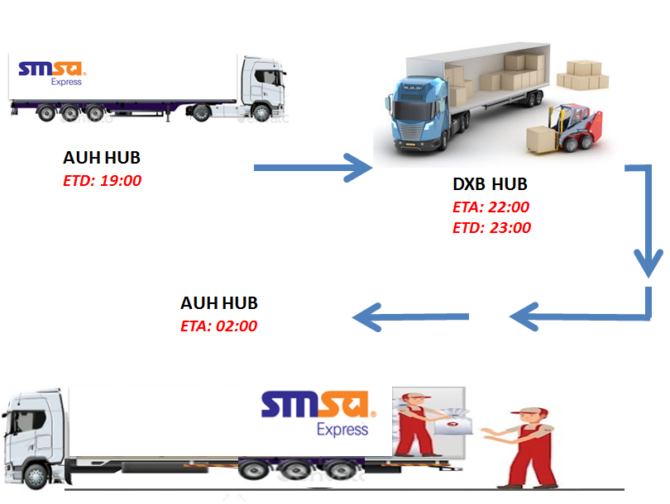

Note: ADAFZA PM Station agent might help in the HUB Line haul connection if the HUB PM agent wasn’t available. All pre-alerts/ revert alerts communication should remain the same.

SAFETY & SECURITY
Security and safety are the collective responsibility of all SMSA team members. In the current security climate it is critical that we all remain vigilant and that any suspicious activity is reported to SMSA Express management.
The security personnel needs to ensure all security policies, procedures and security measures that are in effect with special focus and attention on the following:
- Report any suspicious activities or persons near SMSA facilities. This may include any person(s) showing an uncommon interest (e.g. photographing or videotaping assets) in company security measures, personnel, entry points, access controls, perimeter barriers (e.g. fences or walls) and critical networks or systems.
- Follow all TAPA policies and procedures.
- Ensure all access control protocols are strictly enforced, including but not limited to, escort policies for visitors.
- Ensure all CCTVs are working and covering all the facilities activities including loading and offloading processes.
- Aware of emergency contact lists.
- Any suspicious activity or security concerns must be immediately reported to the facility in charge.

ENVIRONMENT HEALTH & SAFETY (EHS)
    - Operations department should coordinate on all issues concerning maintenance with the Enova team (ADAC).
- Safety toolbox should be implemented regularly.
- Housekeeping should be maintained.
- First-Aider should be assigned at least as one per shift.
- Fire evacuation guidelines and procedures should be informed and followed by all staff.

PREALERTS/ REVERSE ALERTS FORMAT

LINE HAUL
ORIGIN: |  | DESTINATION:
MASTER CONS:
TAGS:
DATE: |  | SHIPMENTS:
DEPARTURE TIME: |  | PIECES:
DRIVER NAME: |  | COMAT:
VEHICLE NUMBER: |  | Pallets/ULD:

Load Received Date & Time |  | DD-MM-YYYY HH:MM
 | Pre-Alert | Received
Shipments
Pieces
Comat
Shortage
Overage
Damage

DUBAI TO ABU DHABI HANDLING PROCEDURE

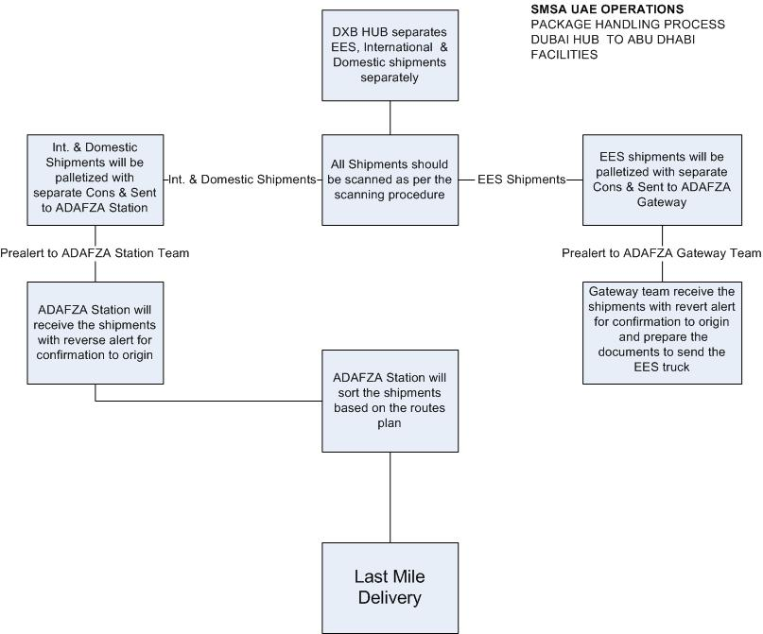

ABU DHABI TO DUBAI HANDLING PROCEDURE

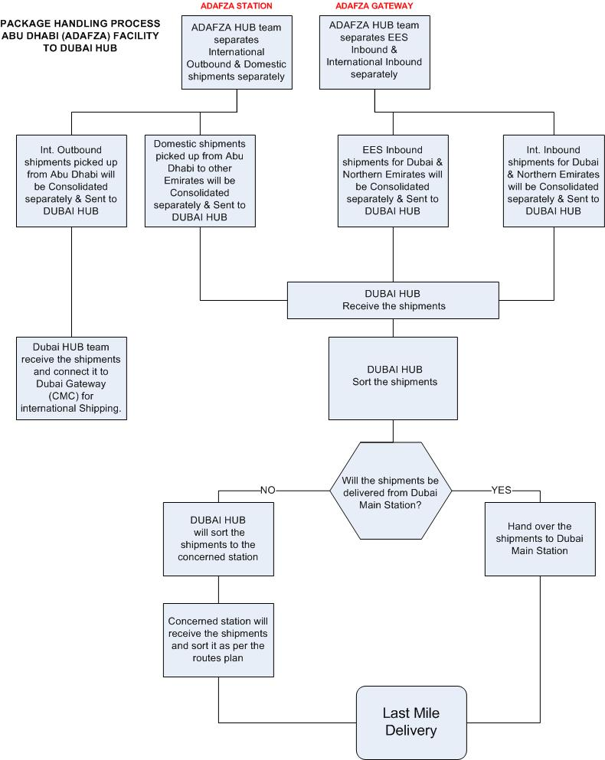

END OF DOCUMENT

