PURPOSE | The work instructions are set to provide a clarification on the proper usage of the Dimensional weighing system (DWS) located in Dubai Um Ramool Warehouse. The purpose of this machine is to measure the actual and dimensional weight of all inbound and outbound shipments and provide a report to finance for billing the heavier weight of each shipment to the shipper.
PERSON AFFECTED | Operation Manager, Stations’ Supervisor, HUB Supervisor, Finance Manager, Billing Agents.
PROCESS & WORK INSTRUCTIONS | INBOUND:  - All inbound packages have to pass through the system before sorted to stations.  - Exempted shipments are envelopes only.  - HIPS scans should be applied before the auto-applied Rex scan by the system.  - DWS operator has to send the report with full details to billing department through email on daily basis.  OUTBOUND  - Um Ramool Station agent has to receive the shipments from couriers, scan SOPS and then put them on the DWS.  - HIPS/HOPS Scans shall be applied only after REX is auto-applied by the system.  - Exempted shipments are envelopes only.  - DWS operator has to send the report with full details to billing department through email on daily basis.
REPORT CONTENTS | - Package AWB  - Sender Company  - Consignee Country  - Sender account  - Weight on AWB  - Length, Width, Height & Dimensional Weight.  - Actual weight  - Chargeable weight ( Maximum of Actual Vs. Dimensional Weights)  - Discrepancy Weight (= Chargeable Weight – Weight on AWB).

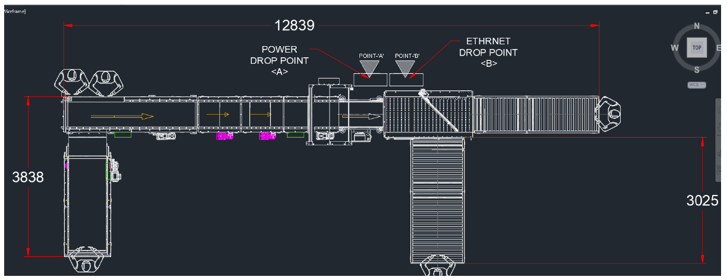

- Above is the layout of the existing system at Um Ramool warehouse, proper and safe handling of the shipments is a must for all employees.
- The DWS operator shall ensure all the packages are passing in a safe manner and shall not overload the system if the loading bay or the shipments exit point is full.
- The DWS operator shall monitor the flow of the packages and recognize the reason behind the auto-stop of the system if happened.
- The DWS operator is responsible for ensuring that all packages were scanned. If the AWBs weren’t read by the system, he shall use the hand scanner or enter the details manually after collecting the packages from the rejection bay.
- The DWS operator is responsible to allocate the handlers in the right positions based on the load.
- The DWS operator shall ensure that all packages received are properly scanned and operations agents are available at the time of operating the machine.
- The DWS operator shall ensure that the machine is operating in an efficient and effective way to avoid delay in connections with stations or gateways.

End of document

