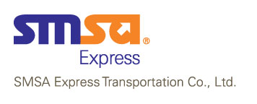

WEEKLY FORKLIFT INSPECTION CHECKLIST

Forklift Type: Automatic |  |  | Date:
Inspected By: |  |  | ID # :
To Be Inspected | Condition Type |  | Remarks
To Be Inspected | OK | Defective | Remarks
Tires
Horn
Lights (Break/Front/Beacon)
Battery
Controlsandgear shifts
Liftsystem(includesswitches,chains,cables,forks, etc.)

Steering

Hydraulic system (forleaks)
Exhaust System
Overheadguards
Belt
Is forklift clean, free of trash, excess oil and grease?

Remarks / Recommendations:

Staff Sign:

