CUSTOMER SERVICE DEPARTMENT

COMPLAINT HANDLING MANUAL


Approvals

The signatures below certify that this process has been reviewed and accepted, and demonstrates that the signatories are aware of all the requirements contained herein and are committed to ensuring their provision.

 | Name | Signature | Position | Date
Prepared By | Falah Al Enazi |  | Customer Experience Manager
Reviewed By | Gandi Sulaiman |  | National Manager - CS
Approved By | Eng. Majed Alesmail |  | Managing Director

Amendments Record

This process is reviewed to ensure its continuing relevance to the system and process that it describes. A record of contextual additions or omissions is given below:

Page No. | Context | Revision | Date
Introduction page  16 & 17  4  Introduction page  All pages  22  23 | New addition : Complaint handling policy  Severity Classifications  Invalid complaint  New addition : Complaint handling policy  CITC  Update customer criteria  Key performance Indicator | Added Note: All complaints to be logged including the invalid cases.  Added: SMSA is also committed to comply with the external government authority rules in case of escalation or disputes and reduce the financial and operational impact on the customer.  Relaced with “Regulator”  “and ensure updating the complainant about the status every (2) days maximum”  Adjusted to 90% | 25 Oct 2019  26 Oct 2019  01 Nov 2019  01 Jan 2020  01 Nov 2022  09 Jan 2024  02 Feb 2024

SMSA Express - Complaints Handling Policy

SMSA aims to continuously improve the services provided to its customers. Effective complaints management is fundamental to the provision of quality services and provides the channels for obtaining feedback from its customers with the purpose of resolving disputes and reforming policies and procedures. SMSA is also committed to comply with the external government authority rules in case of escalation or disputes and reduce the financial and operational impact on the customer.

Foreword

Our procedure has been developed by our complaint management who adopted a standard approach to handling complaints across the market, which complies with ISO standard 10002 on a model complaints handling procedure. This procedure aims to help us ‘get it right first time’. We want quicker, simpler and more streamlined complaints handling with our valued customers, early resolution by capable, well-trained staff.

Complaints give us valuable information we can use to improve customer satisfaction. Our complaints handling procedure will enable us to address a customer’s dissatisfaction and may also prevent the same problems that led to the complaint from happening again. For our staff, complaints provide a first-hand account of the customer’s views and experience, and can highlight problems we may otherwise miss. Handled well, complaints can give our customers a form of redress when things go wrong, and can also help us continuously improve our services.

Resolving complaints early saves money and creates better customer relations. Sorting them out as close to the point of service delivery as possible means we can deal with them locally and quickly, so they are less likely to escalate to the next stage of the procedure. Complaints that we do not resolve swiftly can greatly add to our workload.

This complaints handling procedure will help us do our job better, improve relationships with our customers and enhance the public perception of SMSA Express. It will help us keep the user at the heart of the process, while enabling us to better understand how to improve our services by learning from complaints.

Eng. Majed Al Esmail
Managing Director

Contents

1. Purpose ................................................................................................................................................. 2

2. Scope ..................................................................................................................................................... 2

3. Commitment ......................................................................................................................................... 2

4. Terms & Definition ................................................................................................................................ 3

5. Complaints & their nature .................................................................................................................... 5

5.1 What is Complaint? ..................................................................................................................... 5

5.2 What is not a Complaint? ............................................................................................................ 5

5.3 Complaint Classification – Categories and Sub-Categories ...................................................... 5

6. Roles and Responsibility – Customer Service Management................................................................. 8

6.1 All Employees – Receiving Complaints ...................................................................................... 8

6.2 Resolving Complaints – Complaint Owners .............................................................................. 9

6.3 Customer Service Executive – Gate Keeper............................................................................. 10

6.4 Escalation – Department Managers/ Directors ...................................................................... 11

6.5 Management – Continuous Improvement ............................................................................... 11

7. Complaint Handling Process ............................................................................................................... 12

7.1 Stage 1 – Receive the Complaint .............................................................................................. 14

7.2 Stage 2 – Assess the complaint ................................................................................................. 17

7.3 Stage 3 – Investigate the Complaint ......................................................................................... 18

7.4 Stage 4 – Resolve the Complaint .............................................................................................. 18

7.5 Stage 5 – Monitor the Effectiveness ......................................................................................... 20

8. Learning and Continuous Improvement ............................................................................................. 21

9. Service Level........................................................................................................................................ 22

10. Key Performance Indicators ............................................................................................................... 23

1. Purpose

The purpose of this guideline is to provide suggested framework and mechanism for dealing with complaints in accordance with ISO 10002 & SMSA’s policies. The guideline may prove helpful when considering how to progress complaints as mandated by our principles.

SMSA considers the feedback on its brand and services not as complaints, but as means of improvement and development tool forwarded to work on, correct and take measures. All complaints, whether justifiable or not, given by our customers are considered as complaints, and each complaint is an opportunity for us to remove any deficiency in services we provide

2. Scope

This document covers all the complaints made regarding our services received at various contact points. The scope is to enhance customer satisfaction, determine ways of improvement, develop the business processes and take necessary actions accordingly, determine the perceived service quality as a result of business process and reinforce customer loyalty.

3. Commitment

We are committed to efficient and effective complaints management. Our commitment involves:

a. All levels of the company (SMSA), particularly the organization’s
Management;
b. Encouraging an organizational culture to welcome complaints as an opportunity to improve services
c. Implementation and maintenance of a Complaints Management System to manage complaints;
d. Reporting information about complaints management in executive reports.
Page2

4. Terms & Definition

A. Complainant means the person or a company making the complaint.

B. Client/Customer means a person or a company engaged in a business relationship, or any other person or organization having an interest in the functions or activities of SMSA.

C. Acknowledgement means communication to the complainant or their organization that the complaint has been received and is being processed

D. Priority suggests the severity of a complaint to help determine the course of action to be taken

E. Assessor means a person or a company who may or may not be an employee of SMSA and is responsible for evaluating the circumstance of the claim, assess the damage/ loss determine if the claim is covered under the policy and assist in settling claims.

g. Dispute means a customer’s formal disagreement with the services of SMSA which leads to some type of internal or external review or determination

h. Concerns means a request for the resolution of a problem or difficulty by a customer. Concerns can be resolved, partially resolved or not resolved.

- Comments/Suggestion mean any point of view expressed formally to SMSA
about the quality of the company’s service.

j. Compliments means any appreciative statement about a service or employee from customer, organization or individual who still isn’t our customer. Compliments will be recorded on the Customer Service Management system and can be used to facilitate learning, bring attention to service development and reinforce good practice.

k. Touch points means the interface of SMSA’s service or SMSA brand with customers/users, non-customers, employees and other stakeholders, before, during and after a transaction.
Page3

l. Complaint Management System (Core system) is the process of how SMSA handles, manages, responds to and report customer complaints. System is put into place to track and trend the data that is captured by the complaint management processes.

m. Complaint Owners mean an individual who is responsible for resolving the complaint. The complaint owner may or may not be the source of the complaint.

n. Service Level Agreement (SLA) is an internal agreement between SMSA’s management and its employees that defines the level of customer service required by each of SMSA’s employees.
Page4

o. Regulatory & External Government Parties : is currently under the umbrella of postal services regulator in case of any government or legal cases escalated by SMSA customers.

5. Complaints & their nature

5.1 What is Complaint?

Any expression of dissatisfaction by a customer, potential customer or other business partner or any regulatory body (e.g. Postal services regulator) made to SMSA directly or indirectly which is related to services provided by SMSA or which is related to an employee of SMSA or provided by another business partner of SMSA.

Some examples of justified complaints are

- The complainant has a reason to be dissatisfied with how the shipment was handled and got damaged/lost
2. The claim was denied when it should have been paid;
3. The complainant was given poor customer service, for instance, the customer’s
Repeated phone calls to SMSA are not returned,
4. SMSA did not deliver the shipment as they committed to the customer they would do;
5. SMSA employee misguided about the service information or provided incorrect information.

5.2 What is might be an invalid Complaint?

Any expression of dissatisfaction concerning denial of SMSA complaint policy such as:

- Refusing the paid amount (which complies with SMSA policy) against a claim of lost shipment where insurance option was not selected by the customer.
- Customer requests more than the value of his shipment (lost/damage cases)
- Customer asks SMSA to provide specific service which is not available.
- Any subject or request breaching SMSA terms and conditions which were agreed with the customer in a contract.
- The customer complaint against non-availability of a service (such as online payment) which mostly considered under improvement domain.

Note: All the complaints even not justified, will be recorded at the complaint management system.

5.3 Complaint Classification – Categories and Sub-Categories

For the sake of ease, various type of complaints received by SMSA are segregated into categorizations denoting the origin of function;
Page5

Complaint Categories and Sub Categories

Complaints | Category | Sub-Category
Complaints | Delivery | Late Delivery  Wrong Delivery  Switched delivery  Mis-route  Partial Delivery  No notification SMS
Complaints | Pick up | Mis Pick up  Late Pick up  Wrong Vehicles Size  ..etc.
Complaints | Damage
Complaints | Missing /Lost
Complaints | Package Acceptance
Complaints | Staff Behavior
Complaints | Duty / Taxes
Complaints | Retail Duty hours
Complaints | Sales Issue
Complaints | Technical Issue
Complaints | Other

6. Roles and Responsibility – Customer Service Management

The roles and responsibilities of those who are involved in customer service management are discussed below;

Roles | Responsibility
Receiving Complaints | All Employees
Resolving Complaints | Customer care (Major)/ Call back (Minor) MajordccؤؤؤcmxxddهءCallcسBac(Teamsسء(Minor
Escalation | Complaint Managers/ Management
Continuous Improvement | SMSA Management

- The term manager refers to the function performed rather than job classification or title
- Several roles might be performed by the same individual
- A role may be split up among several individuals or competencies
- Responsibilities include but are not limited to those listed for each role

6.1 All Employees – Receiving Complaints

- Receive complaints from the customer via telephone, email, social media or in person or complaint management system
- Request clarification and additional information on the complaint
- Collect required information from the customer and log them to CORE:
o Name of customer
o Name of the company
o Contact details
o Nature of complaint
o Classification of complaint ticket
o Attach any support documents, photos to the complaint ticket.

- Employees who do not have access to the complaint system have to inform their team manager for the purpose of logging the complaint on the Complaint Management System or inform the customer to contact one of customer support channels.
- Log the complaint on to the Complaint Management System if not already logged.

- Acknowledge the customer complaint via Complaint Management System
(Automated) or provide ticket number via support channel (Call/Email/…etc).

- Classify the severity or priority of the complaint received

- Assign the ticket to “Customer Care Group” on ticketing system. If the complaint is minor requires only direct action (delivery, pick up … etc.) then it should be logged to system and assigned to the concern department then call back team will follow up and ensure accomplishment.

- Immediately escalate the complaint if the complaint is deemed High Priority or
Urgent.

- Categories and subcategorize the complaint if not already done
Page8

- If and when required, direct or route customer complaint to appropriate personnel for assistance.

- Handle dissatisfied customers in a polite and professional way.

6.2 Resolving Complaints – Complaint Owners

The individual, along with receiving of complaints, may be responsible for resolving complaints as well. The following responsibilities are in additional to that of receiving complaints.

- Understand the nature of the complaint.
- Identify the cause of the complaint
- Identify the possible solution and the required timeframe to solve customer complaint.
- Respond to customer complaint or to notify them of investigation results and any planned actions with the estimated time frame for resoltuion.
- Resolve customers' service complaints by performing activities or coordinating with other Departments.
- Monitor the Complaint Management System to track and follow-up all customer requests in a timely manner.
- Return customer calls in a timely manner to ensure customer satisfaction.
- Conveying the solution to the customer
- Confirming that the customer agrees with the solution.
- Taking appropriate escalation if the customer does not agree with the solution
- Escalating the complaint to appropriate management level
- Adhere to all SMSA policies and statutory requirements and recommends to senior management adoption and/or changes to policies and guidelines to reflect circumstances within the customer service area.
- Research, prioritize and resolve customer issues in timely and accurate fashion.
- Deliver prompt and professional solutions for customer complaint via phone, email, in person, etc.
Page9
- Closing the complaint
- Prepare claim file if a refund resulted from the customer complaint.
- If the complaint is relevant to H&SE, customer regulatory or legal requirements
then the complaint will be forwarded to the concern department (QRM / Legal Depts.)

6.3 Escalation – Department Managers/ Directors

There are two types of escalation, first is when the complaint is either High priority or Urgent complaints are escalated to the manager/ department owner upon receiving them and second is auto escalation by the complaint management system (Core System) when the complaints are not actioned or updated within 1 business day or resolved within the given timeframe. The below scenario is implemented one escalation occurs :

- Review the nature of complaint, Investigate and identify appropriate solution for customer service complaints.
- Resolve the customer complaint promptly.
- In case of escalation, identify the reason for the escalation and ensure necessary actions are taken to resolve the complaint.
- Coordinate with team members to develop preventive actions for the nature of customer complaint.
- Provide team members with guidance in handling difficult or complex issues or problems so they can be resolved effectively and efficiently.

6.4 Management – Continuous Improvement

- Ensure complaint handling process and objectives are established and communicated to customers and complainants.
- Identify and allocate resources for effective and efficient complaint handling process.
- Review quarterly reports on the customer complaint received and the customer service performance of SMSA.
- Review the performance and effectiveness of complaint handling system of
SMSA and report the findings annually.
- Discuss and identify areas that needs to be improved for better and efficient customer service.
Page11



7. Complaint Handling Process

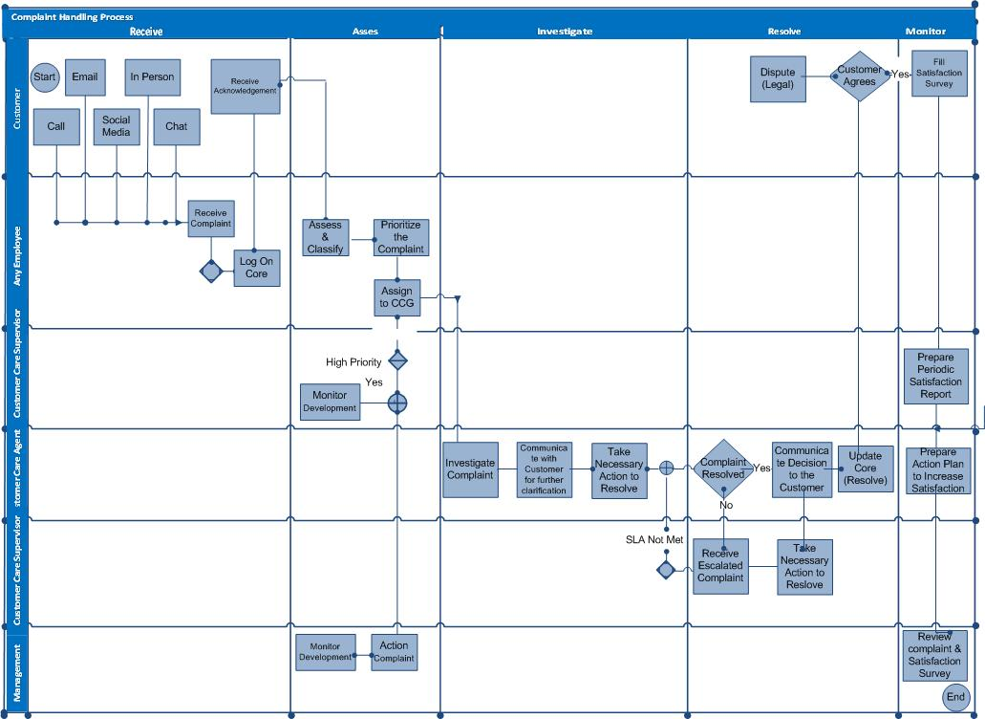

Page12

There are five stages of complaint handling process,

1. Receive the complaint
2. Assess the complaint
3. Investigate the complaint
4. Resolve the complaint
5. Monitor the complaint

Complaint Handling Process Stages

Monitor
Receive

Resolve
Assess

Investigate

The below describes the strategies for dealing with each stage of complaint management process;
Page13

7.1 Stage 1 – Receive the Complaint

The employees who receive the complaints are required to;

- Actively listen to the complainant
- Not to react defensively
- Understand, empathize and acknowledge his/her viewpoint
- Express regret that they have had a poor experience, and
- Assure them that steps will be taken to investigate and resolve their concerns

A customer who is complaining about the service may have an emotional need to vent their anger over what has happened to them. It is important that you respond in a positive and helpful manner and that you remain calm and objective. Some tips are listed below;

- Let the person be angry and do not interrupt as they tell their story.
- Keep the volume and pitch of your voice low. Lowering your voice and speaking calmly helps to calm an emotional person.
- Reinforce the person’s right to complain, to be heard, and to receive a response.
- Be open, non-judgmental and empathic
- Respect and empower the complainant
- Accept what is being said without attempting to justify another’s action or without
denying the complainant.
- Listen to the problem fully before deciding if you can or cannot assist in the matter.

Phrases to Use (Complaint handling scripts)

- Thanks for your patience Mr. Ahmad ….
- I’m so sorry that you feel this way, Mr Ahmad…”
- “As a solution,”
- “May I suggest that…?”
- “What I’ll do right now is… and we estimate this will take ….. time “
- “We really do appreciate this feedback, Mr Ahmad …”
- “May I arrange for an update call, at a time most convenient for you?”
- We do appreciate your business

Look for Solutions

- Provide relevant information that will assist the customer to better understand the decision or action that they are aggrieved about.
- If there are things you can do straight away, do so.
- Give reasons for what happened and, if appropriate, apologize
- Focus on solving the problem/ complaint rather than blaming or finding faults
- Explain clearly what can and cannot be done
- Offer possible resolution methods. Providing alternatives will empower the person and give them a feeling of entering into a partnership in the process of resolving the complaint.
- Let the client know what you intend to do and when you will get in touch with them.
- Contact them on the day and at the time you said you would, even if you haven’t made
- any progress to keep them informed.
- If an action needs consideration or approval by a manager/ director/ management, inform them and work out when and how will you inform the complainant of the outcome.
- Confirm the outcome of the conversation and make sure that the person agrees with what has been decided.
- Inform the complainant when you have taken the action
- Make sure you follow up on a promised action.
- End the conversation with the agreement on what is to happen next.

Record and Acknowledgment of the complaint

- All received complaints are to be recorded in the complaint management system (Core system) by filling a complaint ticket.
- Comprehensive information about the complainant and the nature of complaint is to be recorded in the system.
- When a complaint is recorded in the system, acknowledgement of the complaint received is to be send to the customer (automated via SMS) or by providing ticket reference No. by calling/Email…etc.
- The online system is designed to automatically send the complaint acknowledgement with a reference tracking number for complainant via SMS to track the status of their complaint and for other correspondence.
- Customer will be able to contact any customer support channel and track the status of his complaint.
Page15
- The above actions is complying with the rule imposed by the regulator that the customer should be acknowledged for his complaint through written mean (SMS) containing the complaint reference number as well.

Complaint Receipt Channels:

Telephone:

All complaints are forwarded by calling at the toll free number 920009999. Complaints are recorded by Customer Service Executive and solution process is started. Service hotline provides service 24/7.

Email

An email complaint can be send to info@smsaexpress.com and is automatically captured by the complaint management system and the complaint handling process is started.

Website

Select the section “Customer service” on www.smsaexpress.com which leads to complaint form. All complaints made by using these ways are automatically generating ticket number and forwarded to Customer service unit and solution process is started.

Fax

Written feedbacks may be sent at SMSA Express fax number +9661 2931736 at our office. These complaints are forwarded to customer service executive, the complaint is recorded and process is started.

Face to Face (Walk-in customer)
Customer/ Client can visit our office and fill a complaint form which will be made available at the front desk. The complaint form shall be forwarded to the Customer Service Executive who in turn shall register the complaint the system and the process is started.

Social Media
Customer could also approach SMSA to get the required support for the complaint through SMSA accounts on social media:

- Twitter : @SMSACARE
- Facebook: /SMSAEXPRESS
- Instagram: SMSAEXPRESS

7.2 Stage 2 – Assess the complaint

The purpose of the assessment process is to;

- To identify the source of the complaint so as to assign the complaint to the appropriate department/ complaint owner if not already done.
- Classify the complaint appropriately to determine the appropriate action
- To ensure the process is commensurate the seriousness of the complaint and the issue raised.
- The prioritization of a complaint shall be based on the severity of the complaint and
the nature of customer.

All complaints are classified into the following;

- High Priority – A complaint that has immediate and higher than the perceived impact on the customer satisfaction, SMSA image or reputation, unless not resolved within the expected timelines. This is resultant of any financial losses or legal issues or a complaint posted on public channel like social media networks or escalated to external regulatory party. In this case the complaint severity is evaluated by the complaint team and if impact is serious then it will to be escalated to top management ASAP. For example :
- Lost shipment
- Damage condition
- Wrong delivery of customer shipment
- Complaint on Public in Twitter
- Complaint escalated to postal services regulator.
- Late delivery of sensitive contents (Passport,Cheque…etc.)
- Extensive Delay (where delay exceeds 48 hrs from the commitment date)

- Medium Priority –A complaint that has intermediate and has no serious impact on the customer satisfaction or SMSA reputation. This might lead to disgruntled customer and lead to minor financial losses such as the routine complaints like :

- Late delivery
- Wrong invoice
- Miss pick up
- Payment issues.

- Low Priority – A complaint that had low impact and no serious implication on the retention of the customer and financial losses. The low priority complaints may be vague in nature or lack specifics, but contain sufficient information to determine they are service standard related or related to poor service in general terms.

Medium High
Impact

Low

Urgency
Page17

7.3 Stage 3 – Investigate the Complaint

The purpose of the investigating is to obtain a sufficient amount of information in order to decide what has occurred and identify appropriate action. Not all complaints need to be dealt with in exactly the same way. These guidelines should be varied in accordance with the circumstance and the nature of complaint.

During the investigation, we need to;

- Clarify the complainant’s expectation
- Establish the facts
- Identify the source or origin of the problem
- Liaise or forward the case to the concern department to conduct the required investigation like lost/missing incidents to be forwarded to QRM department.
- Ascertain what did or did not happen, what should or should not have happened
- Identify resource required
- Identify course of action to resolve the complaint
- Record and document the investigation findings on the complaint management system.
- Make recommendations that constitute an improvement for preventive measures.

7.4 Stage 4 – Resolve the Complaint

At the end of the investigation stage, the complainant is advised about the outcome. Immediate action is to be taken to resolve the complaint with a formal communication with the complainant advising him if the complaint was resolved or not. If no satisfactory solution was achieved, SMSA shall inform about the company’s position on the situation and the reason for not being able to resolve up to complainant’s expectation.

Closure of Complaint

A complaint will be considered as closed if any of the below mentioned scenarios are met with:

- SMSA has agreed to the request of the complainant and resolved the issue fully.
- Complainant has indicated the acceptance of the decision.
- If no reply is received from the customer within 3 business days of response, then the complaint will be considered closed. If customer re-called after that then a new ticket should be initiated and reference of the old complaint No. to be referred.
Page18

Complaint re-opening process

- In case the customer is not satisfied with the decision, the customer can approach any of the touch points mentioned in the document or reply to the email which informs the customer about the closure of complaint within 2 days of the receipt of our communication (failing which, we will consider the complaint to be satisfactorily closed.)
- In the event of customer coming back within 2 days, the original
‘Complaint’ interaction will be reopened for review of the earlier decision. Post reviewing all the facts, a suitable decision will be provided to the customer as per policy.
- Alternatively, the complaint may be reopened if the customer provides fresh evidence
or additional requirements to support his claim.
- Reopened complaints to be escalated to the complaint manager.
- Note: In the complaint management system (Core system) the ticket will be escalated to the next management level in case no update/action has been taken on the ticket for within 24hrs. The ticket escalation structure has been made to reduce the resolution time for all ticket and been agreed with the top management.

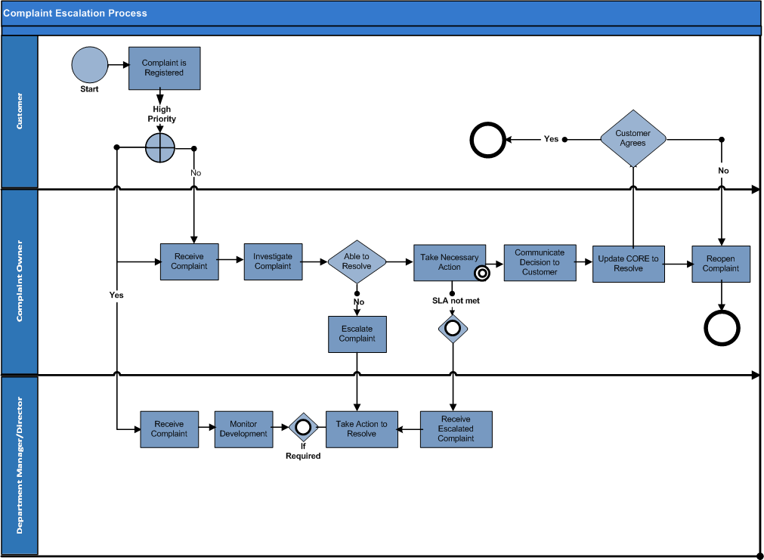

in

7.4 Stage 5 – Refund policy (When required)

The customer has the right to claim for refund once he/she feels that the service was not provided in satisfactory method. This includes the incidents of damage and non-delivery. All refund requests will be investigated considering SMSA terms and conditions that are mentioned on the back of shipping air waybill.

Claim Related Authorities:

  - All claim should be accepted from the customer within the time frame mentioned in SMSA Terms and conditions on SMSA air waybill.

  - All claims should be initiated and processed through Customer Care unit.

  - All claims must be approved by Customer Care supervisor and customer Service manager.

  - In case the customer rejects the decided refund as per SMSA policy then special claim form called VCC (Voice of Customer Committee) should be prepared and approved by the committee members (SMSA MD is member in this committee). E.g. (Customer claims for full refund when his shipment is not insured).

7.5 Stage 5 – Monitor the effectiveness

Two level of monitoring is to be followed to analyze the effectiveness of the complaint management process.

- Firstly, a satisfaction survey is to be conducted on monthly basis to analyze if the complainant is satisfied with the level of service provided while resolving & managing the complaint.
- Secondly, monthly meeting at management level will be held to discuss the major issues of complaints, data analysis of complaint and review their root causes by department and region wise. It will also review effectiveness and productivity of the process along with developing preventive measure & increase customer satisfaction. The output of this monthly meeting will form of the inputs to monthly management review meeting. This meeting will be formed by the following members:

Complaint management representative | Nat’l Customer Service Manager / Customer Care Manager
Operations | Service assurance Manager
Service Centers | Service assurance specialist
Mailroom | National administrator – MRM
Sales | National administrator - SLS

In order to determine satisfaction level of the customers who provide feedback in connection with the complaint management process, surveys are conducted to measure customer satisfaction. Performance of the complaint management process is measured with the predefined criteria.
Page20

Monthly, the customer service executive shall prepare a Complaint Monitoring report that shall be circulated to the department owners for their action. Meanwhile, quarterly the department owner shall prepare a report on lessons learned and preventive action considered. As a result of the data analysis, efforts will be made to generate solutions to prevent occurrence of the critical customer complaints again and corrective action may be taken in this respect according to the corrective and preventive actions procedure.

For analysis, the management shall meet once in 6 months. In these meetings, the main agenda is to conduct data analysis about the customer complaints such as complaint classes, types of complaints, mode of complaint, lessons learned, preventive action developed and business impact. Decisions taken at the end of the meeting are shared with the respective owners of the process.

Minimum Requirement | Frequency | Evidence | Responsible  Individual | Responsible for  action plan monitoring
Complaint monitoring reports (analysis of number & types of complaints, failure areas) | Monthly | Complaint Management System | Customer Care Supervisor | Department  Owners
Annual Report (analysis of  number & types of complaint, learning, recommendation & preventive actions) | Annually | Complaint Management System | Customer Service  Manager | Management

8. Learning and Continuous Improvement

SMSA aims at improving efficiency and effectiveness of the process for dealing with the complaints by means of actions it performs. It performs adoption of the corrective/preventive actions, study of innovations and comparison methods and prevention of the repetition of the problems that have led to complaints and prevent occurrence of possible problems.

- Using complaints data to identify the root cause of complaints
- It researches and implements the best practices to deal with the complaints;
- It procures that a customer-oriented is adopted throughout the organization;
- It encourages innovations in the developments for dealing with the complaints; and
Page21
- It acknowledges any exemplary behaviors in dealing with the complaints.

9. Service Level

SLA (Service Level Agreement) has been designed for the complaint categories and the SLA shall consider Business Hours of SMSA. The turn-around time only considered active when SMSA is supposed to take an action and doesn’t have to wait for the Insurance Company, Customer or any other third party to respond or take action. The turnaround time for acknowledge, response & resolve for various department are as follows;

Severity Criteria:

Complaint | Acknowledgement | Response | Resolution
High Priority | Auto | 2 Hours | Based on category
Medium Priority | Auto Hos | 1 Day | Based on category
Low Priority | Auto | 1 Day | Based on category

Solution Time Criteria:

Complaint | Resolution Time
All Complaints | 7 Business days

Update customer TimeFrame Criteria:

Complaint | Update Time
Any complaint | The complaint owner should pass the estimated time frame of solution to the customer and ensure updating the complainant about the status every (2) days maximum. If the deadline became due, then staff must update the customer with the complaint status or new estimated time of resolution if the case requires more time.

10. Key Performance Indicators

Certain indicators shall provide insight on the performance and effectiveness of the complaint management system.

No. | Performance Indicator
1 | 90 % of complaints to be resolved within 7 Business days

