Overview | To standardize a procedure on the action to be taken, for Missing Shipment Notification Report (MSNR) reporting in Operations Department
Responsibility | Supervisor/Manager: in charge of MSNR preparation and accuracy of given information.  Service Assurance Specialist: responsible for the checking of MSNR’s completeness  Service Assurance Manager: responsible for the checking of MSNR’s accuracy and authenticity, and ultimate submission to Customer Service and QRM Departments once validated.
Person Affected | Operations Supervisor/Manager, Service Assurance Analyst, Service Assurance Manager, National Operations Manager
Instruction | Following steps to be followed when accomplishing a MSNR Form  - MSNR forms will be filled up once missing shipments are identified thru (1. Versus Reports, 2. Incident Reports (Stolen/Theft), 3. PAR Report)  - Operations Supervisor / Manager to accomplish the MSNR Form and properly identify the personnel accountable for such losses, he then submits it to Service Assurance Specialist for processing  - Service Assurance Specialist to determine and ascertain the completeness of information and accountable personnel name and employee number, rejection will be returned to Ops Supervisor/Manager, otherwise will be forwarded to Service Assurance Manager.  - Service Assurance Manager to check on the accurateness and authenticity of the filled up form. Rejected forms will be returned to the Service Assurance Specialist for the needed revisions.  - Approved MSNRs will then be submitted to Customer Service Department for claims processing

Mapping of Process – Part 1
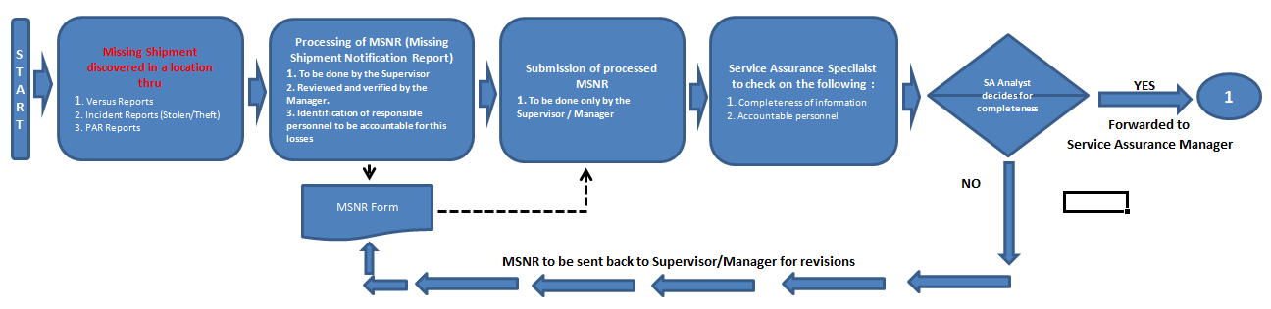

Mapping of Process – Part 2

