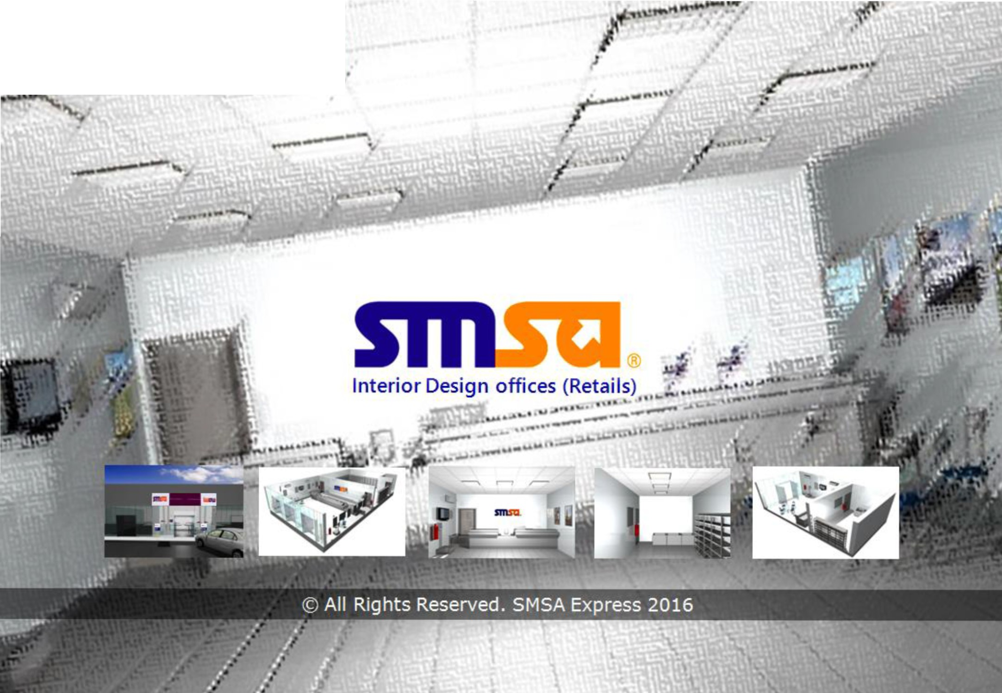Confidential
SSC (SMSA Service Center)

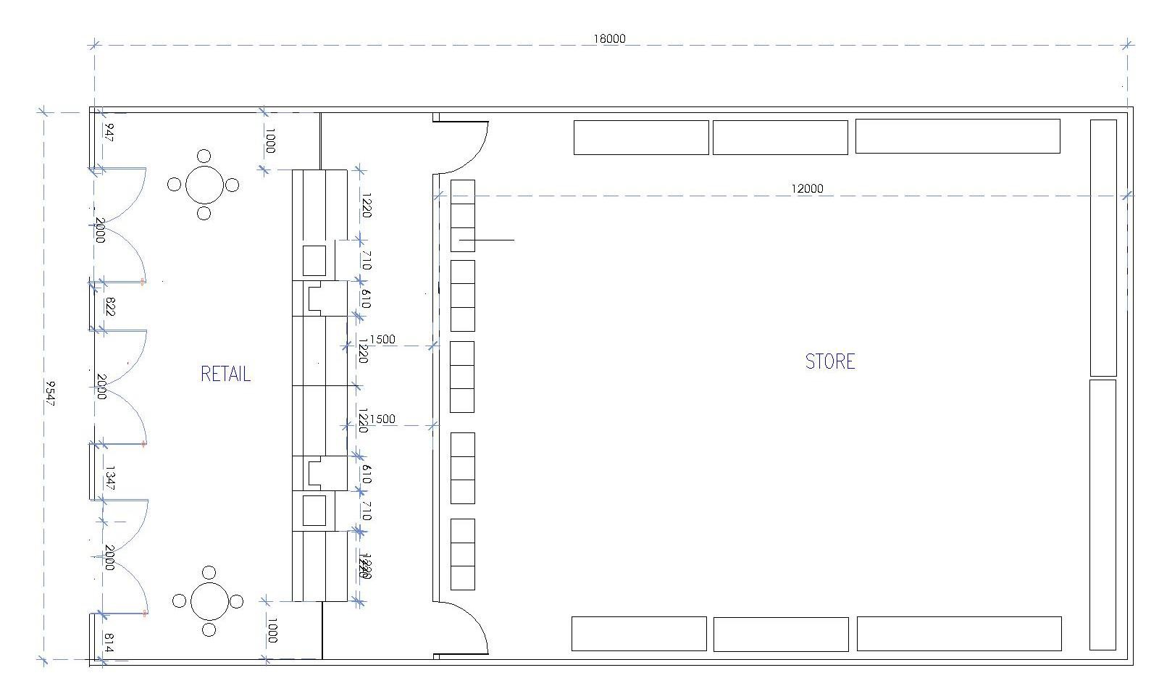SSC PLAN TYPE (A)

Between 15-19 m

Between 9-12 m

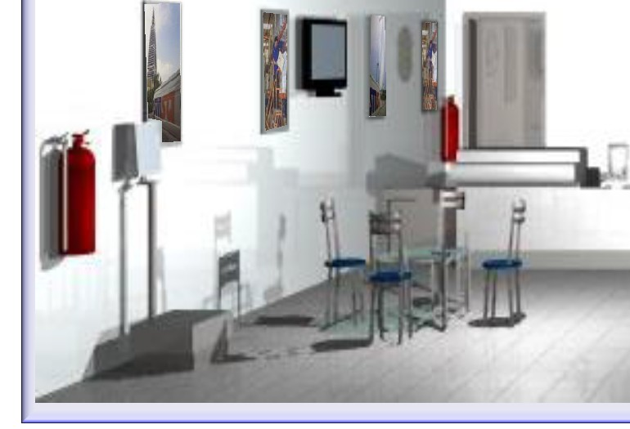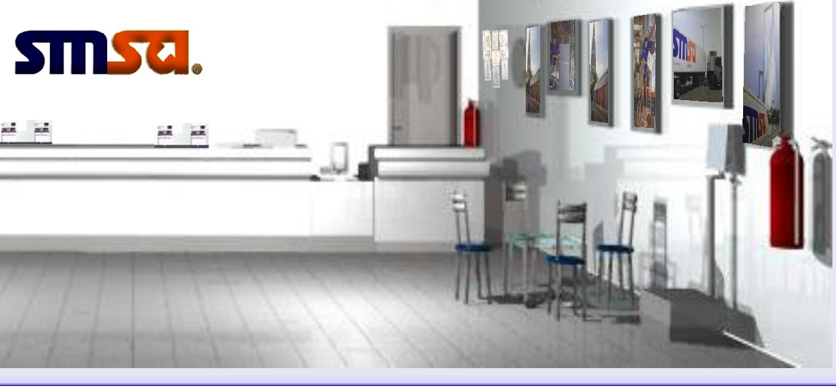
 | INTERIOR PERSPECTIVE TYPE (A)
 | ,----....,  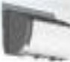 | ' | f,..- | 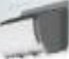

Outdoor Perspective TYPE (A)

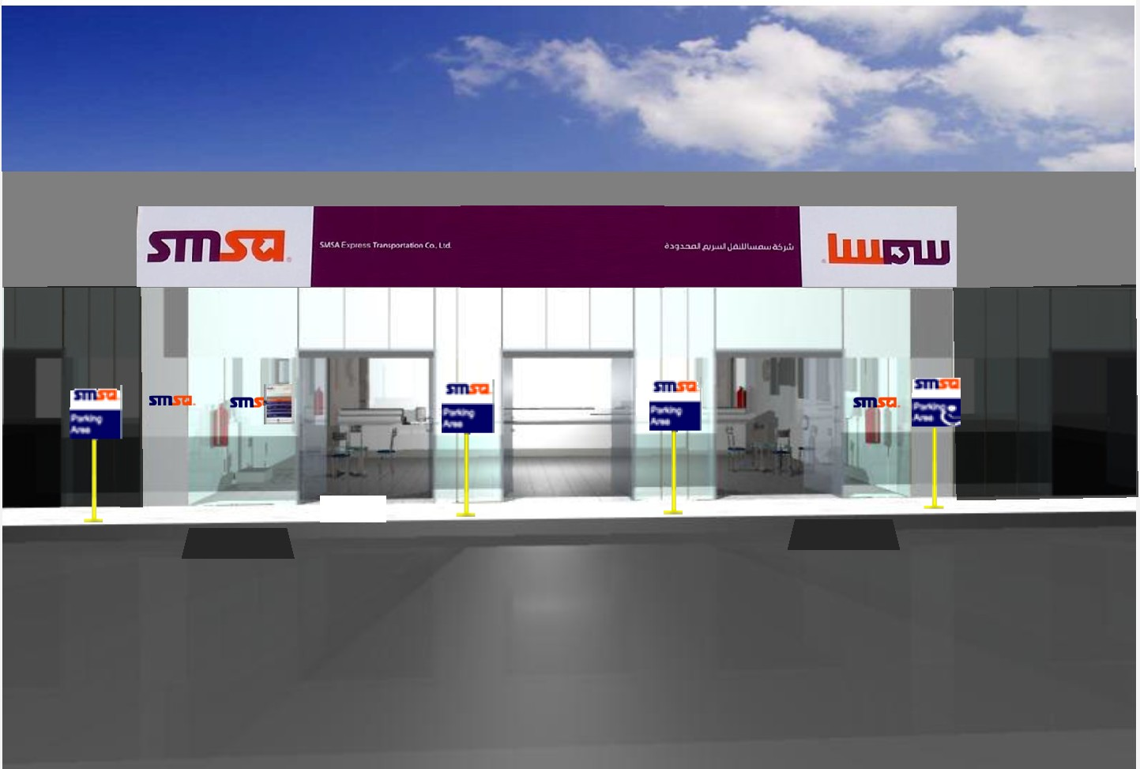

Interior Design offices (SSCs)

Perspective TYPE (A)

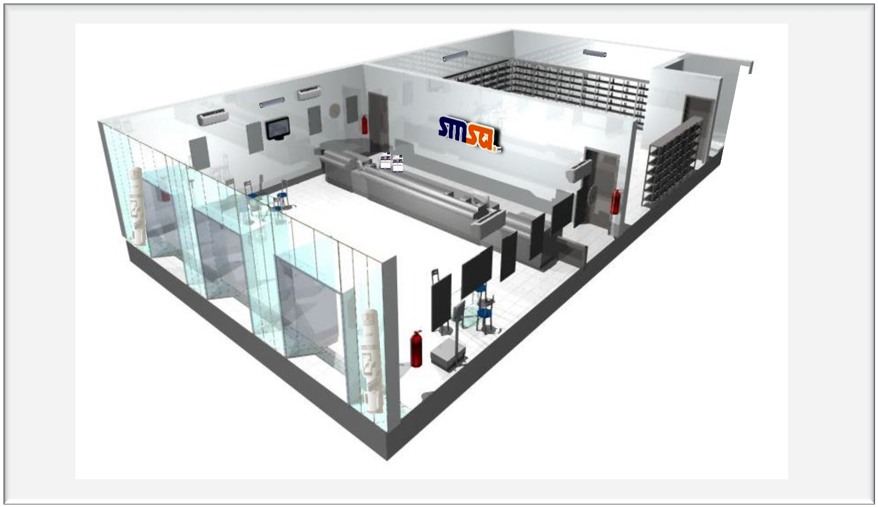

Interior Design offices (SSCs)

Perspective TYPE (A)

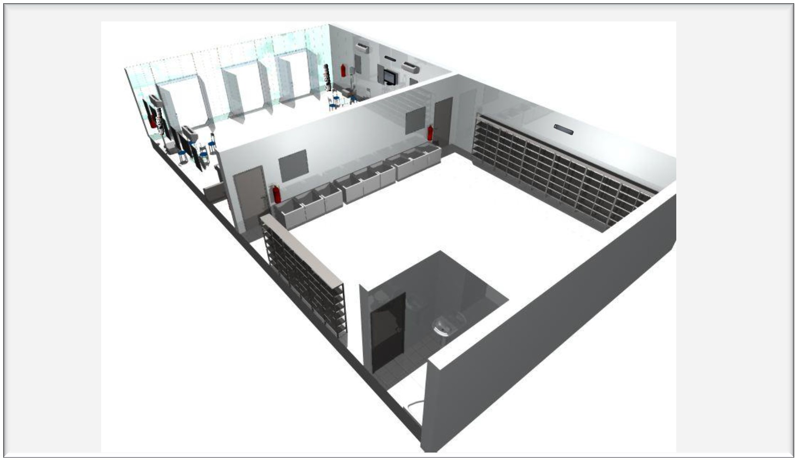

Interior Design offices (SSCs)

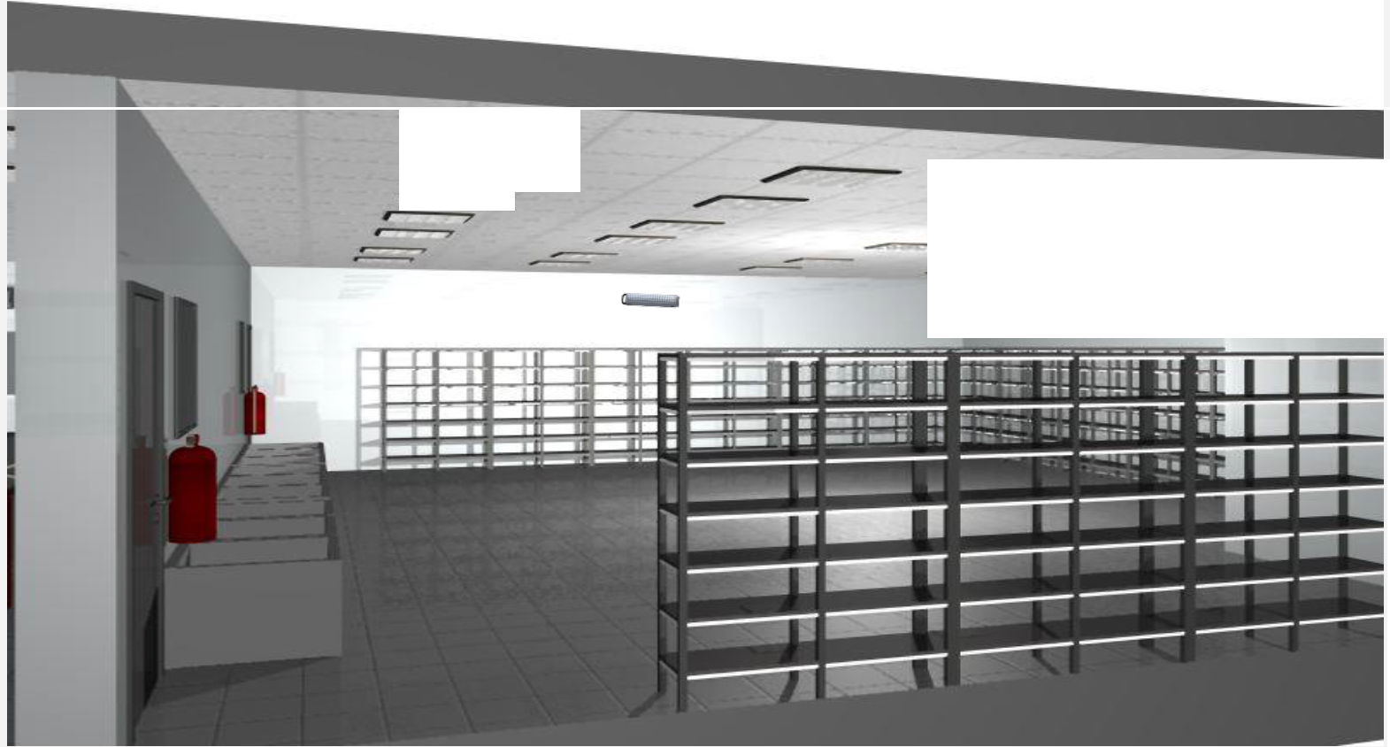STORE VIEW TYPE (A)

, 7 ----------
>
# -
----

Interior Design offices (SSCs)

STORE VIEW TYPE (A)

r 7 , .,r---
r

---

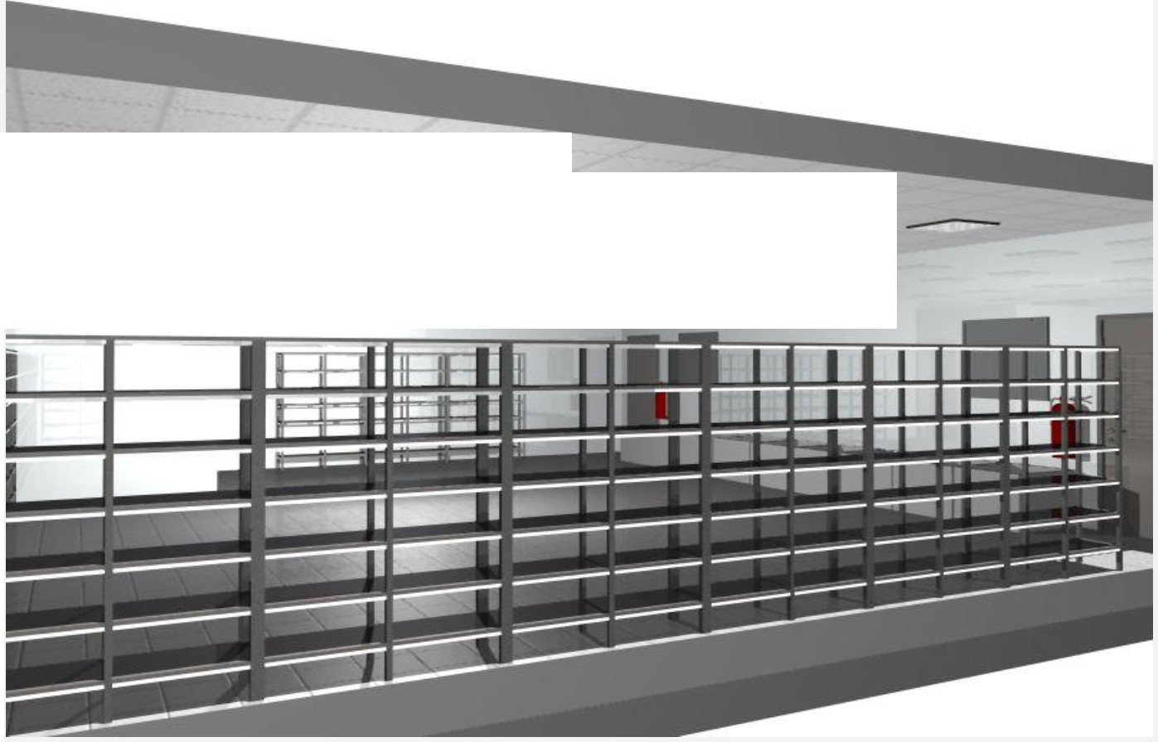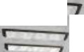- ---- -
....;;c_ - -

Interior Design offices (SSCs)

SSC PLAN TYPE (B)

Between 12-15 m

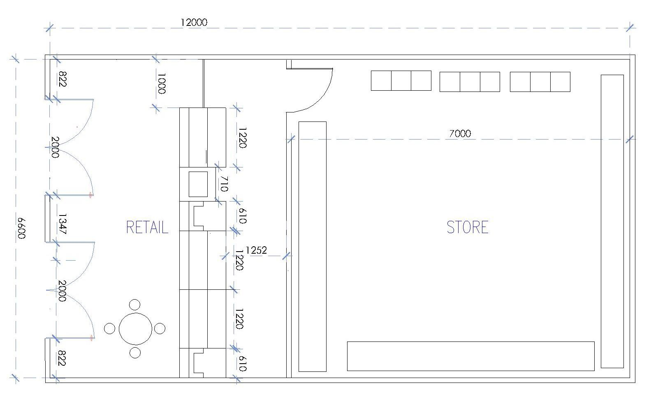Between 7-10 m

SSC Store

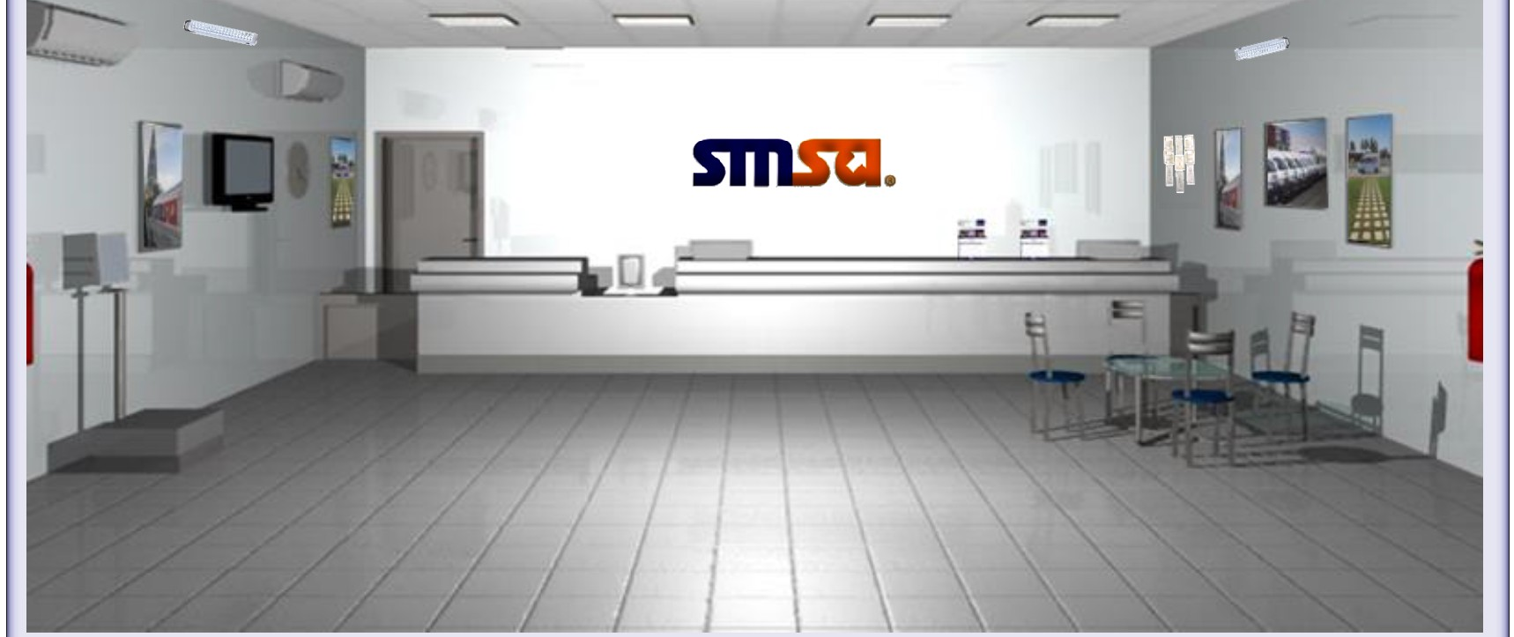INTERIOR PERSPECTIVE TYPE (B)

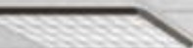 \ I 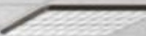

' I

Interior Design offices (SSCs)

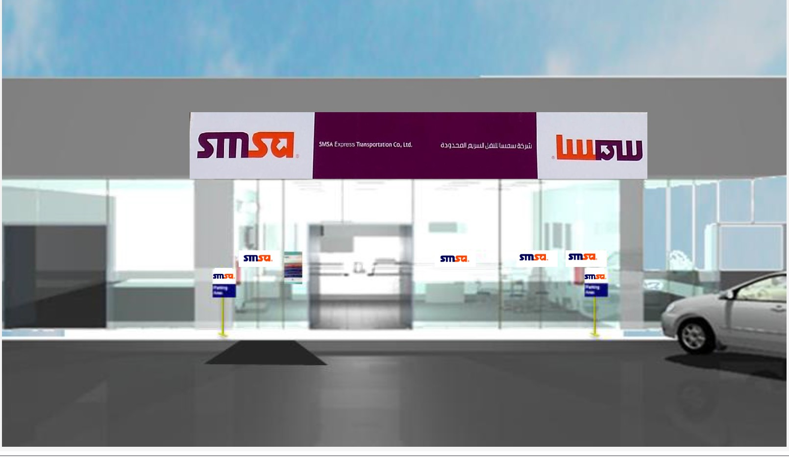Outdoor Perspective TYPE (B)

Interior Design offices (SSCs)

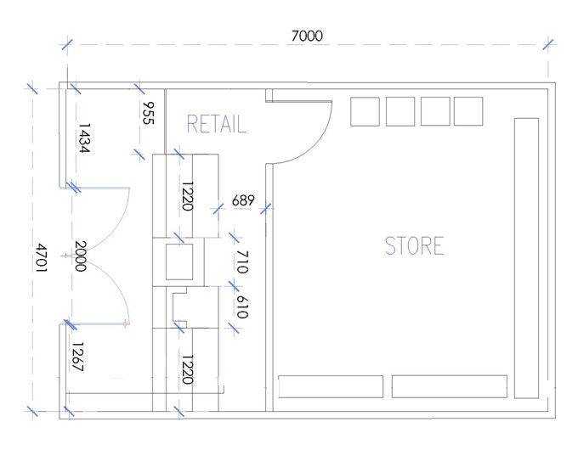SSC PLAN TYPE (C)

Between 8-10 m

Between 3-5 m

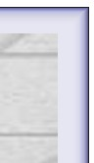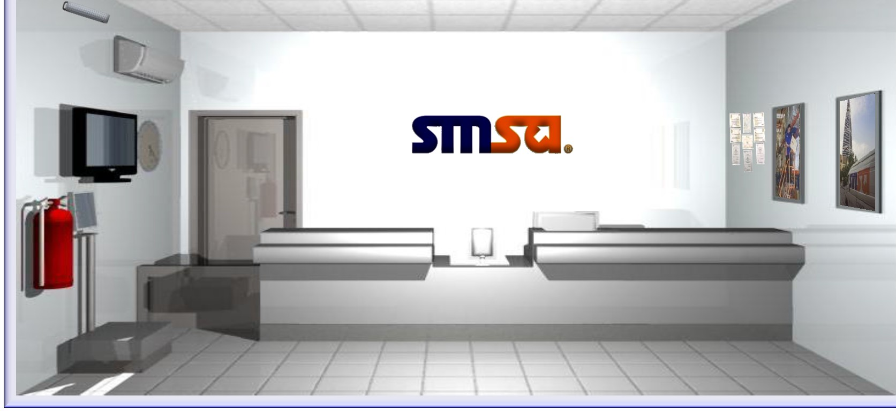INTERIOR PERSPECTIVE TYPE (C)

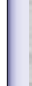

' \ I /

Interior Design offices (SSCs)

Outdoor Perspective TYPE (C)

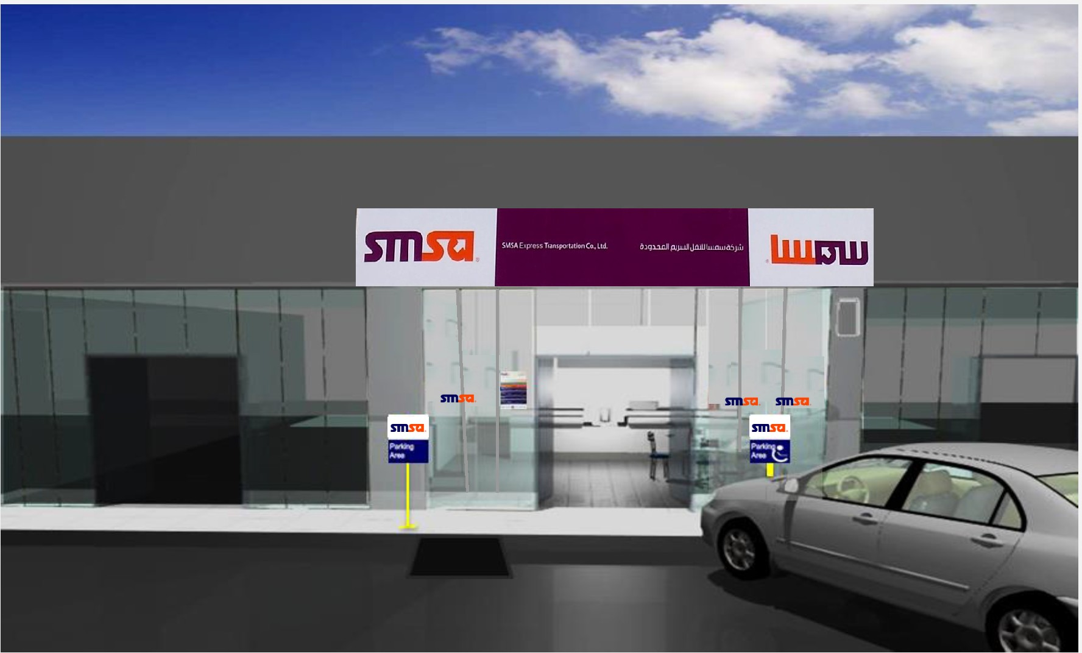

Interior Design offices (SSCs)

Perspective TYPE (C)

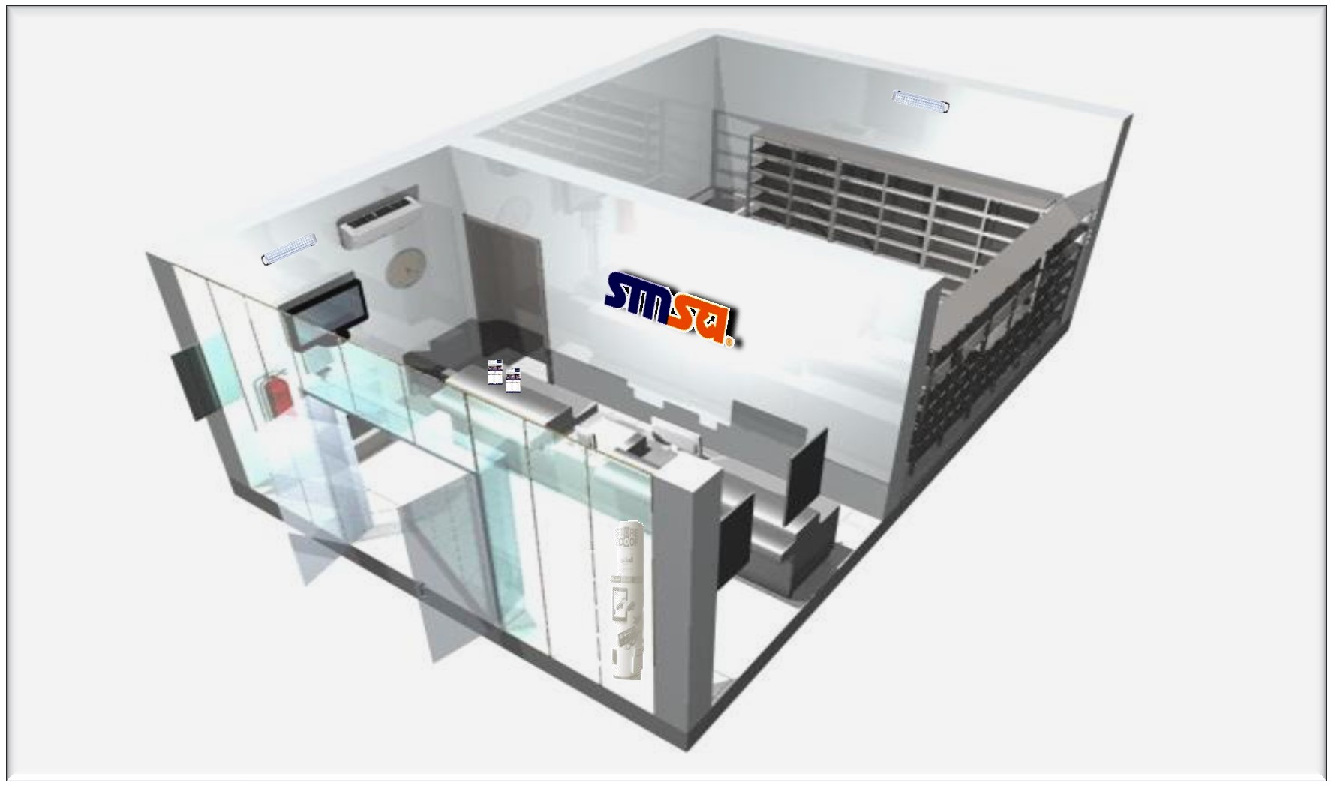

Interior Design offices (SSCs)

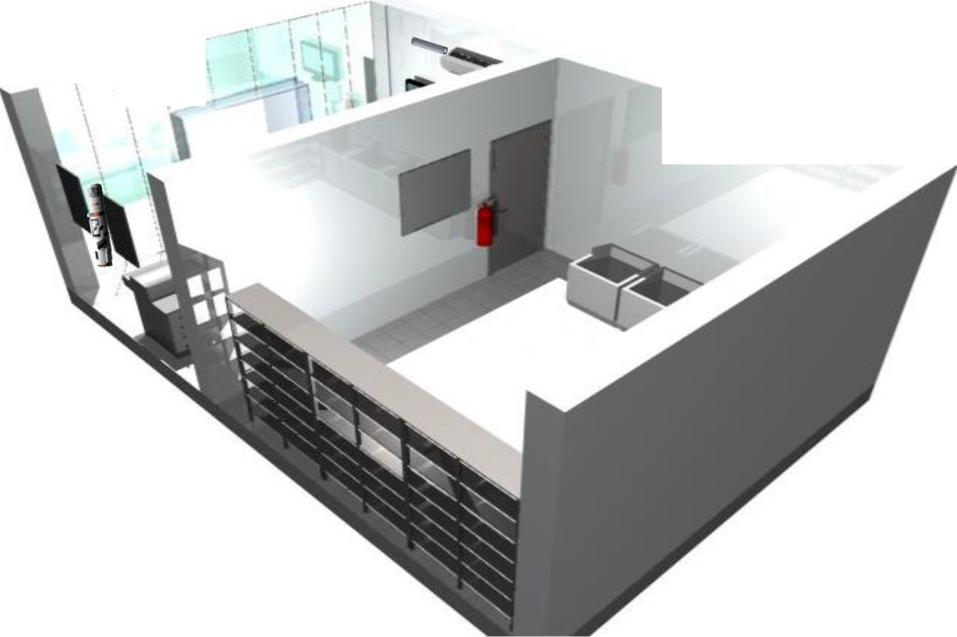Perspective TYPE (C)

\
\

Interior Design offices (SSCs)

STORE VIEW TYPE (C)

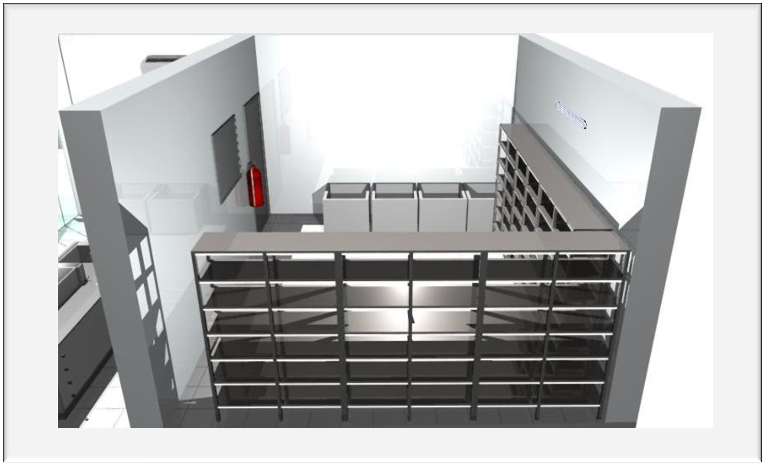

Interior Design offices (SSCs)

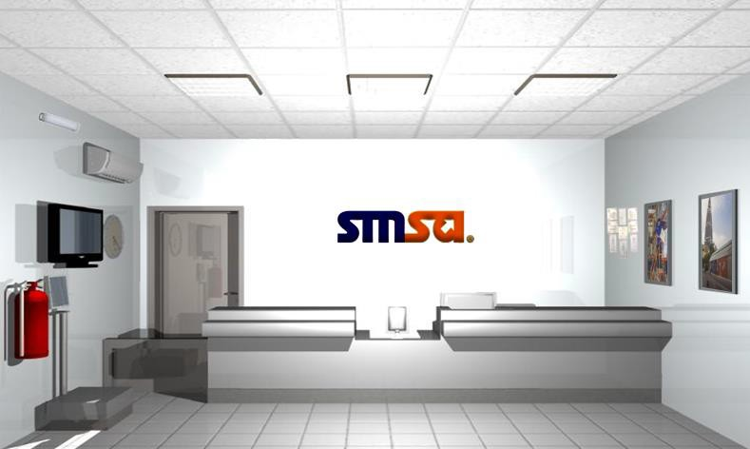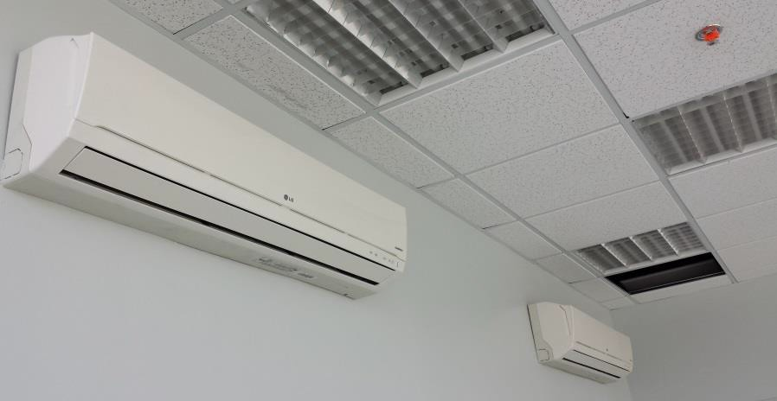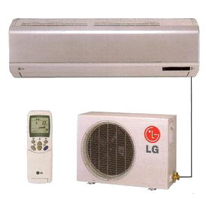Specifications of SSC

1 Air conidian

LG Spilt unit 24,000 BTU Class 1
Multi-System Ductless Split Outdoor Unit

Interior Design offices (SSCs)

Specifications of SSC
0.69m

1.02m

2

2 Wall graphics

* In Type C one set (5 pieces)
Dimensions of

0
Vertical Pictures is 1.02*0.69m

0.51m
Dimensions of
Horizontal Pictures is 0.51 *0.77m with aluminum frames .

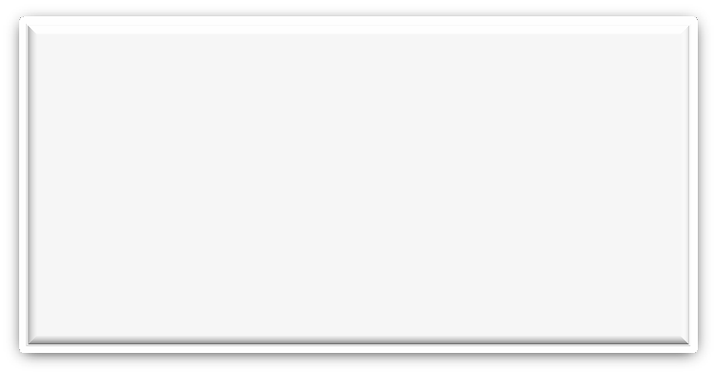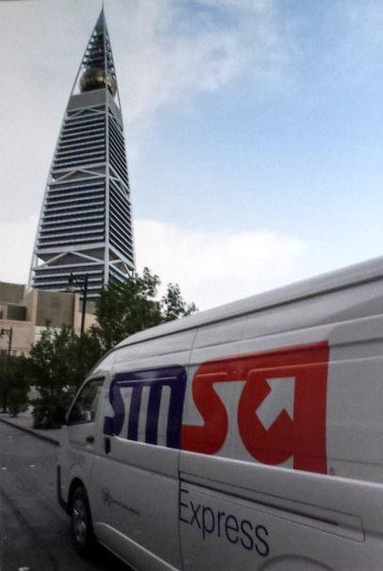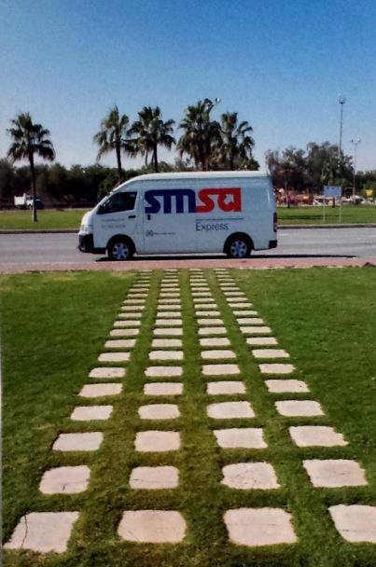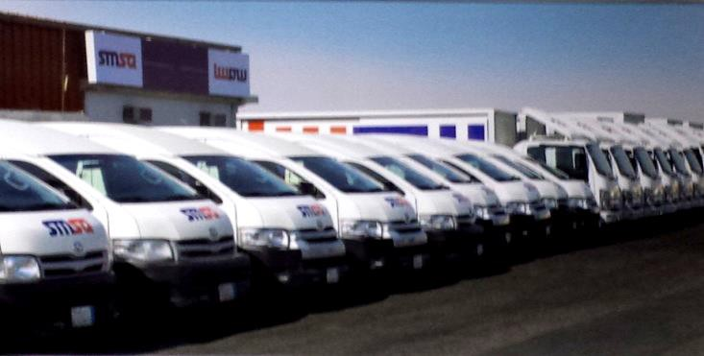

0.77m

Interior Design offices (SSCs)

3 Store door

Leaf Wooden door with frames.

* Dimensions 2.10*1.00

2.10m 5
Specifications of SSC

3

5

Emergency light
1.00m

4

0.40m

0.40m
4 Floor tiles

ALKHAZAF ALSAUDI Ceramic (color : Gray)
* Dimensions 0.40*0.40

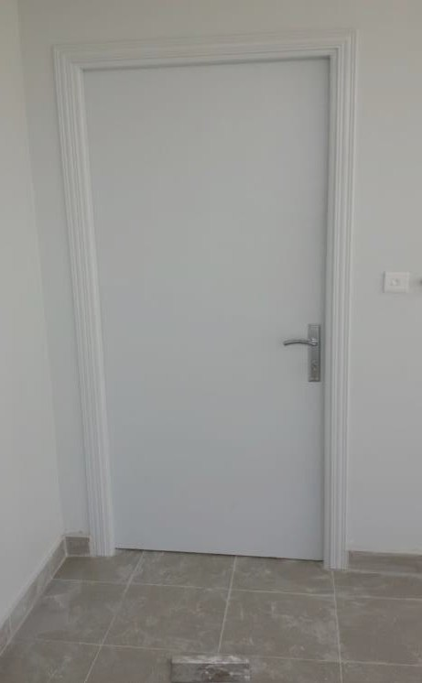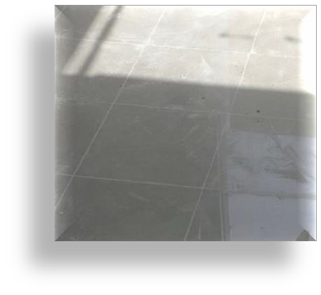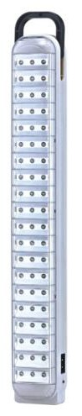

Interior Design offices (SSCs)

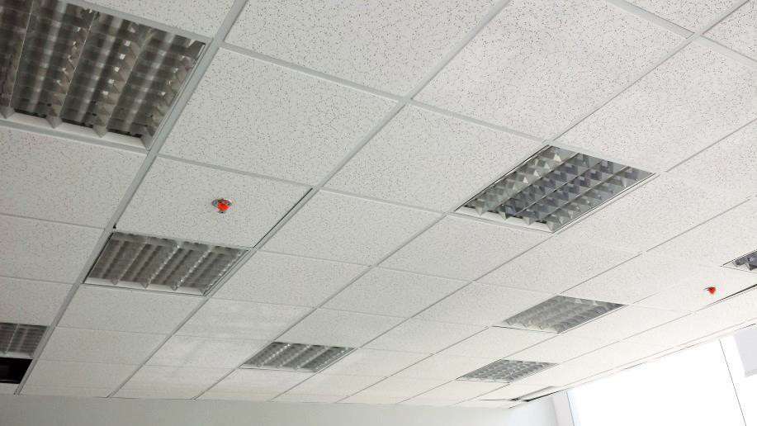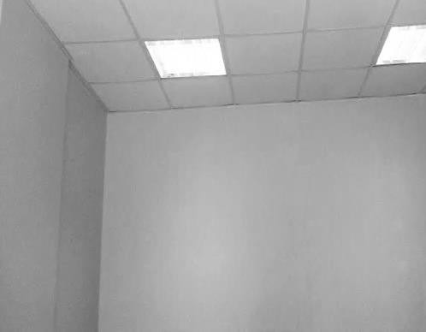Specifications of SSC

0.60m

6
0.60m

6 Roof ceiling
ARMSTRONG MINATONE CORTEGA) 7
ACOUSTIC CELLING TILES
* Dimensions 0.60*0.60

7 WALL PAINTING

3 COATS OF SIGMA PAINTS 3220

Interior Design offices (SSCs)

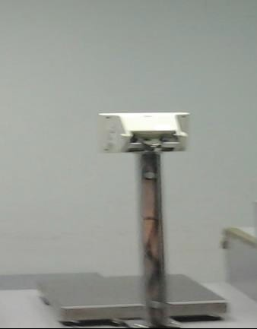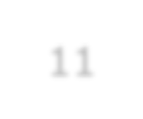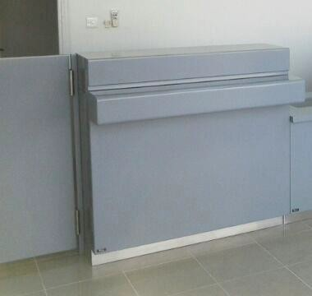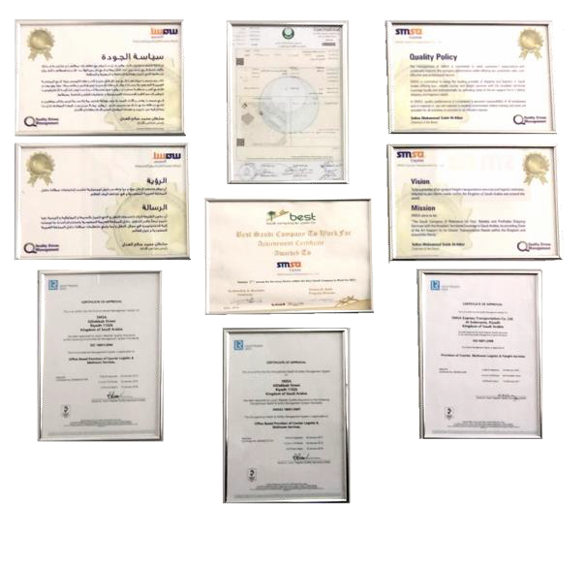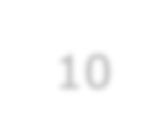Specifications of SSC

LEAF WOODEN DOOR OF COUNTERS

* Dimensions 1.00*1.00
8

10 11

8
9 WIGHT SCALE 9

- LCD screen with CCTV

- Licenses boards 9 pieces
03 cm between each frame

Interior Design offices (SSCs)

Specifications of SSC

3D SMSA Signage size in type (C)

1.40 m

0.08 m

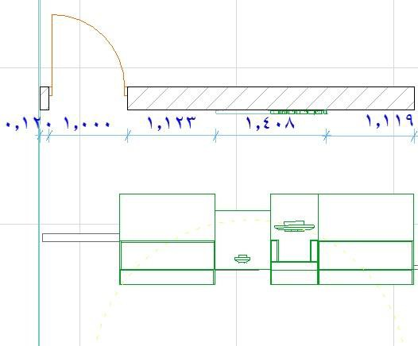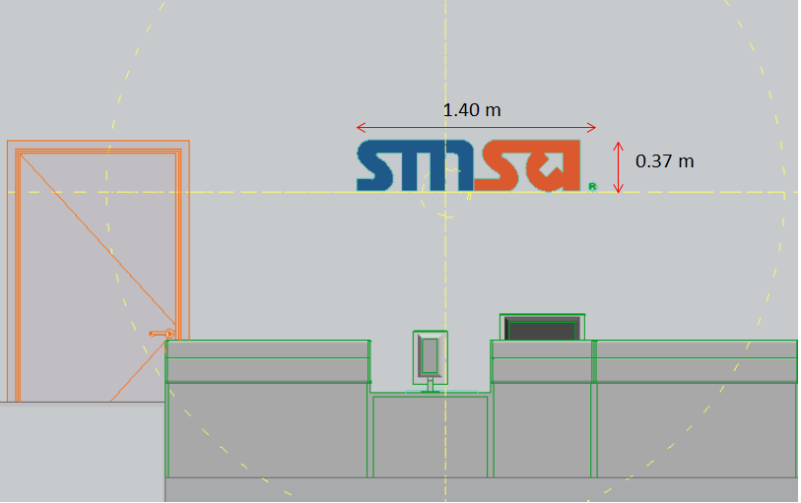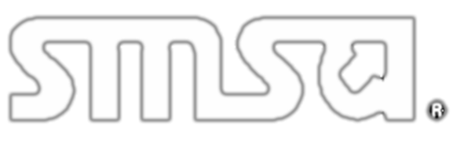

0.37m

ELEVATION

Acrylic white plastic with sticker LED Illuminated at the back
1.40 x 0.37 m
The distance from the wall 0.08 m

FLOOR PLAN

Interior Design offices (SSCs)

Specifications of SSC

3D SMSA Signage size in type (B)

2.00 m

0.08 m

0.53m

Acrylic white plastic with sticker LED Illuminated at the back
2.00 x 0.53 m
The distance from the wall 0.08 m

ELEVATION

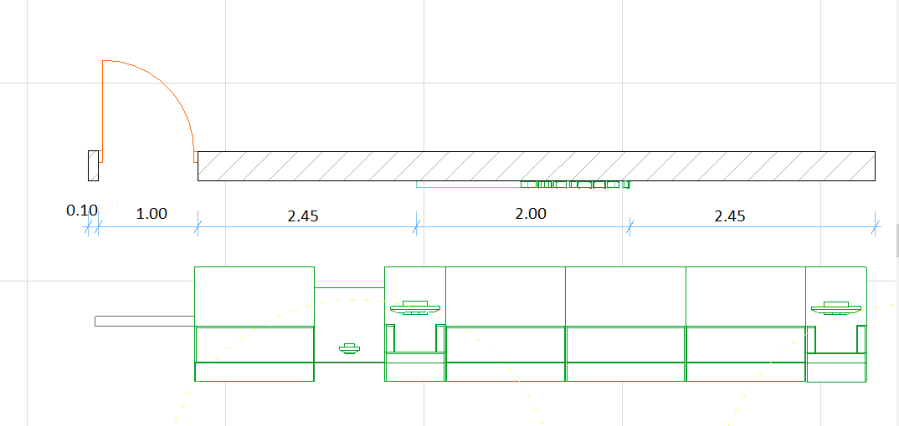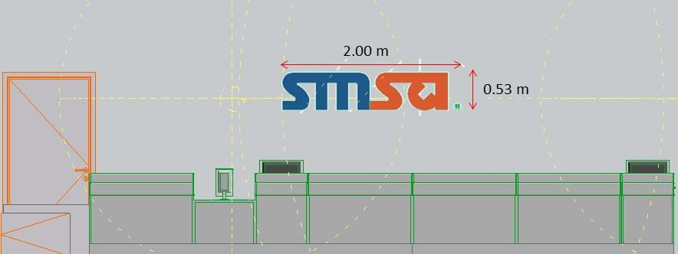

Interior Design offices (SSCs)
FLOOR PLAN

Specifications of SSC

3D SMSA Signage size in type (A)

2.50 m

0.08 m

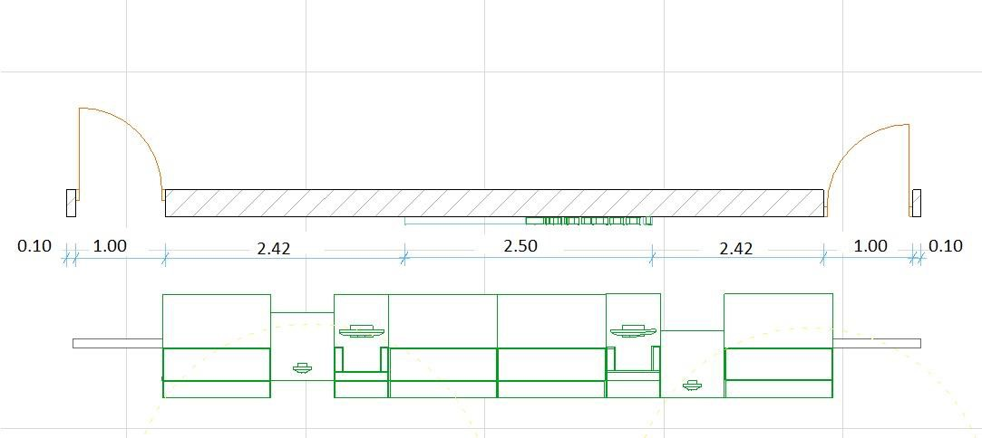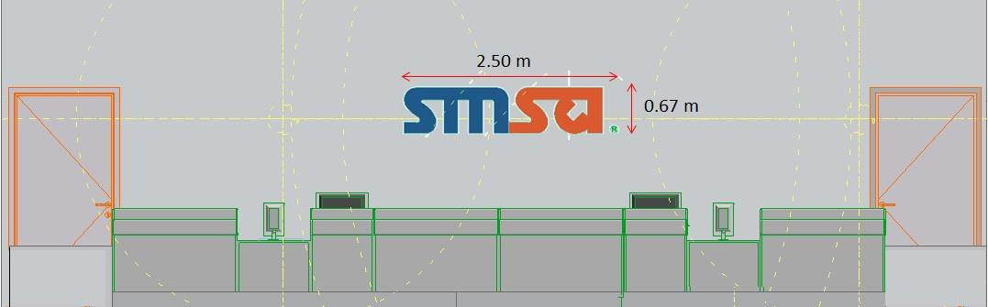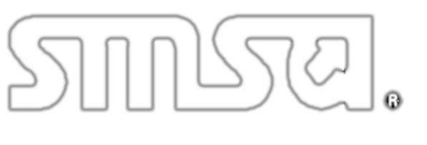

0.67m

Acrylic white plastic with sticker LED Illuminated at the back

ELEVATION
2.50 x 0.67 m
The distance from the wall 0.08 m

Interior Design offices (SSCs)

Elevations

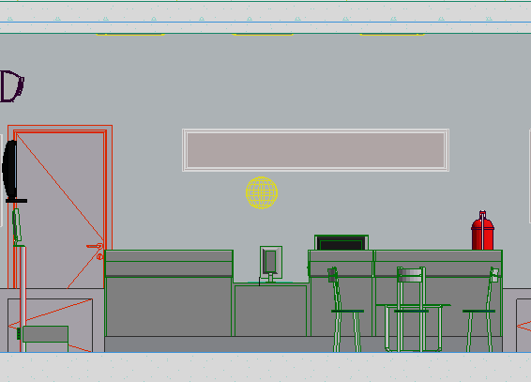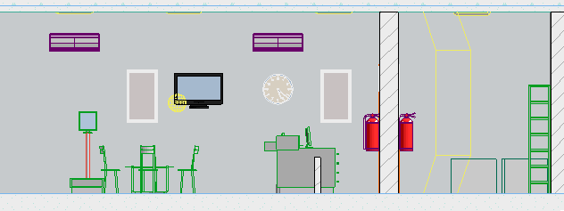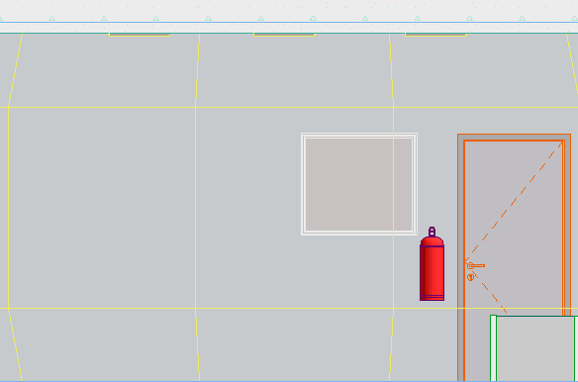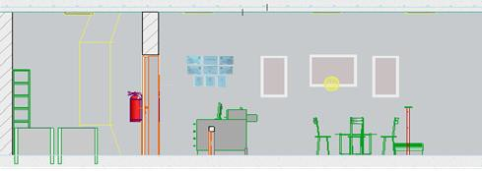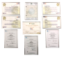Left side elevation

Right side elevation

Interior Design offices (SSCs)
Front side elevation

store side elevation

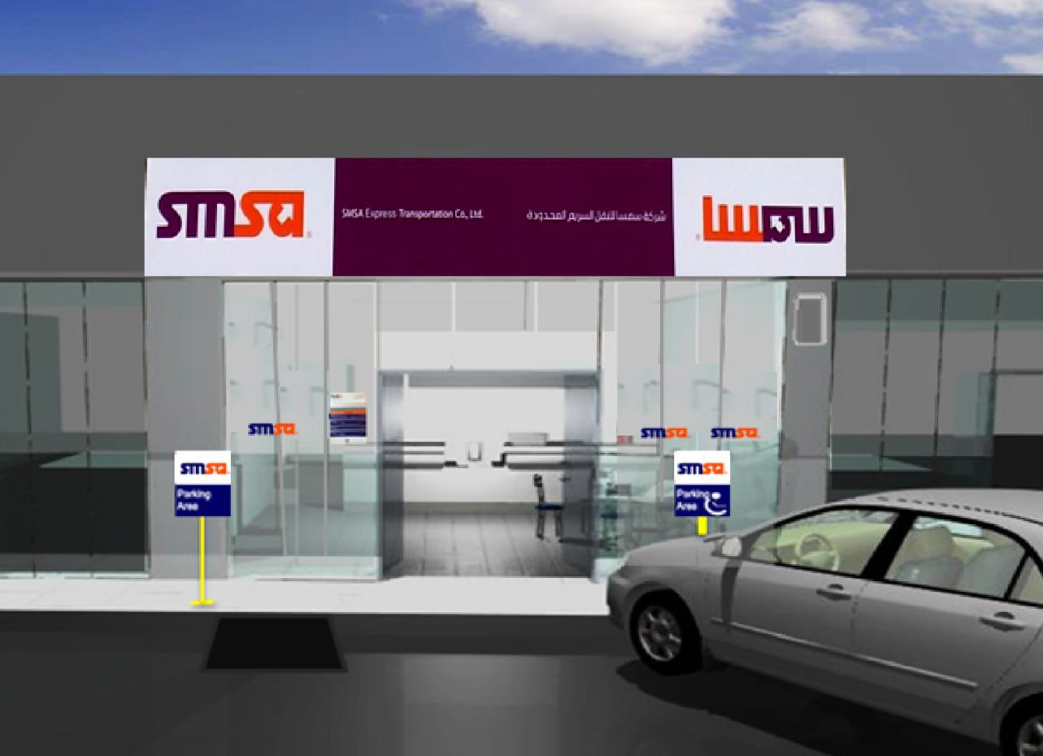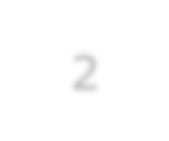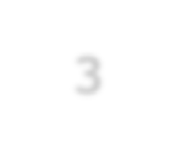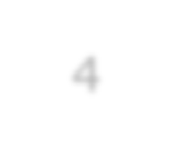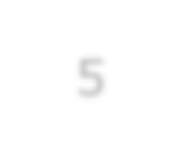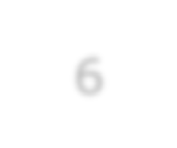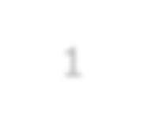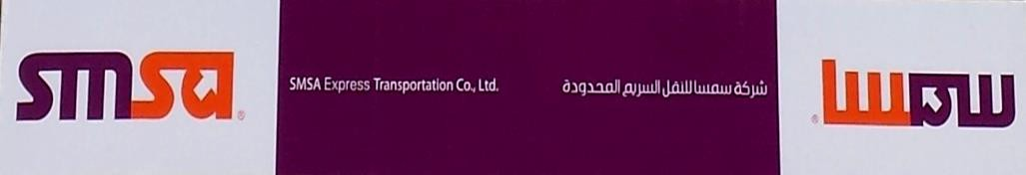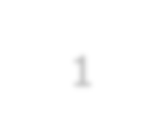Specifications of SSC

1 SMSA Outdoor Signboard.

5 SMSA Outdoor flag sign.
1
3 Parking sign.
2 5
2 SMSA curtain . 3 6
4 Ramp.

6 Working hours sign.
4

Interior Design offices (SSCs)



Presented by: Eng.Motaz Yahia Idris
Regional Supervisor- Facilities

