Brief | SMSA required specific documentation for shipments based on customs and regulatory requirements for the origin and destination locations.
Purpose | Failure in providing the Required Shipping Documents may cause shipments’ hold at customs. Providing those documents speedup customs clearance
Responsibility | The SSC Executive is responsible to ask the shipper to provide the required shipping documents, if needed, at the time of shipment(s) acceptance.  The SSC Supervisor is responsible to ensure that the SSC Executive are following this procedure and well trained to do so.
Guidelines | Required Shipping Documents:  - AWB  - Commercial Invoice  - Certificate of Origin  - Export License  - Exemption Certificate  Based on the type of services other documentation may be required.  Procedure  How to Complete a Commercial Invoice -  The seller/exporter provides this document to describe the parties involved in the shipping transaction and the goods being transported. It is the primary document used by Customs. The Commercial Invoice should be prepared in the official language of the country to which the goods are being exported when possible.  The Commercial Invoice should include a detailed breakdown of all items in the shipment. For each commodity you must include:  - Any generic or scientific name  - Grade and quantity  - Composition and/or construction  - Country of manufacture  - Price or cost  - Currency used  - Harmonized System number  - Terms of delivery  The sample shown is a suggested format.  Blank Commercial Invoice [PDF format- Adobe Acrobat Reader first before use the link]  The Commercial Invoice should include the following information:  1. General Information:  Provide the Reference No (Shipper order no., ID No or any other ref for the shipment), SMSA air waybill no, Origin, destination and date.  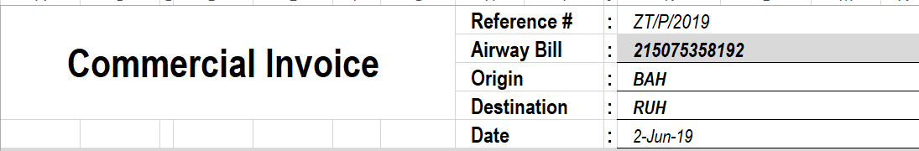  2. Sender (Shipper) & Receiver (Consignee)  Complete address of the Sender and Receiver. Important to ensure that full address is obtained including phone number and alternate phone numbers if available.  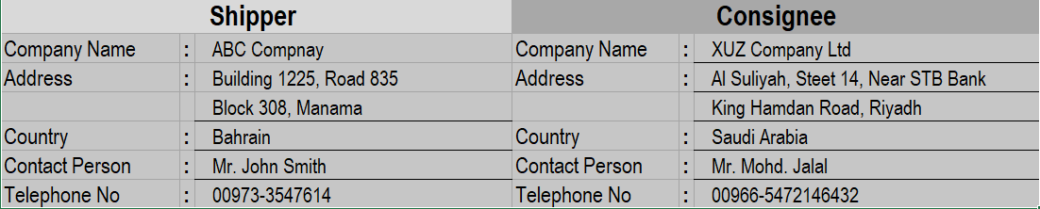  3. Description of product and other package information  Ensure to include the following in details  - Full description  - Packaging type  - Pieces  - Weight (Kgs)  - Country of Origin  - Unit Value (BHD)  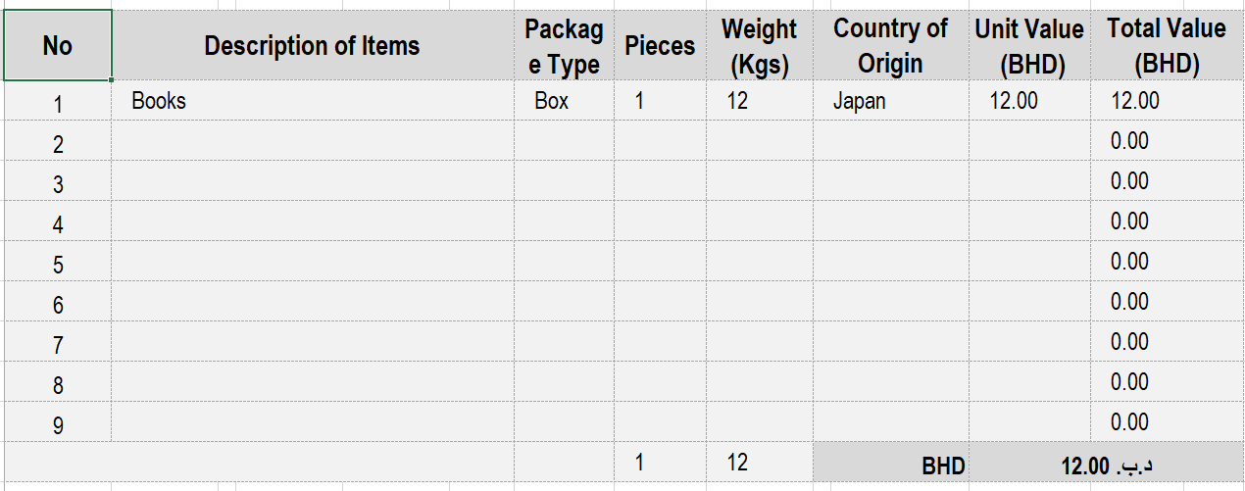  4. Enter the total Number of boxes, and chargeable weight (actual or the volume weight whichever is higher. )  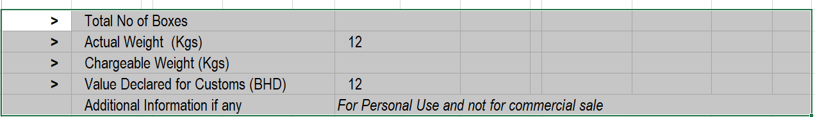  5. Sign and date the Commercial Invoice certifying that the details provided are true and correct representations of the contents covered by the Commercial Invoice. Ensure that all the information is consistent with the Air Waybill or your shipment could be delayed in Customs.  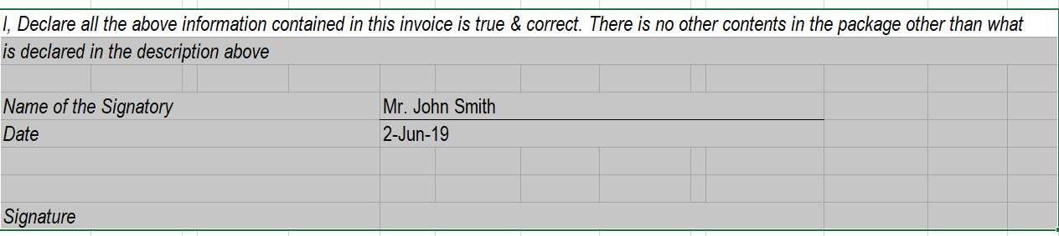  We need one original Commercial Invoice with 3 copies, all individually signed. We also recommend that you put a copy inside one package.  Certain commodities may need extra documentation or export licenses.
  Requirements vary from country to another based on commodity, origin and destination. At time of shipments acceptance the SSC Executive refer to the express SRG for country information, and guidelines for completion and auditing.
   | Definition | Procedure
  AWB | Refer to AWB completion | Needed for every shipment.
  Commercial Invoice | The (CI) is the primary document required by Customs authorities to clear shipments. The CI is required for goods sold or transferred between senders and consignees. | Requirements are vary from country to another.  Refer to SRG for country information.  Shipper that does not have corporate invoice may type information in plain paper and sign it.  You may provide the sender with a blank CI.
  Certificate of Origin | The (CO) is used to clear shipments when it is required by Customs authorities in the destination country. | Refer to SRG for country information.  Mainly required for textile and clothing.
  Exemption Certificate | It is required for all textile shipments with a value of US$250 or less and originate in countries that do not quota restraints (usually countries of the Far East) | Refer to SRG
Exceptions | Any exceptions to this policy must be approved by the Managing Director.

