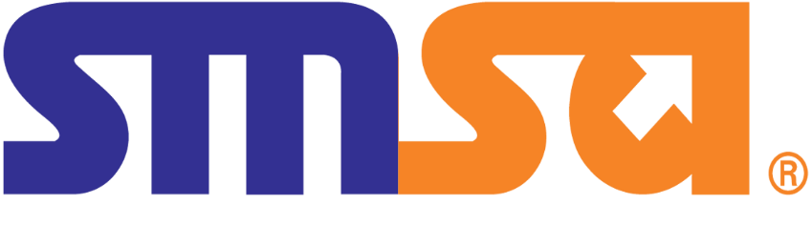

Training Manual
A guide for SMSA Express Training Activities

  - Issue / Edition number and Effectively / Validity Date
Last Review/Updates Details
Document Updated by: | SMSA ID: 6856, 6866
Reviewed on: | 12 Jun 2023
Version number: | 02
Document number: | 6236
Effective Validity | Annual review

Important Note:

This manual is intended for the sole use of SMSA Express. The contents of this manual may not be reproduced or reprinted in whole or in part without the express written permission of SMSA. This manual is to be read in conjunction with the Appendices listed on page 9. For latest version of the manuals/listed documents in appendix section/departmental processes/Org charts and related forms – refer to GUIDE.
1.2 Company Contact Details

Head Office | Prince Abdullaziz Ibn Masa'ad ibn Julawi (Dhabab) St., P.O. Box 63529 Riyadh 11526, Saudi Arabia  Phone Number: +966 11 218 7777  Email ID: info@smsaexpress.com
Training Facility Riyadh | AL Fayha Dist, Prince saad Bin abdul rahman, Riyadh  Phone Number: +966509917053  Email ID: msiddiqui@smsaexpress.com
Training Facility Jeddah | Al Madinah AlMunawarrah Rd, Jeddah  Phone Number: +966595195493  Email ID: agahnam@smsaexpress.com
Gateway Facility Dammam | King Fahd International Airport Dammam  Phone Number: +966 11 218 7777  Email ID: abaramy@smsaexpress.com
Gateway Facility Riyadh | King Khalid International Airport Riyadh  Phone Number: +966 11 218 7777  Email ID: sfallaj@smsaexpress.com

  - Effective pages
For revisions to the manual, please refer to section 1.4 below.
1.4 Record of Revision

When amendments are made, details shall be entered into this sheet.

Issue No. | Date | Details of Change | Amended Pages
1 | 06 June 2021 | Creation of Training Manual | NA
2 | 11 June 2023 | Document formatted to SMSA Standard | All
3 | 11 June 2023 | Content page updated with page numbers | 9
4 | 11 June 2023 | Definitions and abbreviations updated | 11
5 | 11 June 2023 | Issue edition and validity updated | 2
6 | 12 June 2023 | Training specification plan reference added | 12
7 | 12 June 2023 | Training Curriculum reference added | 12
8 | 13 June 2023 | Organization chart updated | 18
9 | 13 June 2023 | List of effective pages added | 36
10 |  | Training modules objectives updated | 36
11 | 13 June 2023 | Removed Job descriptions and added reference to JD as separate document | 12
12 | 13 June 2023 | Policy statement amended to include notification to the presidency for acceptance of revisions. | 15

1.5 Distribution List

The Manual is sent for acknowledgement within SMSA to all the staff via GUIDE system. For latest acknowledgement log, please refer to the GUIDE system.
Distribution list (Hard / Soft Copy)
Department/Location/Job Title | Issued By | Acknowledged By
GACA | Dr Bandar Al Otaibi | GACA Representative

1.6 Table of Contents

Ref. | Sections and Subsections | Page
1.1 | Issue / Edition number and Effectively / Validity Date | 1
1.2 | Company Contact Details | 2
1.3 | List of Effective Pages | 2
1.4 | Record of Revision | 4
1.5 | Distribution List | 5
1.6 | Table of Contents | 6
1.7 | Definitions & Abbreviations | 8
1.8 | Appendices / List and Sample of Forms | 9
i | Company Profile | 10
ii | Mission Statement | 11
iii | Vision Statement | 11
iv | Training Mission Statement | 11
1.9 | Manual Review, Amendment & Administration Procedures | 12
1.10 | Training Policy | 12
1.11 (a) | Training Policy Statement | 12
1.11 (b) | Responsibilities and Duties | 13
1.11 (c) | List of Training Instructors & Outsourced Training Providers | 13
1.11 (d) | Provision for Annual Training Plan | 14
1.11 (e) | Training Facilities and Equipment’s | 14
2 | Training Management & Organization
2.1 | Training Organization Objectives | 15
2.2 | Training Standards | 15
2.3 | Corporate & Training Organization Chart | 16
2.4 | Management Personnel Duties & Responsibilities | 16
2.5 | Delegation of Authority (In Absence) | 17
2.6 | Record of Instructional, Examination and Assessor Staff | 17
2.7 | Record of Training Sub-Contractors | 17
2.8 | General Description of Training Facilities & Equipment (Theoretical and Practical) | 17
2.9 | Qualifications, Selection & Evaluations of Instructors | 17
2.10 | Qualifications, Selection & Evaluations of Examiners / Assessors | 18
3 | Training & Examination Procedures
3.1 | Training Methods | 18
3.2 | Training Program Design | 19
3.3 | Training Needs Analysis (TNA) / Review & Update | 21
3.4 | Annual Training Planning | 21
3.5 | Course Design & Preparation | 23
3.6 | Course Delivery | 24
3.7 | Course Syllabus/Material Review & Update | 25
3.8 | Preparation of Examinations | 26
3.9 | Conduct of Examinations | 26
3.10 | Practical / On the job (OJT) Training | 26
3.11 | Practical / OJT Training Assessment | 27
3.12 | Preparation, Control & Issue of Certificates | 28
3.13 | Assessment of Training Efficiency & Examination Results | 28
3.14 | Training & Examination Records (Storage & Retention) | 29
4 | Training Program
4.1 | Functions and Tasks of the Ground Service Staff | 29
4.2 | Training Curriculum | 29
4.3 | Training Syllabus | 29
4.4 | Knowledge Training Hours | 30
4.5 | On Job Training Hours | 30
4.6 | Qualification Criteria for Knowledge Examinations and OJT Assessment | 30
4.7 | Recurrency Requirement for Training Modules | 30
5 | Training Material/ Subjects (Theory & Practice)
5.1 | Regulatory Awareness | 30
5.2 | Health & Safety Awareness | 31
5.3 | Emergency Response Awareness | 31
5.4 | Security Awareness | 31
5.5 | Human Factors Awareness | 32
5.6 | Aerodrome Familiarization | 32
5.7 | Fire Safety Awareness | 32
5.8 | Safety Management System Awareness | 33
5.9 | Dangerous Good Training (Relevant to applicable DG Categories) | 36
5.10 | Emergency & Contingency Training (Specific to Job Function) | 37
5.11 | Operational Training (Specific to Job Function) | 37

1.7 Definitions & Abbreviations

Term | Description
QMS | Quality Management System
QAS | Quality Assurance Specialist
SDC | Special Distribution Channel
MRM | Mail room Management
SSC | SMSA Service center
QRM | Quality & Risk Management
IBU | International Business Unit
OPS | Operation
SFD | SMSA Freight Division
QA | Quality Assurance
WI | Work Instructions
TNA | Training Need Analysis
SGO | SMSA Ground Operations
MHE | Material Handling Equipment
OJT | On Job Training
TAPA | Transported Asset Protection Standard
PRO | SMSA Process Training
DDT | Defensive Driving Training
PMS | Performance Management Specialist

1.8 Appendices / List and Sample of Forms

Doc# | Title
4444 | JD – Director HR & Admin
4537 | JD – Training Manager
6280 | JD – Talent Learning Supervisor
6278 | JD – Training Specialist
6277 | JD – Talent Learning Specialist
6276 | JD – Assistant Talent Learning Specialist
6279 | JD – Talent Learning Coordinator
4825 | JD – National Manager Linehaul HUB and Gateway
4662 | JD – Regional Manager Gateway
4673 | JD – Supervisor Gateway
4645 | JD – Operations Agent Gateway
4664 | JD – Senior Handler Gateway
1918 | Control of Documents
1917 | Control of Records
48 | Training & Development Policy
3659 | Trainer Observation Evaluation Form
3593 | Training Curriculum
5784 | Specialized training specification document
1.1.5.2.14 | Gateway Process

- Company Profile
History

SMSA Express Transportation Co., Ltd. began its operation in March 1994 under the able leadership of Sultan Mohammed Saleh Al-Athel. Since then it has become the largest domestic express and service centers network in Saudi Arabia.

SMSA has reached new heights in the international market. It provides the best, most cost-effective, diverse express, freight, outbound and inbound shipping services available.

In SMSA’s endeavour towards total quality management, SMSA has achieved the following internationally recognized certification:

ISO 9001 -Quality Management System, ISO 14001 – Environmental Management System, ISO 45001 – Health & Safety Management System, WHO-GDP – World Health Organisation Goods Distribution Practices for Pharmaceuticals, TAPA-FSR – Transported Asset Protection Association Facility Security Requirements, ISO 10002 – Customer Service Management System, ISO 10015 – Competence Management System.

Capabilities and Facilities

SMSA serves more than 325 cities, towns and villages throughout the Kingdom of Saudi Arabia. Operating under the hub and spoke model, 34 operational facilities and 396 SMSA Service Centers are strategically located with three regional offices and international gateways in Riyadh, Jeddah, Dammam, Dubai, Cairo and Bahrain. . Supported by a fleet of over 2286
vehicles and over 3851 dedicated employees handling an average 1093227 shipments per month.

Big Achievements and Major clients

SMSA valued international customers from different industries include Siemens, CISCO, Microsoft, Acer, Volvo, General Motors, Chevron, Bayer, Kodak, Schlumberger, Citibank, and British Airways.

Top domestic customers include Alinma Bank, Ministry of Health, Saudi Chevron Phillips Co, Saudi Aramco - Mld – Gld, Nice One – Cod, Bank Al Jazirah, Salla Application For Information Tech Co (Cod)Mak, Saudi Telecom Mailroom Mgmt, Banque Saudi Fransi M. R Proj, Al Rajhi Bank ( S D C ), Nat'l Guard Health Affair Expr, Elm Company ( Muqeem Project ), Nupco ( Health Care Project ), Prince Sultan Medical Miltary City, Iherb, Stc ( Loading Project ), Fragrancex.Com, Riyadh Bank ( Kingdom Mailrooms ), Vogacloset Inc, Landmark Arabia, Prince Sultan Medical Miltary City ( Project 2 ), King Faisal Specialiist Hospital&Research, Noon – Namshi, Boutiqaat – Ecom, Amazon – Afn, Kfsh (Jeddah) Medicine Delivery, Stc Bank – Ecom, Saudi Emircom Co - Sfd Credit, Ocs Kuwait - Cod Collection, Xiyin E Commerce Fze - B2c, My Beautiful For Trd Co. Llc – Cod, Neom, Vogacloset (Returns Pup) And Zong Heng Trd Co Ltd - B2C.

ii. Mission Statement

To be a pioneer amongst the top global logistics and transportation companies with value added multi product line that meets every customer need by utilizing existing and emerging technologies to the highest ethical and professional standards.

iii. Vision Statement

To be a pioneer amongst the top global logistics and transportation companies by:
- Providing maximum reach around the world with highest quality of service.
- Empowering and investing in our people.
- Being a dynamic and market-oriented service provider utilizing emerging technologies.

iv. Training Mission Statement

At the Training Department, we aim to provide tangible contributions that shall provide a vehicle to improve performance & promote professionalism of our staff throughout the kingdom.

1.9 Manual Review, Amendment & Administration Procedures

The purpose of this section is to establish the standard process in the set-up, uploading, review, authorization, promotion, acknowledgement, and changes on the training Manual.
SMSA Express utilizes the Quality Management System (GUIDE) to streamline the process of documents administration and control. All training procedures, documents and guides are uploaded on the GUIDE System and are updated regularly to ensure the documents are kept current and relevant. Document management and control procedure is documented under Doc number 1918 on GUIDE.
Any Changes to the Manual would first be submitted to the GACA presidency for acceptance of the revisions. The approved document will then be uploaded on GUIDE.

1.10 Training Policy

The Training policy has been developed to ensure that all Employees have the knowledge and skills required to meet the needs of the business in their current roles. To train and develop staff to levels where they are capable of supporting the business in the future. The Training policy specifies the procedures for maintaining the complete training cycle in SMSA. This includes provision for current and recurrent training in SMSA estate. The training policy is documented under Doc number 48 on GUIDE.

1.11 (a) Training Policy Statement

The management of SMSA is committed to continually improve the company’s performance and meeting its customer’s expectations while offering them a safe, efficient, and professional service.

It is the Policy of SMSA Express Trans. Co. to continually invest in training and development that is essential for improving the performance of our employees in their current and potential job roles and to further enhance their ability to meet future business requirements

This training manual and any associated training material are in compliance with GACAR 151 & GACAR 68 and shall be complied with at all times.

_________________
Eng Majed Al Esmail
Managing Director

1.11 (b) Responsibilities and Duties

The duties, responsibilities and competencies for SMSA training manager / post holder, training specialist / instructor / assessor and training coordinator are documented in the respective Job descriptions. The Job description is documented on GUIDE as follows.

- JD – Director HR & Admin (Doc num 4444)
- JD – Training Manager (Doc num 4537)
- JD – Talent Learning Supervisor (Doc num 6280)
- JD – Training Specialist (Doc num 6278)
- JD – Talent Learning Specialist (Doc num 6277)
- JD – Assistant Talent Learning Specialist (Doc num 6276)
- JD – Talent Learning Coordinator (Doc num 6279)
- JD – National Manager Linehaul HUB and Gateway (Doc num 4825)
- JD – Regional Manager Gateway (Doc num 4662)
- JD – Supervisor Gateway (Doc num 4673)
- JD – Operations Agent Gateway (Doc num 4645)
- JD – Senior Handler Gateway (Doc num 4664)

1.11 (c) List of Training Instructors & Outsourced Training Providers

Internal Training Specialists
SL No | List of trainers | Position
1 | Jonahbert Allan Miso | Training Specialist
2 | Mohammed Al Khaled | Talent Learning Supervisor
3 | Moayad Alfatih | Talent Learning Specialist
4 | Ahmed Yislam Gahman | Talent Learning Specialist
5 | Shoaib Khan Mayana | Assistant Talent Learning Specialist
6 | Shajin Kuttappan | Talent Learning Coordinator (Assists in the prep of Training)

External Training Providers
SL No | Company Name | Address
1 | MELI (Middle East Logistics High Institute) | Al Ashriah Street, Ash Shati Al Gharbi, Dammam 32413
2 | Corner Stone (Talent Management System) | Block 9, P.O.Box 502998 The Knowledge Village, Dubai - United Arab Emirates
3 | Talent LMS (Learning Management System) | 239 Kensington High Street,1st Floor London W8 6SN, United Kingdom
4 | Capytech (E-Learning Solutions) | 17 Iridium Building, UAE
5 | IATA (International Air Transport Association) Training Operations – IATA Training | IATA Centre, 33 Route de l’Aeroport, PO Box 416, Geneva 15 Airport -1215 Switzerland

1.11 (d) Provision for Annual Training Plan

- Training Needs Identified
- Design and plan the training
- Training design ready
- Define constraints
- Constraints Identified
- Select training methods and criteria
- Create training specification plan
- Training specification plan completed
- Select training provider
- Training plan ready

1.11 (e) Training Facilities and Equipment’s

SMSA includes equipment specifications aligned with current industry standards. Designed for technical and Practical training practitioners and policymakers. Included are as below:

SL No | List of Training facility | Capacity | Teaching Aids
1 | Riyadh (Al Fayha Dist, Exit:15) | Up to 15 Participants | Electrical Equipment designed for training purpose Laptops, Flip charts, Lamps, speakers, Projectors
2 | Dammam (Al Rakkah Dist,) | Up to 15 Participants | Electrical Equipment designed for training purpose Laptops, Flip charts, Lamps, speakers, Projectors
3 | Jeddah (Madinah Al Munawara Rd) | Up to 15 Participants | Electrical Equipment designed for training purpose Laptops, Flip charts, Lamps, speakers, Projectors

2. Training Management & Organization

2.1 Training Organization Objectives

- To ensure that all Employees have the knowledge and skills required to meet the needs of the business in their current roles.
- To train and develop staff to levels where they are capable of supporting the business in the future.

2.2 Training Standards

SMSA outline the elements that effective training and learning programs should include and serve as a foundation upon which curricula and programs should be developed, supported, and evaluated. In some situations, it may not be possible to meet all the standards.

2.3 Corporate & Training Organization Chart

Corporate Org Chart
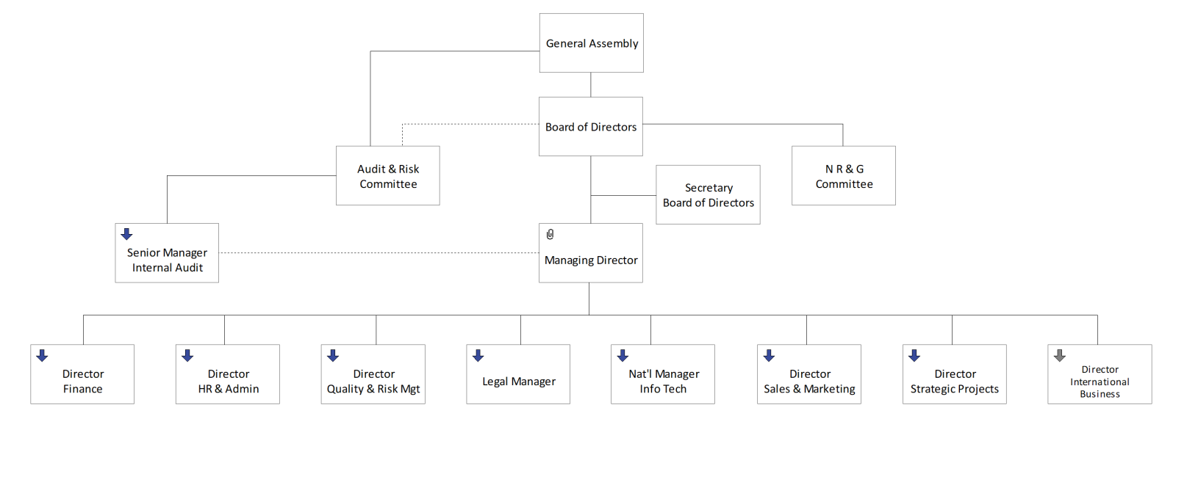

Training Org Chart

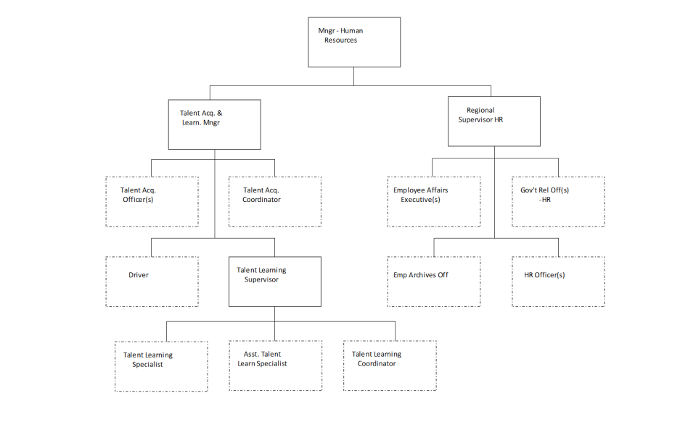

2.4 Management Personnel Duties & Responsibilities

For Duties & Responsibilities refer to section 1.11 (b) above.
2.5 Delegation of Authority (In Absence)

In case any of the post holders are absent, personnel are assigned as temporary replacements to handle their responsibilities until the post holders resume their duties: (Organizational Roles, Responsibilities and Authority are documented in depth in the Quality Manual).

- HR (Director – HR & Admin): In case of absence authority will be delegated to Training Manager.

- Training Post-Holder (Manager – Training & Development): In case of absence authority will be delegated to Training Specialist/ Performance Management Specialist.

- Training Specialist: In case of absence authority will be delegated to Asst Training Specialist.

2.6 Record of Instructional, Examination and Assessor Staff

For Record of Instructors and Assessors refer to section 1.11 (c) above.

2.7 Record of Training Sub-Contractors

For Record of Training Sub-Contractors refer to section 1.11 (c) above.

2.8 General Description of Training Facilities & Equipment (Theoretical and Practical)

For Description of Training Facilities & Equipment refer to section 1.11 (e) above.

2.9 Qualifications, Selection & Evaluations of Instructors

Qualification of the instructors is documented in their job description. Refer to 1.11 (b) above.
Selection and Evaluation of the instructors is based on the following process (Evaluation is done using trainer observation evaluation form documented under Doc number 3659 on GUIDE).

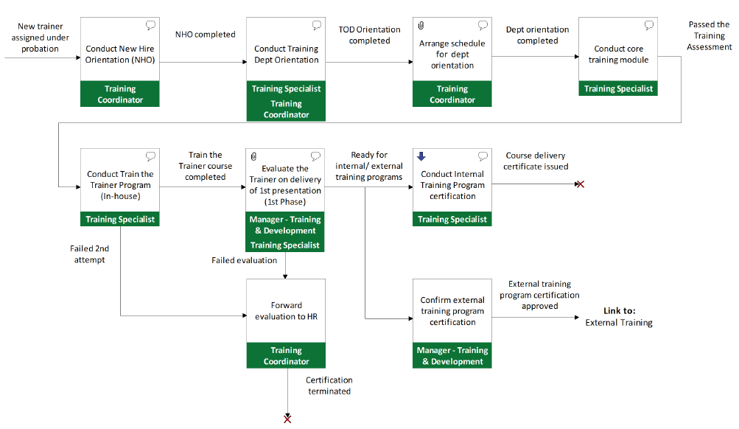

2.10 Qualifications, Selection & Evaluations of Examiners / Assessors

In SMSA training instructors also carry out the function of examiners / assessors. For qualification, selection & evaluation of examiners & assessors refer to 2.9 above.

3. Training & Examination Procedures

3.1 Training Methods

On-Job Training

It is very important for all new hired staff that they actually see and understand the complete work process instead of being theoretical only. This is the responsibility of the Direct Manager / Supervisor, and it should be provided on the first day of joining the business. On-job training is mandatory for core functions new hired staff for minimum period of ten working days (10) to understand the basic role and functionality of the job assigned.

This is not limited to the following:

Familiarization with work conditions.
Become familiar with the organization and the nature of work.
Introductory session to understand the operations of the dept.
Explain how they should work
What are the processes involved.
Role and Responsibilities.
Basic product knowledge to carry out their job function
Core function best practices.
Information on accessible resources relevant to the job

Technical Training (Class Room)

All core business new hired staff will undergo a core business Basic and Advanced technical training, upon completion of their on-job training within six and twelve months respectively, of joining the business (refer to Training Curriculum). This training is mandatory to all core employees. The training calendar will be posted on QMS with an advance training notice; therefore it is the responsibility of the direct manager / supervisor to monitor QMS regularly and nominate their new hired staff including “existing employees for recurrence training”. These technical trainings are outlined in the Training Curriculum, Training Specification and Training Plan which will be posted on Quality Management System (QMS).

Non Core Department Business Training Types:

All Non Core Department business trainings will be conducted through outsourced training academies based on the business needs.
Internal Training:

Training department will liaise with department heads at the end of every financial year to design and develop training activities for the upcoming financial year in line with the sources identified in define training needs and come up with a training specification plan that will be published in QMS.

Common Training for CORE and Non-CORE Business Employees

Customer Service Excellence Training shall be provided for both CORE and Non-Core Business Employees who are directly interacting with our customers either via phone or in person.
Separate modules of Customer Service Excellence Training will be developed and tailor-made depending on the Department and Job Description (e.g. OPS, MRM, SMSA Service Center, Finance, Sales, CSD etc.)

3.2 Training Program Design

The Training Curriculum is designed to be an overall reference for the internal modules/courses being conducted by the training team, in order to achieve the different objectives identified per course. It outlines the corresponding modules reflecting the different departments concerned with such training, and categorizes the courses as a Prerequisite, Basic, or Advanced training, having the prescribed timelines as follows:
- Prerequisite – 80% of New Hires should complete this before joining the business. The remaining balance of new hires (20% or less), who have not undergone this program, should complete the module within 3 months after the joining date.
A New Hire Orientation Video will serve as an equivalent for the classroom training, in the event that it would not be feasible to conduct such sessions, especially for remote locations.
- Basic – these courses should be completed within 6 months of the joining date. On certain circumstances where this would not be possible, which includes but is not limited to manpower, workload, or scheduling issues, lack of participants, etc., the completion period will be within 12 months of the joining date.
For E-learning courses, upon completion of the prerequisite course (NHO – New Hire Orientation), a minimum of 2 courses per month should be accomplished.
Accordingly, a written communication (email or hard copy) should be sent by the Department Manager advising as to why participants are not nominated for his department, whenever Training Announcements are made, to the Training Manager, at least 1 month before the prescribed 6 month period lapses.
- Advanced – these courses should be completed within 12 months of the joining date. On certain circumstances where this would not be possible, which includes but is not limited to manpower, workload, or scheduling issues, of participants, etc., the completion period will be within 18 months of the joining date.

Accordingly, a written communication (email or hard copy) should be sent by the Department Manager advising as to why participants are not nominated for his department, whenever Training Announcements are made, to the Training Manager, at least 1 month before the prescribed 12 month period lapses.
Furthermore, the modules are designed in such a way that the categories are direct requirements before advancing to the next level. As an example, before attending the Basic Courses, an employee should have completed the Prerequisite course. Similarly, before proceeding to the Advanced Courses, one must have completed ALL the Basic Courses.
The curriculum also provides a guideline as to which module/course should be relevant to an individual based on his designation, with respect to the department/division he belongs to.
In order to proceed with any Classroom-based Training Course, a minimum of 5 participants should be nominated. Anything less than this number will involve the course having to be rescheduled and/or cancelled, as it would not be cost-effective to conduct such sessions, especially in areas where Business Travel is required.

3.3 Training Needs Analysis (TNA) / Review & Update

- Identify Competence Needed for Task
- On Annual Basis each Dept. review competency in Goal Settings which have to be in line with Competency in Job Descriptions
- Consolidate Competency Requirements based on below sources:
  - Final Performance Appraisal Gaps in Competencies
  - Monitoring & Measurement Results
  - Training Requests
  - Organizational Needs
  - Previous Training Feedback & Test Results
  - Turnover
  - Internal/External Certification
  - Market Research
- Define Competence Gaps
- Identify Solutions to meet Competency Requirements (all gaps need to be completed within 12 months from the date of identification of the gap)
- Develop Training Needs Specifications (Objectives, Expected Outcome, Constraints, Resources)
3.4 Annual Training Planning

There are several ways training sessions are communicated to the interested parties, namely:
- Specification Plan: developed on a yearly basis and published in GUIDE, which consists of the following:

  - The organization’s objectives & requirements specification for training needs
  - training objectives & desired outcome
  - trainees (target groups or target personnel)
  - training methods & outline of content
  - schedule of requirements, such as duration, dates & significant milestones
  - resource requirements, such as training materials & staff
  - financial requirements
  - Criteria and methods developed for the evaluation of training outcomes to measure: (satisfaction of trainee, trainee’s acquisition of knowledge, skills & behaviors, trainee’s on-the-job performance, satisfaction of trainee’s management, impact on the trainee’s organization & procedures for monitoring the training process.

- Training Announcement – email sent to the concerned departments/individuals, in relation to the posted Training Schedule.

The announcement will contain information such as the Training Name, Training Objectives, Training Outcome, Trainer / Facilitator, City/ Location, Date & Timing, Duration, Targeted Departments/ Individuals, Training Nomination form with Deadline, Language & Topics covered.

- Training Confirmation/Notification – email sent to all the departments/individuals concerned, to confirm the commencement or rescheduling/cancellation of the training, as well as any further relevant information regarding the training.

- Contact between the Trainer & Trainee – To enable contact between trainer & trainee an SMS will be sent to the Trainee reconfirming their participation reservation/any other queries for the nominated training by the Trainer.

Responsible Parties & Timeline of Communication

Trainer – individual in charge of sending the Training Communication/s to the Department Coordinators, Supervisors and Middle Managers, & any other additional concerned individual of the following:

- Training Announcement – sent to all the concerned Department Coordinators, Supervisors, Middle Managers, at least 1 week before the actual training date mentioned in the Training Calendar.

- Training Confirmation – sent to all the concerned Department Coordinators, Supervisors, Managers, at least 1 day before the actual training day, to confirm the commencement of the training.

- Training Notification – in the event of no participants nominated, or nominations having less than 5 individuals, this will be sent to all the concerned Department Coordinators, Supervisors, Managers, , at least 1 day before the actual training day, to reschedule and/or cancel the training.

Training Coordinator – individual in charge of liaising with the Training Specialists for the planning of the Training Calendar, and sending the same to the QRM for upload to GUIDE.

- Training Schedule – should be communicated to the QRM team at least 1 quarter before the end of the fiscal year.

He will also act in behalf of the Training Specialist, for exceptional situations, in sending Training Announcements & Confirmations, whenever applicable.

- Department Coordinators, Supervisors, and Middle Managers – individuals who should respond to the Training Announcements by sending the list of nominated participants for their department.

In the event that no participant will be nominated for the announced training, the aforementioned individuals should respond via email of such, and the reason behind not having sent participants for the training, bearing in mind that they would have to adhere to the Timeline in the Training Curriculum.

Any deviation from the Training Timeline, due to non-nomination of participants during training, will be escalated to the Department Managers/Senior Managers for further deliberation & actions to take during prescribed meetings.

3.5 Course Design & Preparation

Design & Plan:
- Define Constraints
  - Regulatory Requirement, Policy Requirement, Financial Constraints, Timing & Schedule, Availability, In-House Resources, Availability of Training Provider, Any other available resources
- Training Methods & Criteria Selection

Methods:
  - Course & Workshop (20% & above or more than 5 employees with the same gap, same department & same city will be addressed with Class room training (External/Internal))
  - On-Job Coaching – by department (19% & below or less than 5 employees with the same gap, same department & same city will be addressed with Coaching)
  - Self-Training (brochures, videos, online knowledge assessments)-This method will be selected based on financial & participants availability constraints.
  - Distance Learning (e-learning/webinar) - This method will be selected based on duration, availability of participants/courses, etc.
The above-mentioned training methods may include one or more of the below given criteria.
  - Date & Location
  - Facility
  - Cost
  - Training Objectives
  - Target Group
  - Duration
  - Assessment, Evaluation & Certification

3.6 Course Delivery

On-Job Training

It is very important for all new hired staff that they actually see and understand the complete work process instead of being theoretical only. This is the responsibility of the Direct Manager / Supervisor, and it should be provided on the first day of joining the business. On-job training is mandatory for core functions new hired staff for minimum period of ten working days (10) to understand the basic role and functionality of the job assigned.

This is not limited to the following:

- Familiarization with work conditions.
- Become familiar with the organization and the nature of work.
- Introductory session to understand the operations of the dept.
- Explain how they should work
- What are the processes involved.
- Role and Responsibilities.
- Basic product knowledge to carry out their job function
- Core function best practices.
- Information on accessible resources relevant to the job

Technical Training (Class Room)
All core business new hired staff will undergo a core business Basic and Advanced technical training, upon completion of their on-job training within six and twelve months respectively, of joining the business (refer to Training Curriculum). This training is mandatory to all core employees. The training calendar will be posted on QMS with an advance training notice; therefore it is the responsibility of the direct manager / supervisor to monitor QMS regularly and nominate their new hired staff including “existing employees for recurrence training”. These technical trainings are outlined in the Training Curriculum, Training Specification and Training Plan which will be posted on Quality Management System (QMS).

Non-Core Department Business Training Types:

All Non-Core Department business trainings will be conducted through outsourced training academies based on the business needs.

Internal Training:

Training department will liaise with department heads at the end of every financial year to design and develop training activities for the upcoming financial year in line with the sources identified in define training needs and come up with a training specification plan that will be published in QMS.

Common Training for CORE and Non-CORE Business Employees

Customer Service Excellence Training shall be provided for both CORE and Non-Core Business Employees who are directly interacting with our customers either via phone or in person.
Separate modules of Customer Service Excellence Training will be developed and tailor-made depending on the Department and Job Description (e.g. OPS, MRM, SMSA Service Center, Finance, Sales, CSD etc.)

3.7 Course Syllabus/Material Review & Update

It is the responsibility of training department to ensure that all training materials are in line with business requirements and updated regularly in order to enhance knowledge and close all the learning gaps. Hence revision of training material plan of action has been created & the assigned employee will ensure that training materials are up to date.

The training material for the related modules will be designed/revised based on the inputs of the Consolidate Competency Requirements which consists of following sources:
- Final Performance Appraisal Gaps in Competencies
- Monitoring & Measurement Results
- Training Requests
- Organizational Needs
- Previous Training Feedback & Test Results
- Turnover
- Internal/External Certification
- Market Research

Training Material Revision Procedure:
The Assigned employee will gather the data from the different sources, such as those mentioned previously, and design/revise the training material based on the required input. Once the training material is revised it will be published in training material folder so that it can be used in class room trainings.
The changes of each module will be logged in “Training material change log sheet” which consist of the following:
- Date
- Module Name
- Changes (Points revised/rewritten)
- Source of data

3.8 Preparation of Examinations

It is essential to evaluate the trainees after every course or the training they attended, In order to evaluate the employees the examinations are conducted by the end of the specific class doesn’t concern with the mode of the course Online or Classroom training, The examinations are generally based on the modules based on the training delivered, In which the employee is expected to score the 80% of the total score which may consider the participant as passed and failed if not. Each employee is assigned to re-attend the class if he is not matching with the passing score in the Classroom Training.

3.9 Conduct of Examinations

The Examinations or the tests are conducted right at the end of the each course or the training delivered either it could be online training or the Classroom training, The examinations are generally conducted on the subject and the modules of the trainings delivered. Each participant is assigned with the examination to be achieved at least eighty percent of the total score and will be awarded with the certificate if he met with the targeted score, The participant will have to re attend the training if he incase did not achieve his passing score.
3.10 Practical / On the job (OJT) Training

It is very important for all new hired staff that they actually see and understand the complete work process instead of being theoretical only. This is the responsibility of the Direct Manager / Supervisor, and it should be provided on the first day of joining the business. On-job training is mandatory for core functions new hired staff for minimum period of ten working days (10) to understand the basic role and functionality of the job assigned.
This is not limited to the following:

- Familiarization with work conditions.
- Become familiar with the organization and the nature of work.
- Introductory session to understand the operations of the dept.
- Explain how they should work
- What are the processes involved.
- Role and Responsibilities.
- Basic product knowledge to carry out their job function
- Core function best practices.
- Information on accessible resources relevant to the job

3.11 Practical / OJT Training Assessment

Evaluating Training Outcome
Short Term Evaluation
- Completed Trainee Feedback on training methods, resources used & skills gained as a result of the training. (Training Evaluation Form)

Long Term Evaluation
- Trainee Job Performance & Productivity will be assessed by department / direct manager in Performance Appraisal review forms. (Performance Objective / Competency Review Forms)

Collecting Data & Preparing Evaluation Report
- Evaluation Criteria (Different parameters like Commitment to learning, Observed behavior etc).
- Description of the source (Trainee & Training evaluation)
- Methods & schedule of evaluation (Paper based upon completion of class)
- Recommendation for improvement by trainer on areas that was scored low during the test.
- Analysis of data collected & interpret results (Trainee Evaluation, Training Evaluation, & Failure Analysis Report with corrective & preventive action)

3.12 Preparation, Control & Issue of Certificates

Certificates in any format whether hard copy or digital, are considered as a company property, any falsification, unauthorized reprinting or copying, is subject to strict disciplinary action as per the Disciplinary Violation Document (DVD) refer to Doc num 230 & Saudi Labor Law (SLL Article 80).
Certificate of Achievement - Employees who attain passing marks of 80% and achieve 90% attendance of the entire course /module will be eligible for a certificate of Achievement.
Certificate of Attendance – Employees should complete 90% attendance of the entire course/module will be eligible for the Certificate of Attendance
Certificates of achievement and attendance are issued in electronic/digital format to the employees, and will be forwarded to the department administration through official communication channels. It is the department’s responsibility to ensure forwarding of the e-certificates to the concerned employee. Talent Learning team will also upload the e-certificate to the employee’s credentials in the company official Learning Management System (LMS - SMSALMS).
Printing a hard copy of any certificate, will be subject to Internal/External regulatory requirements or upon the Department head’s request, with a clear justification to HR Manager. The same applies to client specific requests, or any business requirements.
Outsource/External Training Certificates – Employees should provide a copy of any attained Certificate from Outsource/External Trainings to the Talent Learning section, to be filed on his/her Personnel File.

3.13 Assessment of Training Efficiency & Examination Results

It is the responsibility of the training department to conduct an Employee Knowledge Assessment in order to meet and exceed the expectation of our valued customers. If in case any employee scores less than 80% thru online knowledge assessment. The following corrective actions will be taken:
- Training department will provide the list of those employees who were unable to score passing marks (Below 80%) on monthly basis to department administrators.
- The direct manager / department manager must ensure that such employees will be properly coached and sent to attend classroom training within 90 days from the date of publishing the online assessment results.
If in case any employee scores less than 80% in classroom knowledge assessment, the following corrective actions will be taken:
- Training department will then suggest the department manager the area of improvement.
- Coaching and mentoring must be performed by the Department Manager/Supervisor. After which Department Manager/Supervisor should send the employee for re-training within 3 months of the last training he failed on.
- If an employee fails for the 3rd time/attempt, on the same training in a year, the Training Dept. will inform respective manager in order to escalate to the concern to HRD for the appropriate disciplinary action.

3.14 Training & Examination Records (Storage & Retention)

Storage and Retention of records are done as per the documented policy for Control of Records document number 1918 on GUIDE.
Training records in SMSA would be retained for the entire period the staff is employed.

4. Training Program

4.1 Functions and Tasks of the Ground Service Staff

SMSA Training Program covers the functions and tasks required to be performed by the ground service staff relevant to the operations specifications as outlined in the Training Curriculum and Syllabus on GUIDE Doc. No. 3593 are documented as a process flow on GUIDE under map reference num 1.1.5.2.14
4.2 Training Curriculum

The training curriculum outlines the training courses that are available for implementation including the associated learning objectives, delivery methods, duration and course owners. The training curriculum is designed to be an overall reference for the internal modules / courses being conducted by the training team, in order to achieve the different objectives identified per course. It outlines the corresponding modules reflecting the different departments concerned with such trainings with different category of courses. The training curriculum is documented under Doc num 3593 on GUIDE.

4.3 Training Syllabus

Each course syllabus and summarized objectives are documented in the training curriculum and is outlined in the Training and Development Policy GUIDE Doc. No. 48. Refer to section 4.2 above.

4.4 Knowledge Training Hours

All staff in SMSA are required to undergo the basic mandatory trainings prior to being enrolled on the advanced category of the course as documented in the training curriculum. Duration of courses are well documented in the training curriculum. Refer to section 4.2 above.

4.5 On Job Training Hours

Refer to section 3.10 & 4.2 above.

4.6 Qualification Criteria for Knowledge Examinations and OJT Assessment

Refer to section 3.11 and 3.13 above.

4.7 Recurrency Requirement for Training Modules

Requirements of recurrence trainings is documented in the training curriculum. Refer to section 4.2 above.

5. Training Materials / Subjects (Theory & Practice)

The following training courses exist in SMSA and the objectives of those are listed in the sections below. The prerequisite, qualification criteria, training hours, target participants, delivery method are documented in the training curriculum. Refer to training curriculum under Doc num 3593 and Specialized training specification document under Doc num 5784 on GUIDE.

5.1 Regulatory Awareness

Regulatory awareness is covered as part of the Environment Health and safety awareness and the Quality Management System awareness training. Refer to section 5.2 below. Objectives of the training mentioned here specifies the regulatory awareness is carried out as part of that training.

5.2 Health & Safety Awareness

Health & Safety awareness is a 4 hours course offered annually to all the staff in SMSA. The objectives of the course are summarized below.
- Introduction to ISO 45001 and ISO 14001.
- Introduction to SMSA EHS policy
- To know about Health & Safety Foundations.
- To gain more knowledge about Organizing for Health & Safety.
- To promote a Positive Health & Safety Culture.
- To know about Risk Assessment.
- To know about regulatory requirements and controls
- To gain knowledge on OHSAS risk assessment and environmental aspects registrar
- To learn setup and implementation of objectives targets and programs
- To learn Principles of Control.
- To know about Incident Investigation, recording and reporting.
- To learn about Monitoring, Review and Audit.

5.3 Emergency Response Awareness

Emergency response awareness is given as fragmented topic covering Fire safety awareness, Spill Management, Medical emergencies / First Aids, Contingency during deliveries, Accidents, Lockout tag out, electricity failures and MHE failures etc. All of these operational control procedures are documented on GUIDE and communicated to all the staff.
Emergency response awareness training module would be developed in SMSA as a consolidated training that would be planned and given to all the staff in SMSA.

5.4 Security Awareness

Security awareness is a 4 hours course offered annually to all the staff in SMSA. The objectives of the course are summarized below.
- Security procedures can be followed.
- Requirement of TAPA.
- Understanding your role and responsibilities.
- Standards are followed.
- Access Control Procedures
- Visitors Management
- Security Systems Procedures
- Managing security of staff, shipments & facilities
- Storage retention
- Reporting provisions
- Reduce Risks.

5.5 Human Factors Awareness

Under development

5.6 Aerodrome Familiarization

Under development

5.7 Fire Safety Awareness

Fire Safety awareness is a 5 hours course offered annually to all the staff in SMSA. The objectives of the course are summarized below.
- Introduction to fire safety.
- To understand the types and classes of fire
- To know the elements of the fire triangle
- To understand the main causes of fire
- To know the fire prevention goals
- To know the types of extinguishers
- To understand the proper use of fire extinguisher
- To understand good housekeeping best practices
- To know electrical safety guidelines
- To understand fire protection goals
- To know how fire spreads
- To know about fire evacuation procedure and responsibilities
- To understand key factors for effective safety management

5.8 Safety Management System Awareness

Refer to section 5.2 & 5.3 above. Other modules on safety offered are as follows:
Suspicious Package Awareness - Online Self-paced (to be completed within 3 months)

- To identify mails & packages & what makes it suspicious.
- To know what Mail/Package bombs look like.
- To learn Critical Actions to take on suspicious packages.
- To know about Information for Emergency Services.
- To recognize Bomb threats, it's Goals, Types, & Telephone Bomb threats.
- To learn about Envelopes with Powder & Biological Agents.
- To know about Response Procedures for Biological Agents.
- To learn procedures If a Chemical Release is Suspected in Facility.
- To know about one's responsibility for Suspicious Packages.

Defensive Driving Training – Online Self-paced (to be completed within 3 months)

- To know the meaning of Defensive Driving.
- To learn about Accidents Occurrences, Costs & Classification.
- To understand the Ten Major Causes of Traffic Injury.
- To learn about Other Common Driving Errors.
- To understand about Driver Attitude.
- To learn about Seatbelts.
- To know the Five Keys of Defensive Driving.
- To know the Six Conditions Affecting Driving.
- To learn about Driving Situations.
- To know about Accident Prevention & Reporting Procedure.
- To know Why You Should Drive Safely.
- To learn about KSA (Or IBU Unit) Traffic Rules .

Foreign Corrupt Practices Act (FCPA) – 4 Hours session

- To know the meaning, details of the Foreign Corrupt Practices Act & its components.
- To understand the FCPA: Anti-Bribery Provisions.
- To learn about FCPA: Who is a Covered Person.
- To gain more knowledge about FCPA: What Types of Payments Violate the Law.
- To know about FCPA: Who is a Foreign Official.
- To understand the FCPA: to “Obtain or Retain Business”?
- To learn about FCPA: Is there “Corrupt” Intent.
- To know about the FCPA: Exceptions and Affirmative Defenses.
- To understand the FCPA: Enforcement and Penalties.
- To learn about FCPA: Is there “Corrupt” Intent.
- To gain more knowledge about the FCPA: Recent Enforcement Trends.
- To know about the FCPA: Recent anti-bribery cases.
- To learn about the Organization for Economic Cooperation and Development (OECD) Anti-bribery Convention & Other anti-bribery rules/initiatives.

Forklift Safety & Operations - 8 Hours session

- To know the different Forklift components.
- To learn about the Forklift driving habits.
- To learn about the use of Seatbelts in Forklifts.
- To understand about Visibility in Forklift Operations.
- To know about Pedestrians while using the Forklift.
- To be familiarized with the Stability Triangle.
- To learn how to read a Forklift Capacity Plate. (with Load, without Load and proper distance from backrest)
- To know about the Occupational Safety & Hazard Administration regulations about Pre/Post Trip Inspection.
- To learn about Forklift Operations (Speed & Movement).
- To understand about Operations on Inclines (with Load & without Load).
- To know about Overhead Clearance.
- To be familiar with Danger Zones in Forklifts.
- To learn about Load Stability.
- To learn Maneuvering in Tight Quarters (Forward & Reverse movements).
- To understand about Blocking & Bracing.
- To know about Load Transportation and Handling.
- To learn how to properly Park the Forklift.
- To be familiar with Equipment Interface.

X-Ray Training – 3 Days

- To know about action and reaction in suspected circumstances
- To gain knowledge about prohibited / suspicious items and what to do if you discover them
- To understand the use of X-ray machines
- To know about hand Inspections
- To gain knowledge on dealing with phone calls about a bomb
- To understand the objectives and organization of Aviation Security
- To understand the principles of shipping security and customer classification
- To understand the principles of security oversight
- To know about concealment methods
- To gain knowledge on the presence and identification of wires and thin metals visible outside the package
- To know about identification and control of suspected shipping mails/parcels of different categories.
TAPA FSR Awareness training – 4 Hours session
• Introduction to the TAPA management system
• Introduction to security manual.
• To understand the different categories of certification
• To understand the audit and certification cycle
• To know about the waiver process and criteria
• To understand the responsibilities of Security
• To learn about Access Control system management
• To learn about Alarms and system management
• To learn about CCTV control and management
• To learn about lighting monitoring and measurements
• To learn about Confidentiality.
• To learn about visitors’ management
• To learn about ID cards and management.
• To learn about Emergency contacts and maintenance programs.
• To learn about staff searches.
• To learn about key, access and Lockers.
• To learn about Incident management and reports.
• To learn about risk assessments
• To learn about vehicle checks and seal management
• To learn about customer assets security and control
• To learn about recruitment and resignation procedures implementation and control
• To understand control of records and documents

5.9 Dangerous Good Training (Relevant to applicable DG Categories)

Dangerous Goods Training (CAT 4,5,6 & 12) courses scheduled as per Training Plan, which is conducted by IATA Certified Instructors, to relevant staff in SMSA. Personnel must receive recurrent training and assessment within 24 months. Refer to Training Curriculum – Guide Doc. No. 3593 . The objectives of the course are summarized below.

- General Philosophy
- Limitations
- General requirements for shippers
- Classifications
- List of dangerous goods
- General packing requirements
- Packing instructions
- Labeling and marking
- Shipper’s declaration and other relevant documentation
- Acceptance procedures
- Recognition of undeclared dangerous goods
- Storage and loading procedures
- Pilot’s notification
- Provisions for passengers and crew
- Emergency procedures

5.10 Emergency & Contingency Training (Specific to Job Function)

Refer to section 5.3 above.

5.11 Operational Training (Specific to Job Function)

(a) Dangerous Goods – Refer to section 5.9
(b) Load Control/ Weight & Balance – Not Applicable to SMSA
(c) Loading Supervision (Aircraft) – Not Applicable to SMSA
(d) Passenger Handling (DCS/CRS) – Not Applicable to SMSA
(e) Customer Services – Not Applicable to SMSA
(f) Airside Driving (Specific to Aerodrome) – Not Applicable to SMSA
(g) Ramp Supervision – Not Applicable to SMSA
(h) Headset Operations – Not Applicable to SMSA
(i) Baggage Handling – Not Applicable to SMSA
(j) Baggage Reconciliation – Not Applicable to SMSA
(k) Cargo Handling (Cargo Warehouse Facility) – Under development by training team
(l) Marshalling/ Hand Signals – Not Applicable to SMSA
(m) Aircraft Cabin Cleaning – Not Applicable to SMSA
(n) Aircraft Exterior Cleaning – Not Applicable to SMSA
(o) In-flight Catering Operations – Not Applicable to SMSA
(p) Into-plane Fueling Operations – Not Applicable to SMSA
(q) Customer Airline Specific Training (DCS/CRS) – Not Applicable to SMSA
(r) English Language & Aviation Terminology Training – Not Applicable to SMSA

