
WORK  INSTRUCTIONS |  | تعليمات  العمل
SPECIAL DELIVERY CHANNEL (SDC) Operations Department | قناة التسليم الخاص (SDC)  قسم العمليات
This work instruction is prepared based on the Service Level Agreement (SLA) between SMSA & Client. | تم إعداد تعليمات العمل هذه بناءً على اتفاقية مستوى الخدمة (SLA) بين سمسا والعميل.
Changelog: | التغيير:
Added new project names:  - Jawazat Makkah project  - Tweeq  - Absher - Vehicle License document  - Neoleap - Xpense  - Neoleap - Moola  - Neoleap - Nera  Removed discontinued project names:  - ANB - Credit Cards  - ANB - Credit Renewals  - ANB - Debit Cards  - ANB - Debit Renewals  - Arabian Shield Insurance - Riyadh & Jeddah  - BLS International – CR & WR  - Liv. (By Emirates NBD)  - Medical & Pharmaceuticals Services Co.  - STCC Service Center – PUP  - Saudi Commission for Health Specialties | تمت إضافة أسماء المشاريع الجديدة:  - مشروع جوازات مكة  - طويق  - أبشر - وثيقة رخصة المركبة  - نيوليب- إكسبنس  - نيوليب- مولا  - نيوليب- نيرا  تمت إزالة أسماء المشاريع المتوقفة  - البنك العربي الوطني - بطاقات الائتمان  - البنك العربي الوطني - تجديد الائتمان  - البنك العربي الوطني - بطاقات الخصم المباشر  - البنك العربي الوطني - تجديد بطاقات الخصم المباشر  - الدرع العربي للتأمين - الرياض وجدة  - بي إل إس إنترناشيونال - CR & WR  - ليف. (من بنك الإمارات دبي الوطني)  - شركة الخدمات الطبية والصيدلانية  - مركز خدمة إس تي سي سي - بي يو بي  - الهيئة السعودية للتخصصات الصحية

Last updated September 2024
OVERVIEW | Outline the procedures and guidelines to adhere to when overseeing SDC shipments
PERSON AFFECTED | SDC Employees
LIST OF PROJECTS AND THEIR SERVICE
CLIENT NAME | PROJECT NAME | SERVICE
Absher | Absher - Passport Renewal | Branch Delivery
 | Absher - Saudi ID | Branch Delivery
 | Absher - Vehicles Plates 1 Way | Standard Delivery
 | Absher - Vehicle License document | Standard Delivery
 | Absher - Hold at Jawazat Branch Project | Direct Branch Delivery
Al Inma Bank | Inma - Credit Cards | Standard Delivery
 | Inma Bank - Labor Cards Project | Standard Delivery
Al Rajhi Bank | Al Rajhi Bank | Standard Delivery
 | Al Rajhi Bank (Cash Back) | Standard Delivery
 | Al Rajhi Leasing Keys | Standard Delivery
 | Al Rajhi Priority | Standard Delivery
 | Al Rajhi VIP | Standard Delivery
 | Xpense | Standard Delivery
 | Moola | Standard Delivery
 | Nera | Standard Delivery
Bank Al Bilad | Bank Al Bilad | Standard Delivery
 | Bank Al Bilad - Mada Petty Cash Cards | Standard Delivery
Bank Al Jazira | BAJ Debit Cards | Standard Delivery
 | BAJ Visa Telesales | Ret-Doc Delivery
Banque Saudi Fransi | Banque Saudi Fransi & Renewals | Standard Delivery
D360 | D360 Bank | Standard Delivery
ELM Co | Elm Company (Muqeem Project) | Standard Delivery
Emirates NBD | ENBD Credit Cards | Standard Delivery
 | ENBD Debit Cards | Standard Delivery
Emkan | Emkan Finance Company | Standard Delivery
GIB (Meem) | Meem (GIB) Cards Delivery | Standard Delivery
 | Meem (GIB) Debit Cards | Standard Delivery
Yusuf Bin Ahmed Kanoo Company Ltd | Yusuf Bin Ahmed Kanoo Company Ltd – Riyadh, Jeddah & Khobar | Standard Delivery
Roshn | Roshn Real Estate - CR & WR | Ret-Doc Delivery
Saudi National Bank (SNB) | SNB Auto Lease - Nakheel Center | Standard Delivery
 | SNB Auto Lease - Riyadh, Jeddah & Dammam | Standard Delivery
 | SNB HQ - Auto Lease | Standard Delivery
Tawuniya | Tawuniya Drive Sensors | Standard Delivery
Urpay | Urpay | Standard Delivery
 | Urpay - Cash Back Other | Standard Delivery

TYPES OF SERVICES

- STANDARD DELIVERY
Confirm the customer ID and deliver the package directly to the customer.
- RETURN DOCUMENT (RET-DOC) SHIPMENTS DELIVERY
In addition to the standard delivery process, the courier is required to get a signature on the bank’s acknowledgment form (RET-Doc), and then continue with the shipment delivery.
- CASH ON DELIVERY (COD)
During delivery, the courier must also ensure the collection of the specified COD amount from the customer.
- Branch delivery
Shipments that could not be delivered are sent to designated branches as instructed by the shipper.
- Direct Branch Delivery
Deliveries are made to the shipper’s branches according to the provided information.

WORKFLOW
PICK UP
- Shipments are collected from the shipper's premises by the SDC Line Haul courier at the scheduled time.
- Following this, the Client provides a data sheet containing customer information to the SDC Call Center.
- The dispatch team conducts a verification process to ensure the data aligns with the physical shipments. Once verification is complete, a confirmation email will be dispatched to the SDC Call Center.
- The SDC Call Center will then upload the information into the SDM system.
- The SDM system will reflect the shipment status as "REGISTERED”

VALIDATION
There are three types of address validation methods:
WhatsApp Validation
- Upon registration, SDM automatically sends a message to the customer via WhatsApp, requesting their location.
e-Validation
- On the following day, customers who did not respond via WhatsApp or any other means will receive a text message with an address validation link.
Calling
- Customers who do not respond through WhatsApp, SMS, or other communication methods will subsequently be contacted via phone calls.
- The SDC Call Centre Supervisor will be responsible for assigning AWBs for these calls.
- During the validation process, the agent will communicate the delivery commitment time, which may vary based on the customer's location and the cutoff time of 3:00 PM.
- If a customer does not answer the calls, they will receive an automated SMS that includes the AWB and an optional toll-free number for callback.
- Follow-up calls will be made on the subsequent days for the second and third attempts.
- After three attempts have been made, the shipment status will automatically update to "RETURN PROCESS STARTED," and it will be returned to the shipper within the agreed timeframe.

DISPATCH
- While the shipment is being registered, the dispatch team will print and affix location labels to all packages. This will facilitate easy identification once the shipments are validated. The packages are securely stored in a fireproof or fire-resistant cabinet (Barcode sample, Refer to GUIDE Doc# 1955)
- All validated shipments will appear in the SDM system and dispatch will print the manifest based on the project.
- Dispatch will pull out the shipment from the storage cabin, print the airway bills, and pack the shipment in SMSA Envelope. (Barcode sample, Refer to GUIDE Doc# 1955)
- Once packed, dispatch applies “SHIPMENT DISPATCH TO OPS” scan and sent to Operations.

OPERATIONS
- Upon receiving shipments, the operations team applies "OPERATIONS IN" scan.
- The shipments are then sorted based on their respective destinations or cities.
- Shipments destined for other locations are forwarded as "OUTBOUND" (for manifest sample, see GUIDE Doc# 1945)
- Upon arrival at the destination, the station is required to perform an "INBOUND" scan (for manifest sample, see GUIDE Doc# 1944)
- Subsequently, the shipments are sorted according to designated areas or routes and prepared for delivery.
- Shipments confirmed for HAL are sorted distinctly and stored according to their retail locations.

DELIVERY
- The courier collects shipments from designated stations according to their assigned routes.
- The courier is required to perform an “OFD” (VAN) scan using the SDM Mobile courier application.
- Customer details will automatically appear in the “Jobs” section of the SDM Mobile application.
- During delivery, the last four digits of the customer's ID will be displayed on the POD screen, assisting the courier in verifying the identity of the customer.
- OTP verification is essential; the courier cannot finalize the POD scan without entering the OTP.
- When processing the POD, the application indicates the type of service, such as COD, RET-DOC, or OTP.
- For RET-Doc projects, the courier must obtain a signature on the acknowledgment form provided by the bank and return it to the SDC.
- For COD shipments, couriers must ensure that the COD amount indicated on the AWB is collected prior to delivering the shipment to the customer.
- The courier should conduct DEX simultaneously. Any undelivered shipments will be returned to the station for a second and third delivery attempt on subsequent days, and the shipments should be handed over to the STN Agent in their respective area.
- After three delivery attempts, the SDM system will automatically mark the shipment as “RETURN PROCESS STARTED,” and the station agent is responsible for identifying and returning the shipment to its original location (Refer to GUIDE Doc# 1946)

BRANCH DELIVERY
- Print and affix the Branch delivery AWB obtained from SDM.
- Generate the Branch Delivery Record from SDM by choosing the appropriate Branch.
- The courier must confirm that the receiver provides the employee’s Name and ID/Mobile number.
- The courier is responsible for returning the signed Branch Delivery Record to the station.
- At the station, the Proof of Delivery (POD) should be recorded by the End of Business Day (EOBD).

HOLD AT LOCATION
- Sort shipments according to their designated retail locations.
- To implement the HAL scan from the SDM, navigate to the status scan section. Choose “HOLD AT LOCATION,” then select the appropriate retail name from the provided list, scan the shipments, and click on register.
- Dispatch the shipments to the corresponding retail locations. After delivery, the courier must confirm that “OPS to Retail” has been applied at the SSC.

Ret- Doc Projects
- A pre-printed acknowledgment form is provided along with the card by the shipper.
- These acknowledgment forms are attached with the shipment, placed inside the pouch of the SMSA envelope.
- RET-DOC shipments to be prioritized.
- Upon delivery, it is essential to obtain a signature and complete the necessary fields before giving the card to the customer.
- Third-party deliveries are not allowed.
- The acknowledgment forms must be returned to the client immediately after obtaining the customer's signature.
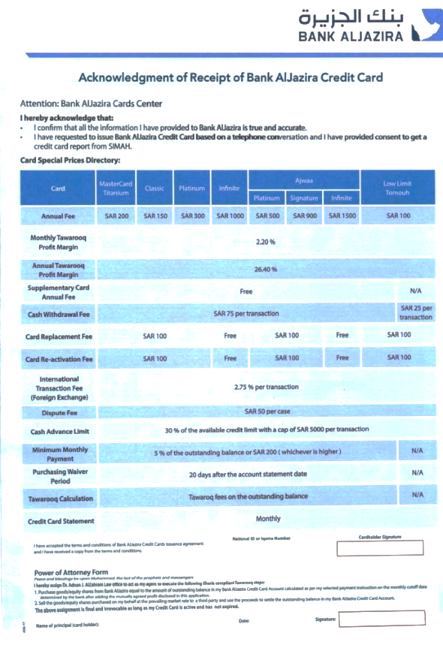


GENERAL INSTRUCTIONS

- Couriers are required to refrain from making bulk deliveries to a single customer and must report such instances to their supervisors for client approval.
- A maximum of three (3) delivery attempts should be adhered to.
- Deliveries involving mismatched or incorrect IDs/OTPs should be avoided.
- Third-party deliveries are not permitted.
- In the event of incidents such as taken by force, refusal to sign delivery acknowledgment forms, refusal to provide ID/OTP, or refusal to pay the COD amount, must be reported immediately.
- Couriers reserve the right to decline delivery if the customer fails to provide their ID/OTP for verification purposes.
- Signed acknowledgment forms must be submitted to the station on the same day they are collected.
- Collected COD amounts should be reconciled by the end of the business day.
- All undelivered shipments retrieved from the SMSA Service Centre (SSC) must be scanned with the “Retail to Ops PUP” designation
- Couriers are required to utilize the SDM Mobile Application on their devices for daily scanning tasks.
- It is essential that all undelivered shipments are returned on the same day.
- Clients may impose penalties of up to two thousand Saudi Riyals for each incorrect delivery or lost shipment, as specified in the agreement.
- Compliance with scanning procedures is mandatory for all shipments, with ongoing checks for adherence.
- Scan compliance is also required for shipments destined for remote areas that are serviced once or twice weekly.
- In cases of OTP failures, manual SDC Delivery Records should be utilized. (refer to GUIDE Doc# 6769).
* Failure on compliance may lead to disciplinary action.

