Brief | Special Delivery Channel (SDC) use Special Delivery Management (SDM) Systems for daily operations
Purpose | To understand the systems used by SDC
Person Affected | All Staffs using SDC Systems
Instruction | Refer below

TABLE OF CONTENTS

Special Delivery Management (SDM) Application 2
SDM Mobile Courier’s Application for Android 5

Special Delivery Management (SDM) Application

Proof Of Delivery (POD) Process:

- Shipment Dispatch to Ops
- Operations In
- Sort shipments at operations
- OFD
- POD Capture
- Outbound (Same Day of Operations In)
- Create Outbound Manifests
- Destination Inbound
- OFD
- POD Capture

Return Process:

- 1st Day OFD
- Exception registered (Requested Future Delivery/Mobile No response/Switched Off)
- 2nd Day OFD
- Exception registered (Requested Future Delivery/Mobile No response/Switched Off)
- 3rd Day OFD
- Exception registered (Requested Future Delivery/Mobile No response/Switched Off)
- Delivery attempt over (RETURN PROCES STARTED)
- Apply return scan and Create Return Manifest for the Client.

Dispatch Process:

- Print Validated shipments manifest.
- Print Manifested AWB labels.
- Shipment dispatch to Ops

Menus in SDM:

- Reports

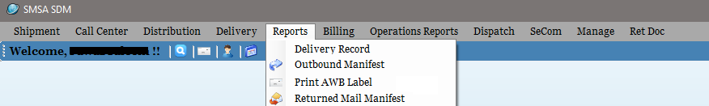
Reports | Print AWB label | To print a duplicate copy of Validated AWB
Reports | Delivery Record | To reprint Delivery Record
Reports | Outbound Manifest | To reprint Outbound Manifest
Reports | Returned Manifest | To reprint Returned Manifest

- Delivery

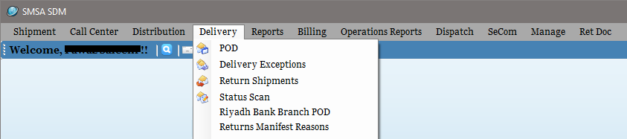
Delivery | Delivery Exceptions | Apply DEX scans
Delivery | POD | Apply POD Scan
Delivery | Return Manifest Reasons | Get undelivered reason of returned shipments
Delivery | Return Shipments | Apply Returned to client scan
Delivery | Branch POD | Apply POD of shipments delivered to branch
Delivery | Status Scan | Apply Future Delivery/HAL/DEX with comments

- Distribution

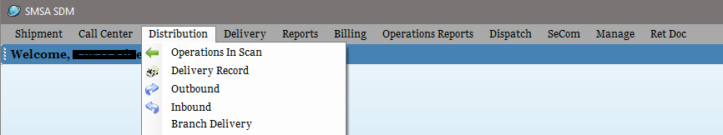

Distribution | Branch Delivery | To print Branch Delivery Records
Distribution | Delivery Record | To print Delivery Records
Distribution | Inbound | Applied on shipments received from other destination
Distribution | Operations In | Applied on shipments received from dispatch at origin
Distribution | Outbound | Applied on shipments send to other destination

- Operations Reports

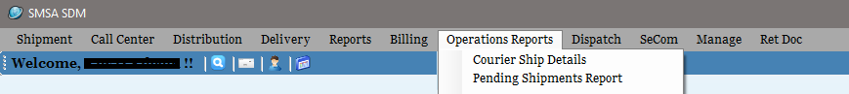
Operations Reports | Courier Shipment Details | Provides summary of shipments processed for delivery
Operations Reports | Pending Shipments Report | Provides number of pending shipments available at each region

- Dispatch

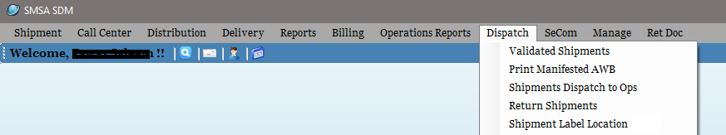
Dispatch | Validated Shipments | Check and print Validated shipment’s Manifest
Dispatch | Print Manifested AWB | Print Manifested AWBs
Dispatch | Return Shipments | Print unvalidated shipments
Dispatch | Shipment Dispatch to Ops | Transit scan, Dispatch to OPS
Dispatch | Shipment Label Location | To print label location barcode on new shipments

- Ret Doc

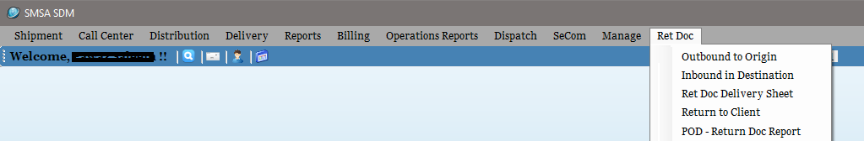
Ret Doc | Inbound in Destination | Ret Doc received at destination scan
Ret Doc | Outbound to Origin | Ret Doc forwarded to origin scan
Ret Doc | POD - Ret Doc Report | To get list of Ret Doc pending for return to shipper
Ret Doc | Return to Client | To return the Ret Doc back to shipper
Ret Doc | Ret Doc Delivery Sheet | To reprint Ret Doc Delivery record

SDM Mobile Courier’s Application for Android

HOME Screen
Shows all the shortcuts in the application.

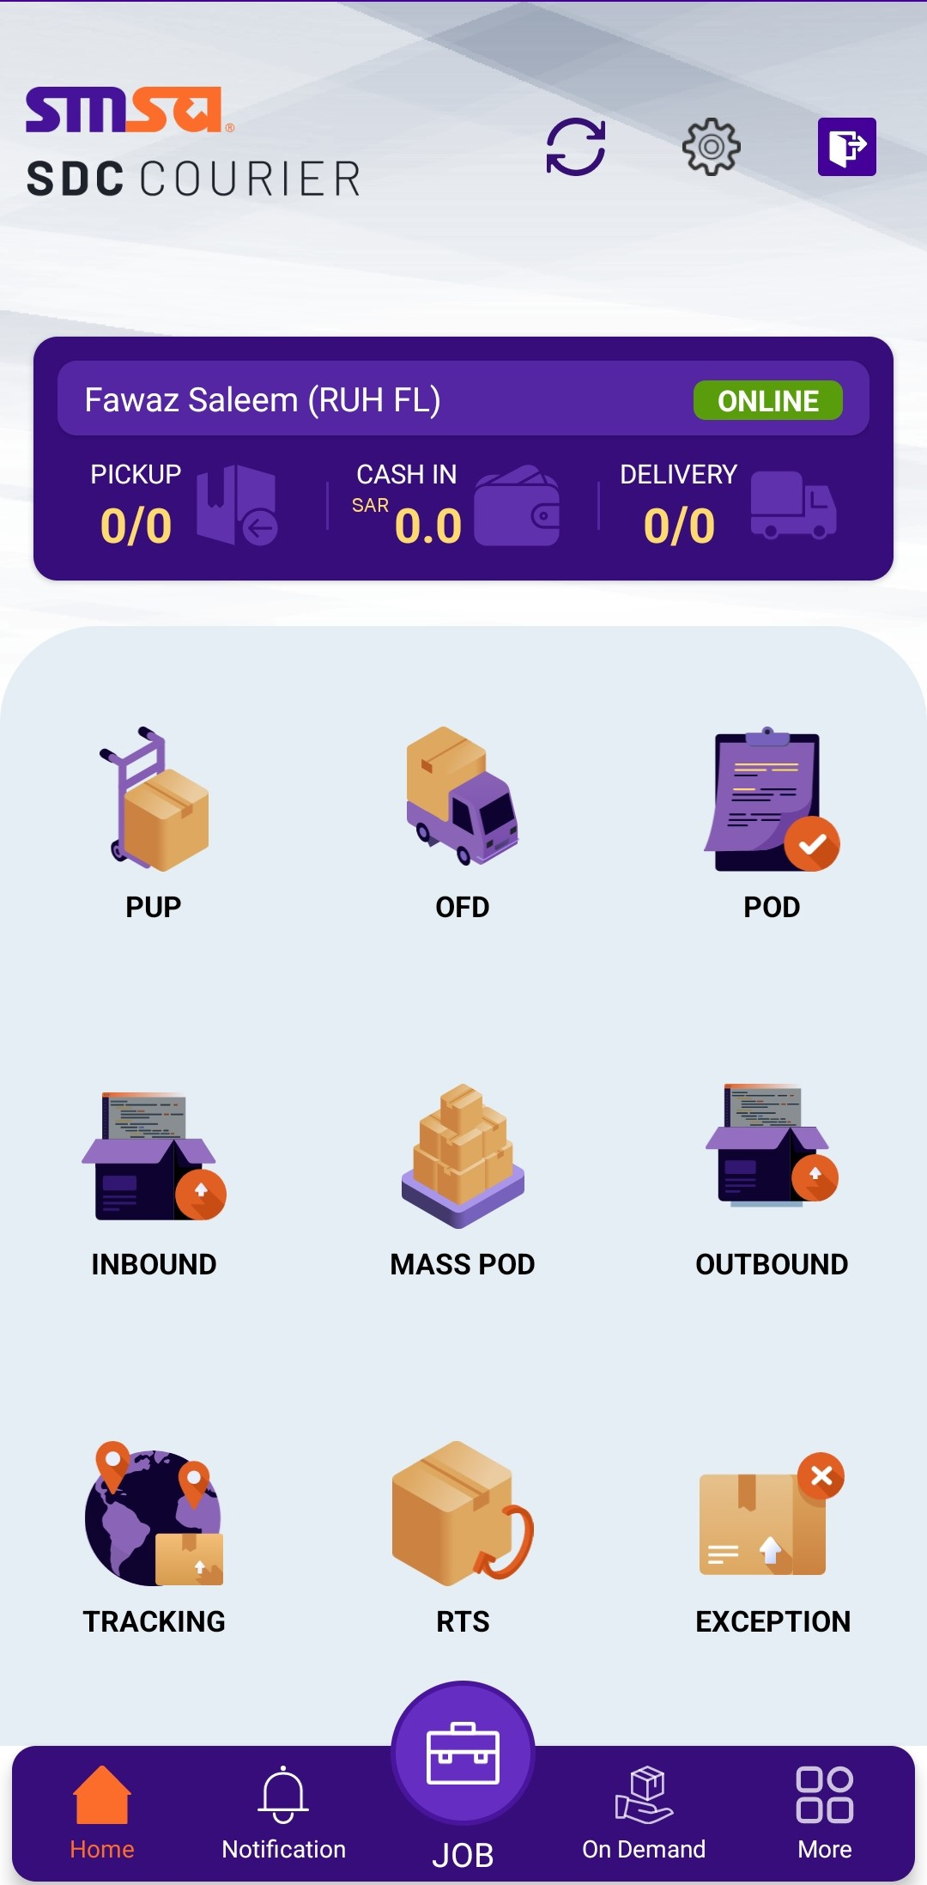
To apply DEX on an undelivered shipment
To Capture POD for a delivered shipment
To apply OFD scan on a shipment

JOBs Screen
AWB Number
Recipient details
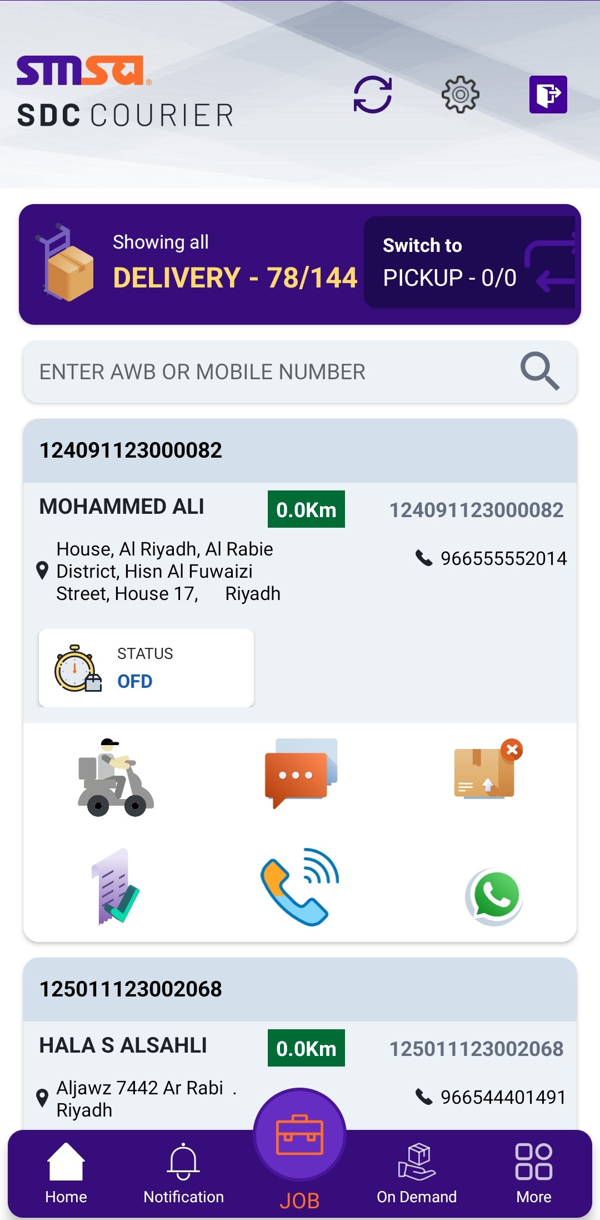
Displays details of all the shipments scanned by the courier (OFD Scan)
To send SMS.
To apply DEX
To send WhatsApp
To place call
To apply POD
Yours Next. When enabled, customer gets notified saying the courier is approaching.
POD Screen DEX Screen
Allows courier to capture delivery details. To apply DEX on undelivered shipments.
