Truck Inspection Form |  |  | Date:
Type Of Truck: | :Truck Plate No. |  | Truck Route From:
Driver Name: | Emp. No/ Third party Co: |  | Truck Route To/ VIA:
All outbound vehicles leaving the facility need to be inspected by the security and a seven-point vehicle inspection check needs to be carried out as per the TAPA best practice: These checks are to ensure that there is no damage to the vehicle that will lead to a theft and to ensure that the vehicles is secure with the necessary security seals. The 7 points covers the whole of the vehicle.
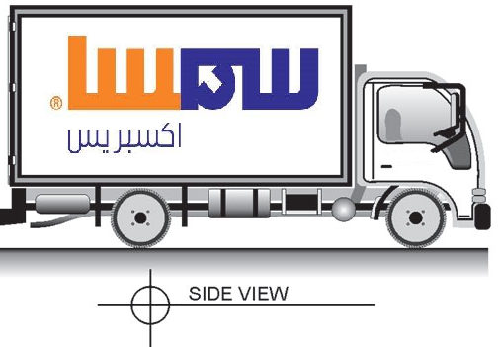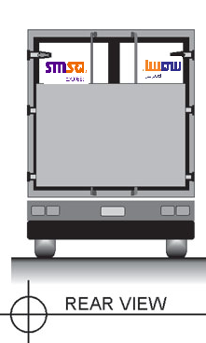

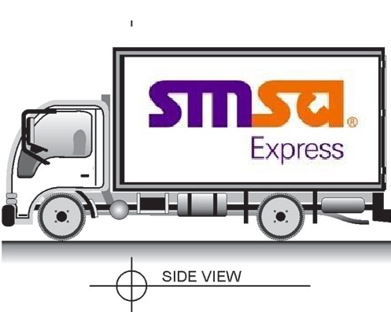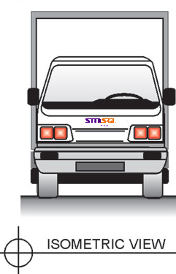
Security Findings:

Checks on HV items Carried Out  Yes No |  | Random Cargo Checks Carried Out  Yes No |  | Vehicle Security Seal No.:
What was checked? |  |  |  | HV Items Sealed:  Yes No
Signature: |  | Emp# |  | Security Inspection Officer:
Signature: |  | Emp# |  | Reviewed by Security Executive:

