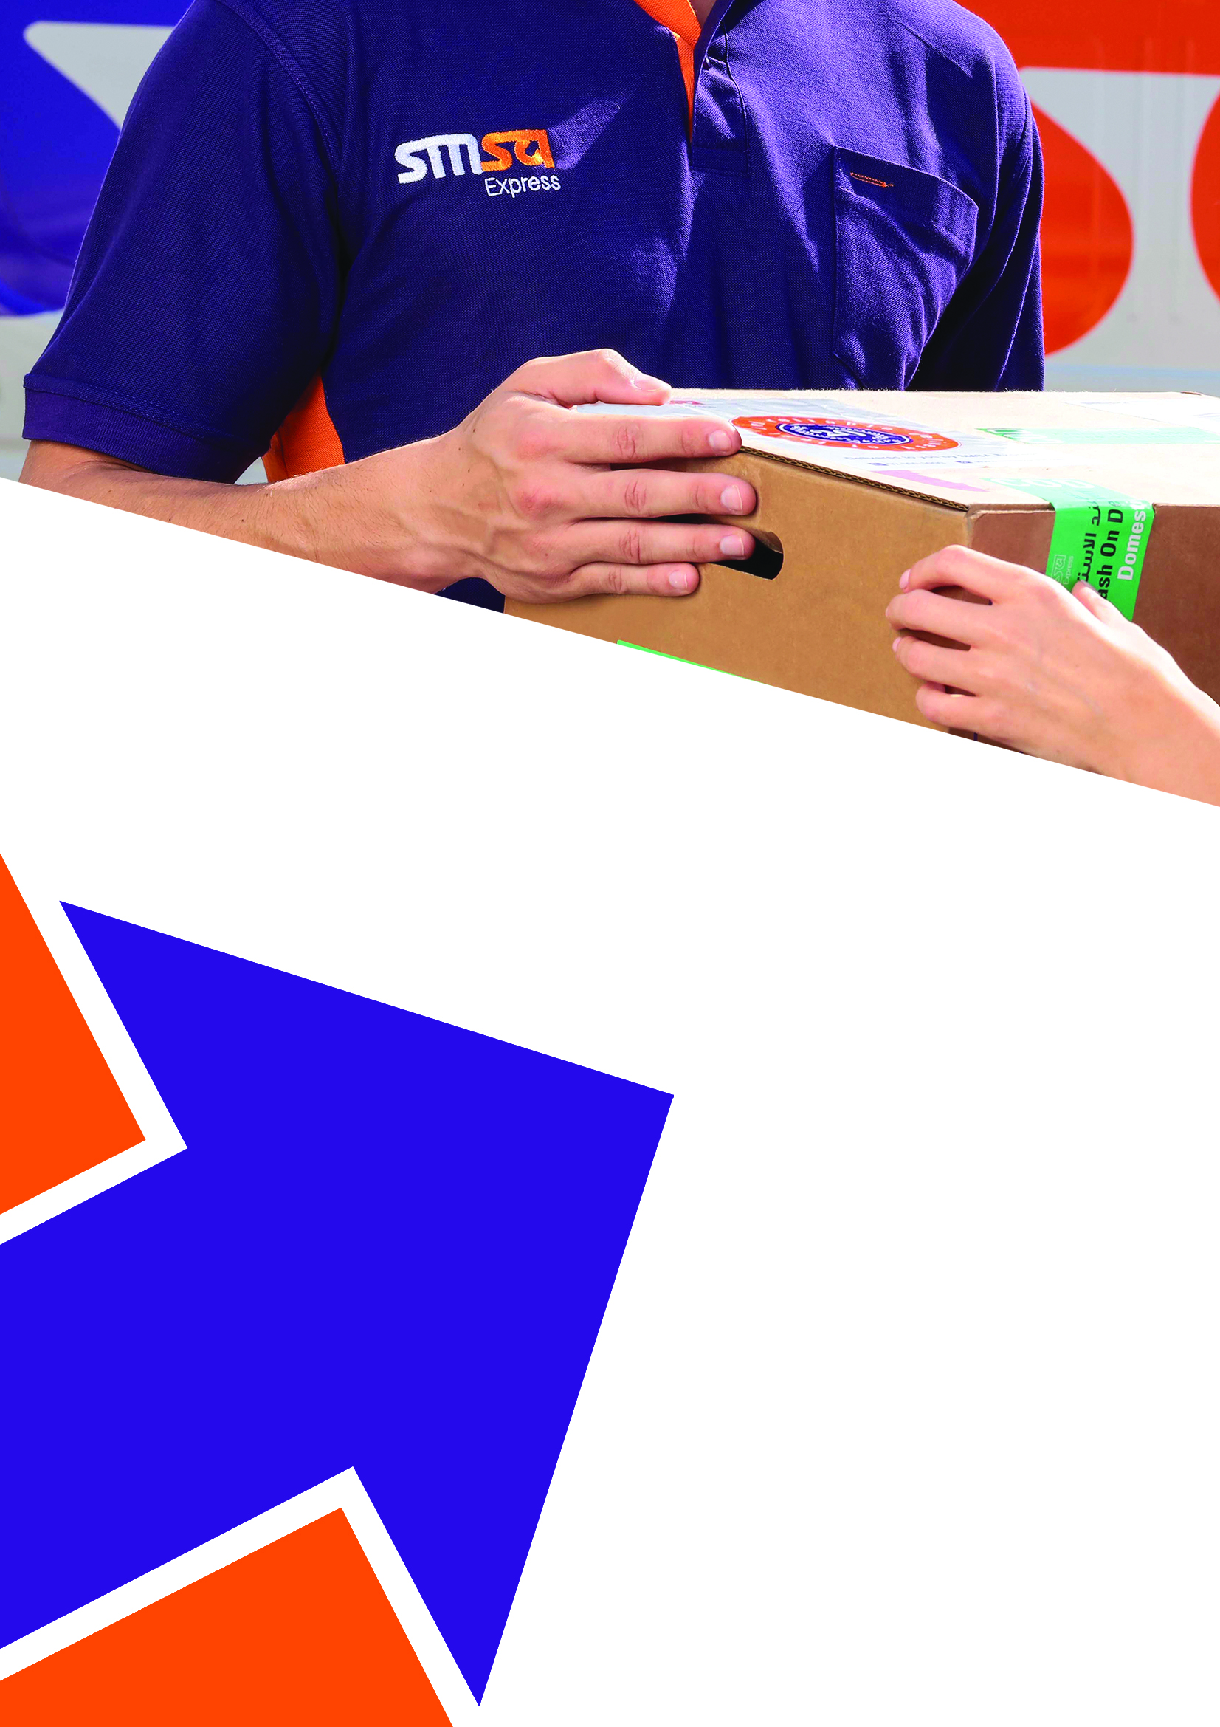
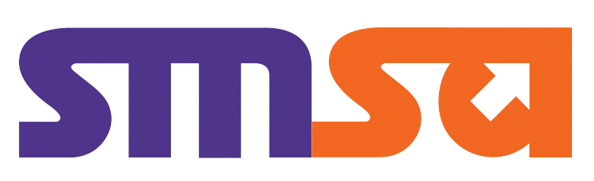

And

Disclaimer & Confidentiality
The information contained herein is confidential information regarding SMSA Express Transportation Co. Ltd. W.L.L by accepting such information, the client agrees that it will, cause its directors, officers, employees and representatives to, use such information only to evaluate our proposals and not for any other purpose and will not divulge any such information to any other party. Any reproduction of such information, in whole or in part, is prohibited without our written permission.
COMPANY NAME

And


SMSA Express Transportation Company Limited W.L.L
P.O. Box 22446, Muharraq
Tel: +(973) 17 00 33 33
Fax: +(973) 17 91 04 90
www.smsaexpress.com

Date:

Name
Designation
Address
Kingdom of Bahrain

Subject: Submission of SMSA Proposal & Agreement

Dear Mr._________,

It gives us great pleasure to present to you with a copy of our proposal and contract for your express shipping and logistic requirement.

Leading organizations are always keen to maintain a competitive and reliable business relationship with their suppliers and customers. We offer a spectrum of reliable customer driven services ranging from international and domestic express shipping to consultation and provision of logistics and supply chain management solutions.

We endeavour in building strong partnerships with a distinctive approach of adding value to the logistic and supply chain requirements of our clients, enabling them to focus on their core business and growth.

After reviewing your company’s logistic and shipping requirements, I am pleased to submit the attached for your consideration. The enclosed details of our services highlighted are in line to your business needs and will undoubtedly draw your attention to the advantages and benefits that will add to enhance your current and future logistics requirements.

I am delighted to have had the opportunity to meet with you and I sincerely look forward to a complementing business relationship based on servicing your esteemed organization.

Should you need any further clarification, please do not hesitate to call me directly with the following contact numbers: - 00973 17003333 or alternatively you can write to me on bhsales@smsaexpress.com

Yours Sincerely

Sales Person
Designation

About SMSA

SMSA Express is a 100% Saudi owned Express Courier Company with over 25 years’ experience in the Express, Logistic and supply chain business. SMSA is the largest courier company in the Kingdom of Saudi Arabia connecting 325 cities, towns and villages, having over 4,500 employees and 340 offices. Internationally we serve 225 Countries with daily express connections from our regional hub Bahrain & Dubai.
SMSA caters to all segments of the business be it banks, Oil & Gas, engineering, manufacturing, retail, Health, FMCG, Military and are involved in several government projects. We have grown to be the most reliable and preferred E-Commerce logistics, distribution, fulfilment and final mile Delivery Company within the GCC. We are one of the few companies who handle express and cargo clearance in-house that allows us to have enhanced performance on transit times and improves our reliability to the services that we offer.
Beyond our standard products we specialize in tailoring customers’ needs and building our resources and infrastructure based on the customer needs. Most of the projects that we handle for reputed brands are customized and that privilege’s us to be a strong valued business partners to our customers.
We have several customer automation tools that allow customers to book their shipment, prepare their shipping documents and or even real time tracking that allows them to track their shipment until it is delivered. All our specialized services are supported with several dedicated software’s that allow customer system interface and integration in to SMSA portals that enhances efficiency and reduces manual interventions.
We maintain a high level of safety and security in all our transactions with unparalleled industry standards defined and certified by international agencies. Our lists of Quality certificates are:
Certification Type | Scope
ISO 9001 : 2015 | Quality Management Systems
ISO 10002 : 2018 | Complains Handling
ISO 10015 : 1999 | Training & Development
ISO 45000 : 2017 | Occupational Health & Safety
ISO 14001 : 2015 | Environmental Management Systems
WHO- GDP | World Health Organization
TAPA - FSR 2017 | Facility Security
SMSA Certifications

2018 SMSA has launched its complete range of integrated services in the Bahrain Market. In this short span of time we have attracted several businesses who have seen the value, advantage and reliability of our service that we promote. We feel proud that we have the opportunity and privilege to add value to the existing and new business in the Kingdom of Bahrain. Our experience in the industry and the region is unparalleled to any other and we continue our endeavour of growing to be a preferred and trusted service provider in this market.

SMSA Product & Services
 | SMSA Product Name | Type | Service Areas
EXpress | International Outbound | Documents & Parcels | Refer to Transit Guide
 | International Inbound | Documents & Parcels | Refer to Transit Guide
 | International Economy | Parcels + 30 Kg | GCC Countries
Domestic | Domestic Same Day | Documents & Parcels | All Bahrain
 | Domestic Next Day | Documents & Parcels | All Bahrain
E-Commerce | International COD & PPD | Parcels | Saudi Arabia, UAE, Oman, Egypt
 | Domestic COD & PPD | Parcels | All Bahrain
 | Fulfillment Services | Parcels | Bahrain, Saudi Arabia, UAE
SMSA Freight | Airfreight Services Outbound | Parcels + 45 Kg | RFQ
 | Airfreight Services Inbound | Parcels + 45 Kg | RFQ
 | Road Freight FTL | Full Truck | GCC Countries
 | Road Freight LTL | Cargo + 30 Kg | GCC Countries
 | Clearance & Delivery | Cargo | Bahrain
Banking | Mail Room Management | Documents & Parcels | Saudi Arabia, UAE, Oman, Egypt
 | Special Delivery Channel (SDC) | Credit & Debit Cards | Saudi Arabia, UAE, Oman, Egypt
Cold Chain | Cold Chain International Export | Parcels | Globally
 | Cold Chain Domestic | Parcels | Bahrain
supply chain | Warehousing | Parcels | Bahrain, Saudi Arabia, Oman
 | Warehouse Management System | Dedicated Software | Bahrain, Saudi Arabia, Oman
 | Fulfillment Services | Parcels | Bahrain, Saudi Arabia, UAE

Abbreviation’s: COD (Cash on Delivery), PPD (Prepaid), RFQ (Request for Quotation), FTL (Full Truck Load), LTL (Loose Truck Load)
Volumetric Weight Calculation by Product (Chargeable Weight)
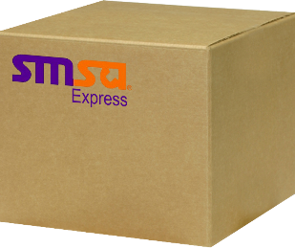
Width
Length
Height
Express Courier | Length x Width x height (cms)  5,000 | = Chargeable Weight in Kg
Road Freight | Length x Width x height (cms)  4,000 | = Chargeable Weight in Kg
Air Freight (Cargo) | Length x Width x height (cms)  6,000 | = Chargeable Weight in Kg

Note: As per the industry and SMSA standards all shipment will be billed for the actual weight or the volumetric weight of the shipment whichever is greater. Before rendering any shipment to SMSA customers need to verify both the actual and volumetric weight and input the higher weight on the SMSA airway bill or any other declared documents.

Service Agreement

SMSA EXPRESS STANDARD SERVICE CONTRACT

This Services Agreement (“Agreement”) is made this ____ day of ___, 2025, by and between:

SMSA Express Transportation Company Ltd. W.L.L, having its head office at (Warehouse 68, Bldg. 3427, Road 185, Block 701, Tubli Bahrain) and C.R. No. 106722-1 (“SMSA”) VAT registration no. 220009863000002.

AND
COMPANY NAME having its office at (Company Address) and CR# (_______), VAT registration no. (_______) (“COMPANY NAME) or (“The Customer””)
- General Provisions
  - The Customer desires to appoint SMSA as their contractor for the Pickup and Delivery of their Products. All Services provided under this Agreement shall be provided in accordance with the terms and conditions of this Agreement, SMSA Standard Terms and Conditions of Carriage, conditions on any SMSA/SMSA waybill applicable international treaties governing air transport and the laws, regulations, decisions, rules, circulars, lawful orders of public authorities and public policies in force in the Kingdom of Bahrain.
  - The Customer accepts the rates to the services described in Exhibit A of this contract and the terms and conditions put forth in this Contact
- Effective Date & Validity

This Agreement shall commence as of the Effective Date and shall remain in full force and effect for a period of 1 year on the Gregorian calendar following the Commencement Date. The term of this Agreement shall be renewed automatically for periods of 1 year on the Gregorian calendar, unless one Party gives notice at least One (1) month prior to the expiration of the initial term or any renewal term of its intention not to renew this Agreement.
- Services

The services under this contract are described in Exhibit B – Service Charges and Tariff Rates
- Rates, Invoicing, Payments & Penalties
  - Rates provided under this contract are based on the volume and revenue commitments that have been provided by the customer at the outset of the account opening form. In the event of any shortfall in volumes SMSA reserves right to revise the rates at any time by giving the customer a written notice of 1 month.
  - Weight calculated for invoicing are based on actual weight or volumetric weight whichever is greater. Refer to Exhibit B for method of volumetric calculation. SMSA may at any time re-weigh or re-measure shipments tendered to SMSA by customer to confirm the chargeable weight. The customer agrees to pay SMSA for any such discrepancies in weight notified by SMS to the customer.
  - Rates provided in this contract are for standard shipments weights and dimensions, in case of shipment with extra ordinary dimensions or weight requiring special handling additional handling surcharges may apply. Example of Non-Standard shipments could be a single piece exceeding 50Kgs and or a pallet over 120cm in length.
  - Duties, taxes, VAT or other taxes applicable for any inbound or outbound shipment will be billed against delivery of the shipment and payments of such invoices are due immediate paid against delivery. In case the customer request for charges to be billed to their credit account, administration charge of 2% of the value of the invoice or 10 BHD whichever is greater will be applicable per airway bill.

SMSA will invoice the customer for all freight charges on a monthly basis and the invoices are due for payment within 30 days from the date of the invoice. In case the customer defaults the payment, terms agreed under this contract, SMSA without any prejudice to any other rights it may have in this regard will seize to render any services until the dues are paid. Further delay in settlement of invoices by the customer post such actions, SMSA may take legal help to recover their monies dues.

- Term and Termination
Service Agreement
  - This Agreement shall commence as of the Effective Date and shall remain in full force and effect for a period of 1 year on the Gregorian calendar following the Commencement Date. The term of this Agreement shall be renewed automatically for periods of 1 year on the Gregorian calendar, unless one Party gives notice at least One (1) month prior to the expiration of the initial term or any renewal term of its intention not to renew this Agreement.
  - SMSA and Customer may both have the right to terminate this agreement at any time after notifying each other with at least (1) One-month notice.
- Dispute Resolution

This Agreement shall be governed by and construed in accordance with the laws, rules and regulations of the Kingdom of Bahrain. In event of dispute in the implementation or interpretation of this contract, the two parties will try to settle it amicably within thirty (30) days from the date of inception. If the settlement is not agreed by the two parties, the dispute shall be forwarded to the relevant court in Bahrain to settle it.
- Exhibits.

The following exhibits are attached hereto and incorporated as an integral part of this Agreement by this reference:
    - Exhibit A : SMSA Terms and Conditions of Carriage
    - Exhibit B : Service Charges & Tariff Rates
- Counterparts.
This Agreement has been executed in counterparts, each of which shall be deemed to be an original, all of which shall constitute one and the same agreement, provided that each Party receives an original fully executed by the other Party. It shall be necessary to account for only one such fully - executed counterpart in proving this Agreement.

IN WITNESS WHEREOF, this Agreement has been executed by the duly authorized representatives of the Parties here to:

SMSA Express Transportation Company COMPANY NAME
Ltd. W.L.L

By: By:

Name : Name :
Title : Territory Manager Title :

Signature Signature

Date: __________________________ Date: __________________________

Company Seal Company Seal

SMSA Terms & Conditions of Carriage- Exhibit -A
SMSA TERMS & CONDITION OF CARRIAGE

(“Terms and Conditions”)
This appendix is an integral part of this and in case of conflict between the standard terms and conditions and the terms and conditions stated in SMSA air waybill or any other carriage document, these standard carriage terms and conditions (or any other appendices attached thereto) shall govern and apply to the extent that they are not in contradiction with the rules relating to air carriage liabilities expressed in the air carriage regulations or international treaties. Non-compliance to impose or apply any of the articles or provisions of these terms and conditions of carriage shall not constitute a waiver of that term or article or annul it in any way SMSA’s right to impose or apply that article or provisions in future.

- Account numbers
To ensure the proper movement of shipments, the CUSTOMER shall have a valid credit account with SMSA. The use of a valid A/C with SMSA will lead to:
  - Sending SMSA invoices to the CUSTOMER’s correct location
  - Summarizing the account activity by SMSA devices
  - Proper billing - CUSTOMER will be legally held responsible for safeguarding the account numbers and shall not disclose it to anyone other than the persons authorized to ship using that account. The use of the CUSTOMER’s account number by those authorized is at the CUSTOMER’s sole risk.

- Correcting Addresses
  - CUSTOMER is entirely responsible for writing the addressee’s full address on the air waybill. However, if the addressee’s address is found to be not complete or incorrect, SMSA shall not be held accountable for its inability to carry out delivery under these circumstances. Incorrect postal codes, non-existing apartment numbers and names of streets where the recipients previously lived are examples of the addresses that need correction.
  - SMSA shall not be held accountable for not meeting its delivery time commitment for any shipment having an incomplete or incorrect address and in all such cases there is no fixed delivery time.

- Billing
  - Sender’s account number shall appear in the designated place on the air waybill and must be valid. The Sender is always ultimately liable for all charges and fees relating to a shipment, including, but not limited to any duties or taxes which SMSA have advanced, regardless of any payment instructions to the contrary.
  - SMSA reserves the right to audit the air waybill to verify the service selected and the weight of the parcel or shipment. If the service selected or the weight entered is not correct, SMSA shall make the appropriate adjustment to the invoice at any time.
  - CUSTOMER is responsible for the accuracy of filling out the air waybill to ensure the correct entry of shipment information in any automatically operated means of shipping as the number of parcels and weight of every parcel are deemed necessary information for SMSA so that it can prepare the invoices properly. If CUSTOMER does not abide by providing SMSA with the correct data and address the invoice will be prepared according to the number of transported parcels and the weight of every parcel as amended and adjusted by SMSA.

- Claims:
  - All claims will be handled by CUSTOMER.
  - All claims due to loss, damage, delay, shortage or deterioration and losses resulting from damage caused by delay or late delivery in the “Territory” must be made to SMSA in writing within one week as from the scheduled time of the shipment delivery.
  - SMSA if needed, will forward incident report with required supporting to CUSTOMER within 30 days of receipt of the claim.
- Dimensional Weight (Metric or volumetric weight)
Dimensional weight rate is applicable to any Express Courier parcel or shipment the size of which exceeds one cubic foot. The dimensional weight of any parcel bigger than 31cm x 31cm x 31cm (i.e.one cubic foot) is calculated according the following formula:
Length (cm) x width (cm) x height (cm) divided by 5000 = Volumetric Weight in Kgs

Customers who fail to apply the dimensional weight to any parcel at the time of transaction, additional charges may be assessed based on the dimensional weight through a supplementary invoice.

SMSA Terms & Conditions of Carriage- Exhibit -A

- Duties and taxes:
To clear certain items through customs, SMSA may be required to pay in advance on behalf of the CUSTOMER certain duties and taxes as assessed by the customs employees. The same will be recovered from the recipient or CUSTOMER along with the rates agreed in Exhibit A on the basis of the option selected on the air waybill. If the recipient refuses to pay, the same will be recovered from CUSTOMER.

- Inspection of Shipments
SMSA may, at its own discretion, open and inspect any shipment at any time without notifying CUSTOMER. Government authorities may also open and inspect any shipment at any time.

- Declared Value and Limits of Liability
  - SMSA will charge minimum of BHD 5.000/- or 2% of the shipment value if it is higher premium on the declared value of goods as extended insurance charges if the customer chooses to use this service. Terms and conditions to the extended liability can be reviewed on the Insurance Request Form. If the shipment is not insured through SMSA Insurance Policy, SMSA maximum liability for any loss or damage will be limited to 100 USD$ or Value of Goods whichever is lower.
  - SMSA does not provide an automatic cargo liability on all risk insurance but the sender may pay an additional charge for declared value for carriage above the limits referred to in section 9.1 of the condition of carriage. The declared value for carriage of any package represents SMSA maximum liability in connection with a shipment of that package, including but not limited to any loss, damage, delay, mis-delivery, any failure to provide information, or mis-delivery of information relating to the shipment
  - The maximum declared value for customs and carriages is limited and may vary per Location. If applicable the declared value for carriage value for customs and carriage is limited and cannot exceed the declared value for customs. The maximum declared value for customs and carriage for the contents of a SMSA Envelope or SMSA Pak, regardless of destination is US$100 per shipment. Goods with a value (actual or declared) are exceeding these amounts, should NOT be shipped in SMSA Envelope or SMSA Pak.
  - Shipments containing items of extra ordinary value are limited to a maximum declared value for carriage of USD$ 1000 per shipment. Import of any of these items may be prohibited by individual countries. For more information, please read our Conditions of Carriage and or contact SMSA representative.
  - Even if the shipment is insured with SMSA regardless of the declared value for carriage of a package, SMSA liability for loss or damaged will not exceed the shipments repair cost, its depreciated value or its replacement cost whichever is less.

- Liabilities not assumed (No damages will be paid in the following cases):
  - SMSA will not be liable for any damages for loss, late delivery or damage as a result of misinformation by the CUSTOMER
  - Non-compliance with any of the terms and conditions contained in SMSA air waybill
  - and the standard terms and conditions of carriage, including, but not limited to incorrect declaration of cargo, improper or inadequate packing, securing, marking or addressing of shipment; perils of air, illegal acts by any person or persons “other than SMSA employees” or entities not in good credit standing using the account number, act of law, customs or quarantine officials acts, state of war hazards or weather conditions (at SMSA’s discretion) mechanical delay or disruption of air or ground transportation networks, conditions that present danger to SMSA employees, or disruption or failure of communication systems, acts or omissions by any person other than SMSA.. In case of occurrence of any of these events, we will make reasonable efforts to transport and deliver the parcels to their destinations as soon as possible.
  - Delays due to customs clearance or government authorities’ procedures
  - Delay in delivery as a result of the SMSA policy regarding payment of duties and taxes.
  - Erasure, loss or irretrievability of information stored on magnetic tapes, files, or any other storage media; or erasure of photographic images, soundtracks from exposed films when in government authority custody.
  - Unavailability of ‘package orientation’ graphics (e.g., “Up” arrows and “THIS END UP” marking, or other sender’s instructions on the envelope), or damage arising from any failure by the sender to pack the material shipped properly before shipping e.g., florescent tubes or neon lights, neon sign boards, X-ray tubes, laser tubes, flat monitors (all types), light bulbs due to their fragile nature. These items require prior packaging approval before shipping.
  - Inability to attempt to contact sender or recipient with regard to incomplete or inaccurate address, lost documentation, payment of customs duties and taxes required for release of shipment or incorrect or incomplete customs broker’s address.
  - Shipments of perishables or whose contents are perishable and liable to leak and damage. If shipment is not accepted by the recipient because it is leaking or damaged, the shipment if possible, will be returned to the sender who shall pay the return charges. If the sender refuses to accept the returned shipment, or it cannot be returned owning to leakage or damage due to the sender’s failure to notify SMSA to exercise caution in packing that shipment, the customer will be held accountable and must indemnify SMSA for all the costs and expenses related to cleaning up any flow or leakage.
  - SMSA will not be responsible for any package which SMSA registers do not show that it has been tendered

SMSA Terms & Conditions of Carriage- Exhibit -A

- Refusal or Rejection of Shipments
SMSA reserves the right to refuse, hold or return any shipment if such a shipment in the opinion of SMSA:
  - Is likely to cause damage or delay to other shipments, equipment or employees after SMSA has explained the proper way of sending a shipment.
  - Is prohibited by law inside Bahrain or abroad or is violation of any of SMSA standard as amended from time to time.

- Unclaimed Shipments
If the shipment cannot be delivered for any reason and the recipient ignored collecting it, SMSA shall have the right to deal with the shipments in whatever manner after the lapse of 30 days from the shipping date as per their regulations. Also the customer must pay return charges if the shipment is returned because it cannot be delivered due to: (e.g. consignee has not paid the customs duties or any other fees imposed on the shipment – Consignee Refused to receive the shipment – government authorities refuse the shipment transit – addresses are incorrect) and the customer shall have no right to ask for a proof of delivery (POD) after the passage of thirty (30) days as of the date of the shipment.

- General Prohibited And Restricted Goods
Wherever possible SMSA will try to provide service to our customers by transporting their shipments. However, a variety of laws and regulations, as well as common-sense safety and security issues, means that some commodities are not acceptable for transport by SMSA.

Prohibited commodities –
Prohibited commodities should, without exception, be refused for carriage in the SMSA network, regardless of value, business potential or who the customer is. There is no exception process available.
- Human Parts (Prohibited)
- Perishable foodstuffs and foods, beverages requiring refrigeration or other environmental control. (Prohibited).
- Live animals including insects. (Prohibited)
- Lottery tickets and gambling devices. (Prohibited)
- Pornographic, sex toys, items related to sex and/or obscene material. (Prohibited)
- Hazardous waste, including but not limited to used hypodermic needles or syringes or other medical waste. (Prohibited)
- Processed or Unprocessed dead animals or parts (Furs, Skins, Tusks, etc.) including insects and pets. (Prohibited)
- Political Material or any related contents. (Prohibited)
- Items offensive to Muslims Culture. (Prohibited)
- Items offensive to country’s rule and regulation, Politics, Habits or Traditions. (Prohibited)
- MONEY (coins, cash, currency paper money and negotiable instruments equivalent to cash such as endorsed stocks, bonds and cash letters), Collectable coins & Stamps
Restricted Commodities –
All the restricted commodities may require special operational and/or security procedures, specific contractual wording or additional costs for acceptance or transportation may be applicable. A business case should clearly document a specific requirement for the carriage of a restricted commodity along with operational, security and contractual details. None of the below material should be tendered to SMSA network without notification and agreement of acceptance by SMSA operation in writing or contractual.
- Hazardous Material (Chemical, Explosives, Fuels, Fertilizers and Poisons “toxics”. (Restricted)
- Alcohol in general. (Restricted)
- Tobacco Advertisements. (Restricted)
- Perfumes, Nail Polishes, Flammable Material & Pressurized Canes (Restricted)
- Electronic Cigarettes, E-Juice, Nicotine Liquids and accessories. (Restricted)
- Military Items/Cloths. (Restricted)
- Spying devices and hidden cameras in any form (Restricted)
- Lithium Battery (Restricted)
- Firearms, weaponry and their parts or equivalent like plastics dummy. (Restricted) - Require an Import Permit from the Ministry of Interior-Public Security)
- Packages that require any special license or permit for transportation, importation or exportation. (Restricted)

- Articles or products from animal or plants protected under CITES (Convention on International Trade in Endangered Species of Wild Fauna and Flora). (Restricted) (Require an Import Permit the Saudi Fungal Life Commission)
- Governments ID’s, Uniforms and Badges whether real or costume. (Restricted)
- Medications (Vitamins, Food Supplements and/or Herbal Medicines). (Restricted) (Require an Import Permit from Saudi Food & Drug Authority)
- Veterinary medications. (Restricted) (Require an Import Permit from the Ministry of Agriculture).
- Any type of Military Items (Night-Vision Goggles, Handcuffs, Laser Sites, or Optical Scopes, etc.) (restricted) (Require an Import Permit from the Ministry of Interior)
- Communications Equipment, Smart Cards, Calling Cards or Radio Transmitters. (Restricted) (Require an Import Permit from the Saudi Communication and Information Technology Commission).

The above list is just few of the prohibited/Restricted commodities and is not complete OR comprehensive. For any further clarification or assistance on Prohibited or Restricted Commodities please send a mail to our sales department bhsales@smsaexpress.com and or speak to your SMSA Account Executive

Service Charges & Tariff Rates- Exhibit - B

