i. Purpose | Describe overall series of activities, covering overall aspect of Cargo screening from  customer handover to airport handover.  Clarify the sub process ownerships, responsibilities, authorities, timings, schedules, paper works, airport requirements and needed resources in the cargo screening project.
ii. Table of  Contents | Contents Page  - Purpose 1  - Table of Contents 1  1.0 General Information 1-3  2.0 Personnel 5-6  3.0 Equipment & Facilities 7  4.0 Package Cargo Screening Procedure 8-9  5.0 Documentation / Paper works 10  6.0 Related Documents 10-11
1.0 General  Information | Cargo Screening project:  - Cargo Screening Project started its operations in June of 2015, receiving packages from customers such as AL MOJIL and BPL CARGO.  - Cargo Screening Project is created to cater to the growing needs of cargo companies who are getting packages from individual customers, sending personal packages to their country via air.  Operations:  - Operating this type of project requires GACA Certification.  - Cargo companies handover packages from 10kg up to 100kg per package to SMSA facility for screening in x-ray, transfer and handover to airport security together with the required paper works and certification.

Timing and Schedule:

SMSA  Receiving | SMSA  Screening | SMSA  Dispatch | Airport  Handover
1200H – 1600H | 1200H – 1500H  & 2300H – 0700H | 0800H (1st) | 0900H
0800H – 1200H | 0800H – 1200H | 1230H (2nd) | 1330H

    - Airport Export Receiving Schedule is from Saturday to Thursday from 0900H -1400H.

    - Above schedule may be changed without prior changes on this Standard operating procedure.

Site:

    - Initially, The project uses DAMMAM Hub to do the processing of packages.

    - The following facility may also be used:

      - Riyadh Hub in Central Region
      - Jeddah Hub in Western Region.

Number of staff:

Position | Count | Schedule
Handler | 4 | 0800H-1600H
Forklift operator / Senior handler | 1 | 0800H-1600H
Project Coordinator /Team Leader | 1 | 0800H-1600H
Security Officer (X-RAY) | 1 | 0800H-1600H
Additional Security | 1 | 2300H–0700H
Heavy Duty Driver | 2 | 0800H-1600H
Total | 10

    - Overtime or Additional handler would be required if volume / weight to be processed exceeds capacity. For Start up, above Initial staff is required, estimated capacity would be around 6 to 8 Tons per day.

    - Existing staff from operation is to be used during off peak times and whenever necessary to handle above tasks.

Responsibility:

    - Handler:
Responsible for unloading packages from customer trucks to pallets, sorts, transfers, and load to x-ray machine, removes prohibited items, seal with SMSA tape, strapped the packages in one pallet.

Forklift operator / Senior handler:
Responsible in ensuring packages are sorted per MAWB in a pallet, unloads pallets from customer trucks to SMSA facility, loads sorted packages in pallets into SMSA truck for dispatch.

Project Coordinator / Team Leader:
Responsible in coordinating the packages from Customer up to handover to airport security. Responsible for ensuring that all needed paper works/documents are available and provided as required.

Security Officer:
Responsible in conducting X-Ray for the packages and notifying Safety & Security Executive for prohibited packages found.

Heavy Duty Driver:
Responsible for transferring and handover the packages from Hub to Airport.

2.0 Personnel

  - Organizational Chart:
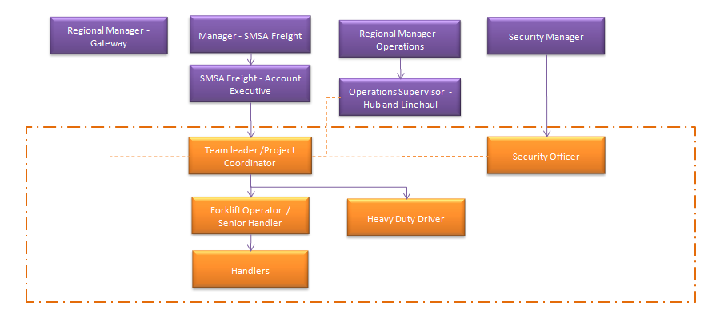

Project Organizational Chart for key personnel:

    - Cargo Screening Project will be under SMSA Freight department. Dotted line to Hub linehaul and gateway Operations. Above organizational chart should be observed and required for smooth operations.

    - Key personnel for the project are:

      - Project Coordinator / Team Leader reports to Account Executive - SMSA Freight. Receives information and support from Security, Gateway and operations.

      - Forklift Operator / Senior handler and Heavy Duty driver reports to Team Leader / project Coordinator

      - Hander reports to Senior handler.

2.2.2.4 Security Officer directly reporting to Security Supervisor / Manager.

Equipment: | Capacity: | Quantity
Forklift | 180 pallets per day | 1
Wooden Pallets | 7 – 20 packages per pallet | 100
Manual pallet Jack | - | 2
X-Ray machine | ~50 packages in hour | 1
Trailer with side curtain | ~25 pallets | 2
Heavy Duty Weighing Scale | Ton / Kg | 1

3.0 Equipment  & Facilities | 3.1 Equipment:  3.1.1 Equipment required depends on the volume and weight of packages to be processed for start-up below equipments are needed:  * validate capacity of X-Ray machines.  Facilities:  - Space required depends on the volume and weight of packages to be processed.  - A separate Staging Area for inbound, X-Ray, sorting and outbound facility is required for the project, for startup below details are suggested.  - Below areas can be shared with other processes / operations so long as it doesn’t affect either one.
3.0 Equipment  & Facilities |  | No. | Space Required: | Qty | Size  (SQM)
3.0 Equipment  & Facilities |  | 1 | Trucks Parking Area (Outbound) Trailer | 1 | 40
3.0 Equipment  & Facilities |  | 2 | Trucks Parking Area (inbound) Customer Trucks with  various sizes. | 1 - 2 | 20
3.0 Equipment  & Facilities |  | 3 | Inbound Area for receiving (truck) | 1 – 2 | 20
3.0 Equipment  & Facilities |  | 4 | Sorting / Checking Area (~10 pallets) | 1 | 10
3.0 Equipment  & Facilities |  | 5 | Weighing Area | 1 | 5
3.0 Equipment  & Facilities |  | 6 | X-Ray Machine Area | 1 | 50
3.0 Equipment  & Facilities |  | 7 | Hold, Sorting and Taping Area and strapping or stretched  wrapping area. | 1 | 10
3.0 Equipment  & Facilities |  | 8 | Outbound Area for Dispatch (trailer) | 1 | 40
3.0 Equipment  & Facilities |  |  | Total Space |  | 200

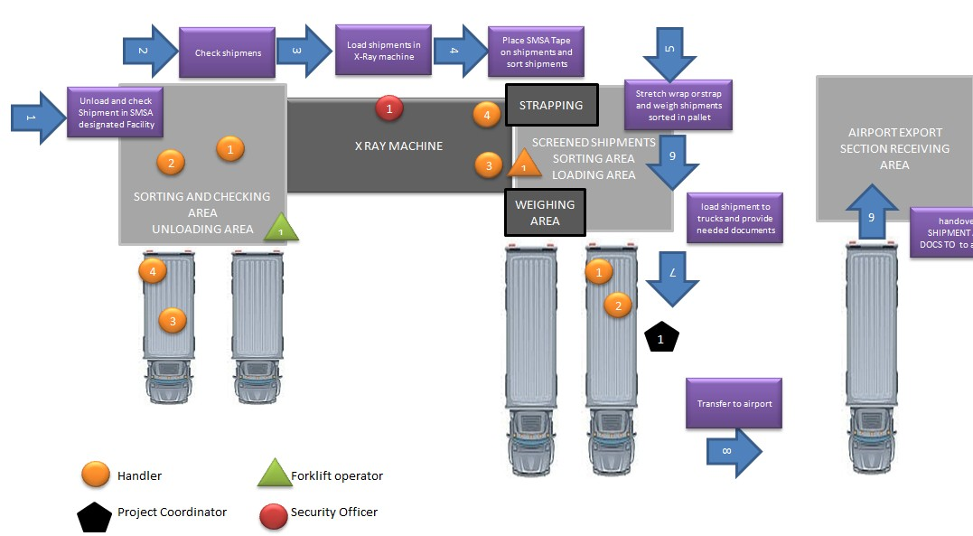

3.2.4 Recommended Set up for the project:

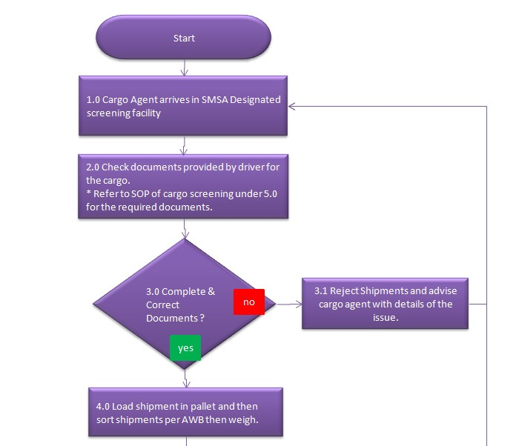
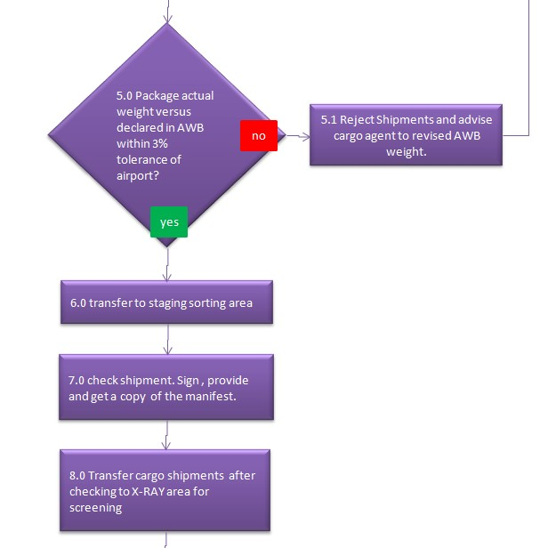
Package Cargo Screening Procedure

  - Procedure (Process Flow)

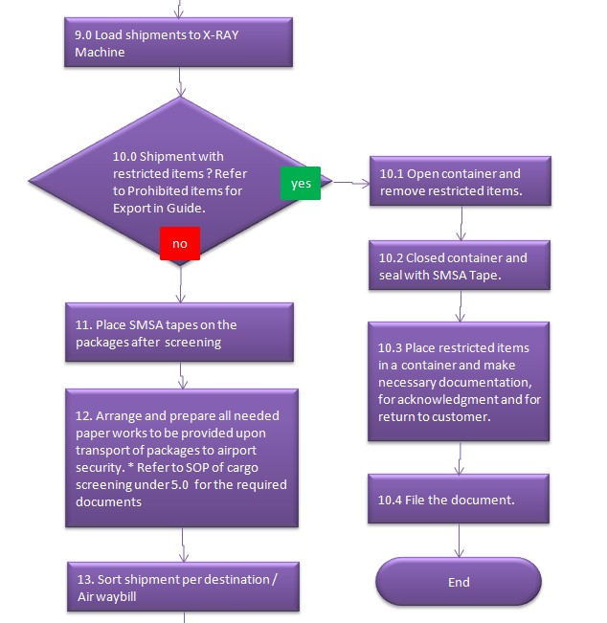
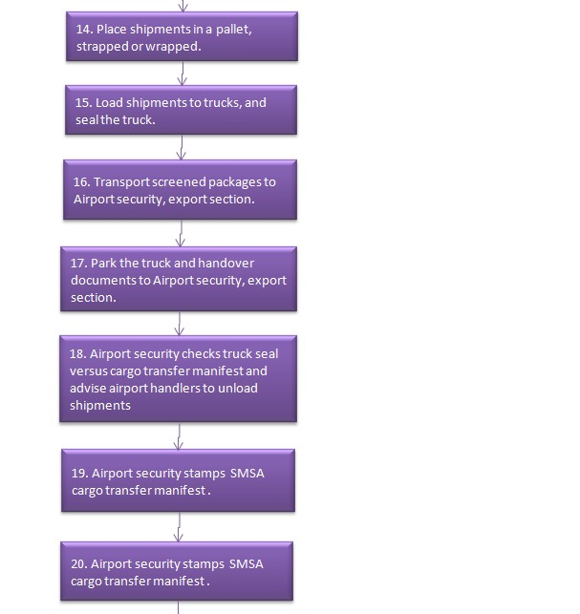

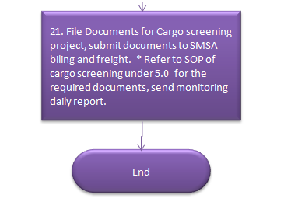

  - Please refer to related documents section under 6.0 for Work Instruction on Cargo Screening.

  - Please refer to related documents section under 6.0 for Work Instruction on Prohibited Shipments During X-Ray (also available in guide).

  - Please refer to related documents section under 6.0 for Restricted & Prohibited Items For Export (also available in guide).
5.0  Documentation | 5.1 Documents to be presented to SMSA designated facility for receiving cargo  for screening:  5.1.1 Customer Cargo Transfer Manifest (2 copies)  - Master copy for SMSA  - Yellow copy for Customer  - Master air waybill  - Export Declaration  - Customer Driver’s IQAMA Copy  Documents to be presented to Airport Security upon handover of Packages (in 3 copies each):  - SMSA Cargo Transfer Manifest  - SMSA Undertaking  - SMSA Security Declaration

    - SMSA Certificate of Shipping License
    - Master Air Waybill
    - Customer Export Declaration
    - SMSA Shipper’s Letter of Instruction for Issuing

Documents to be submitted to SMSA billing / SMSA Freight.

    - SMSA Cargo Transfer Manifest
    - SMSA Undertaking
    - SMSA Security Declaration
    - SMSA Certificate of Shipping License
    - Master Air Waybill
    - Customer Export Declaration
    - SMSA Shipper’s Letter of Instruction for Issuing
    - Customer Driver’s IQAMA Copy
    - Customer Cargo Transfer Manifest
6.0 Related  Documents | - Work Instruction on Cargo Screening.    WORK_INSTRUCTIO  N-Cargo_Screeening.  - Work Instruction on Prohibited Shipments During X-Ray (also available in guide).  Prohibited Shipment During X-Ray - WI (1  - Restricted & Prohibited Items For Export (also available in guide).  Restricted _ Prohibited Items for E

