Brief | To standardize a procedure for Value Added Tax procedures in Operations
Purpose | To ensure Value Added Tax computation and implementation are appropriately carried out
Responsibilities | All Station Personnel
Detailed Procedure/Steps  AWB Sample | - Value Added Tax (VAT) of 5%, will only be applicable on domestic shipments  - The Customer copy of the manual SMSA Air Way Bill, needs to have a printed SMSA Tax Identification Number (TIN – 300057426900003)  - Transport charges amount should be written in the transport amount column  - VAT amount should be written on the other charges column, and write VAT on the side of other charges.  - VAT amount needs to be rounded off to the nearest SAR (49 Halals and below to be dropped; 50 Halals and above to be rounded to the next Riyal), for example:  - SAR 5.50 should be considered as SAR 6.00  - SAR 5.01 to 5.49 should be considered as SAR 5.00  - Total amount will be total of transport charges + VAT amount.  - If the customer is insuring the shipment, then VAT amount will 5% of (Transport charges + Insurance amount).  Example of Calculating VAT on Transportation Charges only:  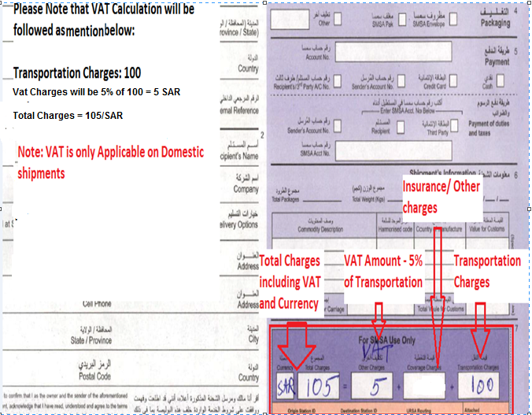  Example of Calculating VAT on Transportation Charges and Insurance:  