Standard Operating Procedure

1.0.0 Stock (Valuable) Receiving process in AWAA provided system.
- Prior to the shipment arrival, Al Waqt Al Abyad team (AWAA) prepares “Draft GRN” as per the factory invoice/PL and notifies the SMSA logistics team through email with GRN number.
- AWAA provide shipment detail in Excel format to SMSA for their system requirement.
- SMSA check the goods against Draft GRN/Invoice/PL based on the physical quantities received. Verify & match the UPC & item code.
- Are there any shortages? Yes:
  - SMSA will notify the AWAA team through email with missing UPC/item code.
  - SMSA will return the GRN through system to AWAA team for amendment.
  - Once amended AWAA inform SMSA through email.
  - SMSA team will print the GRN document and tally with their incoming document.
  - Follow the steps 6 to 8.
- Are there any extras? Yes:
  - SMSA will keep the extra items in the quarantine area.
  - SMSA will notify the AWAA team through email with extra UPC/Item code.
  - If the AWAA team wants to keep the extra items, they will create new Draft GRN and SMSA receives the items against the new Draft GRN.
  - If the AWAA team does not want to keep the extra items, the items will remain in the quarantine area until AWAA team arranges their return to the supplier.
  - AWAA team should finalize the process within one week of receiving the shipment.
  - Follow the steps 6 to 8.
- SMSA will confirm the shipment receipt by confirm the GRN.
- SMSA will acknowledge the GRN copy and will notify the AWAA team though email with acknowledge GRN scan copy.
- AWAA team completes the shipment costing.
- If any deviation/discrepancy found in future, SMSA is solely responsible for whole process.

Non-Stock (Valuable) Receiving process in Seddiqi & Sons provided system.

- SMSA will verify the receipt of all non-stock items (box, instructions, certificates & other items). If any items are missing SMSA will inform AWAA team by email and the AWAA team will notify principal and agree for the missing non-stock items to be sent.
- AWAA creates DGRN (Dummy GRN) in the system and inform the DGRN number to SMSA team through email.
- SMSA team will print the DGRN and tally with their incoming document.
- SMSA will confirm the receipt by confirm the DGRN.
- SMSA will acknowledge the DGRN copy and will notify the AWAA team though email with acknowledge DGRN scan copy.

2.0.0 Stock picking process - Sub-dealers Orders (Normal Order) in Seddiqi & Sons provided system.

- Once proposal confirmed by sub-dealer, AWAA team prepares the quotation including the equal quantities of non-stock items and inform the quotation number to SMSA team by email.
- AWAA also provide the details in Excel format though email.
- AWAA will only be able to prepare the quotation for available stocks in the SIMS.
- SMSA team will pick the items according to the quotation.
- SMSA team will convert the quotation to invoice in the system.
- SMSA team will print invoice and tally with their picklist.
- SMSA team will inform the invoice number to AWAA through email.
- AWAA print the Invoice, confirms the total quantity, and cost as per the LPO.
- AWAA acknowledge the invoice with stamp and send a scan copy to SMSA team though email with LPO copy.
- SMSA team prints invoice and LPO and put the copy inside the box together with watches.
- SMSA will make sure that all the watches are well packed in bubble wrap or principle packing to avoid scratches.
- SMSA team will pack the watches, instructions, guarantees, copy of invoice & LPO together in a carton box sized (size Length 30cm, Width 20cm, Height 10cm). Then seal the box with security seal tape.
- SMSA team will pack the watch boxes in a carton and seal with normal tape.
- SMSA team needs to do all delivery formalities. Such as creating AWB, communicating with delivery provider and handing over the parcel to delivery team.
- SMSA team needs to provide delivery details (AWB number and collection detail) to AWAA team through email.

  - For packaging, please check the video provided in the email.

3.0.0 Stock picking process – E-Commerce Orders in Seddiqi & Sons provided system.

For E-Commerce order, all the order receipt and system processes are similar to normal order process. Follow the steps 1 – 10 from above. Packing is only different. For packing follow the below process.
- SMSA team will fix the watch, instructions and guarantees inside the watch box.
- SMSA team needs to fix the barcode (provided by AWAA team) on the outer cover of the watch box.
- SMSA team will pack all the prepared items in a carton and seal with security seal tape.
- AWAA team will provide delivery schedule through email. For E-commerce orders, fulfilling the delivery on schedule is important. SMSA team needs to make sure that all the orders are delivered on time.
- SMSA team needs to do all delivery formalities. Such as creating AWB, communicating with delivery provider and handing over the parcel to delivery team.
- SMSA team needs to provide delivery details (AWB number and collection detail) to AWAA team through email.

4.0.0 Stock Return process – Sub-dealers Return in AW provided system.
- AWAA team will do the quality check of the return items at sub-dealer location.
- AWAA team will accept only the items which are in sellable condition.
- AWAA team will reconfirm the items with return document.
- Final return document needs to be signed by the sub-dealer representatives present in the location and the AWAA representatives conducting the checking. Copy of this signed return document needs to be put inside the cartons of the return items.
- AWAA team will pack the watches, instructions, guarantees, copies of return document together in a carton box sized (size Length 30cm, Width 20cm, Height 10cm). Then seal the box with tampered through security seal tape.
- AWAA will make sure that all the watches are well packed in bubble wrap or principle packing to avoid scratches.
- AWAA team will pack the watch boxes in a carton and seal with normal tape.
- Transport of returned items to SMSA warehouse will be handled by the company/person authorized by AWAA. This information needs to be coordinated to the customer & SMSA.
- If the carton is tampered or compromised in any way, third party delivery or the authorize person will not pick up said return from the sub-dealer location.
- AWAA will provide the final list of returns in Excel format to SMSA for reconciliation process.
- SMSA team will receive the items by confirming the parcel condition. Tampered security seal and cartons will not be accepted by SMSA.
- SMSA team will open the parcel and confirm the receipt by tallying the return document inside the carton.
- Inventory controller (shareef Khan) will issue the credit not (CRN) in the system as per SMSA confirmation.
- Inventory controller will notify credit note number to AWAA & SMSA team through email.

Abbreviation
- SMSA - SMSA logistics team
- AWAA - Al Waqt Al Abyad
- GRN - Goods receipt note
- DGRN - Dummy Goods receipt note
- CRN - Credit Note

Approvals

Prepared by – Sajid Vazhayil (Distribution- Operation Manager) – Ahmed Seddiqi & Sons 10-June-2021

Approved by – SMSA Logistics Team 10-June-2021

Approved by – Sami Rakan El Awar - Al Waqt Al Abyad 10-June-2021

Approved by –Robert Mccaffrey (Snr. Director – SCL) – Ahmed Seddiqi & Sons 10-June-2021

SIMS Manual

HOME PAGE

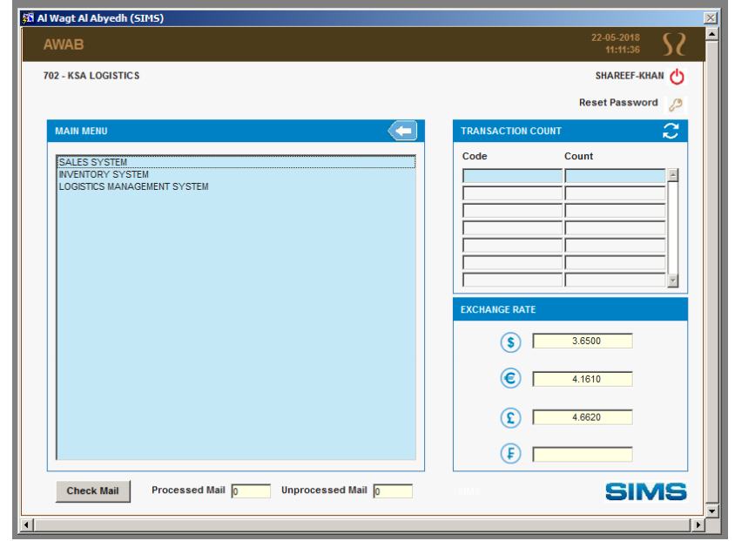

GRN PRINT

From Main Screen
- Click INVENTORY SYSTEM
- Click INVENTORY REPORT
- Click GRN INVOICE PRINT
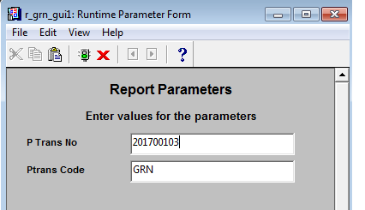

Steps to follow.
- Type GRN Number – (XXXXXX)
- Click ENTER Button

REPORT TEMPLATE

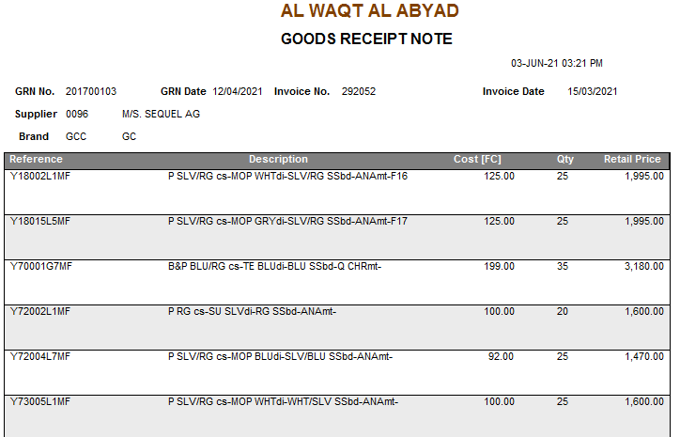

GRN CONFIRMATION

From Main Screen
- Click INVENTORY SYSTEM
- Click INVENTORY TRANSACTIONS
- Click LTO/LTI/GRN CONFIRMATION
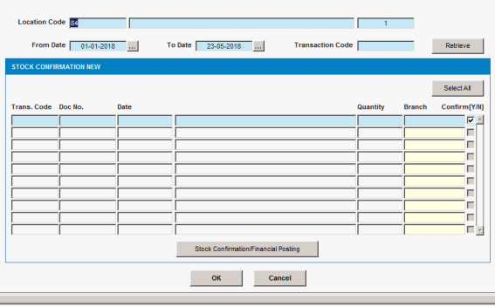

Steps to follow.
- Type Location Code – (702)
- Select Date (From – To)
- Type Transaction Code (GRN)
- Click Retrieve Button
- Select Required Document Number from Generated List ()
- Click STOCK CONFIRMATION/FINANCIAL POSTING

IF ANY AMENDMENT REQUIRED IN GRN AFTER PHYSICAL CHECK

From Main Screen
- Click INVENTORY SYSTEM
- Click INVENTORY TRANSACTIONS
- Click GRN STATUS UPDATE

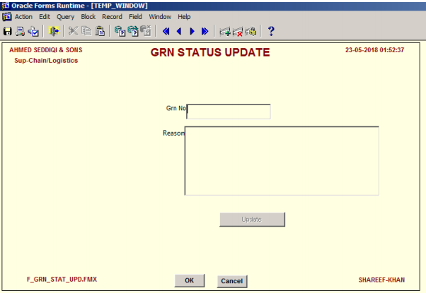

Steps to follow.
- Type GRN Number – (XXXXXXX)
- In Reason Column Type the Reason for Amendment - (i.e., Discrepancy in Shipment)
- Click Update Button
- Click OK Button

SUB DEALER INVOICE PREPARATION (Quotation to Invoice Conversion)

From Main Screen
- Click SALES SYSTEM
- Click SALES TRANSACTIONS
- Click QUOTATION TO INV CONVERSION (FOR ITEMS W/O SERIAL)
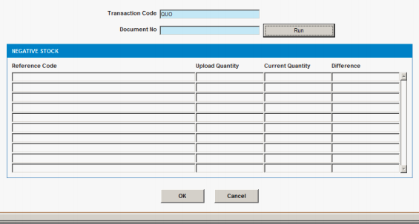

Steps to follow.
- Enter Document No - (XXXXXXXX)
- Click Run Button and then Press OK.
- Once OK Button clicked, system generate invoice and below INVOICE (INV EDITABLE) Form will popup automatically.

INVOICE (INV EDITABLE)

- Once INVOICE (INV EDITABLE) Form Popup Continuously press Enter button until it reaches to Reference Field
- Enter Quotation Number in Reference Field then press Enter Button.
- Select Employee Code Number on Prepared By Field by pressing three dot button then press Enter Button.
- Select Employee Code Number on Rechecked By Field by pressing three dot button then press Enter Button.
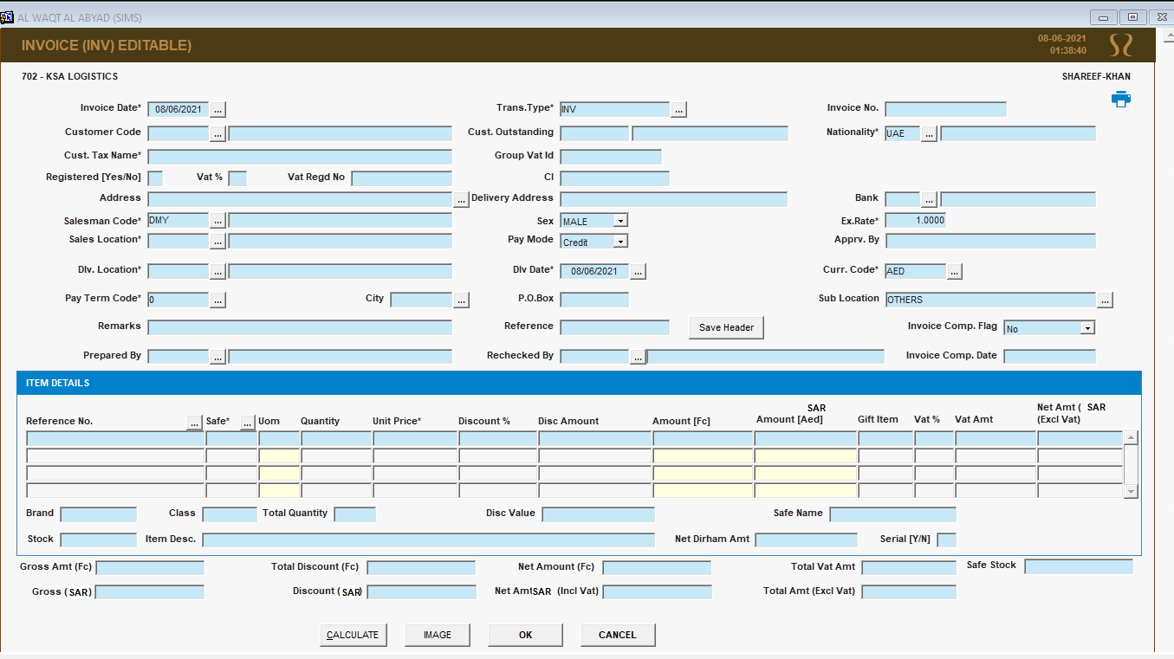

- Click CALCULATE Button.
- Then Click OK Button to Generate invoice.

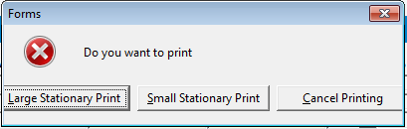

- Click Large Stationary Print Button. Invoice will popup automatically. Note the Invoice Number and inform AWAA through email. For Invoice confirmation follow below process.

INVOICE CONFIRMATION

From Main Screen
- Click INVENTORY SYSTEM
- Click INVENTORY TRANSACTIONS
- Click LTO/LTI/GRN CONFIRMATION

Steps to follow.
- Type Location Code – (702)
- Select Date (From – To)
- Type Transaction Code (INV)
- Click Retrieve Button
- Select Required Document Number from Generated List ()
- Click STOCK CONFIRMATION/FINANCIAL POSTING


LOCATION TRANSFER OUT (LTO) - Creation

From Main Screen
- Click INVENTORY SYSTEM
- Click INVENTORY TRANSACTIONS
- Click LOCATION TRANSFER OUT (LTO)
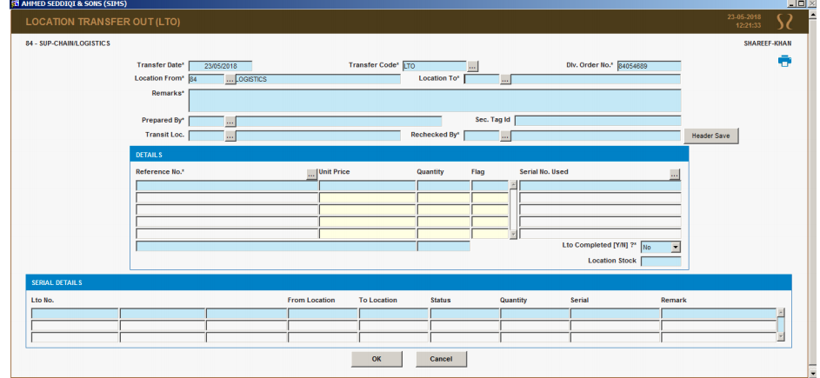

Steps to follow.
- In Location To Field, enter the location code where you need to transfer the Item.
- In Remarks Field enter the remarks. i.e., Number of watches or specific document number.
- Select Employee Code Number on Prepared By Field by pressing three dot button then press Enter Button.
- In Sec. Tag ID Field enter the security seal number. If no Security Seal Enter “0”
- Select Employee Code Number on Rechecked By Field by pressing three dot button then press Enter Button.
- Then Click Header Save Button
- In Reference No Field enter the Reference Number of the item and press Enter button.
- If the items are with serial number, Serial No Field will popup. Enter the Serial Number and then press Enter Button.
- If the items are without serial number, in Quantity Field enter the quantity and then press Enter Button.
- If you have different items, continue the process to enter Reference No and Quantity fields.
- Once all the items are entered, then select YES on LTO Completed [Y/N] field.
- Then press OK button to save the transaction.

LOCATION TRANSFER OUT (LTO) - Confirmation

From Main Screen
- Click INVENTORY SYSTEM
- Click INVENTORY TRANSACTIONS
- Click LTO/LTI/GRN CONFIRMATION

Steps to follow.
- Type Location Code – (702)
- Select Date (From – To)
- Type Transaction Code (LTO)
- Click Retrieve Button
- Select Required Document Number from Generated List ()
- Click STOCK CONFIRMATION/FINANCIAL POSTING

