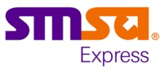 | SMSA Express Transportation Co., Ltd.  P.O. Box 63259 Riyadh 11526, K.S.A. | Document ID: | SMSA-HW01
 | STANDARD OPERATING PROCEDURE  INBOUND RECEIVING PROCESS | Revision No: | 02
 | STANDARD OPERATING PROCEDURE  INBOUND RECEIVING PROCESS | Effective Date: | 01/7/2026
 | STANDARD OPERATING PROCEDURE  INBOUND RECEIVING PROCESS | Next Revision Date: | 30/06/2029
 | STANDARD OPERATING PROCEDURE  INBOUND RECEIVING PROCESS | Function: | Warehouse
 | STANDARD OPERATING PROCEDURE  INBOUND RECEIVING PROCESS | Page: | Page 1 of 11

1.0 PURPOSE
1.1 This document is issued to standardize the inbound operations, make sure there are legal and valid orders and evidence during the inbound, as well, inbound information can be accurately maintained to system/standing-book in time, guarantee the inventory's asset security and consistency between inventory and account.
2.0 SCOPE
2.1 This procedure is applicable to all SMSA Employees working with Huawei Spare part Warehouse.
3.0 ABBREVIATIONS / DEFINITIONS
No. | Term | Description
3.1 | SOP | Standard Operating Procedure
3.2 | POD | Proof of Delivery
3.3 | & | And
3.4 | CWMS | Central Warehouse Management System
3.5 | % | Percent
3.6 | SKU | Stock Keeping Unit
4.0 RESPONSIBILITY
4.1 The receiving shipping operator/team leader shall be responsible for ensuring the procedure implementation and update for this procedure to fulfill operational and customer requirements.
4.2 Any special written notice/ specific requirements from customer will overwrite the procedure as stated below.
4.3 It is also the responsibility of SMSA Project Manager to implement the SOP.
4.4 It is the responsibility of receiving shipping operator/team leader for the quality checking of shipment and approval for receiving.

 |  |  | Name & Designation | Signature |  | Date
 | Author/Originator of the DOC change |  | Firthows Ahmed
 | Reviewer (Process Owner) |  | Aneesh Sebastian
 | Approving Authority |  | Hussein Mustafa Badawy
 |  | SMSA Express Transportation Co., Ltd.  P.O. Box 63259 Riyadh 11526, K.S.A. |  |  | Document ID: |  | SMSA-HW01
 |  | STANDARD OPERATING PROCEDURE  INBOUND RECEIVING PROCESS |  |  | Revision No: |  | 02
 |  |  |  |  | Effective Date: |  | 01/7/2026
 |  |  |  |  | Next Revision Date: |  | 30/06/2029
 |  |  |  |  | Function: |  | Warehouse
 |  |  |  |  | Page: |  | Page 2 of 11

5.0 PROCEDURE
5.1 The Inbound receiving process starts with the receiving shipping operator/team leader checks the delivery/appointment schedule with Supplier or Customer. The Inbound pre alert shall be sent via email from the customer to SMSA.
5.2 Receiving shipping operator/team leader shall check the appointment schedule for the inbound receiving and plan the unloading and space accordingly.
5.3 Once the supplier is available with shipment, the receiving shipping operator/team leader shall check the following details:
5.3.1 Packing List from pre alert email.
5.3.2 Invoice/Delivery challan copy.
5.3.3 POD copy of supplier.
5.3.4 Any physical damage to the vehicle.
5.4 After checking all above details and found satisfactory, the receiving shipping operator/team leader shall proceed to unload the truck or vehicle.
5.5 If the above details are found unsatisfactory, then the receiving shipping operator/team leader shall hold the shipment, provide the reason to the supplier, and ask the supplier to correct the details. Same shall be communicated to the Customer and shall wait for the instruction from Customer for further actions.
5.6 Receiving shipping operator/team leader shall sign the POD copy to supplier by counting the actual boxes/Pallets mentioned on the supplier's delivery challan.
5.7 After unloading, the receiving shipping operator/team leader shall check the following details:
5.7.1 Item's description as per packing list vs Invoice vs Physical.
5.7.2 Item's quantity as per packing list vs Invoice vs Physical.
5.7.3 Any physical damage on boxes or material.
5.8 If all above details are found satisfactory, then the receiving shipping operator/team leader shall acknowledge the receipt of material.

 | Name & Designation | Signature | Date
Author/Originator of the DOC change | Firthows Ahmed
Reviewer (Process Owner) | Aneesh Sebastian
Approving Authority | Hussein Mustafa Badawy

 | SMSA Express Transportation Co., Ltd.  P.O. Box 63259 Riyadh 11526, K.S.A. | Document ID: | SMSA-HW01
 | STANDARD OPERATING PROCEDURE  INBOUND RECEIVING PROCESS | Revision No: | 02
 | STANDARD OPERATING PROCEDURE  INBOUND RECEIVING PROCESS | Effective Date: | 01/7/2026
 | STANDARD OPERATING PROCEDURE  INBOUND RECEIVING PROCESS | Next Revision Date: | 30/06/2029
 | STANDARD OPERATING PROCEDURE  INBOUND RECEIVING PROCESS | Function: | Warehouse
 | STANDARD OPERATING PROCEDURE  INBOUND RECEIVING PROCESS | Page: | Page 3 of 11

5.9 If any of the details as per point 5.7 are found unsatisfactory or any discrepancy is noted, the receiving shipping operator/team leader shall seek the Customer representative for a decision to reject or accept. Once the shipment is rejected, the operator/team leader shall note down the reason for rejection and items to be rejected, and reschedule the delivery with the help of the customer with correct details.

5.10 Receiving shipping operator/team leader then starts the receiving process in CWMS system as below:
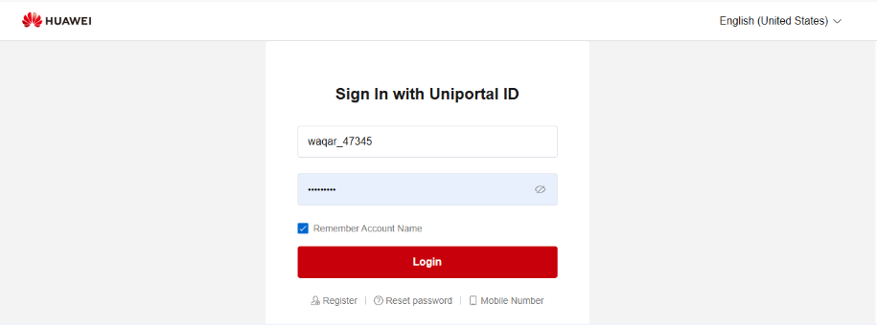
5.10.1 Enter cwms.huawei.com in Internet Explorer and enter the login interface of CWMS. Enter the account number and password to log in. Select the corresponding warehouse name.

 |  | Name & Designation | Signature |  | Date
Author/Originator of the DOC change |  | Firthows Ahmed
Reviewer (Process Owner) |  | Aneesh Sebastian
Approving Authority |  | Hussein Mustafa Badawy
 | SMSA Express Transportation Co., Ltd.  P.O. Box 63259 Riyadh 11526, K.S.A. |  |  | Document ID: |  | SMSA-HW01
 | STANDARD OPERATING PROCEDURE  INBOUND RECEIVING PROCESS |  |  | Revision No: |  | 02
 |  |  |  | Effective Date: |  | 01/7/2026
 |  |  |  | Next Revision Date: |  | 30/06/2029
 |  |  |  | Function: |  | Warehouse
 |  |  |  | Page: |  | Page 4 of 11

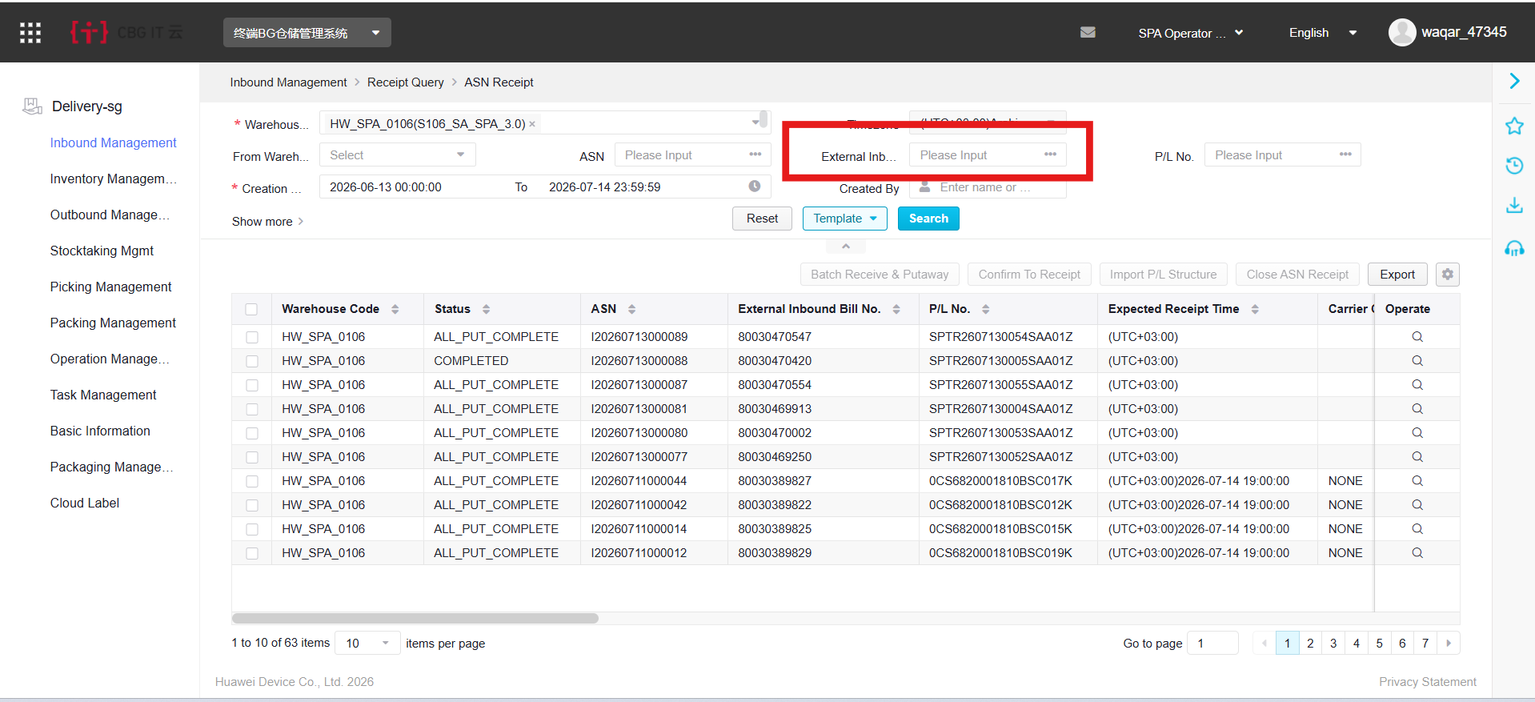
5.10.2 ASN Receipt - Select WMS Inbound -> Inbound ASN/Receipt, click do the search or enter the specific Receipt number in the External Receipt box to find.

5.10.3 Click on the far left of the document bank to enter the document details interface. You can see the goods, description, quantity and sub-warehouse under the current document.
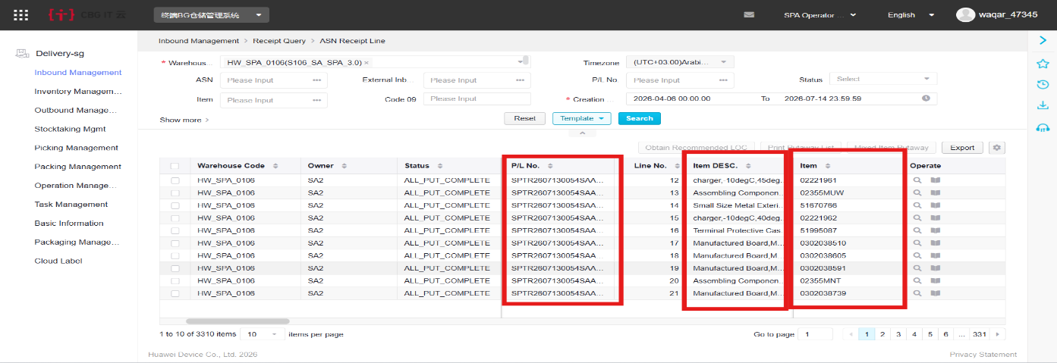

 |  | Name & Designation | Signature |  | Date
Author/Originator of the DOC change |  | Firthows Ahmed
Reviewer (Process Owner) |  | Aneesh Sebastian
Approving Authority |  | Hussein Mustafa Badawy
 | SMSA Express Transportation Co., Ltd.  P.O. Box 63259 Riyadh 11526, K.S.A. |  |  | Document ID: |  | SMSA-HW01
 | STANDARD OPERATING PROCEDURE  INBOUND RECEIVING PROCESS |  |  | Revision No: |  | 02
 |  |  |  | Effective Date: |  | 01/7/2026
 |  |  |  | Next Revision Date: |  | 30/06/2029
 |  |  |  | Function: |  | Warehouse
 |  |  |  | Page: |  | Page 5 of 11

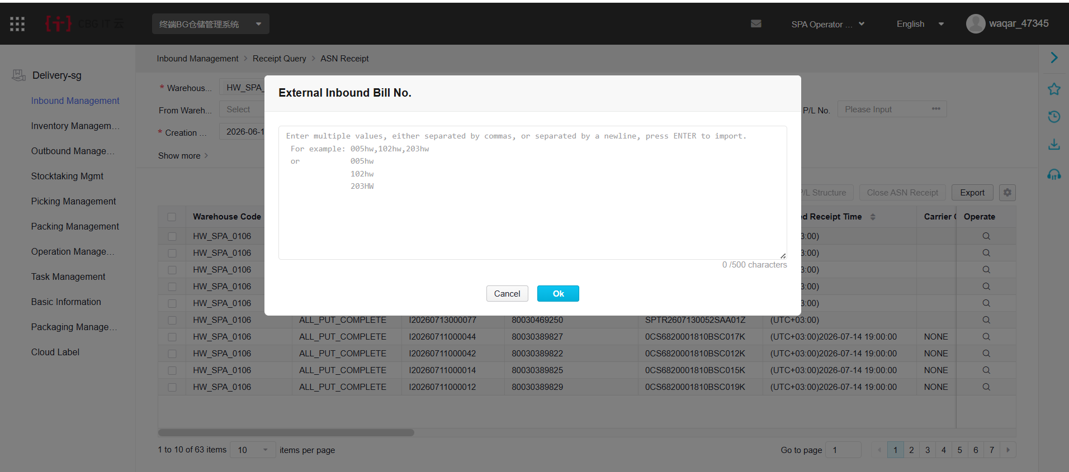
5.10.4 ASN Receive - In the ASN receiving interface, select the corresponding document status or input document at External Receipt for searching.
5.10.5 Click on the far left of the document bank to enter the document details interface. You can see the goods, description, quantity and sub-warehouse under the current document.
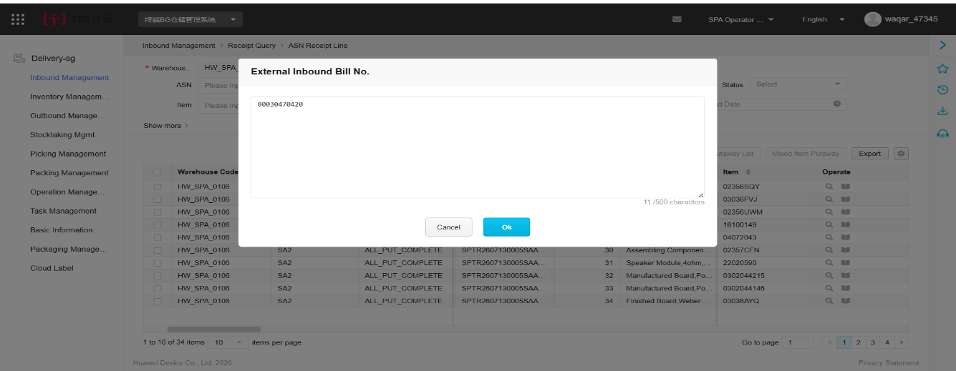
 | Name & Designation | Signature | Date
Author/Originator of the DOC change | Firthows Ahmed
Reviewer (Process Owner) | Aneesh Sebastian
Approving Authority | Hussein Mustafa Badawy

 | SMSA Express Transportation Co., Ltd.  P.O. Box 63259 Riyadh 11526, K.S.A. | Document ID: | SMSA-HW01
 | STANDARD OPERATING PROCEDURE  INBOUND RECEIVING PROCESS | Revision No: | 02
 | STANDARD OPERATING PROCEDURE  INBOUND RECEIVING PROCESS | Effective Date: | 01/7/2026
 | STANDARD OPERATING PROCEDURE  INBOUND RECEIVING PROCESS | Next Revision Date: | 30/06/2029
 | STANDARD OPERATING PROCEDURE  INBOUND RECEIVING PROCESS | Function: | Warehouse
 | STANDARD OPERATING PROCEDURE  INBOUND RECEIVING PROCESS | Page: | Page 6 of 11

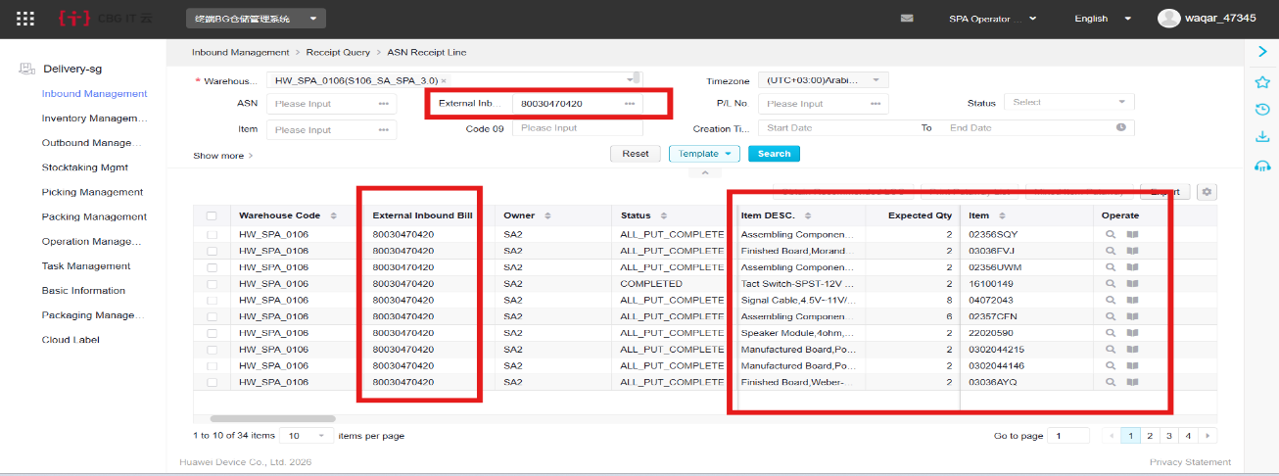
5.10.6 Check the corresponding code line after confirming the correct number of goods received according to the code, and select Submit to complete the goods received.
5.10.7 ASN Putaway - In the ASN shelf interface, select the corresponding document status or input document at External Receipt for searching.
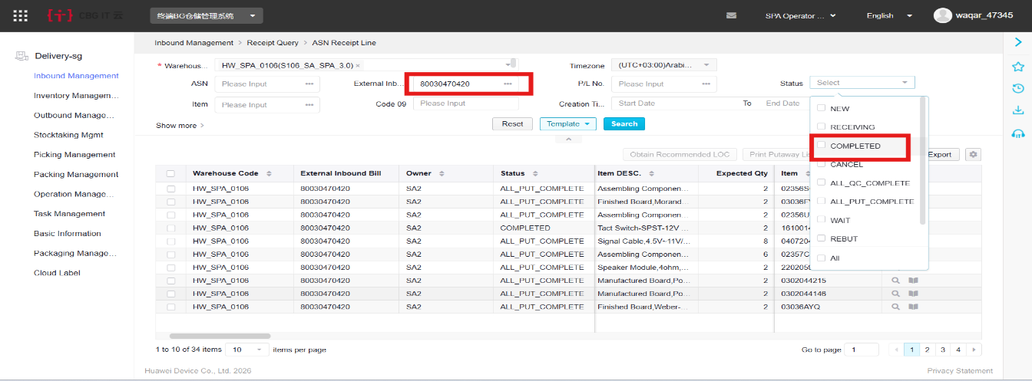

 | Name & Designation | Signature | Date
Author/Originator of the DOC change | Firthows Ahmed
Reviewer (Process Owner) | Aneesh Sebastian
Approving Authority | Hussein Mustafa Badawy

 | SMSA Express Transportation Co., Ltd.  P.O. Box 63259 Riyadh 11526, K.S.A. | Document ID: | SMSA-HW01
 | STANDARD OPERATING PROCEDURE  INBOUND RECEIVING PROCESS | Revision No: | 02
 | STANDARD OPERATING PROCEDURE  INBOUND RECEIVING PROCESS | Effective Date: | 01/7/2026
 | STANDARD OPERATING PROCEDURE  INBOUND RECEIVING PROCESS | Next Revision Date: | 30/06/2029
 | STANDARD OPERATING PROCEDURE  INBOUND RECEIVING PROCESS | Function: | Warehouse
 | STANDARD OPERATING PROCEDURE  INBOUND RECEIVING PROCESS | Page: | Page 7 of 11

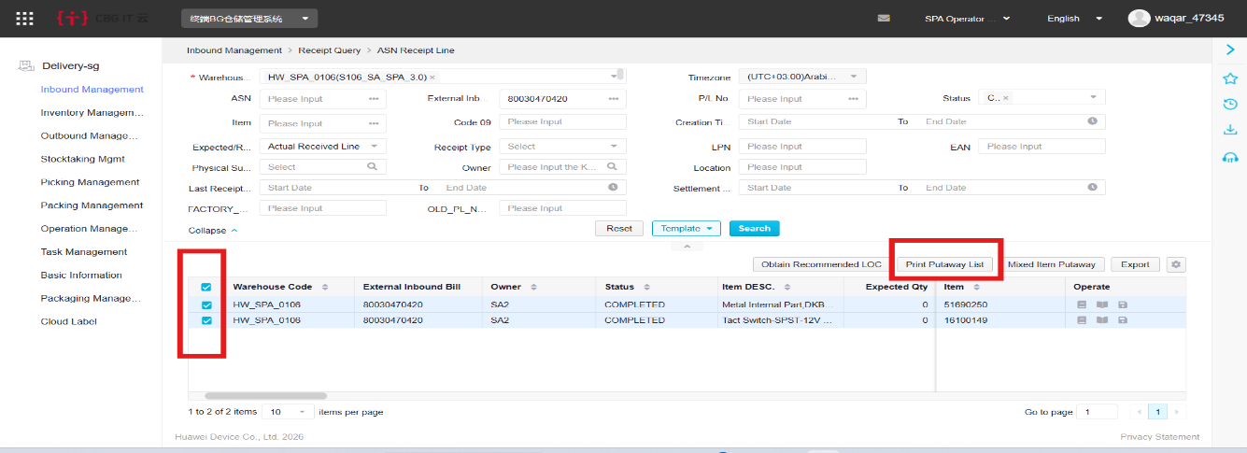
5.10.8 Select the document that needs to be shelved and click on the printing button to print the list.

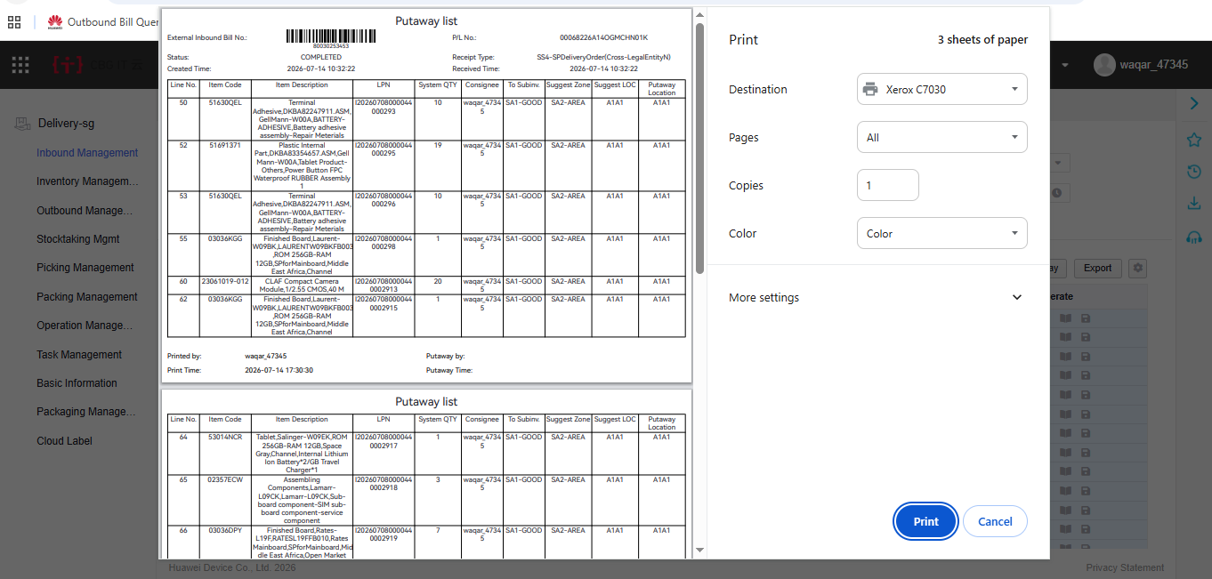
5.10.9 According to the current encoding in the library, the shelf listing sheet recommends the shelf storage location with the dimension of 'Item + sub-library', and the current unstocked coding is recommended to be empty.

 | Name & Designation | Signature | Date
Author/Originator of the DOC change | Firthows Ahmed
Reviewer (Process Owner) | Aneesh Sebastian
Approving Authority | Hussein Mustafa Badawy

 | SMSA Express Transportation Co., Ltd.  P.O. Box 63259 Riyadh 11526, K.S.A. | Document ID: | SMSA-HW01
 | STANDARD OPERATING PROCEDURE  INBOUND RECEIVING PROCESS | Revision No: | 02
 | STANDARD OPERATING PROCEDURE  INBOUND RECEIVING PROCESS | Effective Date: | 01/7/2026
 | STANDARD OPERATING PROCEDURE  INBOUND RECEIVING PROCESS | Next Revision Date: | 30/06/2029
 | STANDARD OPERATING PROCEDURE  INBOUND RECEIVING PROCESS | Function: | Warehouse
 | STANDARD OPERATING PROCEDURE  INBOUND RECEIVING PROCESS | Page: | Page 8 of 11

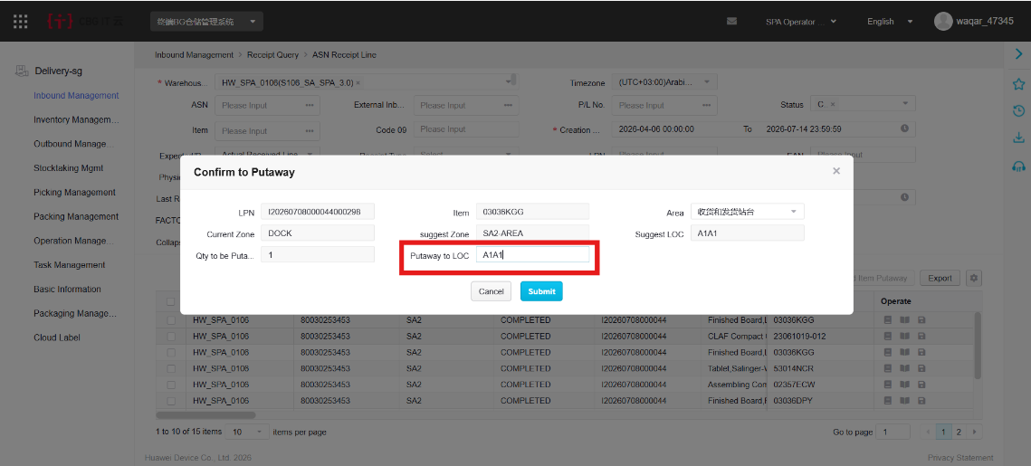
5.10.10 Click the button to the left of the document to be published, and expand the current document details. Maintain the corresponding racking position, check the corresponding code, and click the 'Putaway' button to execute the rack.

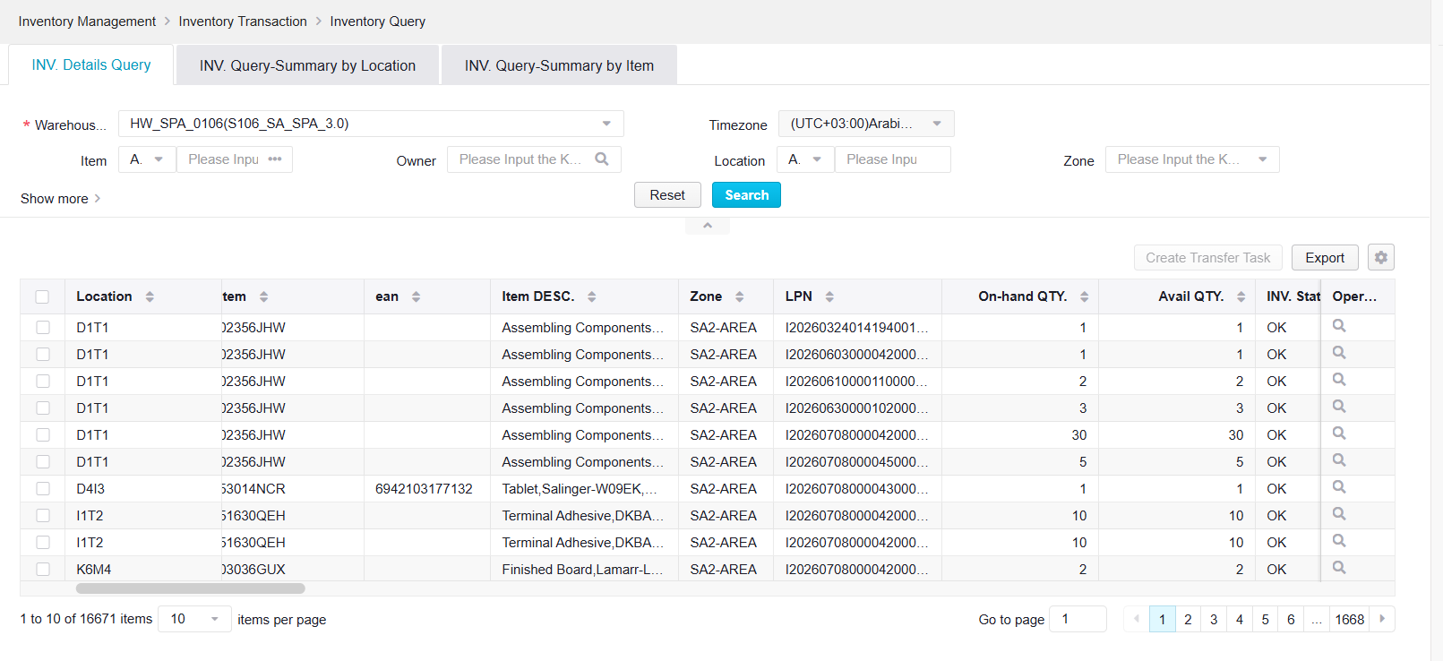
5.10.11 Store Query - WMS Execution -> Inventory -> Inventory Balances. The serial number is generated by the system in the order in which the inbound order is received. It is composed of the internal single number ASN/Receipt + code line number Line # of the inbound order.

 | Name & Designation | Signature | Date
Author/Originator of the DOC change | Firthows Ahmed
Reviewer (Process Owner) | Aneesh Sebastian
Approving Authority | Hussein Mustafa Badawy

 | SMSA Express Transportation Co., Ltd.  P.O. Box 63259 Riyadh 11526, K.S.A. | Document ID: | SMSA-HW01
 | STANDARD OPERATING PROCEDURE  INBOUND RECEIVING PROCESS | Revision No: | 02
 | STANDARD OPERATING PROCEDURE  INBOUND RECEIVING PROCESS | Effective Date: | 01/7/2026
 | STANDARD OPERATING PROCEDURE  INBOUND RECEIVING PROCESS | Next Revision Date: | 30/06/2029
 | STANDARD OPERATING PROCEDURE  INBOUND RECEIVING PROCESS | Function: | Warehouse
 | STANDARD OPERATING PROCEDURE  INBOUND RECEIVING PROCESS | Page: | Page 9 of 11

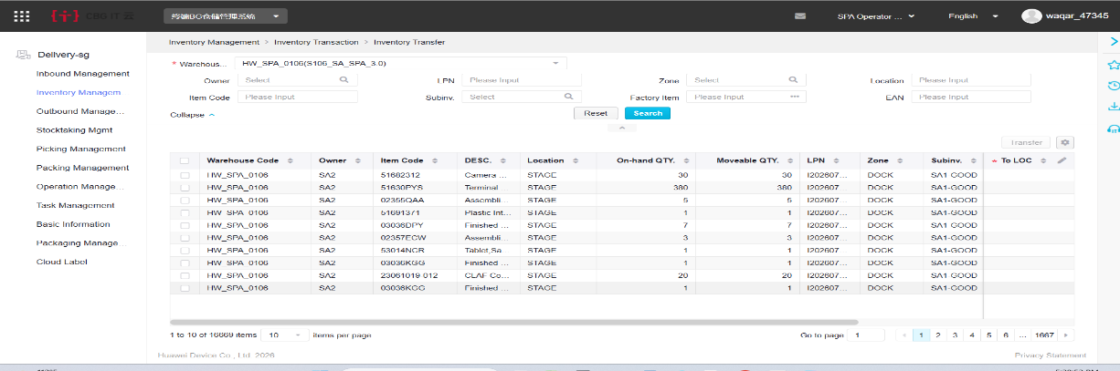
5.10.12 Inventory Query-WMS -> Execution -> Inventory -> Store Query.

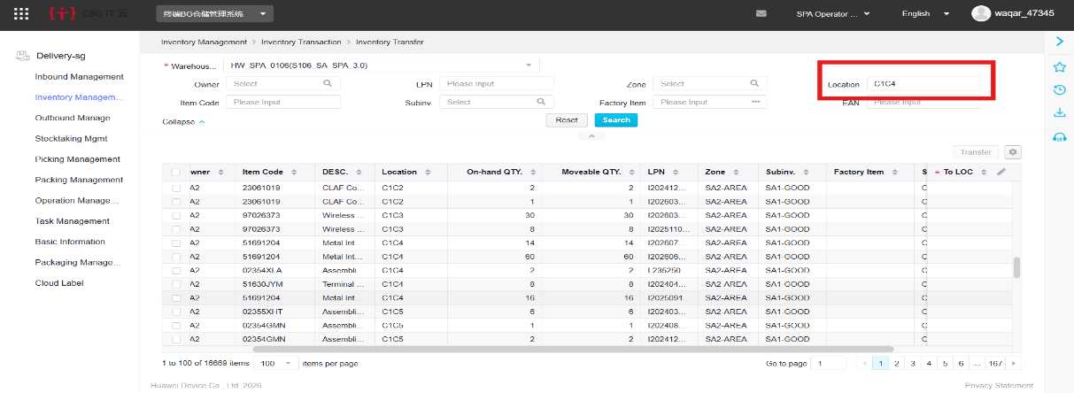
5.10.13 Inventory Query-Summary by location code

 | Name & Designation | Signature | Date
Author/Originator of the DOC change | Firthows Ahmed
Reviewer (Process Owner) | Aneesh Sebastian
Approving Authority | Hussein Mustafa Badawy

 | SMSA Express Transportation Co., Ltd.  P.O. Box 63259 Riyadh 11526, K.S.A. | Document ID: | SMSA-HW01
 | STANDARD OPERATING PROCEDURE  INBOUND RECEIVING PROCESS | Revision No: | 02
 | STANDARD OPERATING PROCEDURE  INBOUND RECEIVING PROCESS | Effective Date: | 01/7/2026
 | STANDARD OPERATING PROCEDURE  INBOUND RECEIVING PROCESS | Next Revision Date: | 30/06/2029
 | STANDARD OPERATING PROCEDURE  INBOUND RECEIVING PROCESS | Function: | Warehouse
 | STANDARD OPERATING PROCEDURE  INBOUND RECEIVING PROCESS | Page: | Page 10 of 11

5.11 Receiving shipping operator/team leader shall check the inventory for the inbound transactions for each day after Putaway in the system for inventory accuracy.
5.12 Annexure-A shall be used for checking the inventory.
5.13 All related documents shall be filed for record purposes.
5.14 Environment, Health and Safety considerations:
5.14.1 Vehicles/Trucks delivering the inbound shipment shall turn off their engine during unloading the truck.
5.14.2 Safe manual lifting practices shall be followed.
6.0 NOTE
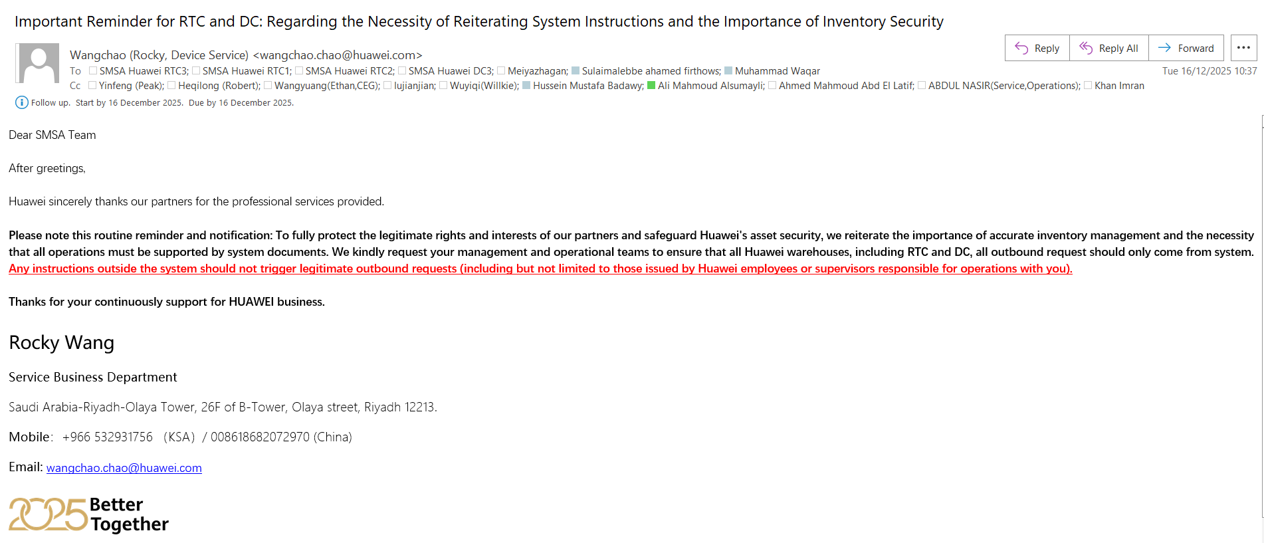
6.1 Stoppage of all manual process as per the email confirmation from Huawei. Email attached.

 | Name & Designation | Signature | Date
Author/Originator of the DOC change | Firthows Ahmed
Reviewer (Process Owner) | Aneesh Sebastian
Approving Authority | Hussein Mustafa Badawy

 | SMSA Express Transportation Co., Ltd.  P.O. Box 63259 Riyadh 11526, K.S.A. | Document ID: | SMSA-HW01
 | STANDARD OPERATING PROCEDURE  INBOUND RECEIVING PROCESS | Revision No: | 02
 | STANDARD OPERATING PROCEDURE  INBOUND RECEIVING PROCESS | Effective Date: | 01/7/2026
 | STANDARD OPERATING PROCEDURE  INBOUND RECEIVING PROCESS | Next Revision Date: | 30/06/2029
 | STANDARD OPERATING PROCEDURE  INBOUND RECEIVING PROCESS | Function: | Warehouse
 | STANDARD OPERATING PROCEDURE  INBOUND RECEIVING PROCESS | Page: | Page 11 of 11

7.0 RECORD
Title of Record | Custodian | Retention Period
Packing list | Team Leader | 03 Year
ANNEXURE-A | Team Leader | 03 Year
8.0 ATTACHMENT
8.1 ANNEXURE-A
9.0 DOCUMENT CHANGE RECORD
Rev No. | Effective Date | Nature of Change | Document Change Request No:
00 |  | New Document
01 |  | Periodic Review, No Change

END OF THE DOCUMENT

 | Name & Designation | Signature | Date
Author/Originator of the DOC change | Firthows Ahmed
Reviewer (Process Owner) | Aneesh Sebastian
Approving Authority | Hussein Mustafa Badawy

Annexure-B
(To be used in conjunction with SOP No. SMSA-HC18)

"Read and Understood"

I have read and under stood the following procedure:

SOP No. : SMSA-HW01
Revision No. : 02
SOP Title : INBOUND PROCESS

Name : Emp No :

Sign : Date :

Annexure-A
(To be used in conjunction with SOP No. SMSA-HC18)

Training Document

SOP No.: SMSA-HW01 Revision No: 02
SOP Title: INBOUND PROCESS
Trainer: Emp No: Sign:
Place: Date: Duration (in hours):

The above subject information was preserved to me as part of SMSA training program. I have read and / or understand the material and have had the opportunity to discuss this material with trainer.
Trainees
Emp. No. | Name | Signature | Date

