1.0 PURPOSE
1.1 This document lays down to standardize the outbound operations of device spare parts, make sure there are legal and valid orders and evidence during the outbound, as well, outbound information can be accurately maintained to system/standing-book in time, guarantee the inventory's asset security and consistency between inventory and account.
2.0 SCOPE
2.1 This procedure is applicable to all SMSA warehouse personnel involved in the Outbound Process.
3.0 ABBREVIATIONS / DEFINITION

No. | Term | Description
3.1 | SOP | Standard Operating Procedure
3.2 | AWB | Air-waybill
3.3 | No. | Number
3.4 | SLA | Service Level Agreement
3.5 | POD | Proof of Delivery
3.6 | & | and
3.7 | CWMS | Central Warehouse Management System
4.0 RESPONSIBILITY
4.1 The SMSA Project Team Leader/Receiving shipping operator shall be responsible for the implementation and update of this procedure to fulfill operational and customer requirements.
4.2 The Receiving shipping operator/team leader shall be responsible for the execution and adherence to the procedure.
4.3 The Receiving shipping operator/team leader shall check the CWMS system for Orders before cut off time per agreed SLA.
4.4 All the items shall be checked and inspect by Receiving shipping operator/team leader prior dispatching to the customers.
5.0 PROCEDURE
5.1 Receiving shipping operator/team leader checks the CWMS for open Orders to be processed.
5.2 Receiving shipping operator/team leader shall check the sufficient quantities available in the CWMS for allocation or not. If not then the issue shall be raised to customer and wait for customer decision for cancel the order or to process the Order with available quantity.
5.3 If stock is sufficient the outbound team/clerk shall allocate orders in CWMS and print the Pick Ticket.
5.4 Receiving shipping operator/team leader picks the items found in the Pick Ticket from the shelves/bins/racks.
5.5 Picked items are then forwarded to the order processing area.
5.6 Receiving shipping operator/team leader shall check all picked items: Item code, Quantity, and physical damage against the Pick Ticket.
5.7 If receiving shipping operator/team leader finds out the picked items without item code label, then they need to print out the item code label, and then stick it on.
5.8 Once the all above parameters are well checking is complete, Receiving/shipping operator/team leader sign documents, that all shipments has passed quality procedures.
5.9 Receiving shipping operator/team leader then pack the shipment ready for delivery.
5.10 Receiving shipping operator/team leader then attaches the air-waybill with the shipment.
5.11 Receiving shipping operator/team leader scan all the AWB by entering the status of shipment that shipment is loaded into truck/van for delivery.
5.12 Receiving shipping operator/team leader now handover all the document containing AWB, to the driver for the deliveries.
5.13 The ready Shipments shall be loaded into Vehicle/trucks.
5.14 A copy of the AWB and Picking Ticket are filed in a labeled binder for archiving purposes.
5.15 Receiving shipping operator/team leader confirms the orders one by one in CWMS system.
5.16 Once the shipment is delivered to the customer driver/ receiving shipping operator/team leader shall confirm the POD by scanning and entering the name of recipient through pod scanner.
5.17 Receiving shipping operator/team leader shall sent confirmation to the Customer with POD for delivered shipments.
5.18 Receiving shipping operator/team leader shall check the inventory for the outbound transactions for each day after Shipped complete in the system for inventory accuracy.
5.19 Also if there any movement, Adjustment in the inventory receiving shipping operator/team leader shall include those transactions in daily inventory count.
5.20 Annexure-A for SOP SMSA-HW01 shall be used for inventory count.
5.21 During processing if there is any empty or leftover cartons, shrink wraps then it shall be send and stored in the cardboard or plastic recycling areas respectively.
5.22 During the movement of cartons it shall be noted that stacking of cartons shall be done properly to prevent the potential of fall down over handlers. Similarly manual lifting has to consider safe practices as outlined in the lifting and carrying method statement.
5.23 CWMS Procedure for Order Processing (HUAWEI)
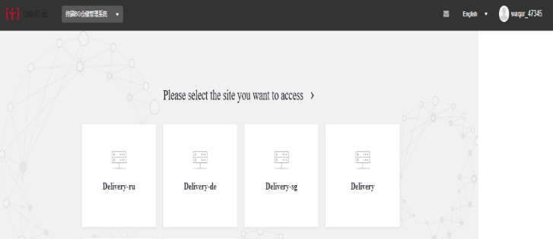
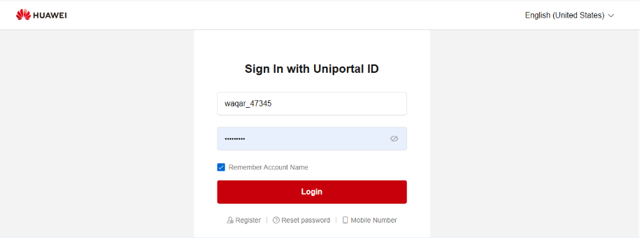
5.23.1 Enter cwms.huawei.com in Internet explorer and enter the login interface of CWMS. Enter the account number and password to log in. Select the corresponding warehouse name.

5.23.2 ASN Shipment Order- Path: WMS -> Outbound -> Shipment Order.

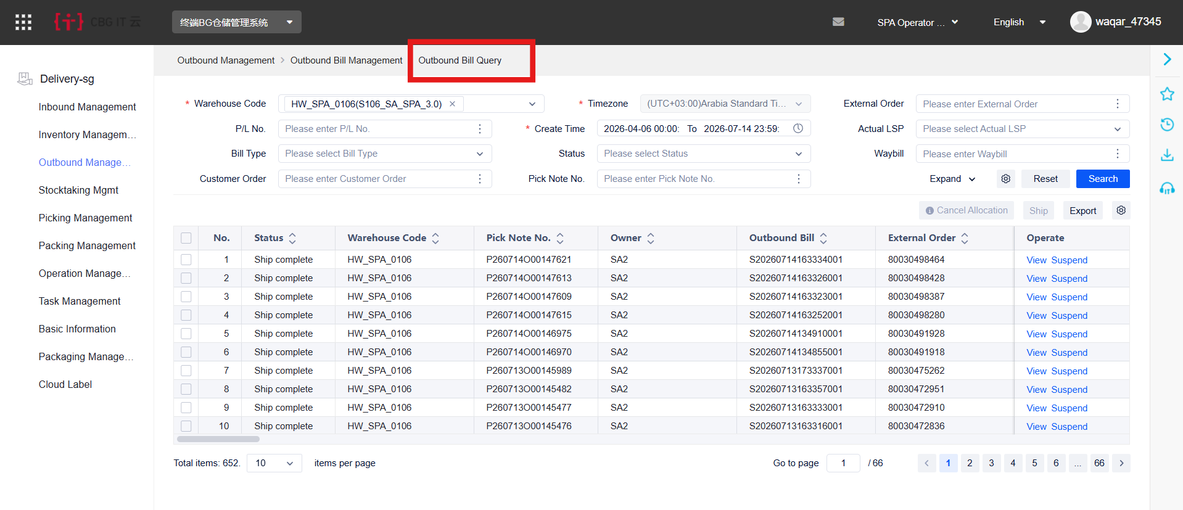
5.23.3 Click Search or enter a specific outgoing document number in the External Order.

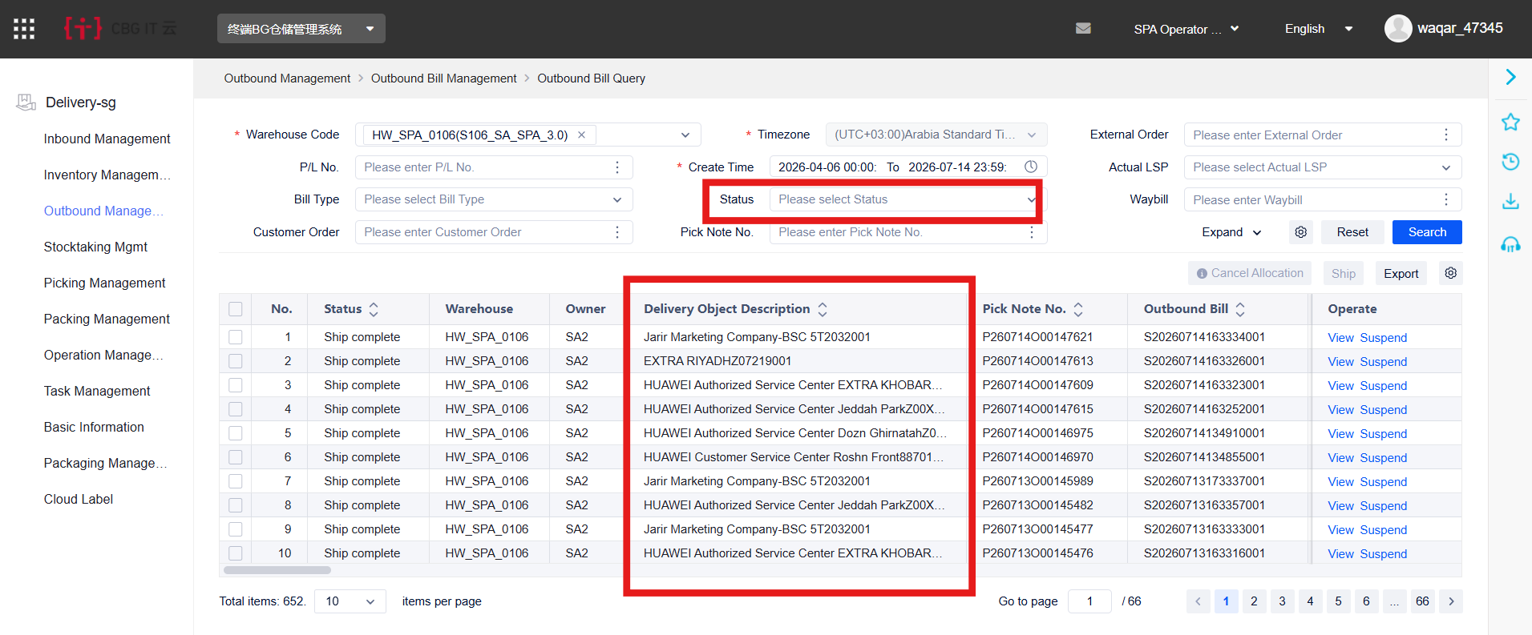
5.23.4 Click on the leftmost side of the document to enter the detailed interface of the document. We can see the goods, drawings, quantities and sub stores under the current documents.

5.23.5 Pick Note Print- Path: WMS -> Outbound -> Pick Note Print.
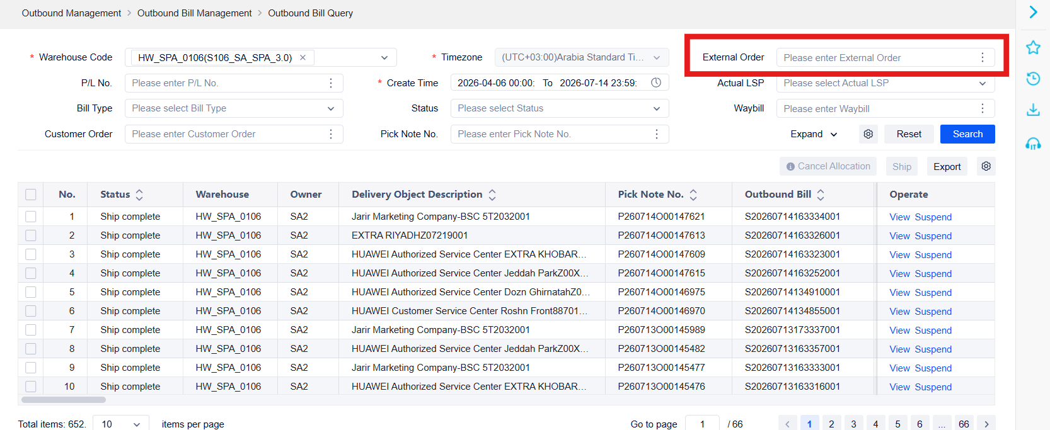
5.23.6 Select the corresponding state of the drop-down status and click Search for the search or enter a specific outgoing document number in the External Order No. column for the search.

5.23.7 Check the number of the document you want to print, and click the Preview or Pick-Note Print button to preview or print. The warehouse can carry out the picking operation in the warehouse according to the goods, the storage position and the quantity on the picking list.
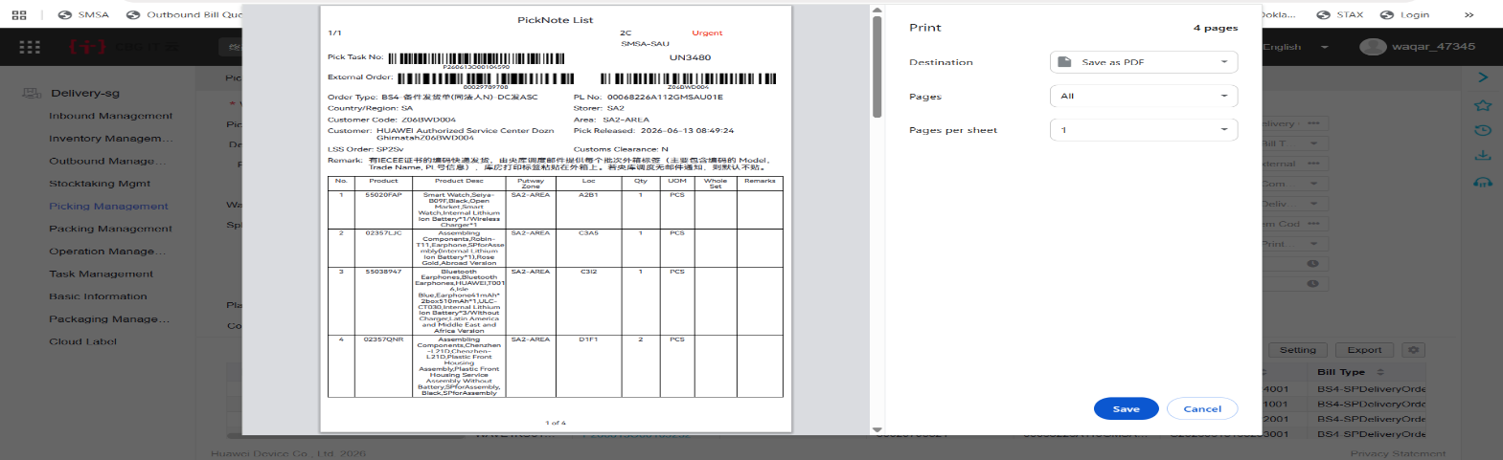
5.23.8 Need Pack 'Packing Confirmation', When Need Pack is Y, it means that the documents need to be 'Packing Confirmation' in the system.
5.23.9 Packing Confirmation-Path: WMS -> Outbound -> Packing Confirmation.
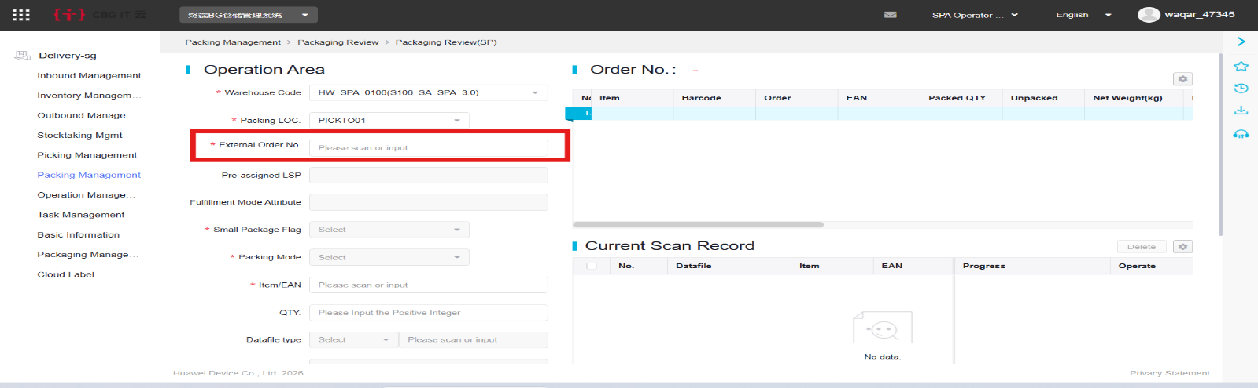
5.23.10 Enter the Order number needed for packaging confirmation in External Order No., and click Search. Input volume and weight according to actual package data.

5.23.11 Decide whether to go HTM according to the actual business. If you provide tender through HTM, click “Save submit HTM”.
5.23.12 “Save Do Not Submit HTM” Otherwise, click “Save Do Not Submit HTM”.
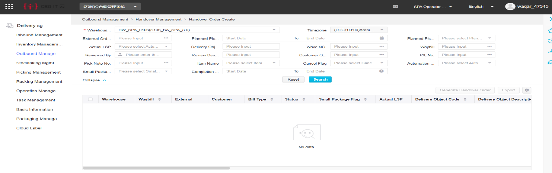

5.23.13 Handover Shipment- Path: WMS -> Outbound -> Handover Shipment.
5.23.14 Enter the Order number required for shipping in External Order No., click Search, or Search according to shipping status.
5.23.15 Order type Scrap Requisition Application/ Subinv Transfer (Different Attribute)/ Mis-out (The order begins with 'ZC'), Need clear the pack date and inquire order.
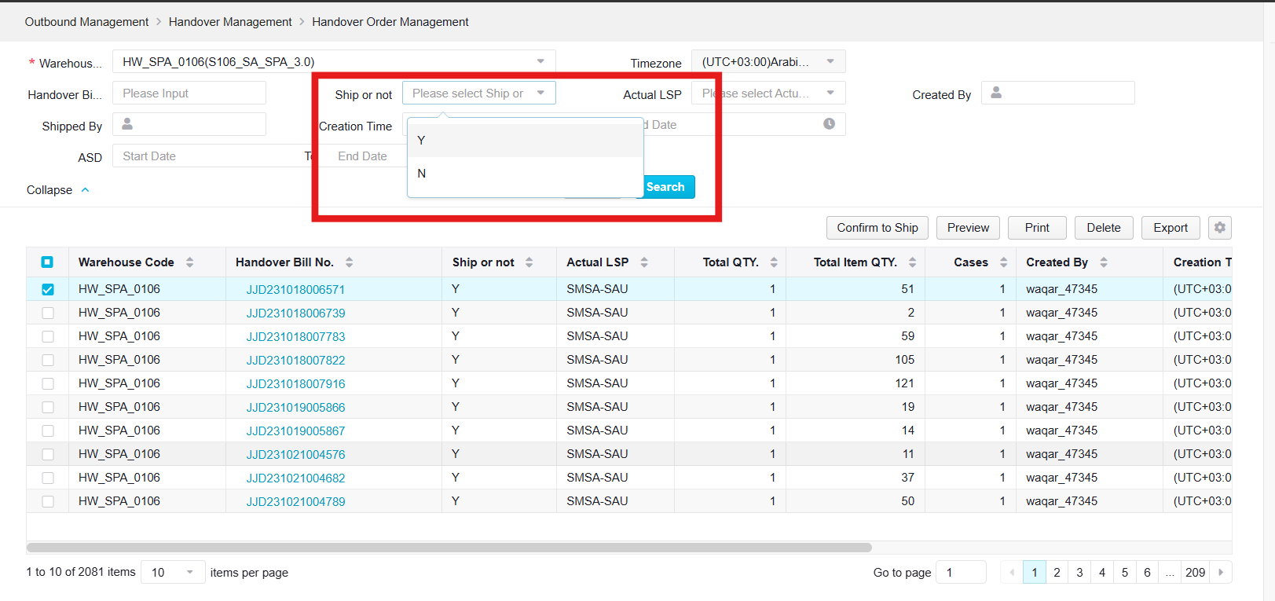
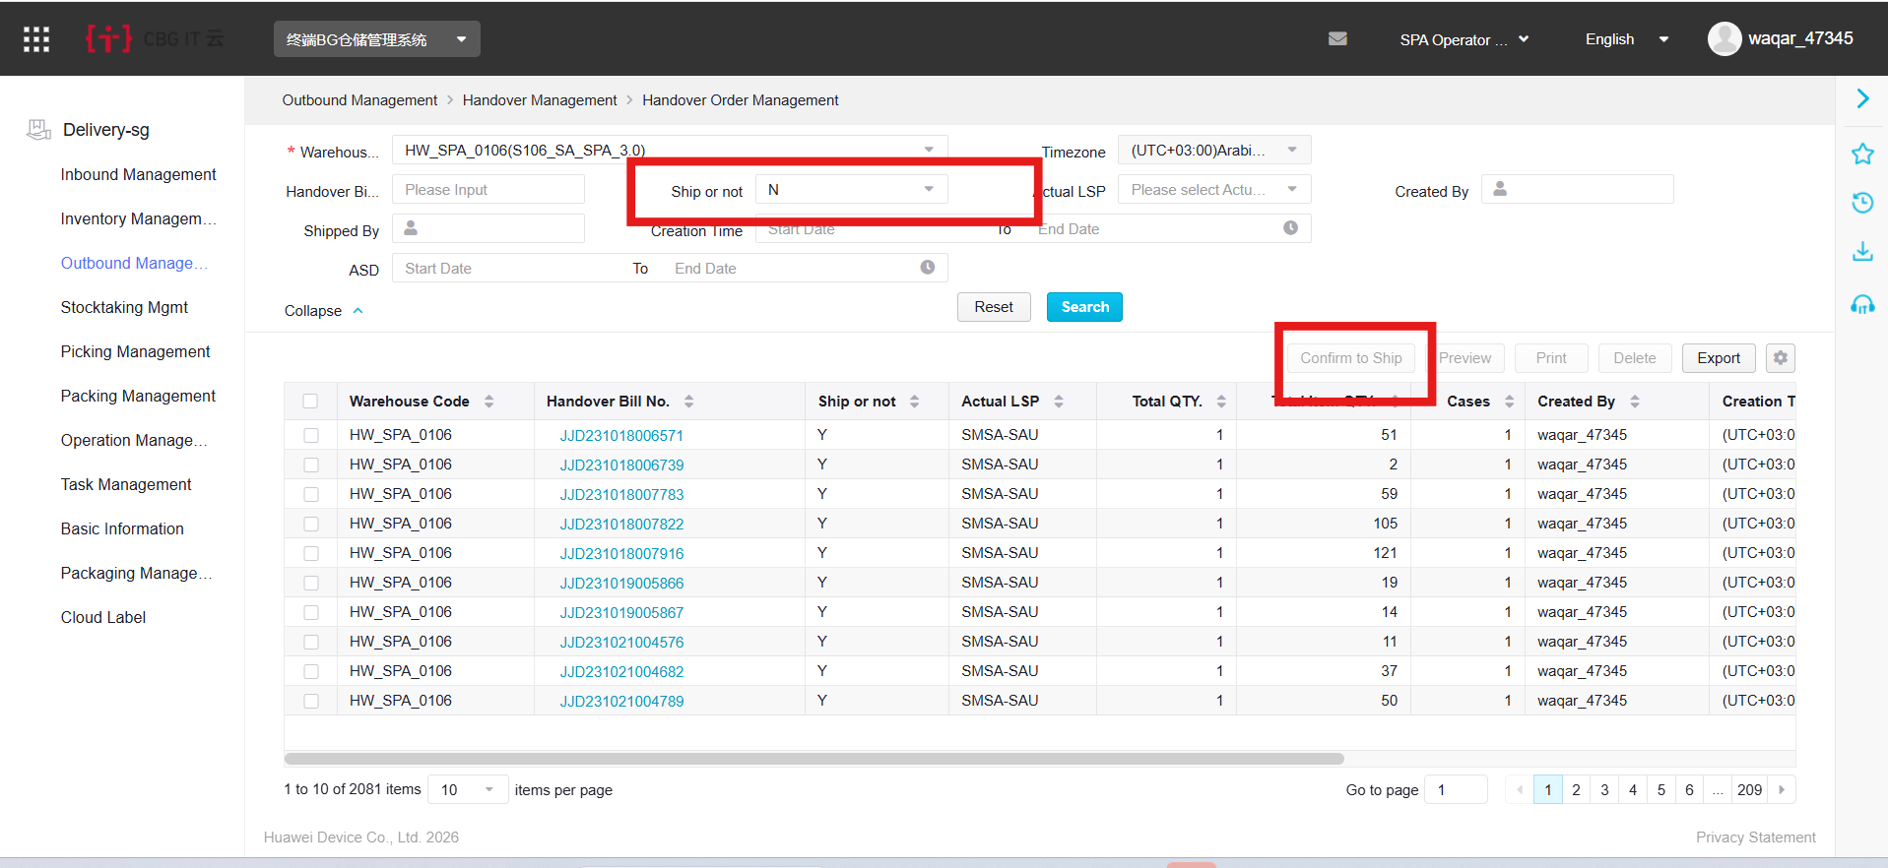
5.23.16 If the order is submitted to HTM, the system will automatically integrate Tender and Carrier Name; If the HTM does not go, the warehouse needs to manually maintain Carrier Name and Ship Order, and then click the Save button. When Can be shipped is 'yes', check the document number that needs to be shipped, and click shipped to deliver the goods.

5.23.17 Outbound KPI Monitoring query- WMS -> Outbound -> Outbound KPI Query.
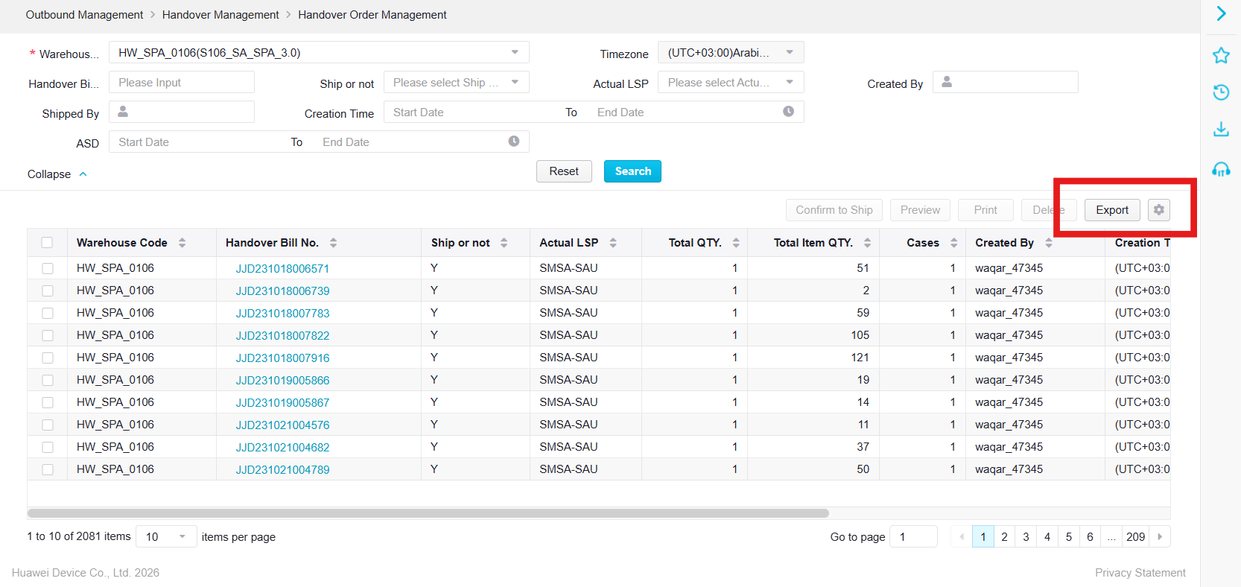
5.23.18 Enter the Order number in External Order No. and click Search, or Search according to Order status or other conditions. The title information can be adjusted for display. The query data can be exported by clicking 'Export'.

6.0 NOTE
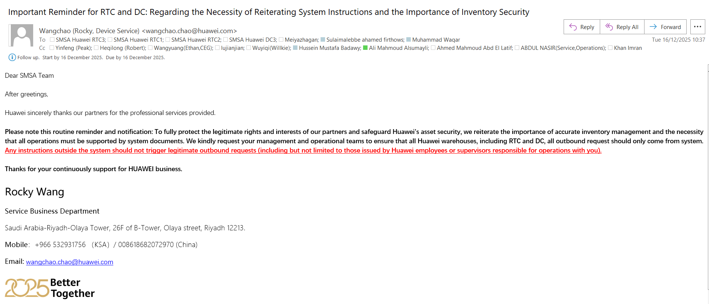
6.1 Stoppage of all manual process as per the email confirmation from Huawei. Email attached.
7.0 RECORD
Title of Record | Custodian | Retention Period
AWB | Team Leader | 03 year
Picking Ticket | Team Leader | 03 year
Annexure-A | Team Leader | 03 year
8.0 ATTACHMENT
8.1 ANNEXURE-A
9.0 DOCUMENT CHANGE RECORD
Rev no. | Effective Date | Nature of change | Document Change Request No.
0 |  | New Document
1 |  | Periodic Review, No Change

END OF DOCUMENT

