

PLAN OVERVIEW 2
I. BCM Structure 7
II. Roles, Responsibilities & Authorities 8
III. Business Impact Analysis & Risk Assessment 9
IV. Business Continuity & Recovery Plan 14
V. Activation Criteria & Procedure 17
VI. Communication & Response Structure 17
VII. Exercise Programme 18
VIII. Evaluation 18
IX. Distribution List 18

PLAN OVERVIEW

Scope
Scope Business Continuity Plans (BCPs) document the activities and information required to recover operations in the event of a disaster or crisis situation while minimizing the additional service disruption and/or financial losses. BCPs are designed to provide for geographical diversity requirements, workplace recovery, work around procedures and other methods to maximize continuity of business operations in the event of a disruption. The plans must be aligned with the criticality rating as identified in the Business Impact Assessment (BIA) results.
Guiding Principles
The following principles will serve as an overall guide for managing an incident of significant adverse event:
- The first priority is the safety and security of our employees, contractors, customers, clients, families, and communities. During an incident, addressing physical security and safety, as well as the psychological wellness of those we serve is critical.
- The second priority is the continuity of our businesses and preservation of our brands. This includes consideration of all business assets, whether financial, physical, or knowledge-based owned or entrusted to us.
- The third priority is the restoration and/or replacement of business operations and/or assets lost or damaged during an incident.
Objectives
The objective of BCP is to direct and guide appropriate actions to assure the capability exists to continue core business functions and activities, and to achieve an orderly recovery from emergency situations across a wide range of potential emergencies or threats, including acts of nature, accidents, technological, and attack-related emergencies.

The objectives of a BCP plan include:
- Identify and document recovery procedures that are implemented in the event of a business disruption.
- Provide for the continuation of the critical business processes over a specific period of time (based on BIA results) yet be able to maintain an acceptable level of service for users of those processes.
- Identify and protect essential equipment, records, and other assets
- Assess and minimize damage and losses
- Provide organizational and operational stability
- Facilitate decision-making during an emergency
- Achieve an orderly recovery from emergency operations.
Assumptions
The Business Continuity Plan has been developed and is maintained on the premise that a worst-case interruption could render facilities totally unusable with no salvageable materials. A result of this worst case scenario is that individual business units would be able to recover from a less serious interruption. It is assumed that sufficient staff would be available to implement the recovery plan, and all data files/vital business records are backed up on a regular basis. For the purpose of this plan, a disaster is defined as “Any situation requiring a possible relocation or use of alternate external resources.” An emergency situation is normally of lesser proportions with recovery being accomplished within the damaged site using alternate internal resources.
Since documentation describing the specific nature of the recovery from all potential emergencies/disasters would yield an impractical and unwieldy plan, the plan will assume full relocation/replacement is required for each element described. Anything less than full relocation replacement will be handled using the same guidelines but with efforts and activities on a proportionally reduced scale.
This document provides a high level overview of SMSA’s Business Continuity framework and general approach. Business Continuity arrangements are determined and maintained in accordance with applicable business requirements, operational risks, regulatory obligations, and approved continuity plans. Specific arrangements may therefore differ by country, business unit, function, facility, or service. This document is intended for general reference and does not replace or supersede applicable Business Continuity Plans, procedures, contractual commitments, or other approved operational arrangements.
Customer specific Business Continuity requirements, where applicable, are subject to separate assessment, agreement, and confirmation by the relevant SMSA business and management functions.
Planning Assumptions
- Assume a complete loss of a single facility during peak processing periods (exception for buildings that are physically joined).
- Personnel with general knowledge of the critical business and technical functions will be available following a disaster.
- The Recovery Time Objective (RTO) begins from time of disaster, not from the time of declaration. The RTO is defined as “the maximum acceptable length of time that can elapse before the interruption of a business function severely impacts the business.”
- An RTO is based upon the level of projected financial exposure, over time, which is acceptable to senior management.
- The Recovery Point Objective (RPO) is that point in time, preceding the interruption, that data must be available and correct to allow business functions to resume operations, following the interruption. Usually, the recovery point objective is the point synchronized backup data is available. The recovery objective is to minimize the amount of data and/or the number of transactions lost as a result of an interruption. To accomplish this, the recovery point objective should be to resume processing at, or as close as possible to, the point of interruption.
- RTOs vary depending on business and system requirements.
- Plans reflect high-level business functions, but may also refer to detailed processes.
- Vital Business Records – Records containing information essential to a firm’s success or survival and whose loss or inaccessibility could cause significant business interruption and/or monetary exposure. Vital records could be computer data or non-computer related records such as paper documents, forms, microfilm, fiche, etc.
- File Backup – All data files required to recover computer operations are backed up on a regular basis and shipped to offsite storage.
Policy
As a baseline of the preparedness for the full range of potential emergencies, all departments within SMSA are required to establish and maintain a viable BCP capability, which ensures the performance of their essential functions during any emergency, or situation that may disrupt normal operations. A viable BCP capability identifies essential functions and consists of plans and procedures, alternate facilities, and alternate interoperable communications and data support systems, reinforced by comprehensive training, orientation, and exercise programs. BCP capabilities must be maintained at a high level of readiness, be capable of being activated both with and without warning, achieve operational status no later than 2-24 hours after activation, and maintain sustained operations for up to 30 days or until termination.
It is the policy of SMSA to respond quickly at all levels in the event of an emergency or threat, to include human, natural, technological, and other emergencies or threats, in order to continue essential internal operations and to provide support to the operations of client and external organizations.
BCPs must be reviewed and updated based on policy requirements or when significant changes occur. Business process owners or managers must maintain an adequate knowledge of their specific responsibilities for the mitigation, preparedness, response and recovery of activities as identified in their plans.

BUSINESS CONTINUITY POLICY STATEMENT
SMSA Express recognizes its responsibilities to operate and maintain its business continuity program both in our facilities as well as external locations where we operate whilst working with our consultants to develop the business continuity program.
- We assess the risks to our operations and understand the impacts of risks
- Manage the identified risks by applying appropriate controls
- Recognize, communicate and respond to incidents in an effective and appropriate manner to minimize impact
- Recover business facilities as quickly as possible , should an incident occur
This policy applies to all SMSA locations we operate in.
All employees of SMSA are committed to the business continuity programs for its continual development and improvement. This policy is reviewed on a regular basis.

Mohannad M.S. Khayyat
Managing Director
(Original Signed)

BCM Structure

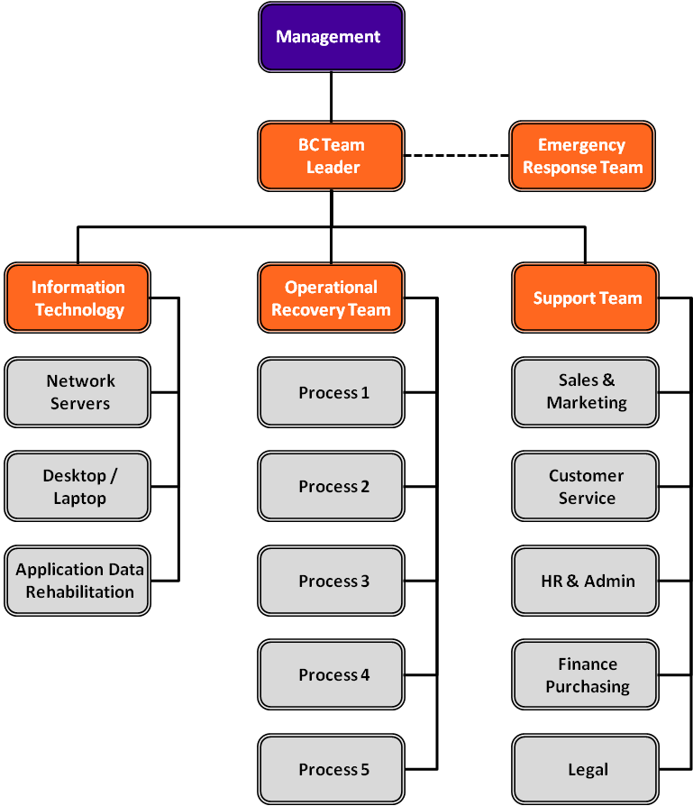

Roles, Responsibilities & Authorities

Below table shows all the roles and responsibilities for all staff who will be involved in the Business continuity plan when an incident happens:

MANAGEMENT | Director – Quality & Risk Management
BC TEAM LEADER | BCM Lead Auditor
EMERGENCY RESPONSE TEAM | Identified ERT department representatives
SUPPORT TEAM | BCM Support Team
INFORMATION TECHNOLOGY | IT Manager

Business Impact Analysis & Risk Assessment

INFRASTRUCTURE RISKS
INCIDENT/ DISRUPTION | IT SERVERS FAILURE | NATURAL DISASTERS & FIRE | LICENSE & AUTHORITIES APPROVALS
FINANCIAL | <500,000 SAR | >500,000 SAR | >500,000 SAR
OPERATIONAL | Interruption of accessing trackers and PCs. | The warehouse can’t be used anymore for operational activities. | Business activities will be on hold.
LEGAL/ REGULATORY | SMSA might lose tracking of important legal documents. | Major authorities’ investigation on the root cause which might lead to fines. | Major authorities’ investigation & fines.
REPUTATION | Customers will lose tracking on their shipments. Complaints will increase by phone calls and social media. | Social media and News platforms interference. | Social media and News platforms interference.
CONTRACTUAL OBLIGATION | Customers’ contracts with SMSA might be terminated. | Customers’ contracts with SMSA might be terminated. | Customers’ contracts with SMSA might be terminated.
PEOPLE | Employees will not be able to perform their duties without PCs or trackers. | Customers might not feel safe anymore. | Employees might lose their jobs.  Customers might not feel safe anymore.
INFRASTRUCTURE | The Warehouse will not be a feasible place to work. This is due to unavailability of PCs, CCTV & trackers. | Huge costs on renovation and buying equipment. | Huge costs on leased locations and equipment.
RISK RATING | MEDIUM | LOW | HIGH
RISK Treatment | Mitigate | Mitigate | Mitigate
UNMITIGATED ACCEPTABLE RISK | No | No | No
LOCATION | Throughout KSA | Throughout KSA | Throughout KSA

RECOVERY PLAN FOR INFRASTRUCTURE RISKS
INCIDENT/ DISRUPTION | IT SERVERS FAILURE & CYBER ATTACKS | NATURAL DISASTERS & FIRE | LICENSE & AUTHORITIES APPROVALS
MTPD (MAX. TOLERABLE PERIOD OF DISRUPTION) | Within 24 Hours  ( 1 Business Day ) | 3 Months | 1 Month
RECOVERY TIME OBJECTIVE | Immediate /within 24 Hours  ( 1 Business Day ) | 2 Months | 1 Week
CONTACT INFORMATION | IT  MD  All Dept Heads  Facility in-charge  HR  QRM | Police/Civil Defense  MD  All Dept Heads  Facility in-charge  HR  QRM | IT  MD  All Dept Heads  Facility in-charge  HR  QRM
RESOURCES & RESPONSIBILITIES | Available staff shall get in contact with IT department to resolve the problem. Supervisor and Manager shall probe the incident and submit an incident report to HR/QRM whatever applicable. | Available staff shall call Civil defense immediately. Police shall probe the incident and submit an incident report to SMSA. SMSA shall take necessary action based on the root cause and submit the incident reports to QRM. | SMSA shall take necessary action to resolve the problem based on the root cause and submit the incident reports to QRM.
INSURANCE COVERAGE | No, back up only | Yes, Insurance is available for all warehouses. | Not Applicable

RESOURCES RISKS
INCIDENT/ DISRUPTION | CIVIL DISORDERS | DATA LEAKAGE | PANDEMICS
FINANCIAL | <500,000 SAR | <500,000 SAR | <500,000 SAR
OPERATIONAL | It will interrupt the delivery process & commitments with customers. | It will interrupt the delivery process & commitments with customers. | It will interrupt the delivery process & commitments with customers.
LEGAL/ REGULATORY | Legal data might be leaked. | Legal data might be leaked. | SMSA shall follow all health authorities’ instructions.
REPUTATION | Complains on social media platforms will have a negative impact on SMSA. | Social media and News platforms interference. | Complains on social media platforms will have a negative impact on SMSA.
CONTRACTUAL OBLIGATION | Customers’ contracts with SMSA might be terminated. | Customers’ contracts with SMSA might be terminated. | Customers’ contracts with SMSA might be terminated.
PEOPLE | Customers might not feel safe anymore if knew about it. | Customers might not feel safe anymore if knew about it. | Customers complains might  Increase due to non-complying with service levels.
INFRASTRUCTURE | Will affect resources planning and daily planned activities. | Confidential data as part of SMSA’S contractual terms might be disclosed and legal implications might occur. | Will affect active planned resources, schedules, Line hauls and daily activities.
RISK RATING | LOW | HIGH | MEDIUM
RISK Treatment | Avoid | Avoid through IT policies and security systems that protect the data. | Mitigate
UNMITIGATED ACCEPTABLE RISK | NO | NO | NO
LOCATION | Throughout KSA | Throughout KSA | Throughout KSA

RECOVERY PLAN FOR RESOURCES RISKS
INCIDENT/ DISRUPTION | CIVIL DISORDERS | DATA LEAKAGE | PANDEMICS
MTPD (MAX. TOLERABLE PERIOD OF DISRUPTION) | 1 Month | 1 Week | 3-6 months
RECOVERY TIME OBJECTIVE | 1 Week | 1-2 Days | 1 Months
CONTACT INFORMATION | MD  Facility in-charge  HR  QRM  All Dept Heads | MD  IT  HR  QRM  All Dept Heads | MD  Facility in-charge  HR  QRM  All Dept Heads
RESOURCES & RESPONSIBILITIES | Available staff shall get in contact with the department’s manager to resolve the problem. Supervisor, Manager shall probe the incident and submit an incident report to GM/HR/QRM. | Available staff shall get in contact with the department’s manager to resolve the problem. Supervisor, Manager shall probe the incident and submit an incident report to GM/HR/QRM. | HR shall probe the incident and submit an incident report to GM & QRM whatever applicable. All Staff shall be informed about the necessary actions taken.
INSURANCE COVERAGE | N/A | N/A | Available

Risk – Impact Matrix

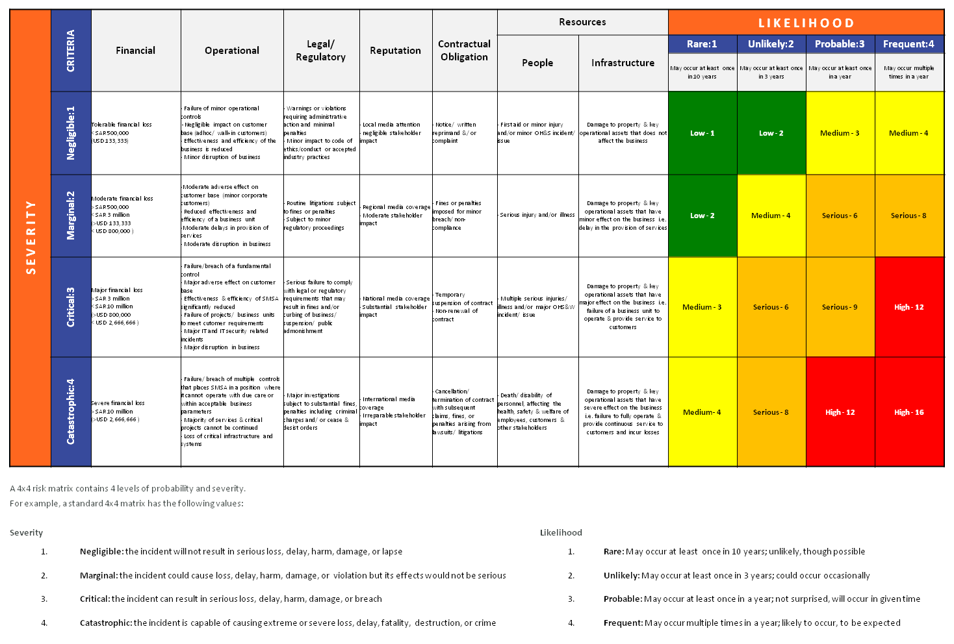

*Refer to SMSA GUIDE Database document no. 2741

Business Continuity & Recovery Plan

- INCIDENT: IT SERVERS FAILURE & CYBER ATTACKS
BUSINESS CONTINUITY ACTION:
Buy a new server in case the problem can’t be resolved.
RECOVERY PLAN:
- Incident report documentation.
- Confirm regularly all data are always auto- backed up on time.

- INCIDENT: NATURAL DISASTERS & FIRE
BUSINESS CONTINUITY ACTION:
- Prepare a plan with engineering for immediate renovation of the warehouse.
- Shift all operational activities to the nearest similar-in size warehouse.
RECOVERY PLAN:
- Incident report documentation.
- Employees’ awareness of the incident, its root cause and its impact to the company.
- Preparation of corrective and preventive action plans.
- Maintain the Safety of the warehouse with the proper equipment, systems & extinguishers locations.

- INCIDENT: LICENSE & AUTHORITIES APPROVALS
BUSINESS CONTINUITY ACTION:
- Arrange for a meeting with the public relations officer and finance manager to resolve the issue.
- Shift all operational activities to the nearest similar-in size warehouse (if necessary).
RECOVERY PLAN:
- Incident report documentation.
- Concerned Employees’ awareness of the incident, its root cause and its impact to the company.
- Preparation of corrective and preventive action plans.
- Maintain the proper work processes and policies to avoid similar incidents in the future.

- INCIDENT: CIVIL DISORDERS
BUSINESS CONTINUITY ACTION:
Stop all responsible staff and confirm with QRM & HR for the replacement process.
RECOVERY PLAN:
- Incident report documentation.
- Confirm regularly all data are always auto- backed up on time.

- INCIDENT: DATA LEAKAGE
BUSINESS CONTINUITY ACTION:
Stop all responsible staff and confirm with QRM & IT for the replacement process.
RECOVERY PLAN:
- Incident report documentation.
- Confirm regularly all data are always backed up.

- INCIDENT: PANDEMICS
BUSINESS CONTINUITY ACTION:
- Remote working alternative schedules.
- Medical tests/Self- Isolation when necessary.
- Use of personal protection equipment inside the company.
RECOVERY PLAN:
- Incident report documentation.
- Employees’ awareness of the incident and its impact to the company.
- Vaccinations; when available.

Activation Criteria & Procedure

When an incident occurs, the BC team leader shall coordinate with emergency response team to contact all the concerned staff through direct calls, emails or SMS messages. The concerned staff shall understand and follow the emergency team instructions as they will be guiding them on the response plan based on the incident.

Communication & Response Structure
SMSA shall handle and carry-out all internal and external communications relevant to the Business Continuity Management System, whilst ensuring the availability of the means of communication during a disruption. All interested parties that will be potentially impacted by an actual or impending disruption shall be alerted.

INTERNAL COMMUNICATIONS
A documented procedure shall be available for all communication, including what, when, with whom, and how to communicate with employees and their emergency contacts.

EMERGENCY CONTACTS
Corporate Office | +966 11 218 7777ext. 8554
Quality & Risk Management | +966 11 218 7777ext. 8523
Information Technology | +966 11 218 7777ext. 7717
Human Resources | +966 11 218 7777ext. 7758
Customer Service | +966 11 218 7777ext. 8000
Administration | +966 11 218 7777ext. 213
Marketing | +966 11 218 7777ext. 8333
Finance | +966 11 218 7777ext. 7738
Legal | +966 11 218 7777ext. 405

EXTERNAL COMMUNICATIONS
All external communications relevant to BCMS shall be in accordance to the Media and Public Relations Policy of SMSA. Refer to GUIDE document no. 3659, including receiving, documenting, and responding to communications to and from interested parties, such as media and government authorities.

Exercise Programme
SMSA shall implement and maintain an exercise and test programme annually to validate over time the effectiveness of the business continuity strategies and solutions, or when there are significant changes within SMSA or the context in which it operates.
After the exercise, a formal report is published, that contains the outcomes, recommendations, and actions to implement improvements.

Evaluation
SMSA shall evaluate the suitability, adequacy and effectiveness of the Business Impact Analysis, Risk Assessment, Plans and Procedures, and all relevant documents to the Business Continuity Management System at least once a year, after an incident or activation, and when significant changes occur. All documentations and procedures shall be updated accordingly.
SMSA shall also conduct evaluations of relevant partners and suppliers’ business continuity capabilities, and compliance with applicable legal and regulatory requirements, industry best practices, and conformity to the business continuity policy and objectives of the company.
The evaluations may be carried-out through reviews, analysis, exercises, tests, post-incident reports and performance evaluations. SMSA has recently acquired a BCM system, which will enable all requirements herein to be carried-out upon its full implementation.

Distribution List
A digital copy of this Business Continuity Plan is available in SMSA’s Quality Management System, GUIDE, under document no. 4318. Access to this document is limited to the system administrators, authors, plan owners, BCP teams, and Quality & Risk Management group. All printed copies of this document are considered uncontrolled copies.

